Read Now: Taking it Further Pyramids of Biomass Date:

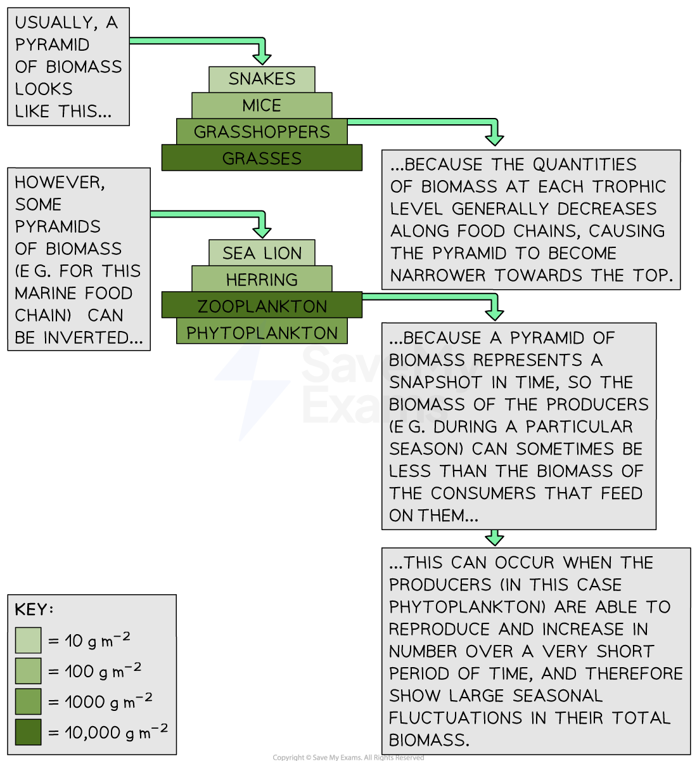

Biomass is the total mass of living things in an area. A pyramid is a shape with a wide base that narrows to a point. A biomass pyramid is a diagram that shows how much biomass is in different groups of living things in an ecosystem. The bottom level shows the most biomass, which decreases as you go up. Each level is called a trophic level. Plants are at the bottom because they make food. Animals that eat plants are next, and animals that eat those animals are at the top.
Questions:
1. What is a biomass pyramid? A) A type of tree B) A chart showing living things C) A shape with a point D) A kind of animal
2. The process of _____ occurs when plants make food.
3. State what is at the bottom of a biomass pyramid.
4. Describe a pyramid.
5. Explain a biomass pyramid.
WHAT: What does a biomass pyramid show?
WHY: Why is it important to know about the biomass pyramid?

MARK SCHEME
1. B
2. photosynthesis
3. Plants
4. A pyramid is a shape with a wide base that narrows to a point.
5. A biomass pyramid shows how much biomass is in different groups of living things in an ecosystem. WHY: It is important because it helps us understand how energy moves through living things.

