Read Now: Uncertainty Date:

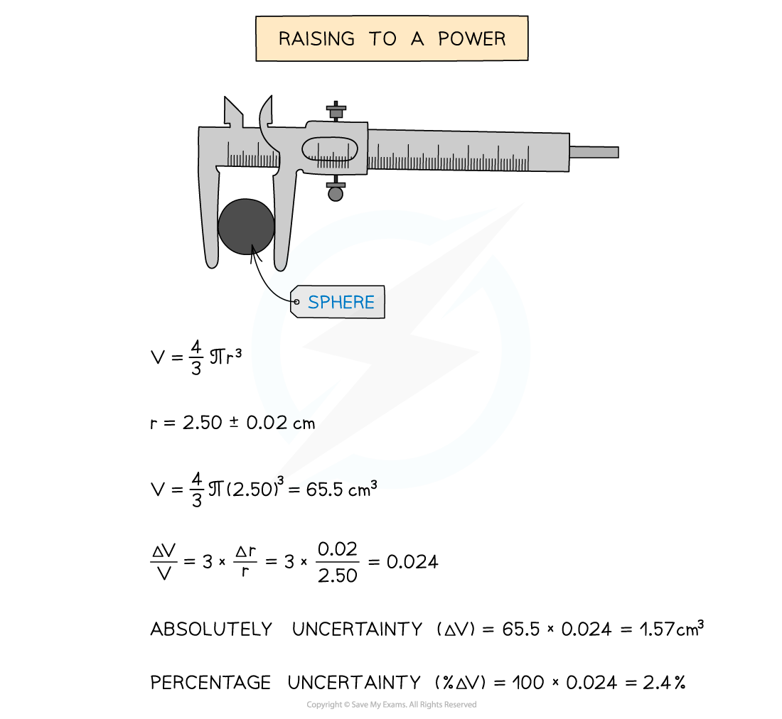

Uncertainty is the idea that in the measurements done in an experiment, there is always some uncertainty about the result obtained. An accurate measurement is one that is close to the true value. To estimate uncertainty, we can use two ways.
First, we can look at the range of a set of measurements. The range is the difference between the highest and lowest values. It helps us see how much the measurements vary.
Second, we can calculate the mean, which is the average of the measurements. We can then use the range around the mean to show the uncertainty. This means that when we repeat our measurements, we can see how close they are to each other.
Questions:
1. What is uncertainty? A) A measurement of time B) The truth of a statement C) The idea that there is always some doubt in measurements D) A type of chemical reaction
2. The process of _____ occurs when we find the difference between the highest and lowest measurements.
3. State what an accurate measurement is.
4. Describe how to estimate uncertainty using the range.
5. Explain how we can find uncertainty.
WHAT: What do we look at to find uncertainty?
WHY: Why do we look at this?

MARK SCHEME
1. C
2. range
3. An accurate measurement is one that is close to the true value.
4. We find the range by calculating the difference between the highest and lowest measurements.
5. We can find uncertainty by looking at the range of measurements.
WHAT: We look at the range and the mean.
WHY: We look at this to see how much the measurements vary.

