Read Now: (HT) Ionic Equations and Displacement Reactions Date:

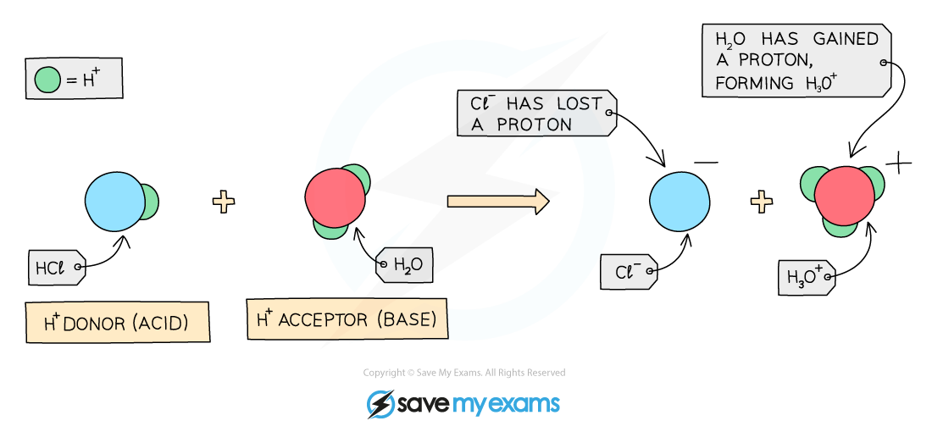

Oxidation is the loss of electrons. Reduction is the gain of electrons. Together, oxidation-reduction refers to reactions where one substance loses electrons (oxidation) and another gains electrons (reduction) at the same time.
In chemistry, we often look at how metals react. The reactivity of a metal is linked to how easily it forms positive ions. For example, metals can react with water or dilute acids. In these reactions, a more reactive metal can displace a less reactive metal from a solution. We can write these reactions using ionic equations.
When metals and non-metals join, they create ionic compounds. These compounds conduct electricity when dissolved because their ions can move freely.
Questions:
1. What is oxidation? A) Gain of electrons B) Loss of electrons C) Both A and B D) None of the above
2. The process of _____ occurs when a substance gains electrons.
3. State what reduction means.
4. Describe how metals react with dilute acids.
5. Explain oxidation-reduction.
WHAT: What happens during oxidation-reduction?
WHY: Why is this process important in reactions?

MARK SCHEME
1. B
2. Reduction
3. Reduction is the gain of electrons.
4. Metals react with dilute acids to form positive ions and release hydrogen.
5. WHAT: One substance loses electrons while another gains electrons. WHY: This process is important because it shows how materials change during chemical reactions.

