Read Now: Fractional Distillation Date:

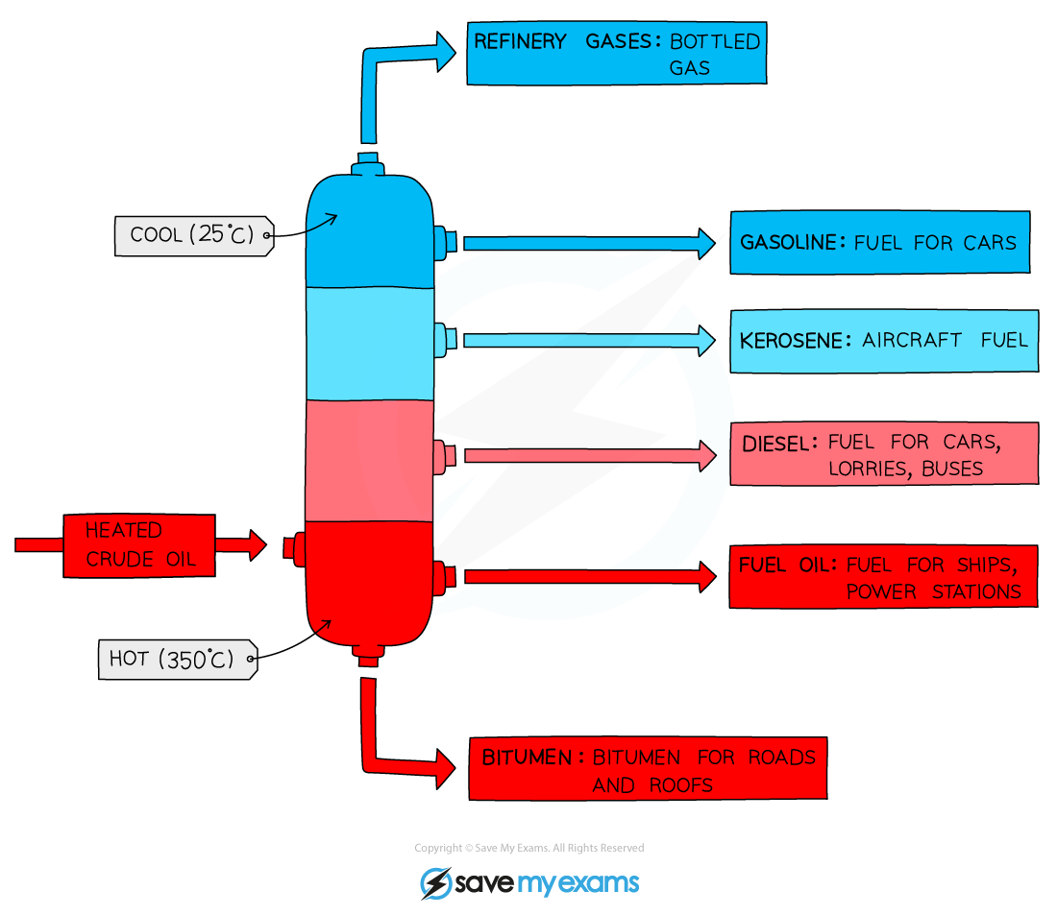

Fractional distillation is a way to separate liquids. It works best when liquids have different boiling points. For example, in oil refining, crude oil is separated into gasoline and diesel.
Here is how it works:
1. Heat the mixture until it boils.
2. The liquid with the lowest boiling point turns into gas first.
3. The gas rises through a column called a fractionating column.
4. As it cools, it turns back into liquid.
5. Each liquid is collected separately.
This method helps to get pure substances from a mixture. It is important in many industries, like making perfumes or fuels.
Questions:
1. What is fractional distillation? (look at line 1)
2. How does fractional distillation separate liquids? (look at lines 2-5)
3. Name one example of where fractional distillation is used. (look at line 6)
4. Define the term "fractionating column." (look at line 4)
5. Why does fractional distillation work best with liquids that have different boiling points? (look at line 2)

MARK SCHEME
1. Fractional distillation is a way to separate liquids. (line 1)
2. It separates liquids by heating them until they boil. (lines 2-3)
3. One example is in oil refining. (line 6)
4. A fractionating column is where gas rises and cools. (line 4)
5. It works best because each liquid boils at a different temperature. (line 2)

