Part 1 – Fill in the Blanks
Word Bank:
four, covalent, giant, hard, high, delocalised, conduct, cutting, drills, bonds, network, electrons

1. In diamond, each carbon atom forms _____ covalent bonds with other carbon atoms.
2. Diamond has a _____ covalent structure made of a rigid network.
3. The strong covalent _____ between carbon atoms make diamond very hard.
4. Diamond has a _____ melting point due to strong bonding.
5. Diamond does not _____ electricity because it has no delocalised electrons.
6. Diamond is useful for _____ tools because it is very hard.

Part 2 – Connect the Lines
Draw lines to match each term to the correct description.
Giant covalent structure |  | Does not conduct electricity due to no free electrons
High melting point |  | A rigid network of atoms held by strong bonds
Electrical conductor |  | Caused by strong covalent bonds throughout the structure
Non-conductor |  | Diamond is not this type of material

Part 3 – Labelling Diamond Structure Diagram
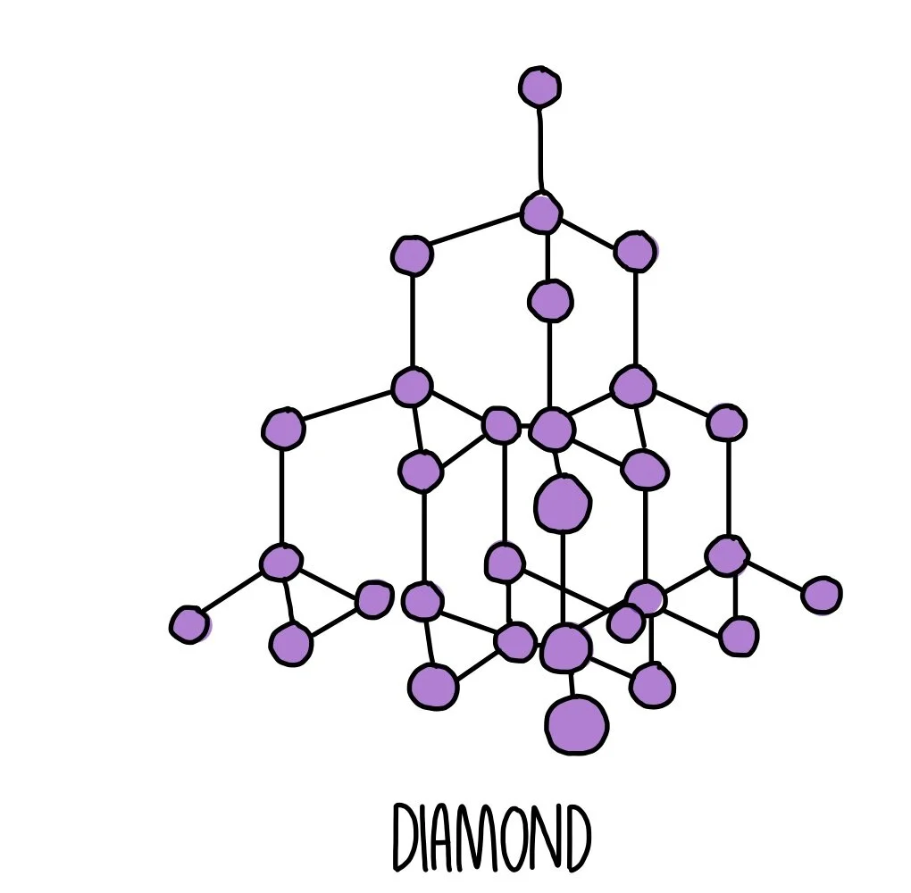
Label the diagram to show:
Carbon atoms
Covalent bonds
Giant structure
How many bonds do each carbon form? _____

- How many covalent bonds does each carbon atom form in diamond?
______________________________________________________________________________
- Give two properties of diamond that make it useful for cutting tools.
Property 1 ____________________________________________
Property 2 ____________________________________________

- Explain why diamond is very hard.
__________________________________________________________________________________________________________________________________________________________________________________________________________________________________________

- Why doesn’t diamond conduct electricity?
____________________________________________________________________________________________________________________________________________________________

- Compare the melting point of diamond to simple molecules like oxygen.
__________________________________________________________________________________________________________________________________________________________________________________________________________________________________________
- Circle the correct type of bonding found in diamond:
ionic covalent metallic

- True or False: Diamond has delocalised electrons.
Explain your answer: ___________________________________________________

