# Exam: Android Mobile (3 Hr.) – Catchy App

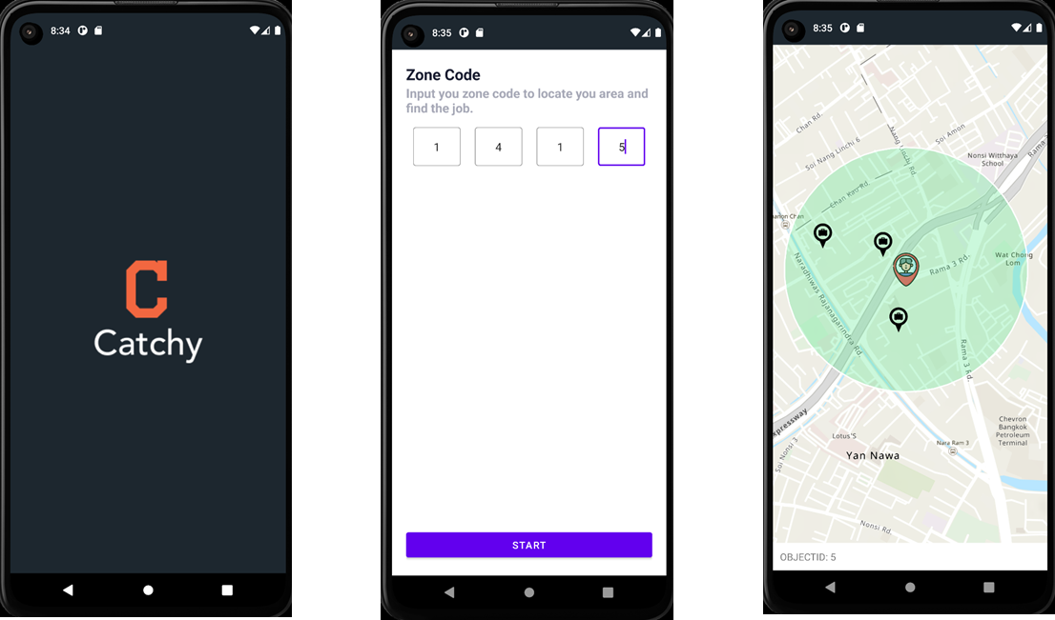

**Requirements**

* ArcGIS Runtime API for Android: 100.15.3
* Use ViewBinding Feature

**Assets Resources**

<https://github.com/mariczone/exam_android_assets>

**Splash Screen Fragment**

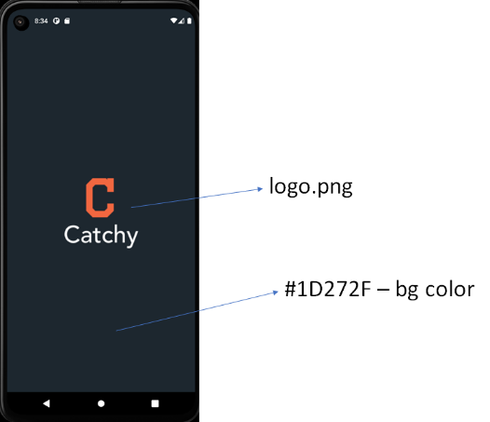

**Tasks**

* Display a screen for 3 seconds then automatically navigate to the next screen.

**Zone Fragment Screen**

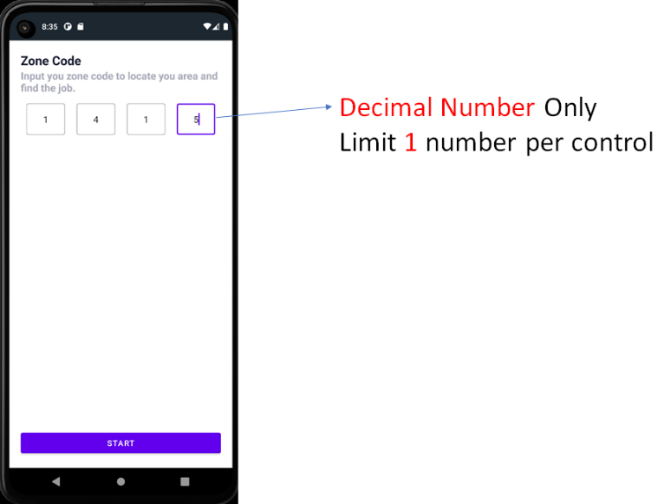

**Tasks**

* Implement the UI as above.
* Bind the click event to “Start Button” to validate the input. When it meets the requirement then navigate to the next screen.
* Pass or share the “Zone Code (Ex. ‘1415’)” Value to use it on the last screen.

**Validating**

* If the Zone code isn’t fulfilled with a 4 decimal number when clicking the start button please alert message “Please fulfill zone code.” as below

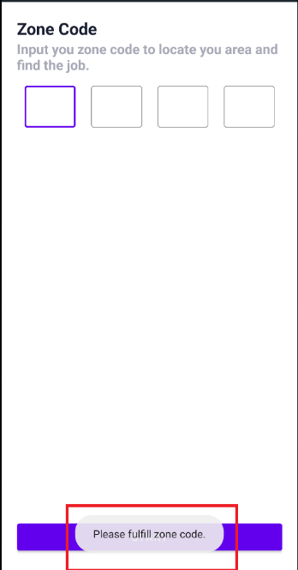

**Map Fragment Screen**

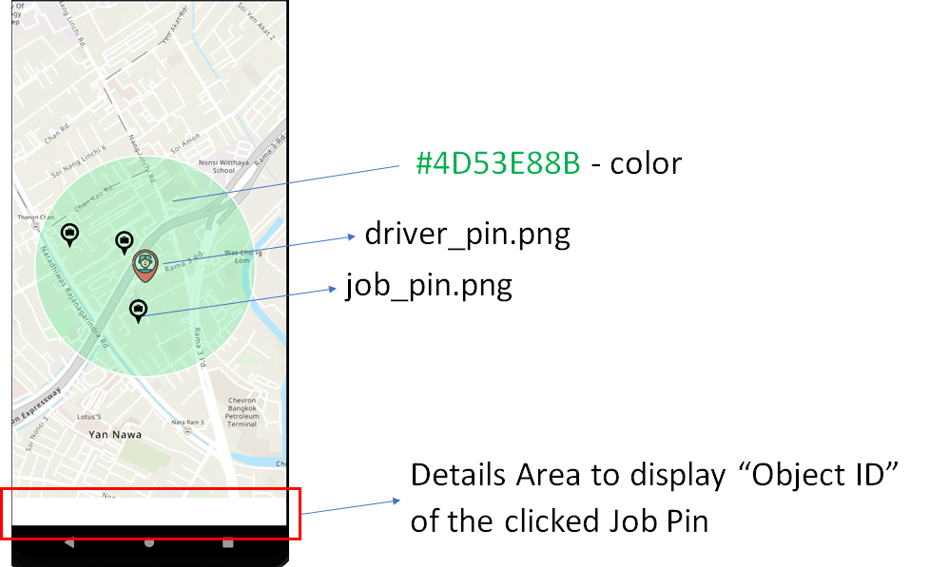

**Tasks**

* Implement the UI with Map as above.
* Initial Map zoom to the location (longitude: 100.543535058, Latitude: 13.703101959)
* Add the Driver's Pinpoint with a Picture Symbol at a specific location (longitude: 100.543535058, Latitude: 13.703101959)

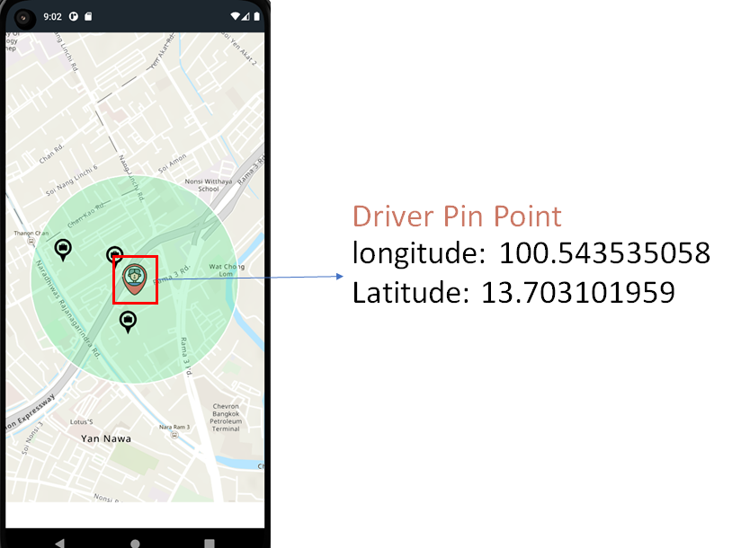

* Create a Green Buffer area 500 meters from the Driver's Pinpoint

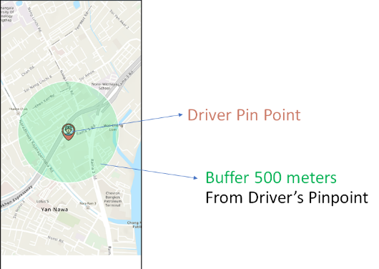

* Query the data from the feature layer ( <https://services8.arcgis.com/1GMGEQ46pmP4Y2wd/arcgis/rest/services/JOB_ZONE_LAYER/FeatureServer/0> ) with specific conditions and display the Job data on the Graphic Layer

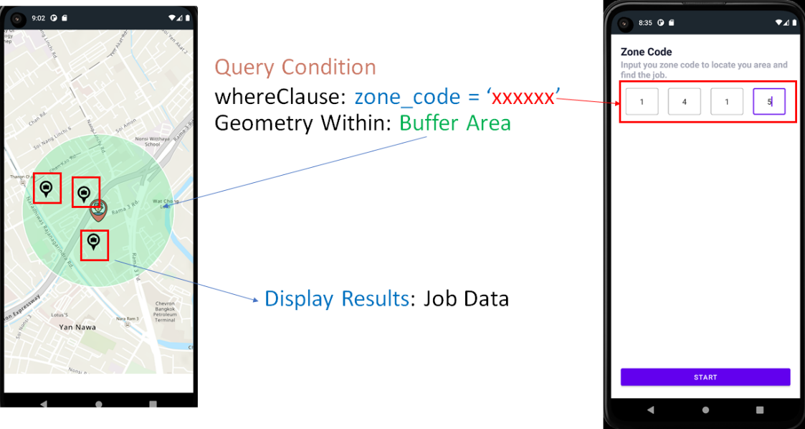

**Map Event**

* When clicking on Job Pin, Update the detail area to show the selected “OBJECTID” pin.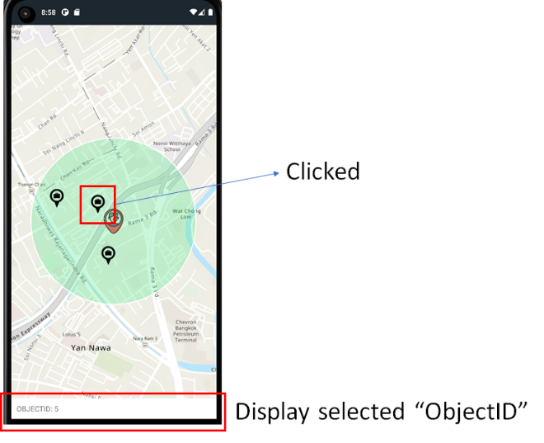
* When clicking on the blank area, Reset the detail area to blank.

