Digital Signal Processing

Halftone Image Enhancer  
  
  
 Project Report

Dr. Mohamed Mostafa

Marie Elia 900150669

Osama Adel Reheem 900153490

# Halftone Image Enhancer

Halftoning is an application of image processing widely used in printing processes. With the evolution of computers and their use of typesetting, printing, and publishing, the field of halftoning that was previously limited in scope, called halftoning screen evolved into its successor—digital halftoning.

# Median Filter

In our project, we used median filter in enhancing the image quality. What a media filter does is the it convolves on the image and replace each pixel by the median of the kernel convolving. For example, if we have a 1-d array as following

|  |  |  |  |  |  |  |  |  |  |
| --- | --- | --- | --- | --- | --- | --- | --- | --- | --- |
| 1 | 9 | 4 | 5 | 7 | 3 | 0 | 5 | 8 | 6 |

If we have a filter of size 3 it will does change it to the following

|  |  |  |  |  |  |  |  |  |  |
| --- | --- | --- | --- | --- | --- | --- | --- | --- | --- |
| 1 | 4 | 5 | 5 | 5 | 3 | 3 | 5 | 6 | 6 |

After adding a zero in the beginning and the end of the array, we convolve a 3 by 1 filter on the input, so we will have the filter at the beginning on [0,1,4]. Thus, it will take the median of the 3 values to be 1 and put it in the first index. It will do so until it reaches the end. This method is great when dealing with “salt and pepper noise“ since it can ignore very high and very low values in the kernel and only care about the median. As we can see here, very high and very low values such as 9 and 0 were not present in the output.

# Bilateral Filter and Gaussian Filter

The bilateral filter is very important in producing the output of the enhancement. This filter is an advanced type of smoothing filters that is built on the gaussian filter idea. The gaussian filter kernel is based on the gaussian distribution on the kernel area and will typically look as following

This kernel takes into consideration the distribution of the powers on each pixel in the kernel area giving the highest power to the center and attenuating as it moves further from the center. This has proved much better results than normal averaging filter which would give all the pixels the same weights.

The Bilateral filter is a gaussian filter that takes into consideration the image content in the kernel weights. Unlike the gaussian filter, the Bilateral filter would detect edges in the kernels area and decrease their weights in order to keep the edges while smoothing the image.

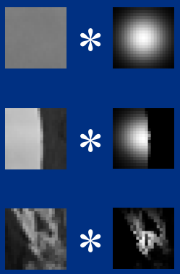 As we can see in the figure that shows different kernel weights for the bilateral filter convolving the same image, the filter acts as a gaussian filter if there is no edge detected. When an edge is detected, the weights begin to change and decrease in the specified area (to 0).

The filter weights can be calculated as following:

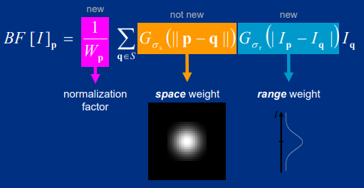

# Experiment and Results

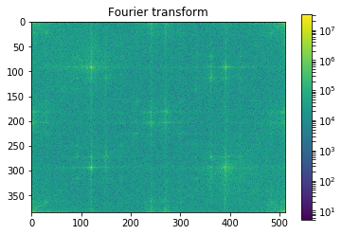In order to reach meaningful results, we first had to identify what caused the halftoning in the image. Meaning that we had to look for the notches in the frequency domain of the image representing the halftoning. A simple solution would be designing a frequency domain filter that would remove those notches (notch filter). However, after trial, this did produce good results. Many other trials were done after that (that can be seen in oldtrials.ipynb for reference) but none has generated good results. Thus, we had to think about improving the image in the space domain and we have come to use specified filters from ready-made libraries.

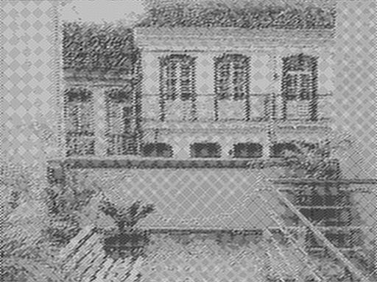 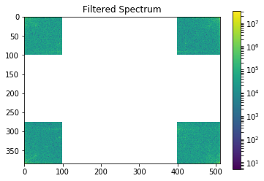

A step that had to be done before designing a good filter, is that trying to be finding a way to evaluate the filter’s performance rather than simple opinion made by us. Thus, we have used a base image and got its halftone from a website and used it in evaluation. We would evaluate the filters performance by getting the L1 distance from the ground truth image and the generated image. We have tried different combinations of filters, kernel sizes, diamaters(for bilateral and gaussian) in order to reach our best design. We found that using a bilateral filter followed by a media filter produced the least errors. However, we could not specify the hyperparameters of each filter using this model since it gave us misleading results. However, the evaluation showed us that blurry images with no halftone effect produced less error than ones with edgy images that have an attenuated effect of the halftone.

We developed a generative mode with different hyperparameters for each filter in order to see which of them looks better. We have chosen a bilateral filter with diameter 7 and a median filter with kernel of size 5. And we have produced the following frequency domain results. The final images are attached

