There are 2 folders in my submission

1-ASSIG1: the 3 classes that I worked on.

2-Game: the java file that I encapsulated in the 3 classes.

Once the user runs the game:

1-The user will be prompted to enter a row number and a column number.  
  
2- The computer will play against the user.

3-There is a checking that happens to ensure that the position is not previously taken

4- Also there is a check for winner

**I have 3 classes:**

1. Controller
2. View
3. Board

**1. In Controller**

I ensure that the game is active and that is not stopped

2 Cases for stopping:

1. Stale

2. Winning Case

**2. In View**

-I display the board with dots (empty board)

-Ask the user for input row and column

**3. In board**

-Player makes the move chosen by user.

-Computer makes the move.

-I check if the move is valid within boundaries or to see if previously taken.

-I also check that the rows and columns are within the boundaries.

-I check for winner row by row, col by col and diagonally.

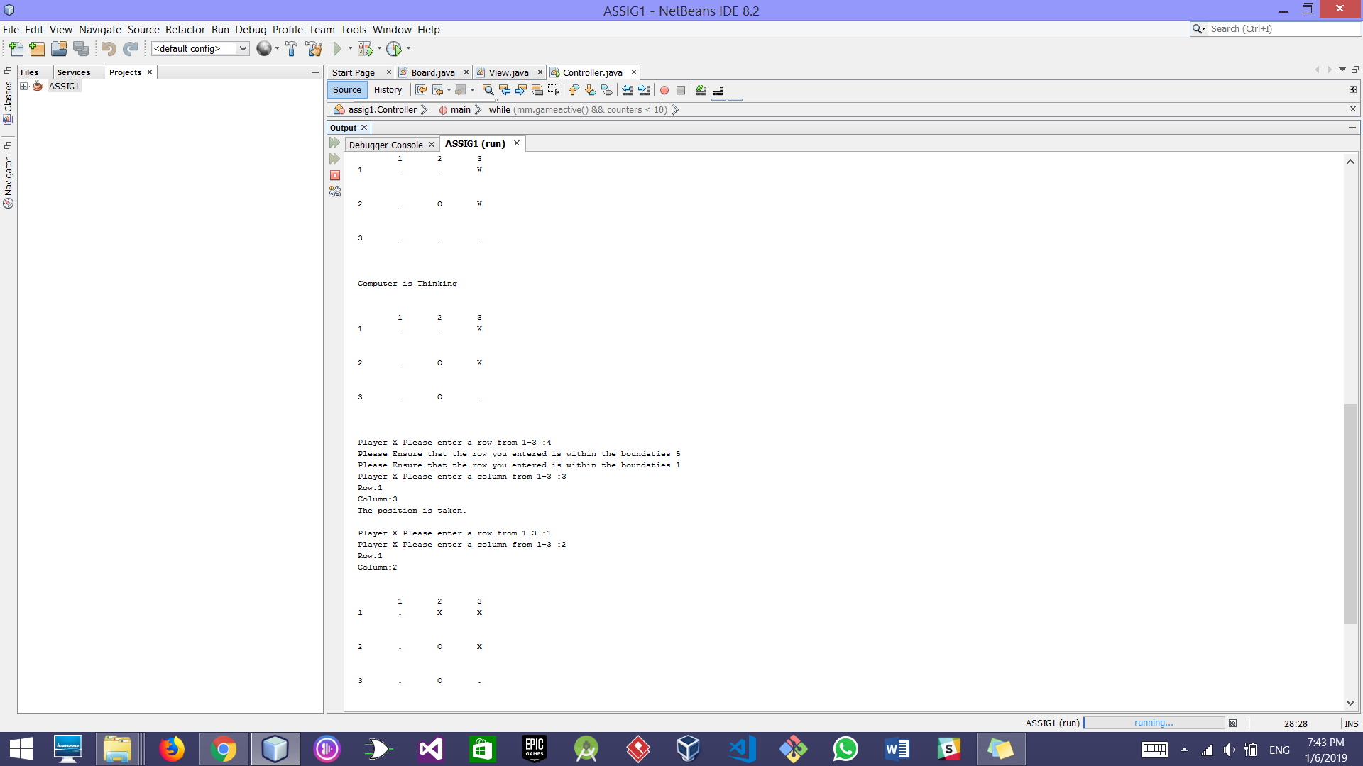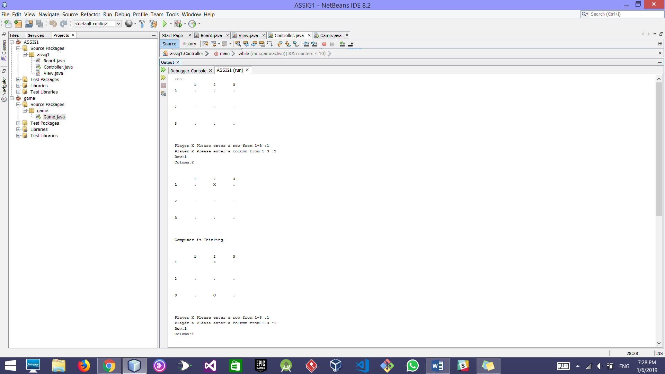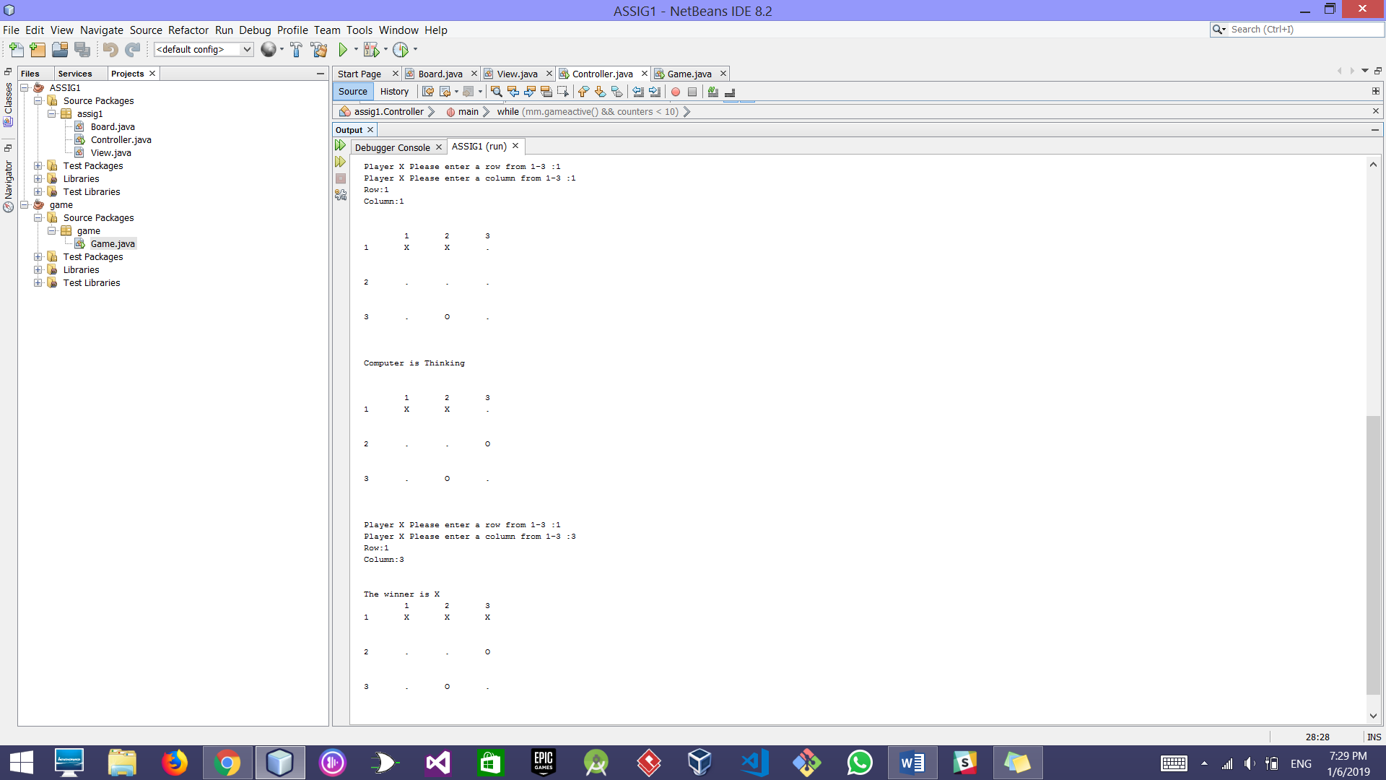

Validation Handling