|  |
| --- |
|  |
| The Documentation |
| [**Web-service** which converts photos from RAW-file to JPG-file online] |
|  |
| **[Bilan Maria]** |
| **[24/04/2018]** |

[Type the abstract of the document here. The abstract is typically a short summary of the contents of the document. Type the abstract of the document here. The abstract is typically a short summary of the contents of the document.]

Table of Contents

[To update the table of contents, right click the message below and select Update Field (F9 on PC, ⌥⌘U on Mac).]

1. Pages
   1. Page Tree

User flow (lo-fi wireframes)  
 Desktop (hi-fi wireframe)  
 Tablet (hi-fi wireframe)  
 Mobile (hi-fi wireframe)

* 1. User flow (lo-fi wireframes)
     1. User Interface

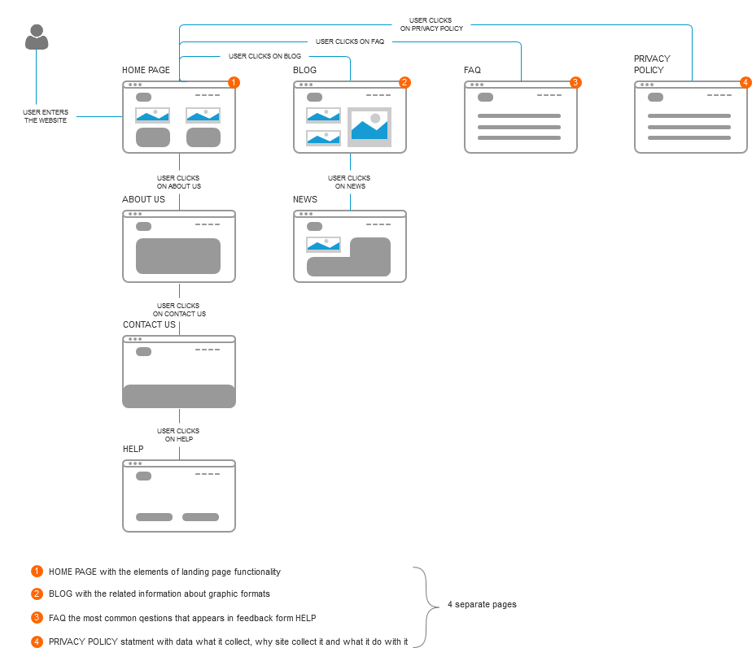

* 1. Desktop (hi-fi wireframe)
     1. User Interface

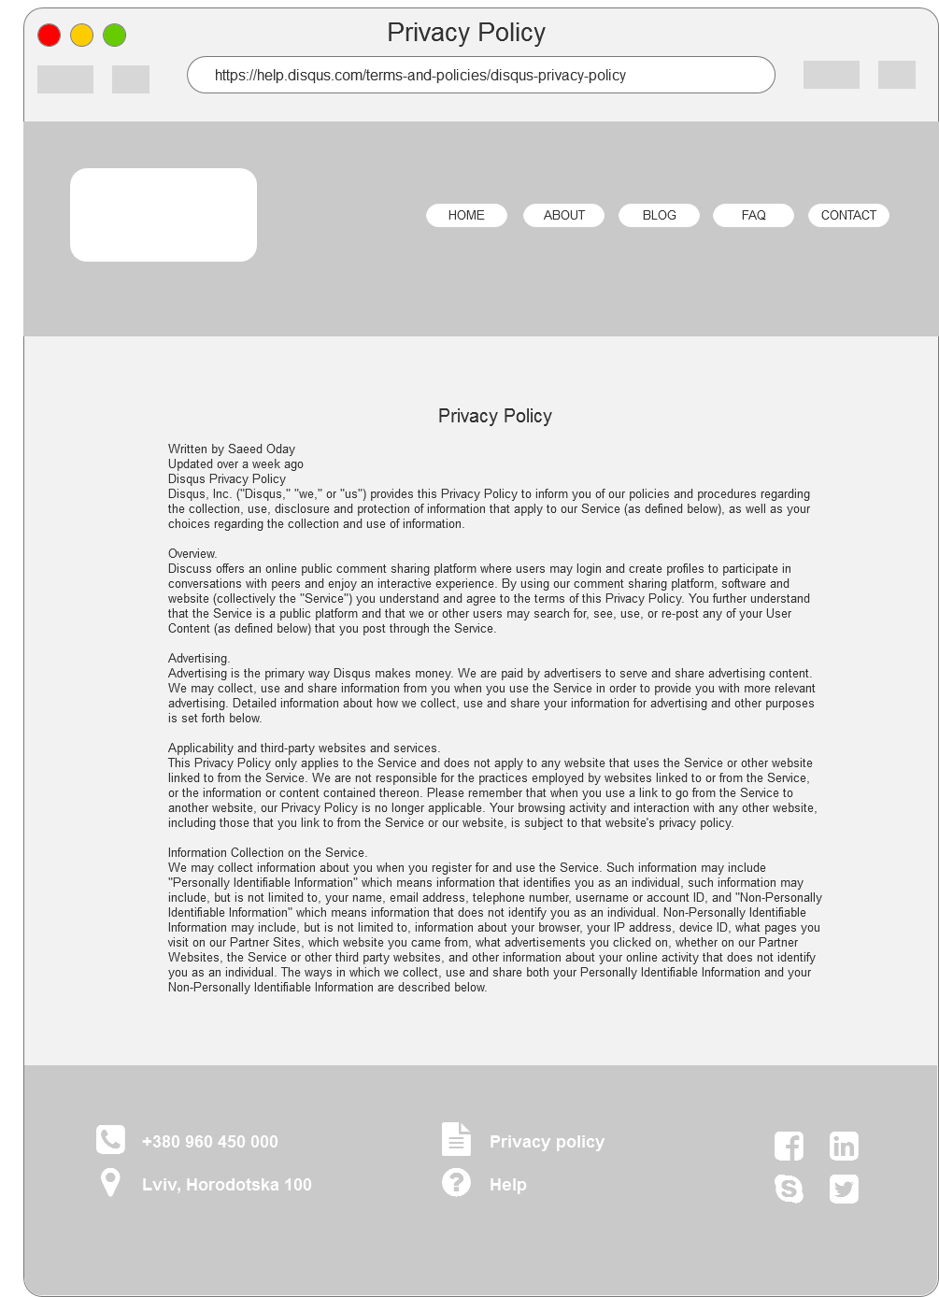

* 1. Tablet (hi-fi wireframe)
     1. User Interface

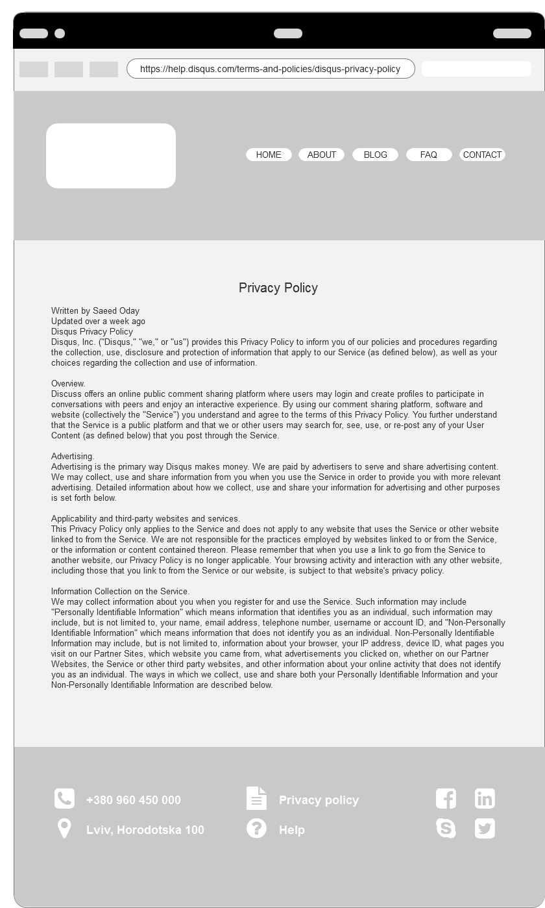

* 1. Mobile (hi-fi wireframe)
     1. User Interface

