Creative Brief

Marie Foss

11/13/19

Project Title: Walker Evans Website

1. PROJECT OVERVIEW

This website will really highlight Walker Evans as an important figure in American history/art history. As much as he used his photography to illustrate American life during the Great Depression and many images of Americana, this website should illustrate his life, his photography, and its legacy in an engaging and striking way.

1. RESOURCES

You can find the Wikipedia page here: <https://en.wikipedia.org/wiki/Walker_Evans>.

You can find more images/body text if you need it here: <https://www.metmuseum.org/toah/search/?search-term=walker+evans>

(just make sure to cite the sources! :))

1. AUDIENCE

The audience for this site will be design professors within Sam Fox, as well as potential employers. Basically, this website will be seen and experienced by various peers and adults who may or may not know who Walker Evans is.

1. MESSAGE

This website should focus on Evans’s legacy and his impact both now and when he was alive.

1. TONE

The tone should be clear, clean, and engaging. It shouldn’t be playful, per se, because it should pay homage to the heaviness of the Great Depression era. It should be "literate, authoritative, transcendent," like Evans’s photographs.

1. 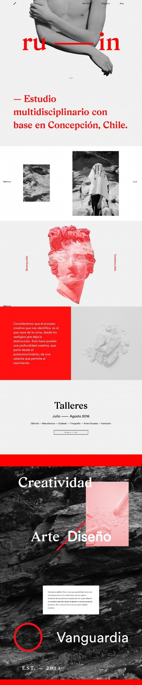VISUAL STYLE

The style of this website should have clean lines/blocks of color to distinguish hierarchy and to lead the eye through the page. Because there isn’t a whole ton of body copy, It would be cool to the text should be broken up effectively and can be larger than text in an article. Think about using some older typefaces for a header, or some typographic element, that reflects the old American signage that Evans would collect and photograph.

