Python Programming for Geomatics – GEO1000

Assignment 4: C++ and github

Deadline: Friday, October 29, 2021, 18h00 CEST

Authors: Rianne Aalders, Marieke van Esch

Student Numbers: 4593987, 4545508

GIT REPOSITORY link: https://github.com/mariekeve/assignment4-nbody

**Differences between the python and C++ program.** (200 words)

Python is a high-level programming language. Python is run through an interpreter, whilst C++ is pre-compiled. Python is an easy to read program for people, and is a dynamically typed language. Whilst C++ is an statically typed language which make use of classes. Information of python is short written. C++ is an extended program with classes and therefore less readable for humans at first sight. All the variables have to be initialized in order to work with it in a proper way.

The information of the simulation in C++ is presented in a way of using classes datatypes. In nbody.cpp “body state” is therefore an array containing all the planets, which in turn use the class “body”. “body” makes use of vector3d class with methods position and velocity. Vector3d makes use of pointers.

In contrast to C++ is the nbody.py structure is presented more in a global way. BODIES is an dictionary data type containing the keys of the planets. The values are presented as a tuple containing first its x,y,z-positions, secondly its x,y,z-vectordirections and lastly its respect to the solarmass. (181 words)

**Reflection paragraph how you went about solving the task** (max 400 words)

*Github operations*

First we had to make an clone of the GIT repository of bmmeijers. After obtaining the files we had to add our cloned files to our index area. After that we commited the change that we cloned our data to our repository. Afterwards we pushed our file towards our own assignment4-nbody remote on Github. If we made changes to the document we needed to pull our remote again to our own working directory. Since we made the document on one computer, we only did the pulling back at the end to check if it worked on another computer as well.

*Program*

*Nbody.cpp*

For C++ we had to install an debugger and an release version in order to compile the files. Afterwards the python interpreter was installed to run python on Clion. After doing that we included some more preprocessor directives to load the files like fstream, iomanip, string and cstdlib. In order to print the csv file a we initialized a void function print_csv which takes the stringtype filename, and the array bodystate[]. The filename will be opened. It gets its header and afterwards it gets its items through an iteration of the number of BODIES_count in body state[]. In main print_csv is called with nbodyCPP.csv as filename.

*Nbody.py*

In python interpreter the function write_csv is established. With parameters file_name, bodies=SYSTEM and names=NAMES. Bodies=System is the values of the bodies global dictionairy. Names are the keys of the global dictionary.The file_name will be opened and instructed to work in write mode. After writing the header a for loop is used to create the table with the names and the certain x,y,z-positions. In the function main iterations for the python executable are used and the function write_csv is called to write the nbodyPython.csv.

*Runner.py*

In order to compute the runnertime of the debugger C++, the Release C++ and the python executable, writing an runner.py was needed. The import of os and perf_counter to be able to calculate the perf_counter. After initializing the steps the several programs can be printed and a table can be obtained of the speed time (table 1: varying from 5,000 till 5,000,000) (graph1: varying from 5,000 and 500,000).

**Table 1: Speed time of nbody (s)**

|  |  |  |  |  |
| --- | --- | --- | --- | --- |
| Steps | C++ release | C++ debug | Python script | Python executable |
| 5,000 | 0.020 | 0.047 | 0.062 | 0.448 |
| 50,000 | 0.023 | 0.087 | 0.409 | 1.030 |
| 500,000 | 0.062 | 0.518 | 3.778 | 7.577 |
| 5,000,000 | 0.466 | 4.628 | 44.650 | 66.306 |

Conclusion derived from the table and graph could be that the C++ speed times are significant faster than the python speed time if the steps of movement are increased. This is because of the good memory management that C++ has, in comparison to Python. The debugger is slower than the release version since it disables its optimization, in order to work in debugging mode. The release version enables its optimisation which makes the program run faster.

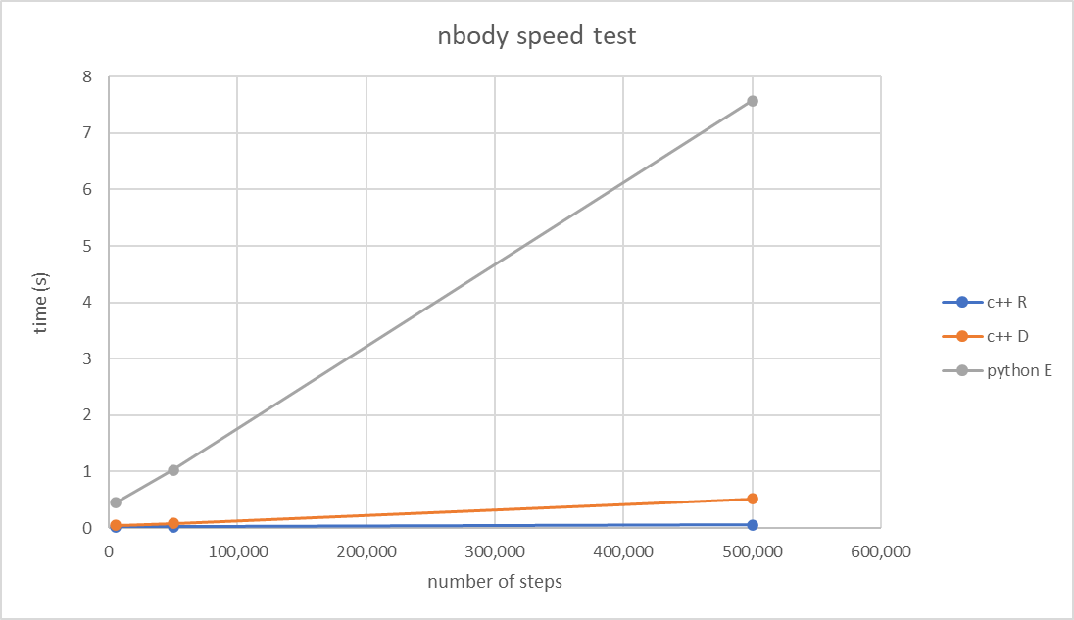

Graph 1: nbody speed test

Figure 1: nbody Python in QGIS

Figure 2: nbody CPP in QGIS