Laboratory Activity 5: Recolor, Reimagine: A Color Theory Redesign Challenge

Bachelor of Science in Information Technology UI / UX and Cross Platform
Mr. Jobert Salvador - Subject Instructor

Submitted by:

Tolentino, Mariely Ann L.

September 25, 2026

I. Activity Overview
Goal: Practice applying color theory — the color wheel, harmony models, and color psychology — to a real interface. You will redesign screens from an existing, popular mobile app using three different color harmony models (complementary, analogous, and triadic), while comparing each redesign back to the app's original color identity. Working Format: Individual work. You will design all versions yourself using Figma, Canva, Adobe XD, or a similar design tool.
Time Allotment: One 3-hour laboratory session.
Materials Needed: A computer with Figma (or a similar design tool), your Topic 5 lecture notes (color wheel, harmony models, color psychology), and a printed or digital copy of this activity sheet.
II. Pick ONE Popular Mobile App

- The Spotify app is originally identified by its signature vibrant green (#1DB954) set against a near-black dark-mode interface.

III. Capture 4 Original Screens (Keep the Real Colors)
Screen 1
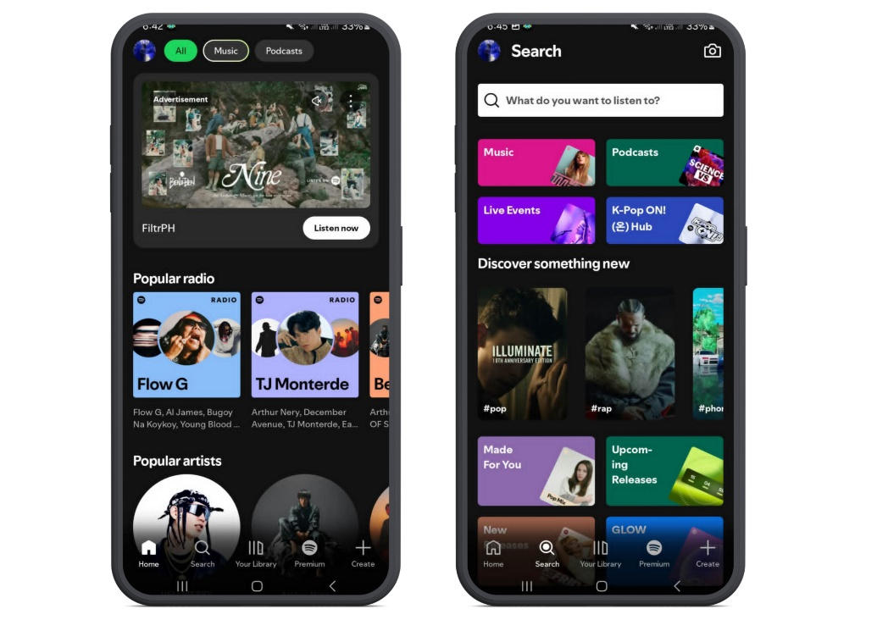
Screen 2
Screen 4
Screen 3
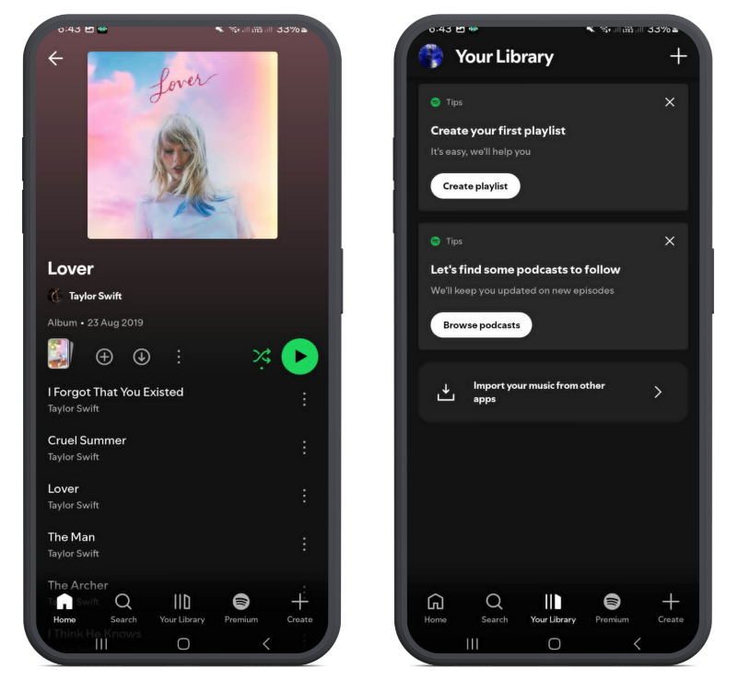

IV. Round 1 — Redesign with COMPLEMENTARY Harmony
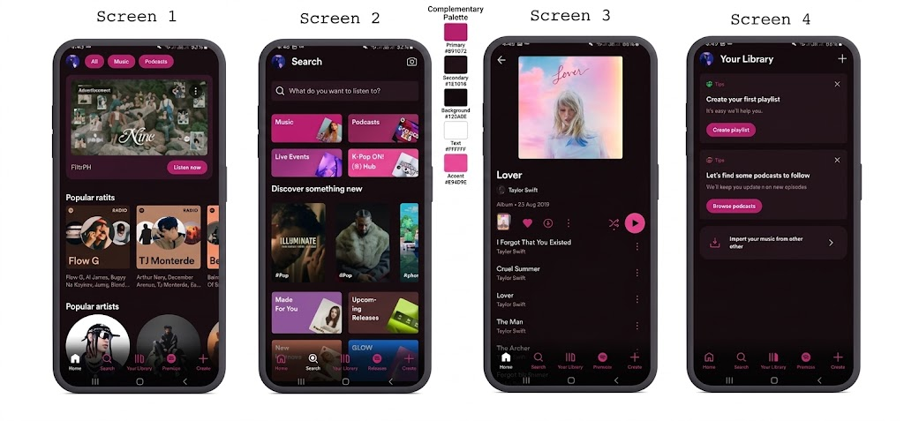

V. Round 2 — Redesign with ANALOGOUS Harmony
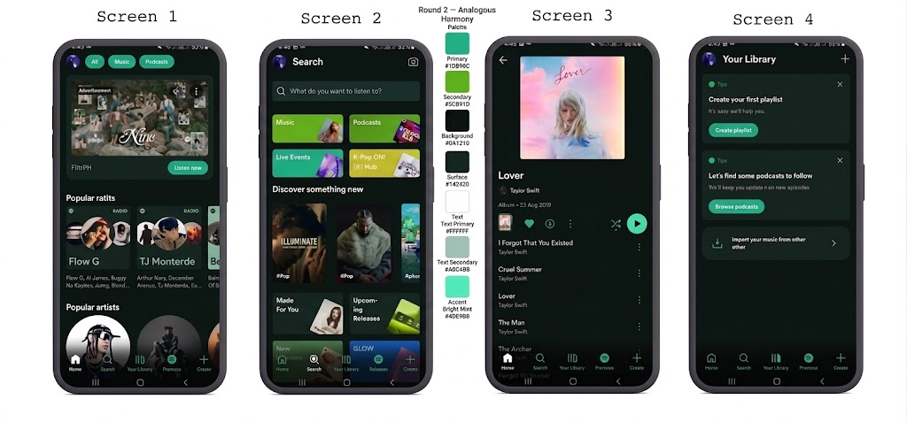

VI. Round 3 — Redesign with TRIADIC Harmony
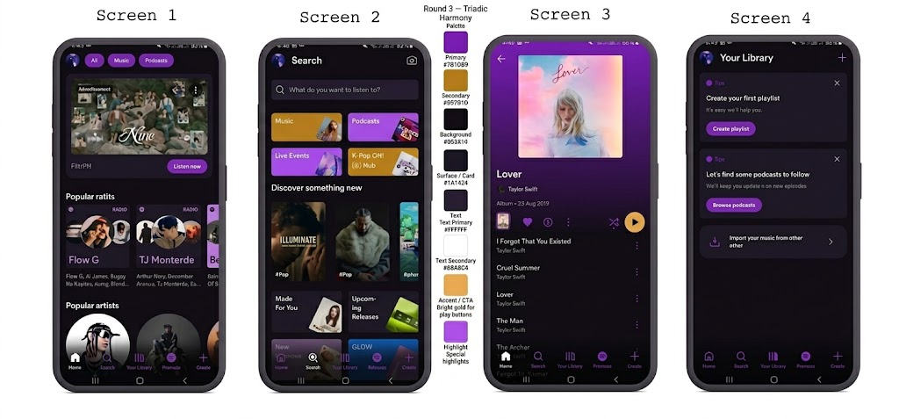

VII. Compare the Four Versions
Fill in the table below comparing your three redesigns against the original app.
Measure | Original | Complementary | Analogous | Triadic
Mood / feeling communicated | Energetic, modern, youthful, "go" / play | Bold, passionate, glamorous, nightlife-oriented | Calm, organic, refreshing, wellness-oriented | Creative, playful, premium, festival-like
Does it still feel “on-brand”? | Yes, this is the brand | No, feels like a dating or nightlife app (e.g., Tinder-adjacent). The dark mode + neon pink evokes a completely different industry. | Partially, the teal-green is close enough to the original green that it still reads as "music app," but slightly more "health/meditation app." | No, purple + gold reads as a gaming, creative tool, or premium streaming service (like Twitch or Tidal).
Readability / color contrast | Excellent, white on near-black with green accents passes WCAG AAA | Good, white on #120A0E maintains strong contrast. The bright pink #E94D9E on dark backgrounds is readable, but pink-on-pink combinations (accent on surface) need care. | Excellent, the dark teal backgrounds maintain the same luminance contrast as the original. Very safe for accessibility. | Good, white on #0E0A14 is fine, but amber text #B97B1D on dark purple #1A1424 can fall below 4.5:1 for small text. Needed to use #E9A84D (brighter) for smaller labels.
Your personal favorite? (Y/N) | Y | N | Y | N
VIII. Conclusion
Answer the following in a short-written reflection (5 to 8 sentences total):
– Which harmony model felt closest to the app's original identity, and why?
– Which harmony model changed the “feeling” of the app the most?
– Did any redesign hurt readability or contrast? What did that teach you about accessibility? – If you were the app's actual designer, would you propose any of these palettes for real? Why or why not?

The analogous harmony felt closest to Spotify's original identity because teal-green and yellow green are direct neighbors of Spotify's signature green on the color wheel; the shift is subtle enough that the app still "feels" like Spotify, just with a slightly cooler, more organic personality. The triadic harmony changed the feeling of the app the most swapping green for deep purple with amber accents, transformed Spotify from an energetic, accessible music platform into something that felt like a premium gaming or creative tool, almost unrecognizable as the same brand. The complementary redesign taught me the most about accessibility: while the magenta-pink on dark backgrounds looked striking, I had to carefully check that secondary text (#C4A8B8) maintained at least a 4.5:1 contrast ratio against the surface color (#1E1018), and some pink-on-pink combinations I initially tried failed that test, reminding me that high hue contrast does not automatically mean high luminance contrast. If I were Spotify's actual designer, I would not propose any of these palettes as a full rebrand Spotify's green is one of the most recognizable brand colors in tech, and changing it would sacrifice enormous brand equity. However, I would consider the analogous teal-green palette as a seasonal or "Spotify Wellness" sub-theme, since it preserves readability and brand adjacency while communicating a calmer mood.

