Laboratory Activity 4: A Prototyping and Usability Testing Sprint

Bachelor of Science in Information Technology UI / UX and Cross Platform
Mr. Jobert Salvador - Subject Instructor

Submitted by:

Tolentino, Mariely Ann L.

September 18, 2026

- Pick ONE Simple Task

- The user wants to set a new alarm for 7:30 AM.

- Sketch the Flow (Wireframe)
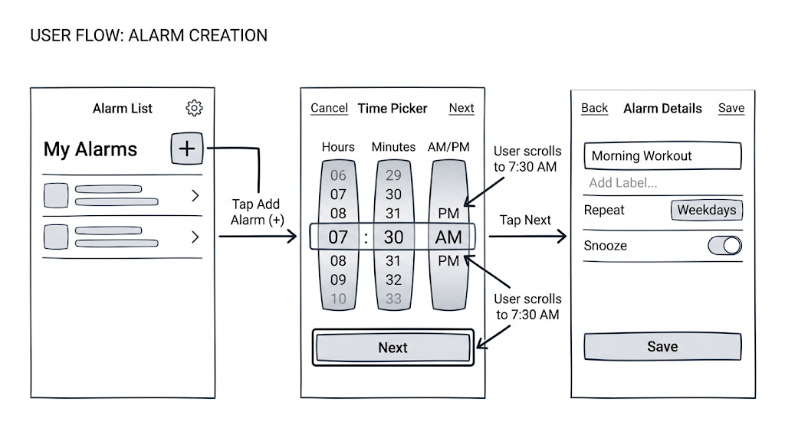

- Build a Mid-Fidelity Digital Wireframe

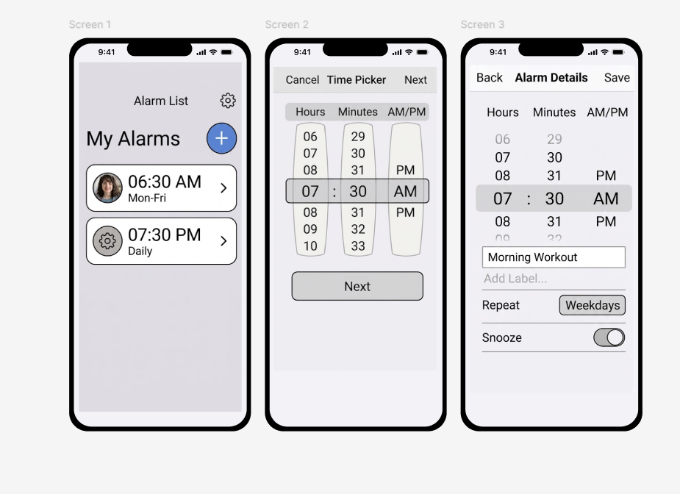

- Usability Test Round 1 (Mid-Fidelity Prototype)

- Testing context: I acted as the tester, thinking out loud while clicking through the grayscale Figma prototype.
- Time to complete: 42 seconds.
- Observations & Errors:
  - Screen 1: Smooth. Tapped "Add Alarm" easily.
  - Screen 2 (Confusion/Error 1): I scrolled the wheels to 7:30 AM. When I went to tap "Next", my finger slipped and accidentally scrolled the minute wheel again (Error 1) because the small text button was too close to the interactive scroll area.
  - Screen 3 (Error 2): I typed "Wake Up" in the label box. I looked for a save button but missed the small "Save" text in the bottom right corner because it looked like a secondary link rather than a primary action. I tapped the screen randomly before finally spotting it (Error 2).

- Build a High-Fidelity Clickable Prototype

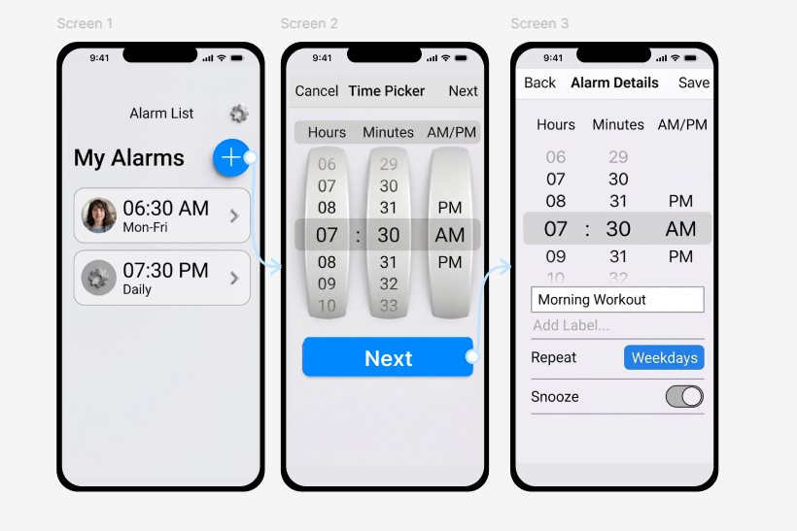

- https://www.figma.com/proto/qWohE4HlQbOZp6reLkJbvl/TOLENTINO-ACT4-SET-AN-ALARM?node-id=0-1&t=wptlZPvRMUwgo9ns-1

- Usability Test Round 2 (Figma Prototype)

- Testing context: I acted as the tester again on the newly updated high-fidelity Figma prototype.
- Time to complete: 14 seconds.
- Observations & Errors:
  - Screen 1: Smooth.
  - Screen 2: No hesitation. The scroll wheels were clearly separated from the large "Next" button at the bottom. Zero errors.
  - Screen 3: Smooth. The "Save" button was immediately obvious. Tapped it to finish.
- Tester Comments: "Much better. I knew exactly where to tap to finish each step without having to hunt for small text."

- Compare Mid-Fidelity vs. High-Fidelity Results

MEASURE | MID-FIDELITY (WIREFRAME) | HIGH-FIDELITY (FIGMA)
Time to complete task | 42 seconds | 14 seconds
Number of errors / wrong taps | 2 errors (accidental scroll, missed save button) | 0 errors
Points of confusion observed | "Next" button was too close to scroll wheels; "Save" button looked like non-interactive text. | None. Visual hierarchy clearly separated interactive zones and highlighted primary actions.
Tester's confidence / comments | Felt clumsy; accidentally triggered wrong elements and had to search for the final action. | Felt very confident; the flow was smooth and the buttons were impossible to miss.

- Conclusion

- Round 1 revealed significantly more usability problems because the mid-fidelity wireframe lacked clear visual hierarchy, causing primary action buttons to blend in with secondary text. Between the two versions, I changed the small, corner-placed text links for "Next" and "Save" into large, full-width, high-contrast primary buttons at the bottom center of the screen. This change helped immensely, as it completely eliminated the tester's hesitation and prevented accidental scrolling when trying to navigate forward. However, the mid-fidelity prototype was actually better at testing the core mechanics of the time-picker scroll wheels, since the lack of realistic styling allowed the tester to focus purely on the interaction without visual distractions. If I had one more round of testing, I would add a "Snooze duration" setting to the final details screen. This would ensure the flow covers the most common secondary needs of a user setting a morning alarm.

