
Automatic Control Project

Second-Order Control System Analysis and Lead Compensator Design
Course | Automatic Control
ID Used | 41
Natural Frequency, omega_n | 41 rad/sec
Damping Ratio, zeta | 0.75
Group Members | 1) Mariem Helmy  2) Marise Joeseph  3) Mohamed Magdy

1. Project Objective
The objective of this project is to analyze a second-order automatic control system and design a suitable compensator to improve the system response. The project requires MATLAB simulation, plotting the system responses, deriving the closed-loop transfer function, designing a compensator, analyzing the compensated system, and designing an analog circuit representing the compensator.

2. Project Requirements
- Choose omega_n as the last two numbers in the smallest ID in the group.
- Derive the unity-feedback closed-loop transfer function before compensation.
- Use MATLAB to obtain step response, impulse response, rise time, peak time, settling time, maximum peak response, and root locus.
- Design a compensator Gc(s) to obtain a maximum peak of approximately 20% and settling time less than or equal to 2 seconds.
- Derive the closed-loop transfer function after inserting the compensator.
- Analyze the compensated system using MATLAB.
- Design an analog circuit that represents the compensator.

3. Given Data and Damping Ratio Selection
The general forward transfer function is:
$$G\left(s\right)=\frac{ω_{n}^{2}}{s^{2}+2ζω_{n}s+ω_{n}^{2}}$$
For this project, the ID used is 41. Therefore:
$ω_{n}$= 41
The damping ratio is selected using the project rule: Since 41 is not a multiple of 5 and is not a multiple of 3, the selected damping ratio is:
$ζ$ = 0.75

4. System Modeling Before Compensation
Substitute omega_n = 41 and zeta = 0.75 into the standard second-order transfer function:
$ω_{n}^{2}$ = ${41}^{2}$ = 1681
$2ζω_{n}$ = 2 x 0.75 x 41 = 61.5

4.1 Open-Loop Transfer Function
$$G\left(s\right)= \frac{1681}{\left(s^{2}+ 61.5s + 1681\right)}$$

4.2 Closed-Loop Transfer Function Before Compensation
For unity feedback, the closed-loop transfer function is:
$$T\left(s\right)=\frac{ G(s)}{(1 + G(s))}$$
$$T\left(s\right)= \frac{1681}{(s^2 + 61.5s + 3362)}$$

5. MATLAB Code
clc;
clear;
close all;
% ==============================
% Automatic Control Project
% ==============================
% Put omega_n here
wn = 41;
% Determine damping ratio zeta
if mod(wn,5) == 0
zeta = 0.6;
elseif mod(wn,3) == 0
zeta = 0.25;
else
zeta = 0.75;
end
disp("omega_n = ")
disp(wn)
disp("zeta = ")
disp(zeta)
% Open-loop transfer function G(s)
num = wn^2;
den = [1 2*zeta*wn wn^2];
G = tf(num, den);
disp("Open-loop transfer function G(s):")
G
% Closed-loop transfer function
T = feedback(G, 1);
disp("Closed-loop transfer function T(s):")
T
% Step response
figure;
step(T);
grid on;
title('Step Response Before Compensation');
% Impulse response
figure;
impulse(T);
grid on;
title('Impulse Response Before Compensation');
% System info
info_before = stepinfo(T);
disp("System Information Before Compensation:")
disp(info_before)
% Root locus
figure;
rlocus(G);
grid on;
title('Root Locus Before Compensation');
% Improved Compensator Design
Gc = 2 * tf([1 30], [1 60]);
G_comp = Gc * G;
T_comp = feedback(G_comp, 1);
disp("Compensator Gc(s):")
Gc
disp("Closed-loop transfer function After Compensation:")
T_comp
figure;
step(T_comp);
grid on;
title('Step Response After Compensation');
figure;
step(T, T_comp);
grid on;
legend('Before Compensation', 'After Compensation');
title('Step Response Comparison');
figure;
impulse(T_comp);
grid on;
title('Impulse Response After Compensation');
info_after = stepinfo(T_comp);
disp("System Information After Compensation:")
disp(info_after)
figure;
rlocus(G_comp);
grid on;
title('Root Locus After Compensation');

6. MATLAB Results Before Compensation
The following figures were obtained from MATLAB for the uncompensated system.
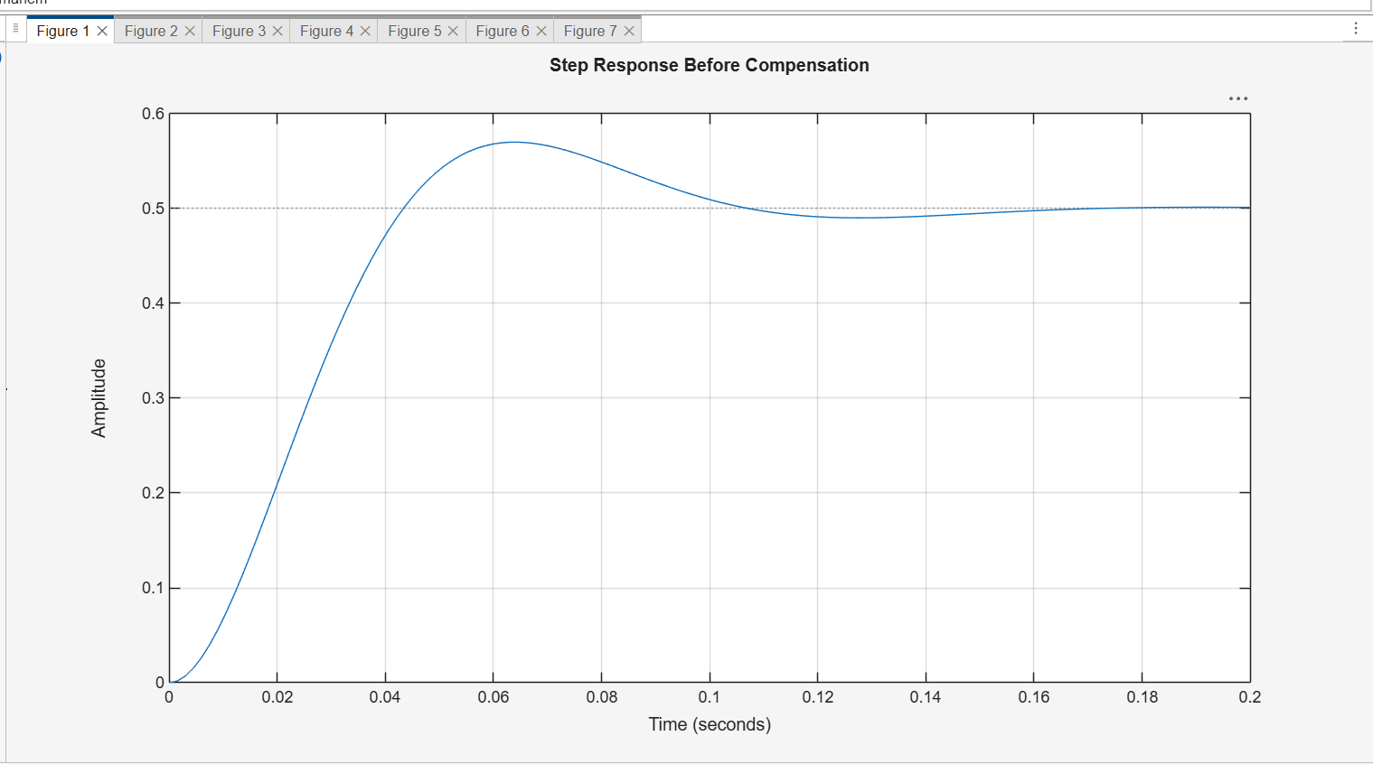
Figure 1: Step Response Before Compensation
The step response reaches a final value of approximately 0.5 and has an overshoot of about 14%. The response is stable and settles quickly.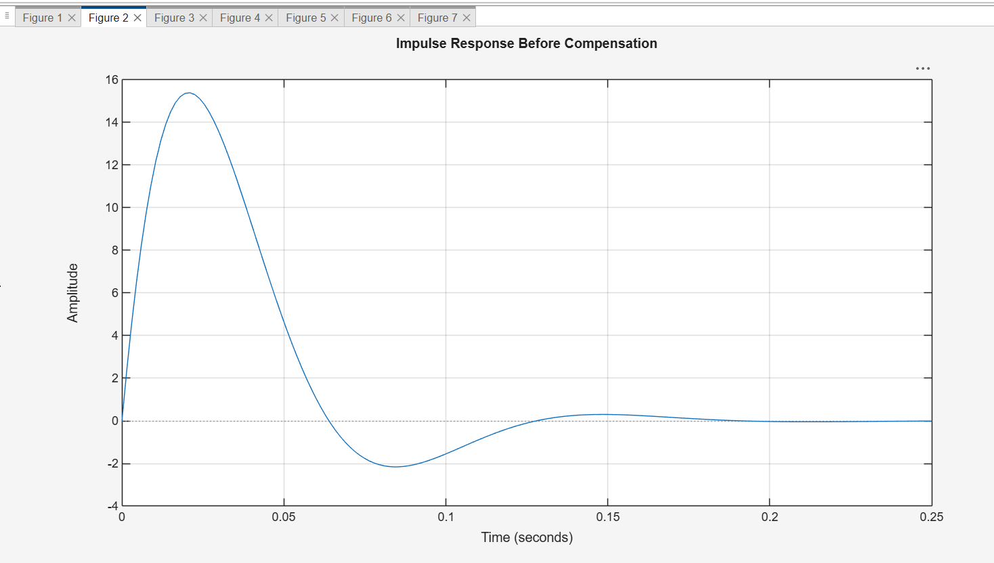
Figure 2: Impulse Response Before Compensation
The impulse response rises quickly, oscillates, then decays toward zero. This indicates that the system is stable.
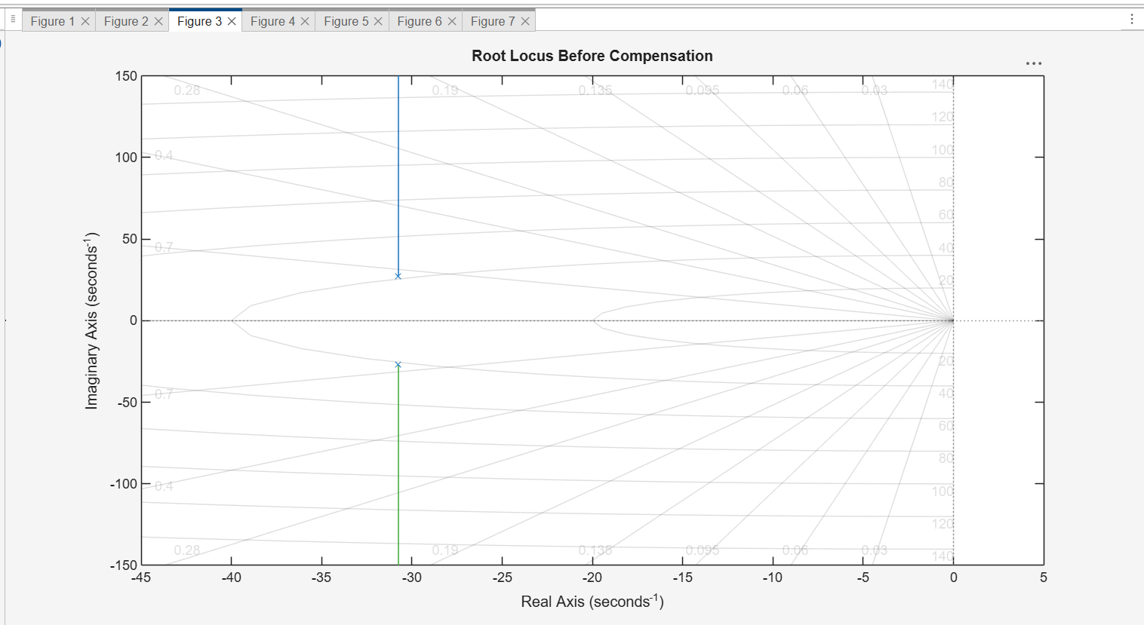
Figure 3: Root Locus Before Compensation
The root locus is used to study the movement of the closed-loop poles as the gain changes. The poles remain in the left half-plane for the selected operating condition.

7. Performance Specifications Before Compensation
Parameter | Before Compensation
Rise Time | 0.0293 sec
Transient Time | 0.0997 sec
Settling Time | 0.0997 sec
Settling Min | 0.4619
Settling Max | 0.5700
Overshoot | 14.0072 %
Undershoot | 0
Peak | 0.5700
Peak Time | 0.0644 sec
Before compensation, the system is stable and fast, but the overshoot is approximately 14%, which is lower than the required maximum peak of approximately 20%. Therefore, a compensator is needed to adjust the transient response.

8. Lead Compensator Design
A lead compensator was selected to improve the transient response of the system. The compensator used in MATLAB is:
$$Gc\left(s\right)=\frac{2\left(s + 30\right)}{(s + 60)}$$
Equivalently:
$$Gc\left(s\right)=\frac{\left(2s + 60\right)}{(s + 60)}$$
The compensator has a zero at s = -30 and a pole at s = -60. The pole is farther to the left than the zero, so this compensator is a lead compensator. This type of compensator is suitable for improving transient response specifications such as rise time, peak time, overshoot, and settling time.

9. System Modeling After Compensation
After inserting the compensator in the feed-forward path, the new open-loop transfer function becomes:
$$G_{comp}\left(s\right)= Gc\left(s\right)G\left(s\right)$$
$$G_{comp}\left(s\right) =\frac{\left(3362s + 100860\right)}{ (s^{3} + 121.{5s}^{2 }+ 5371s + 100860)}$$
The closed-loop transfer function after compensation is:
$$T_{comp}\left(s\right)=\frac{\left(3362s + 100860\right)}{ (s^{3} + 121.{5s}^{2 } + 8733s + 201720)}$$

10. MATLAB Results After Compensation
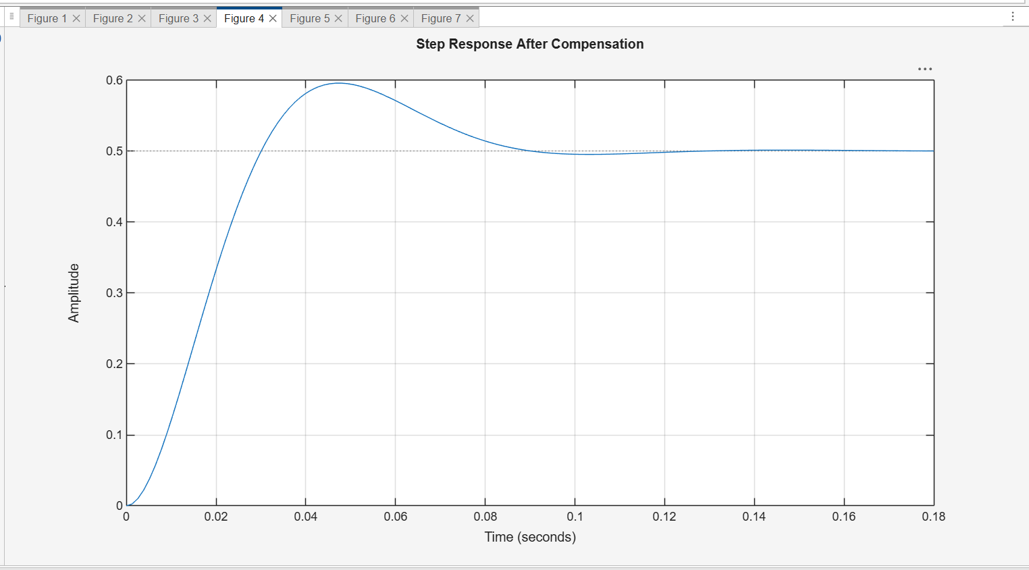
Figure 4: Step Response After Compensation
The compensated step response is faster and has a higher peak close to the required 20% overshoot.
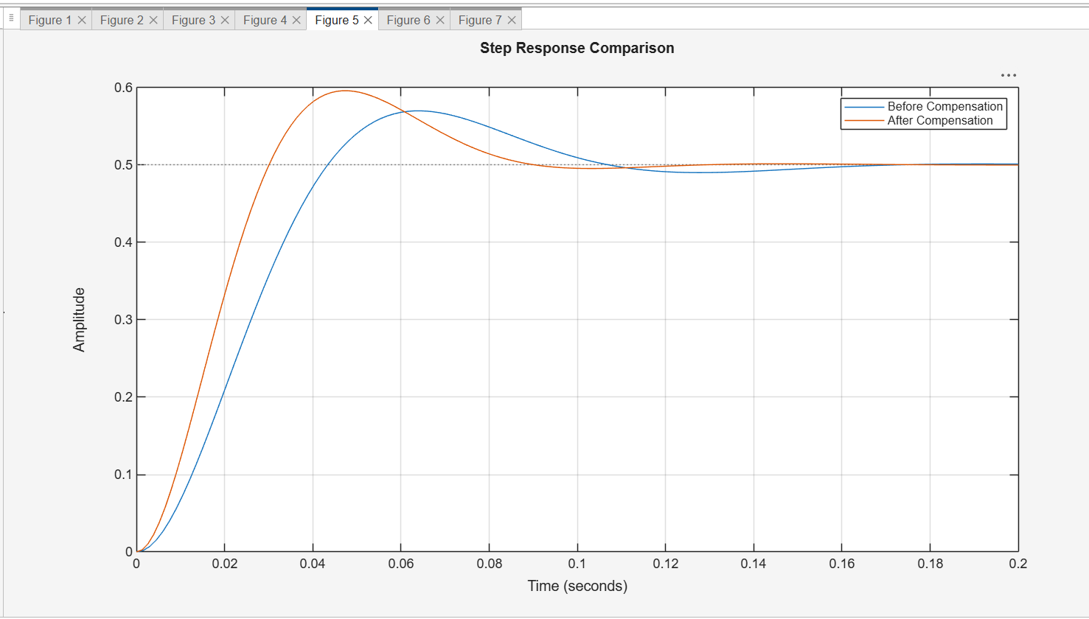
Figure 5: Step Response Comparison Before and After Compensation
This comparison shows that the compensated system reaches the steady-state value faster. The overshoot increases from about 14% to about 19.2%, which satisfies the project target.
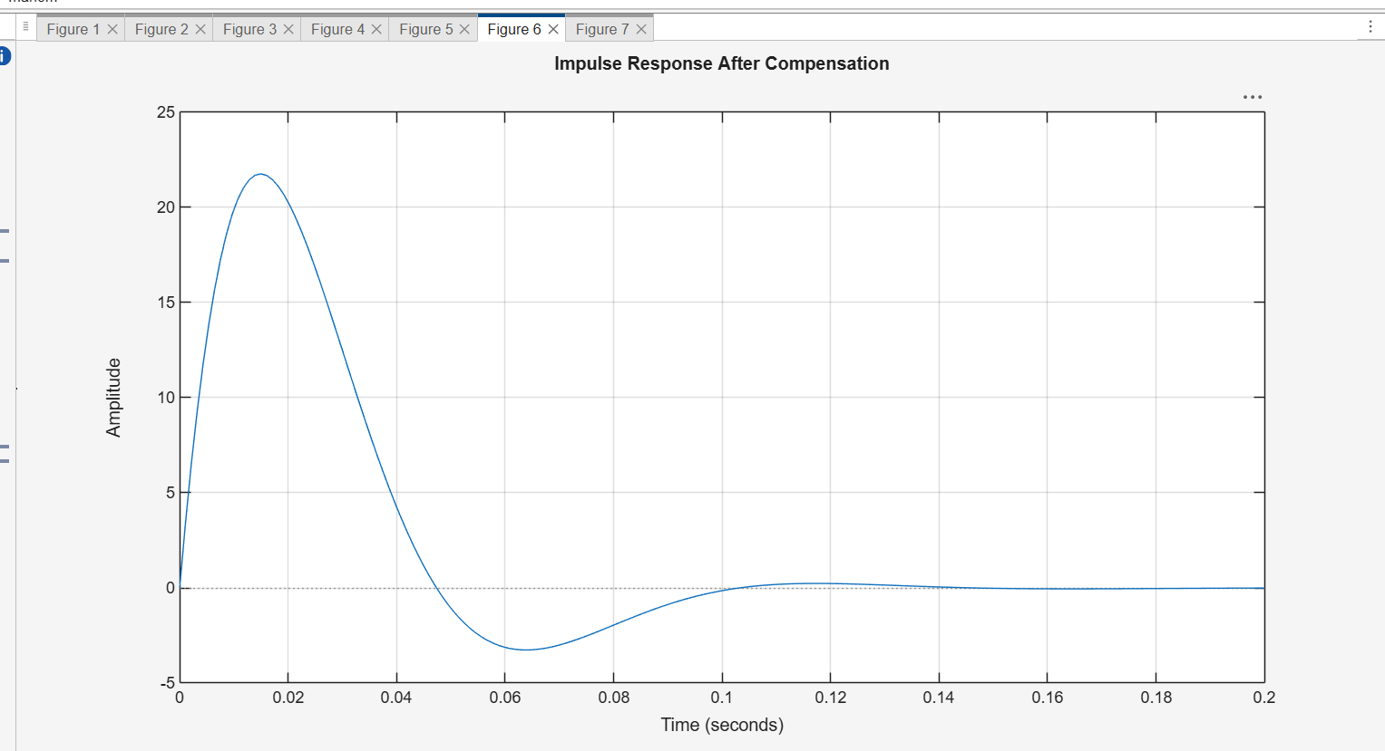
Figure 6: Impulse Response After Compensation
The compensated impulse response decays to zero, so the compensated system remains stable.
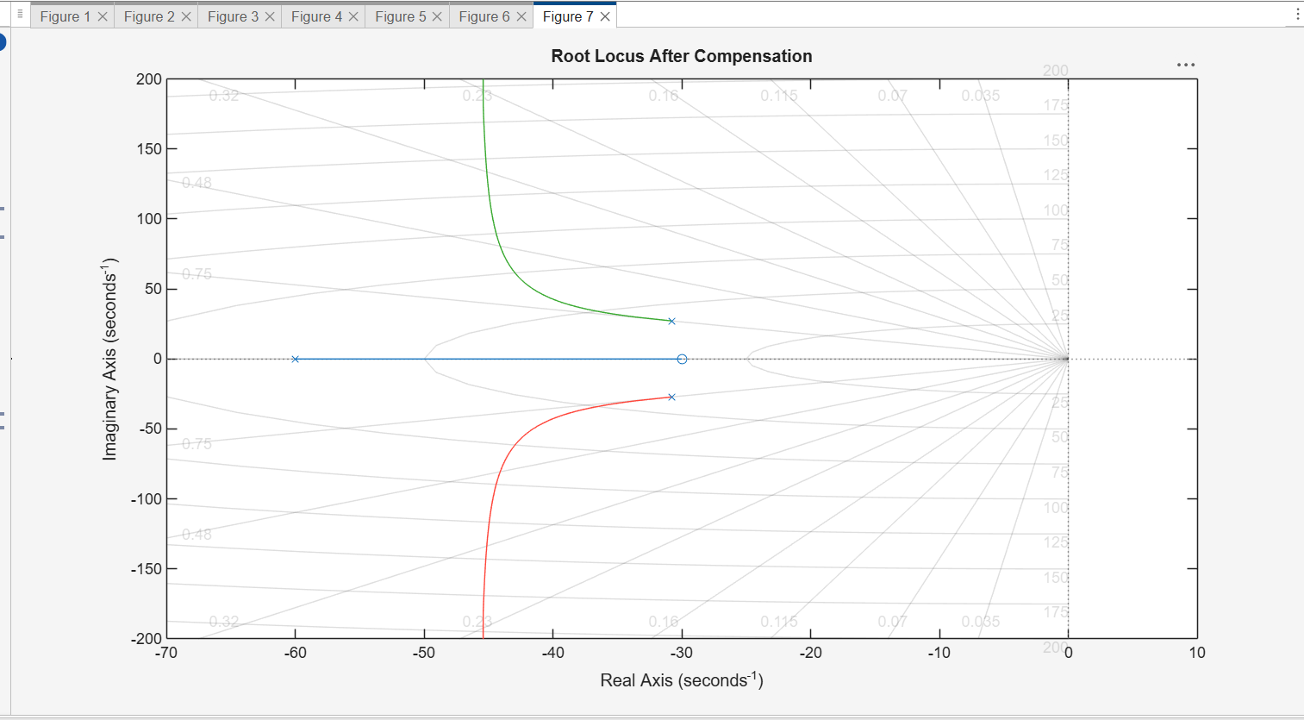
Figure 7: Root Locus After Compensation
The compensator changes the root locus by adding one zero and one pole to the open-loop transfer function. The closed-loop poles remain in the stable region for the selected response.

11. Performance Specifications After Compensation
Parameter | After Compensation
Rise Time | 0.0205 sec
Transient Time | 0.0824 sec
Settling Time | 0.0824 sec
Settling Min | 0.4615
Settling Max | 0.5960
Overshoot | 19.2024 %
Undershoot | 0
Peak | 0.5960
Peak Time | 0.0480 sec

12. Performance Comparison
Parameter | Before Compensation | After Compensation | Comment
Rise Time | 0.0293 sec | 0.0205 sec | Improved
Settling Time | 0.0997 sec | 0.0824 sec | Improved
Overshoot | 14.0072 % | 19.2024 % | Close to 20% target
Peak Time | 0.0644 sec | 0.0480 sec | Improved
Peak | 0.5700 | 0.5960 | Increased as required
From the comparison table, the lead compensator improves the transient response. The rise time, peak time, and settling time decrease, meaning the system becomes faster. The overshoot increases from 14.0072% to 19.2024%, which is approximately equal to the required 20%. The settling time after compensation is 0.0824 seconds, which is less than 2 seconds.

13. Analog Circuit of the Compensator
The general lead compensator form is:
$$Gc\left(s\right)= Kc\frac{\left(s +\frac{1}{τ}\right)}{(s +\frac{1}{(ατ)})}$$
For the selected compensator:
$$Gc\left(s\right)=\frac{2\left(s + 30\right)}{(s + 60)}$$
Quantity | Value
Kc | 2
1/tau | 30
tau | 1/30 = 0.0333 sec
1/(alpha tau) | 60
alpha tau | 1/60 = 0.0167 sec
alpha | 0.0167 / 0.0333 = 0.5
Choosing C1 = C2 = 10 micro F gives the following component values:
Component | Selected Value
C1 | 10 micro F
C2 | 10 micro F
R1 | 3.33 kOhm
R2 | 1.67 kOhm
R3 | 10 kOhm
R4 | 20 kOhm
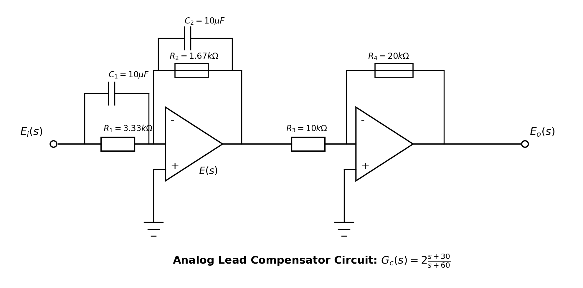
Figure 8: Analog circuit representation of the selected lead compensator

14. Conclusion
In this project, a second-order control system was analyzed using omega_n = 41 and zeta = 0.75. The open-loop transfer function and unity-feedback closed-loop transfer function were derived. MATLAB was used to obtain the step response, impulse response, root locus, and performance specifications. Before compensation, the overshoot was 14.0072% and the settling time was 0.0997 seconds. After inserting the lead compensator Gc(s) = (2s + 60)/(s + 60), the overshoot became 19.2024%, which is close to the required 20%, and the settling time became 0.0824 seconds, which is less than 2 seconds. Therefore, the selected compensator successfully improves the transient response and satisfies the project requirements.

MATLAB Command Window Output
omega_n = 41
zeta = 0.7500
Open-loop transfer function G(s):
1681
-------------------
s^2 + 61.5 s + 1681
Closed-loop transfer function T(s):
1681
-------------------
s^2 + 61.5 s + 3362
System Information Before Compensation:
RiseTime: 0.0293
TransientTime: 0.0997
SettlingTime: 0.0997
SettlingMin: 0.4619
SettlingMax: 0.5700
Overshoot: 14.0072
Undershoot: 0
Peak: 0.5700
PeakTime: 0.0644
Compensator Gc(s):
2 s + 60
--------
s + 60
Closed-loop transfer function After Compensation:
3362 s + 100860
---------------------------------
s^3 + 121.5 s^2 + 8733 s + 201720
System Information After Compensation:
RiseTime: 0.0205
TransientTime: 0.0824
SettlingTime: 0.0824
SettlingMin: 0.4615
SettlingMax: 0.5960
Overshoot: 19.2024
Undershoot: 0
Peak: 0.5960
PeakTime: 0.0480

