Selectivity sheet - InseR

Twin trawls protocol

## Tested devices

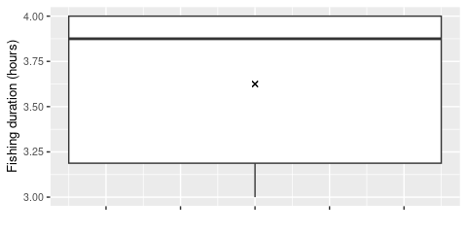

Duration of fishing operation in hours

Note : there are 2 missing values among the 10 fishing operations.