**24RP03521 : Marie Rose KABATESI**

**ASSIGMENT MACHINE LEARNING**

**Task 1:**

**save your trained Model as.pkl**

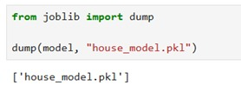

**Task 2:**

Using Gradio Library that provide GUI

Steps:

1. Run the Gradio app:

python gradio_app.py

2. A public link will be generated (e.g., "Running on public URL: https://xxx.gradio.app"). Open it in a browser.

3. Input:

- Select "Number of Rooms" (1-23).

- Enter "House Area" in square meters.

4. Click "Submit" to see the predicted price.

Then the interface was looks like that

Insert Values to be predicted

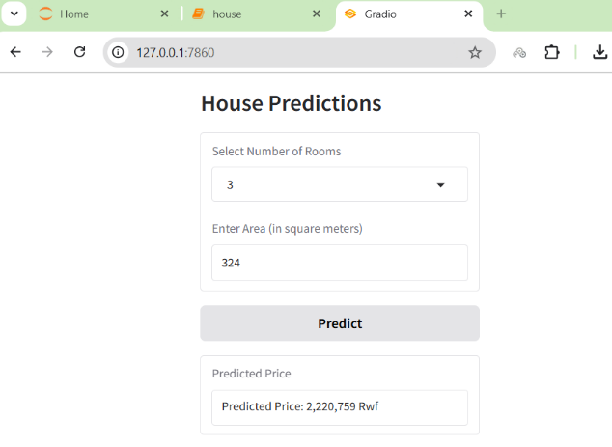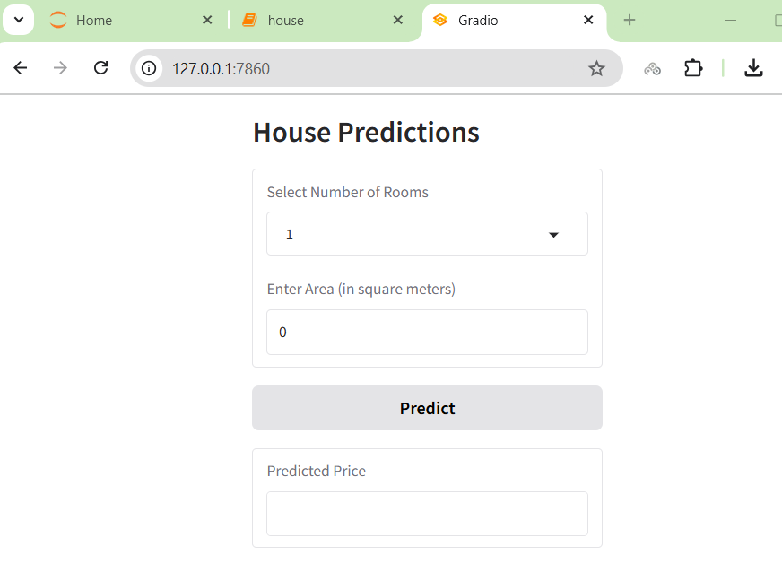

**TASK 3:**

Using APIs on Html

create one html file that will use API to use mode that, that file contain Java Script that will help us to run API this file is look like that

