//marie meith
//February 2026
//Project Three Documentation

Once the user has entered our entry point, they will have four options. The first option will prompt the user with another cin command and allow for the user to specify the exact item they want to see (please refer to SS 1). Once this happens the code will print out the number of times that item has appeared in the input text. The second option will allow for the user to print out all of the items and their associated frequencies (please refer to SS 2). I will do this using a loop for each item. The third option will allow for the user to print out all of the items and their frequencies shown as a list of * symbols (please refer to SS 3). I will do this using two loops, one like the loop in the second option and another inner loop that will print the * symbols. This will allow us to print one symbol for each time the item appears in the list. The fourth option will allow for the user to exit the program (refer to SS 4). This option will be like the other options in past assignments.
The structure of our code will have functions for each option. When the user selects the item, I will use an if statement to check to see which option it matches and then call the function associated with that option. Once that is complete the function will then do the specific things for that option. I will ask the user for the input in a do while statement similar to past assignments (refer to SS 5).
So far, I have only covered the user interface and cin and cout parts of the assignment. I also need the code to be able to read from an input text and store these values in a C++ Map. This will be done with a function that I will call LoadFile and it will handle the reading of the file and putting the data into the map (refer to SS 6). I also need to write the data out to a file called frequency.dat. Another function called WriteFile will do this part (refer SS 7). I will call both of these functions at the very top of our main function to make sure the file part is done before we have any user interface (refer to SS 8).

SS 1 User Option One
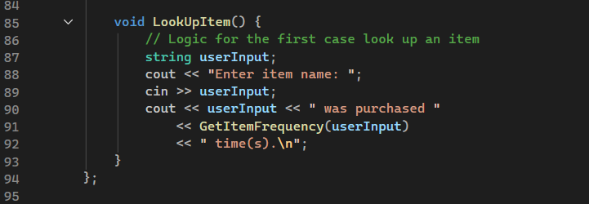

SS 2 User Option Two
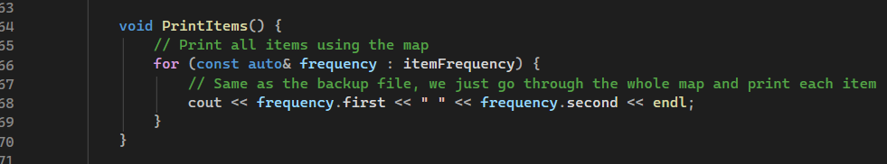

SS 3 User Option Three
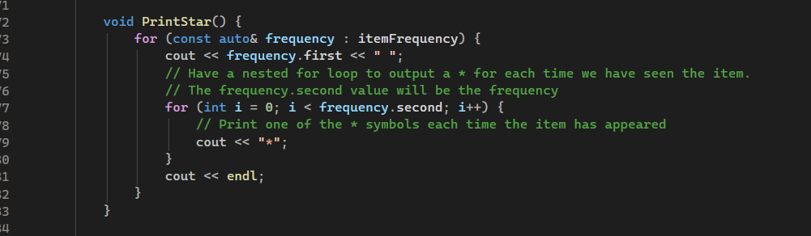

SS 4 User Option Four
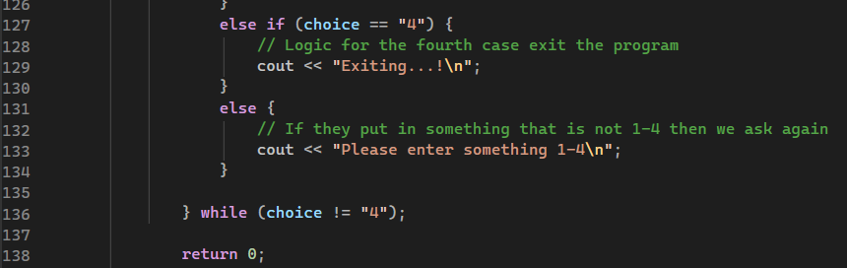

SS 5 Do While Statement
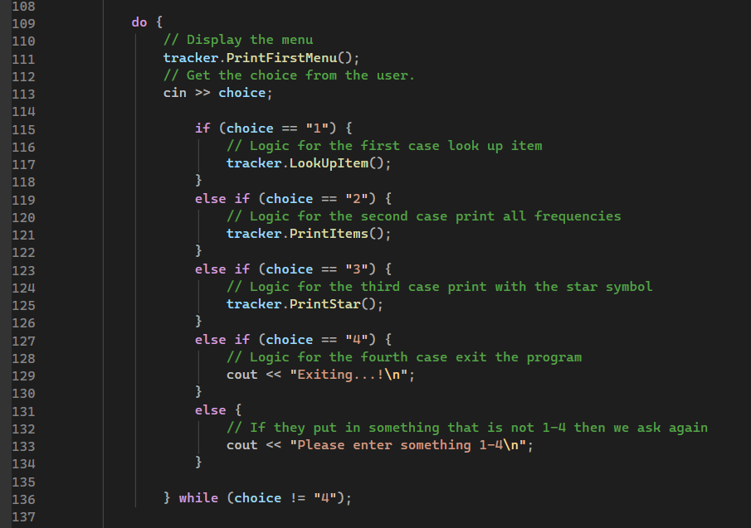

SS 6 LoadFile
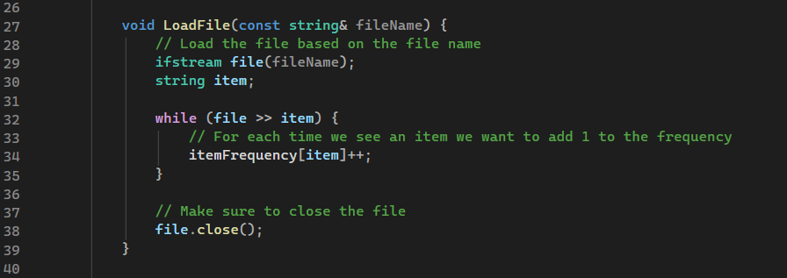

SS 7 WriteFile
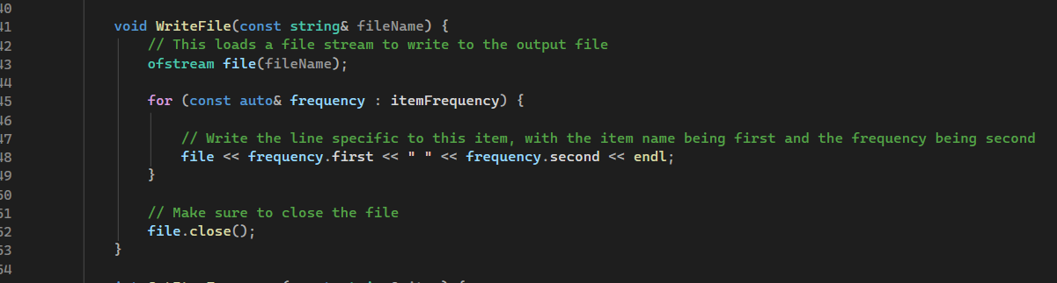

SS 8 Call File Functions
