**UML Diagrams**

Use Case diagram

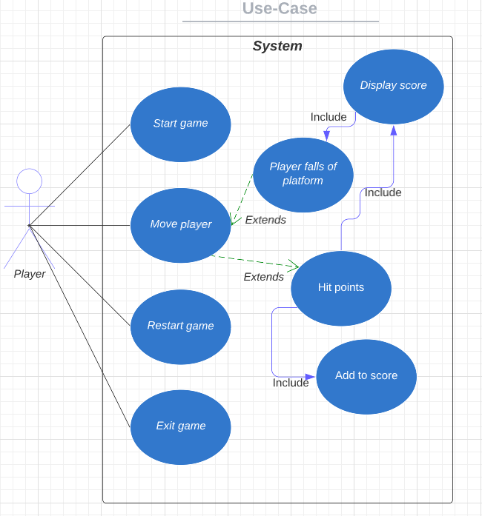

Class diagram

Sequence UML diagram

