MAJOR TABLE

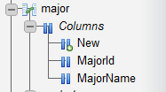

STUDENT TABLE

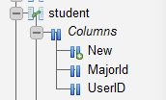

STUDENTREGISTRATION TABLE

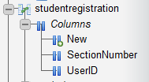

STUDENT DATA:

"L00000017" "Duck" "Huey News" "5555555" "Permanent phone (Main)" [hueyducknews@fake.com](mailto:hueyducknews@fake.com)

COURSE/SECTION DATA:

"Lab" "10186" "CS" "280CN" "Co-op Ed: Computer Network Ops" "L00000002" "Computer Info Technology" "N/A" "LCC19/154" "26-JUN-17" "16-SEP-17" "N/A" "N/A"

AppUser Table Data:

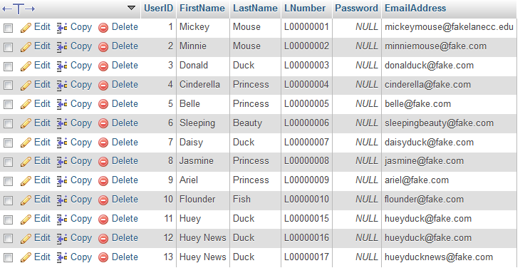

Course Table:

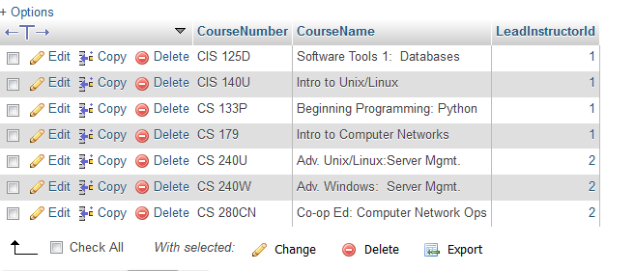

Section Table:

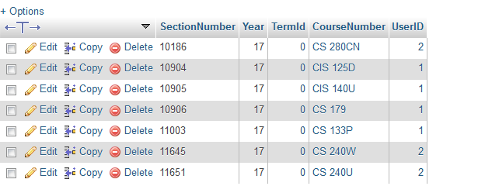

Term Table:

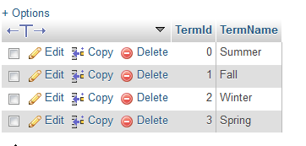

Instructor Table:

