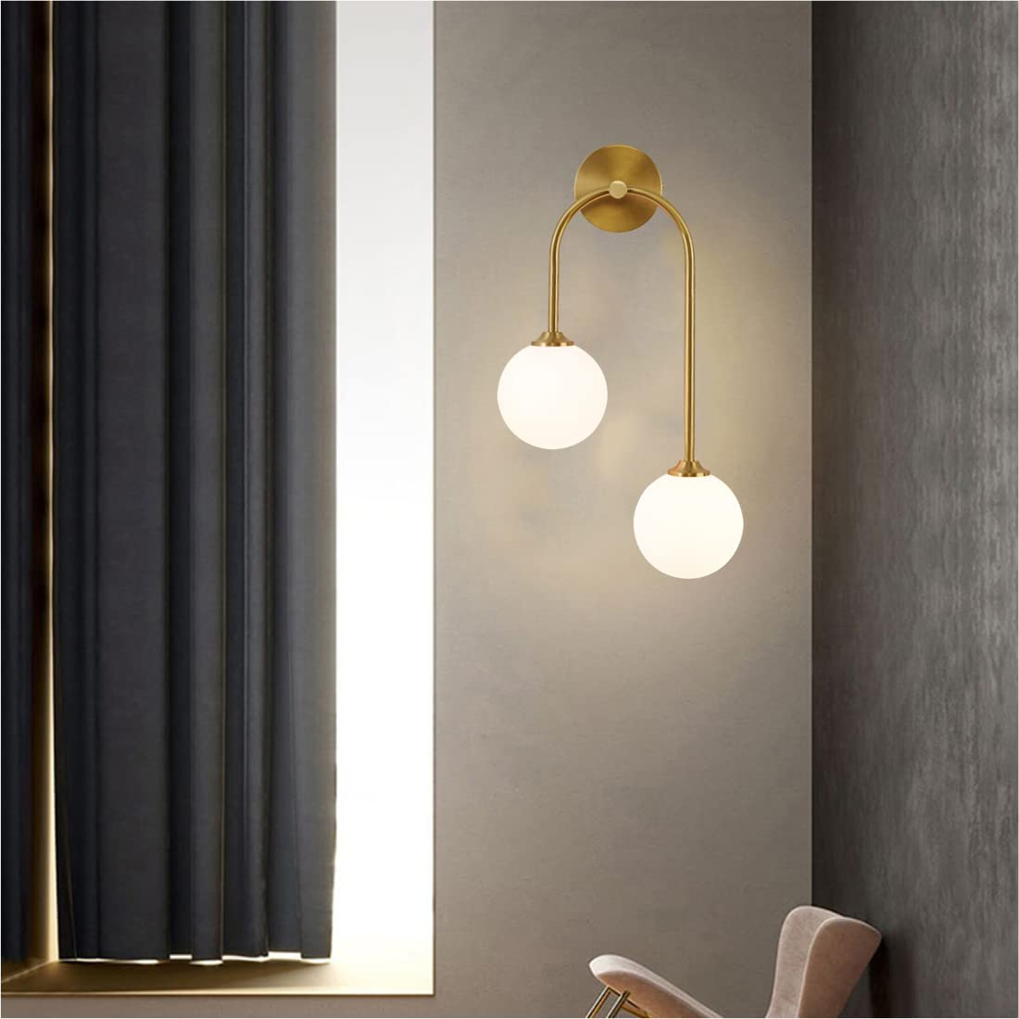

**Product Name:** Ball Wall Sconce

**Price: 3pcs RS 12,000/**

# Description: Ball Wall Sconce with dual lights.



Bright World