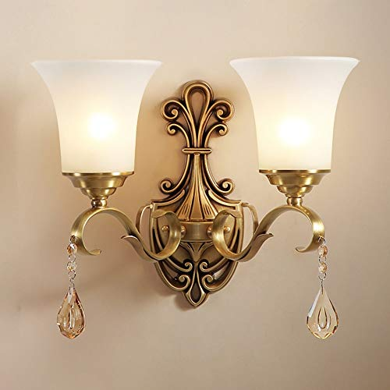

**Product Name:** Wall Sconce

**Price: RS 6,000/**

# Description: European luxury Wall Sconce with dual led lights.



Bright World