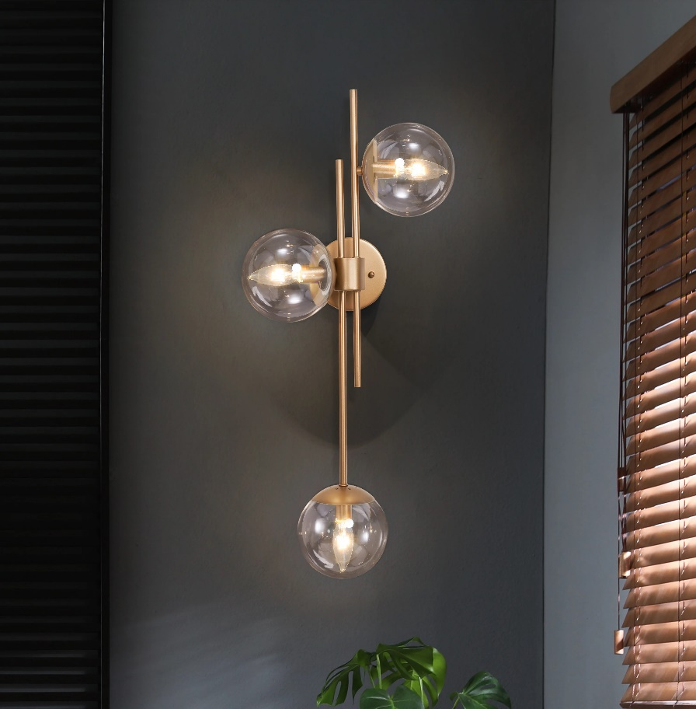

**Product Name:** Wall Sconce

**Price: RS 4,000/**

# Description: Modern triple led wall light for bedside.



Bright World