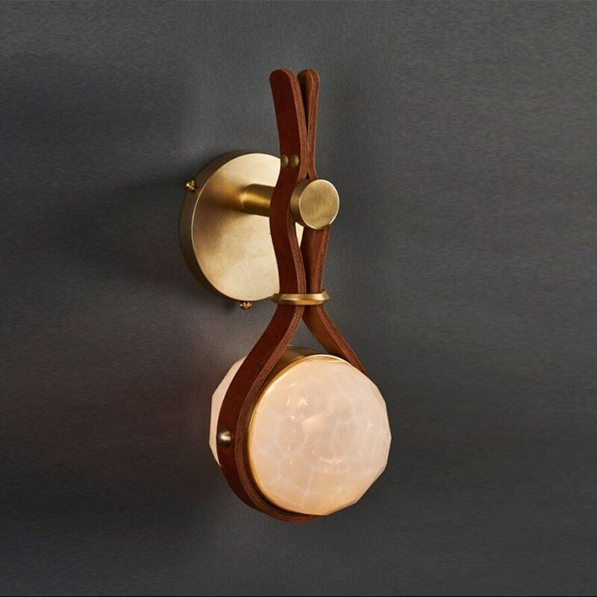

**Product Name:** Wooden Sconce

**Price: RS 4,000/**

# Description: Modern Wooden Sconce for living room, bedroom.



Bright World