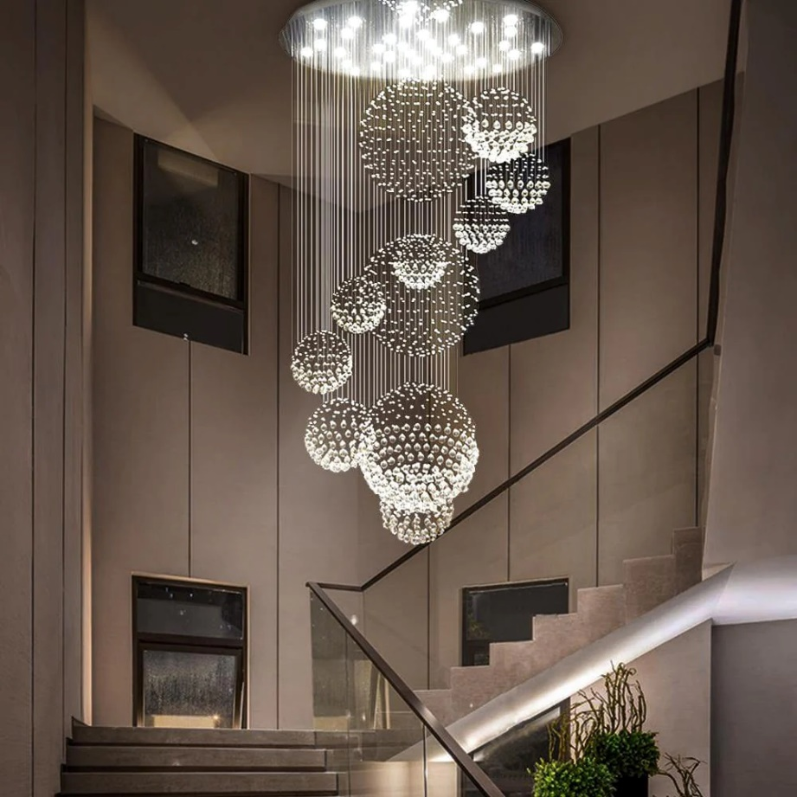

**Product Name:** Chandelier

**Price: RS 11,999/**

# Description: Modern Chandelier, for Stairs.



Bright World