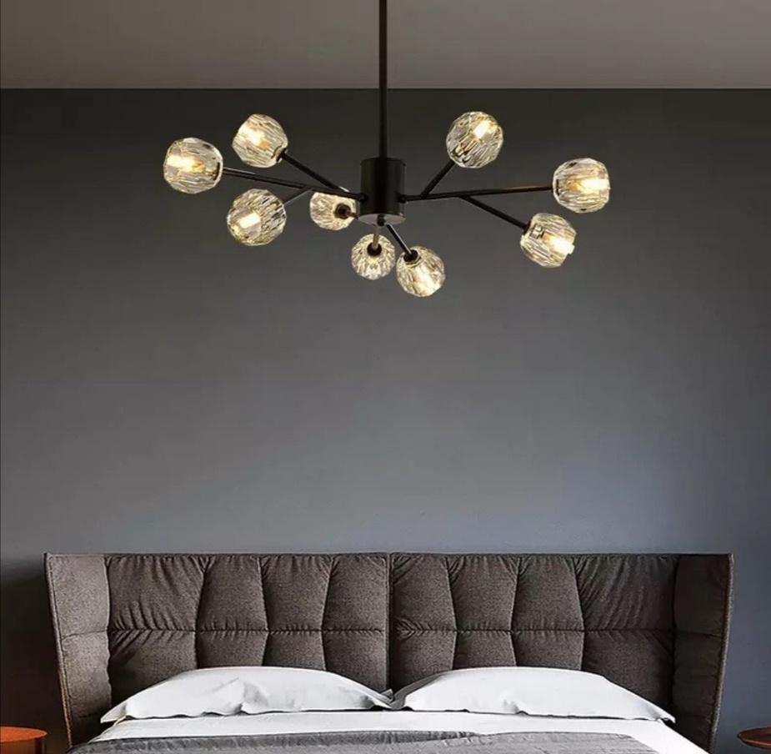

**Product Name:** Chandelier

**Price: RS 8,999/**

# Description: Modern ball Chandelier, for Bed Room.



Bright World