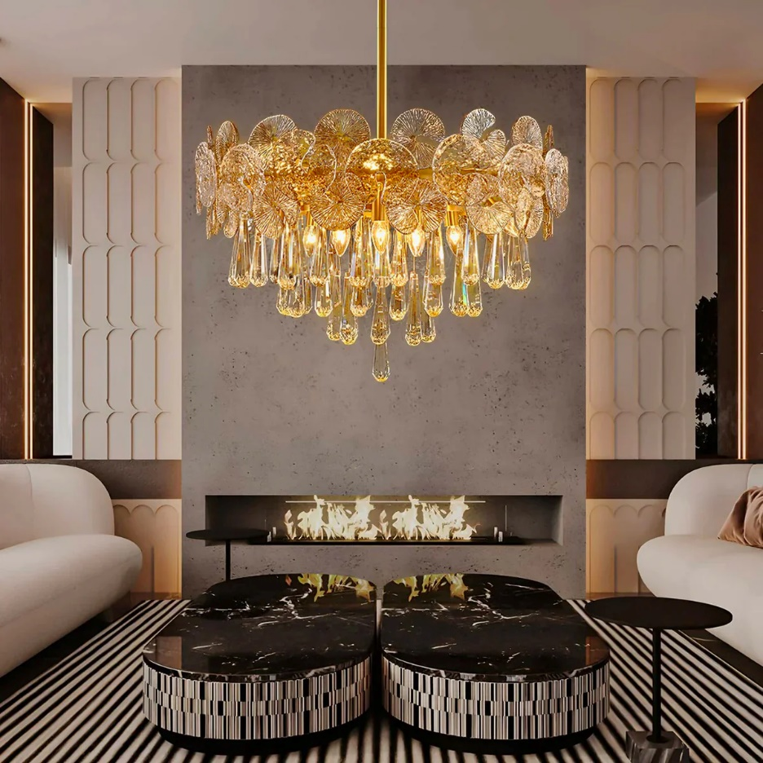

**Product Name:** Chandelier

**Price: RS 19,999/**

# Description: Modern Chandelier, for Hotel Room.



Bright World