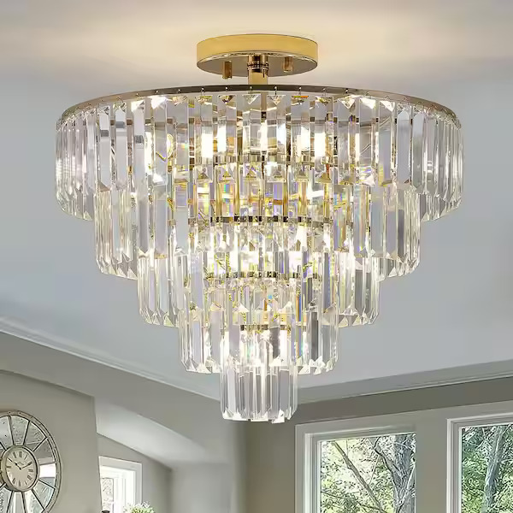

**Product Name:** Chandelier

**Price: RS 15,000/**

# Description: Modern Luxury Chandelier, for Living Room, and lobby



Bright World