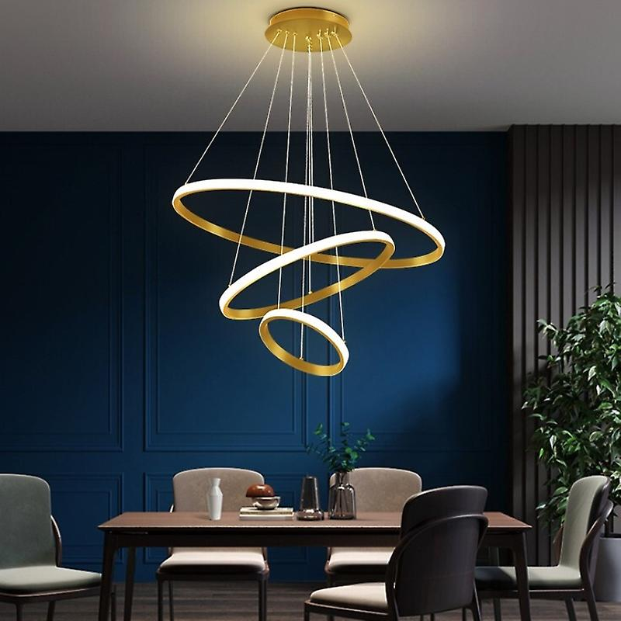

**Product Name:** Chandelier

**Price: RS 6,999/**

# Description: Modern Rings Chandelier, for Office Room.



Bright World