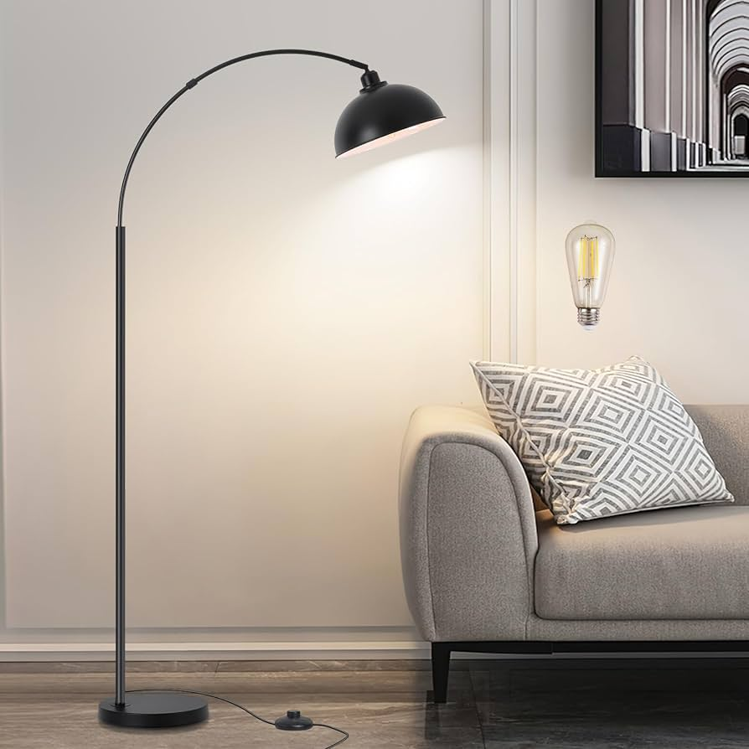

**Product Name:** Arc Floor Lamp

**Price: RS 7,999/**

# Description: Arc Floor lamp for living room, home offices. Gives a unique design.



Bright World