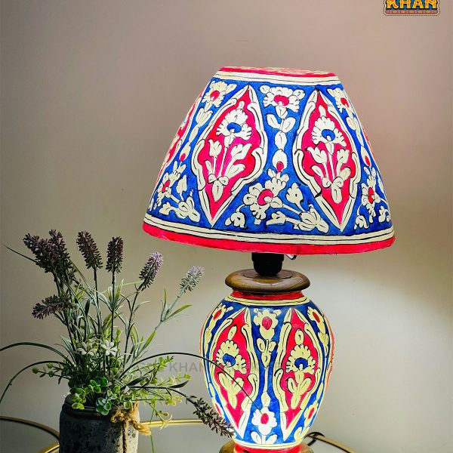

**Product Name:** Cultural Ceramic Lamp

**Price: RS 4,999/**

# Description: Simple & plain cultural lamp for decoration.



Bright World