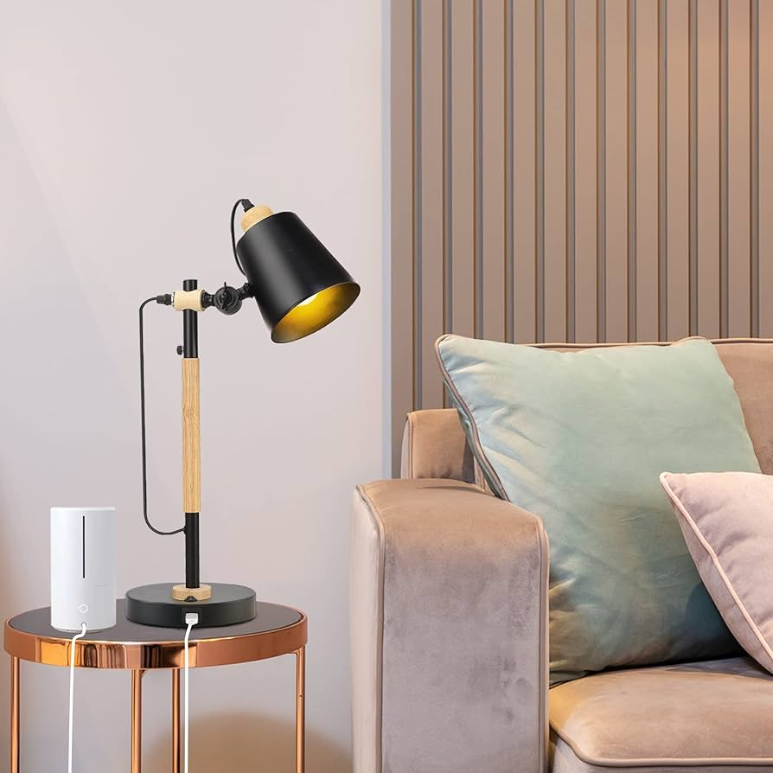

**Product Name:** Table Lamp

**Price: RS 2,499/**

# Description: Study Lamp with movable neck.



Bright World