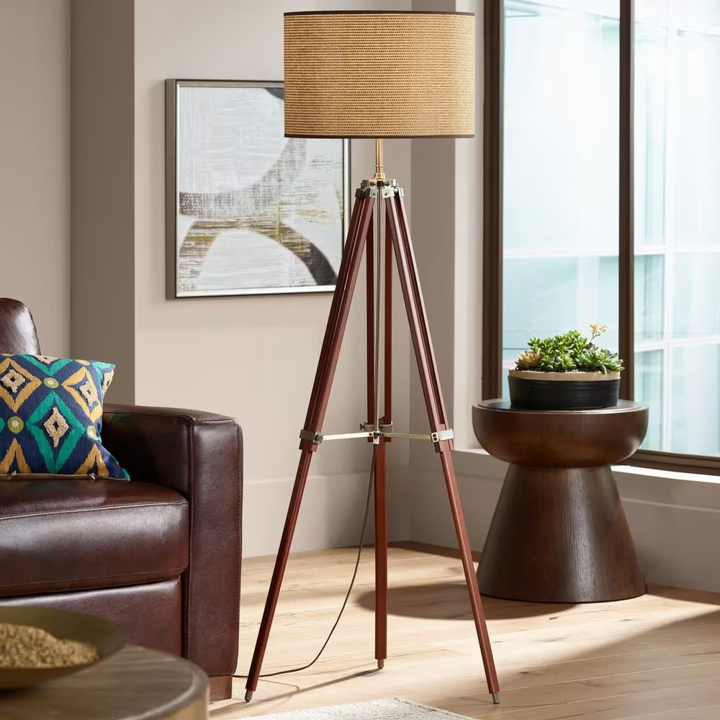

**Product Name:** Tripod Lamp

**Price: RS 10,999/**

# Description: Tripod Floor lamp for Bedroom, Dining room, living room.



Bright World