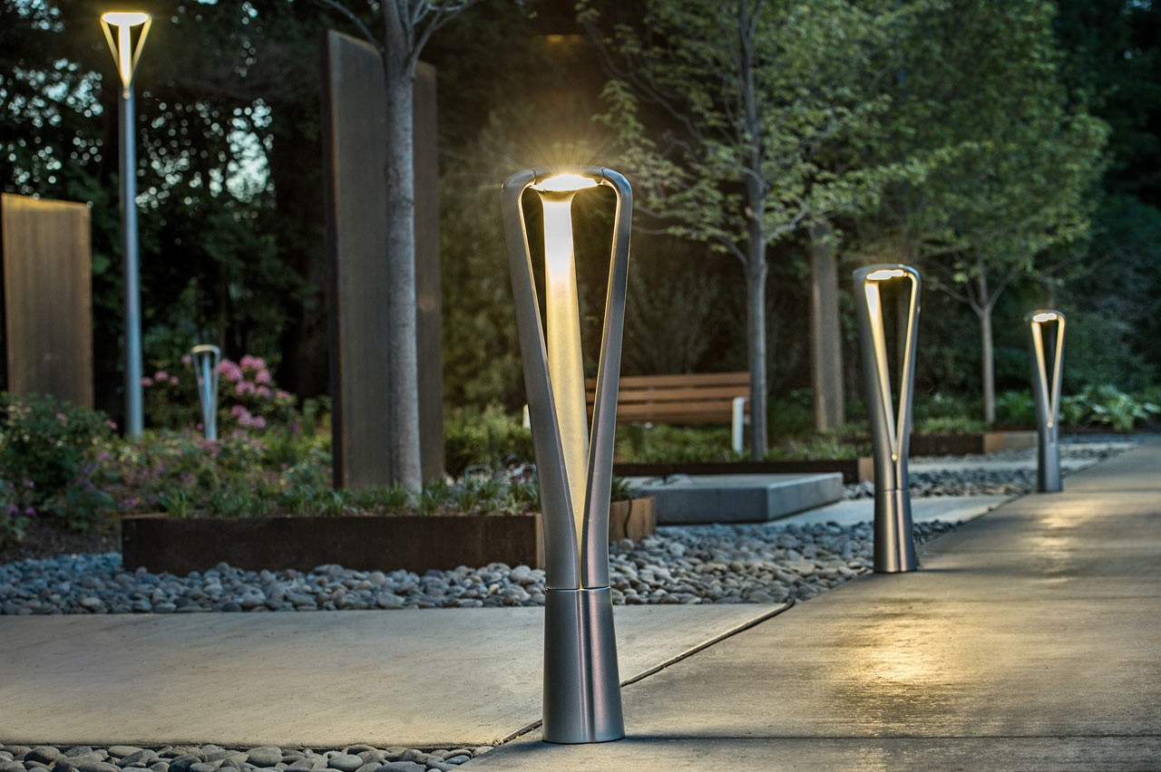

**Product Name:** Bollard Lights

**Price: 2pcs RS 6,000/**

# Description: Ideal for pathways & driveways.



Bright World