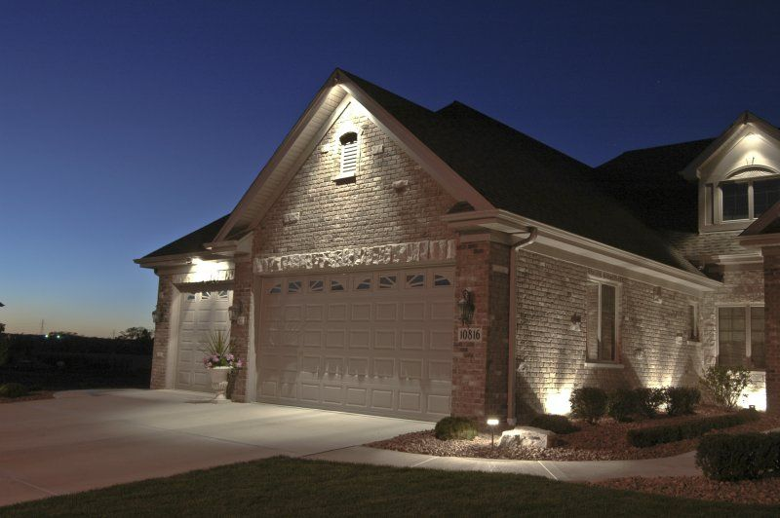

**Product Name:** House Lights

**Price: 6pcs RS 6,000/**

# Description: Exterior House lights, Garage Lighting.



Bright World