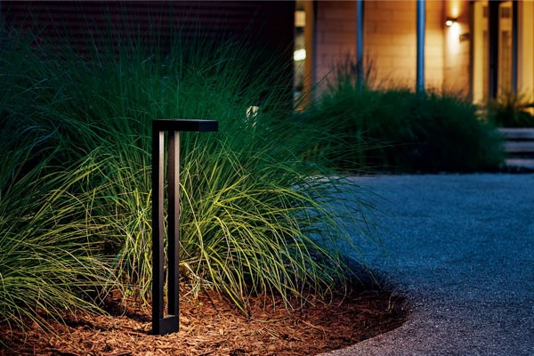

**Product Name:** Path Lights

**Price: 6pcs RS 7,500/**

# Description: Path lighting is the small pools of light.



Bright World