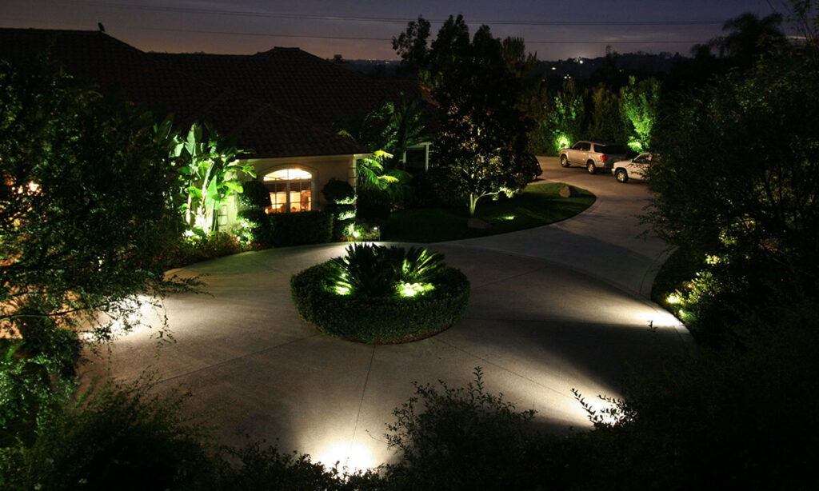



**Product Name:** Spot Lights

**Price: 4pcs RS 8,000/**

# Description: Spot lights can range in brightness.

Bright World