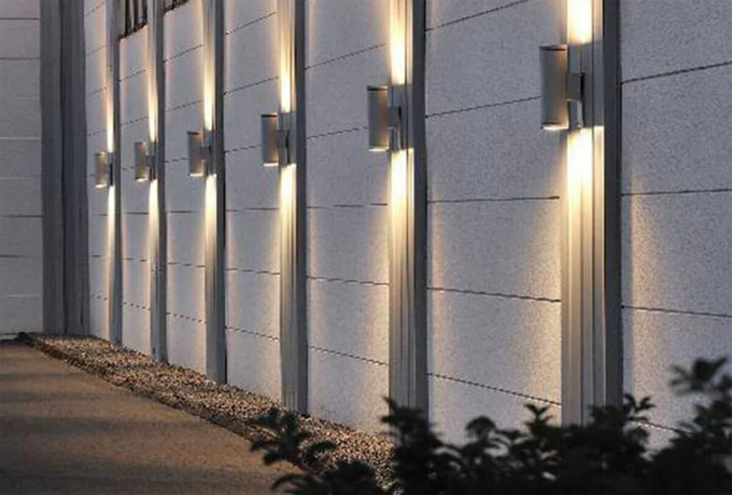

**Product Name:** Wall Lights

**Price: 4pcs RS 8,000/**

# Description: To Enhance the look of the house.



Bright World