Meet Charlie-Dog, your friendly AI HR assistant—because job hunting should be less ruff! Woof-woof! 🐕

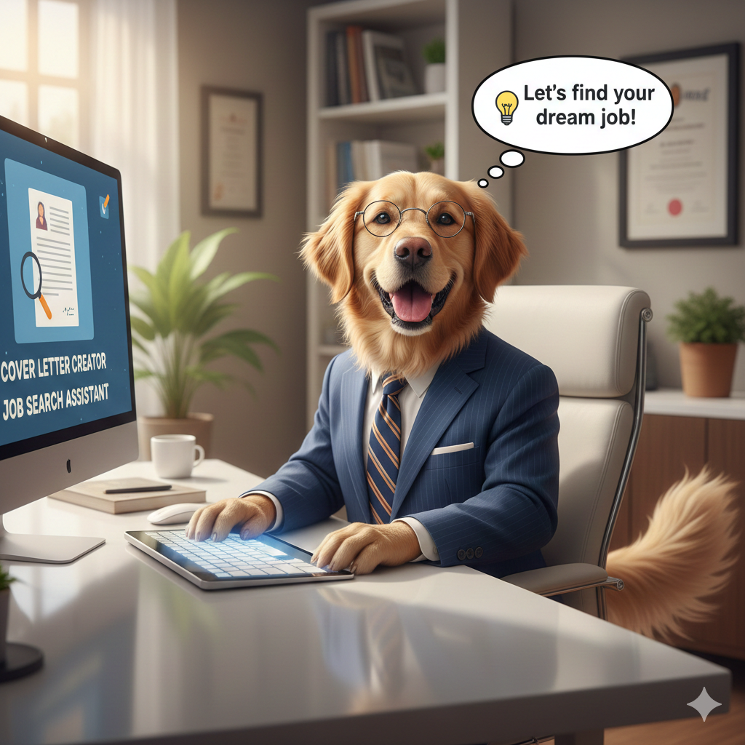

This project reflects my experience in the 5-Day AI Agents Intensive Course with Google and Kaggle.

The Problem
Job seekers face an impossible choice: quality or quantity. Writing a personalized cover letter takes 45–90 minutes per application. Applying to 10 jobs means either spending 15+ hours or sending generic applications that rarely get responses. With 92% of recruiters preferring tailored applications, job seekers need a solution that enables personalization at scale.

Even when using LLMs to assist with applications, substantial time is spent creating and editing prompts, copying and pasting information from documents and websites. Additionally, PDF files are not natively supported by LLM interfaces, requiring extra manual intervention. As a result, full automation of job search, CV reading, job analysis, and personalized cover letter generation is in high demand.

The Solution
The Job Application Agent I developed automates the entire application workflow using multi-agent AI architecture. It identifies relevant, recently posted Data Scientist roles in Melbourne, analyzes the user’s CV, and generates a personalized cover letter within minutes—while keeping the user in control through interactive feedback loops.
The system also features a playful guidance interface with Friendly Charlie the HR Dog, adding an intuitive, engaging element to the user experience!
This is an early demo version, with continued development planned to unlock the project’s significant future potential!

Why Agents?
This problem is perfect for multi-agent systems because:
- Specialized Tasks: Job search, document parsing, strategic planning, and writing each require different areas of expertise
- Sequential Dependencies: You can't write a cover letter before finding a job and preparing a cover letter outline, and you need human feedback at key decision points
- Tool Integration: The system seamlessly combines web search, PDF parsing, and document generation

Agent Architecture

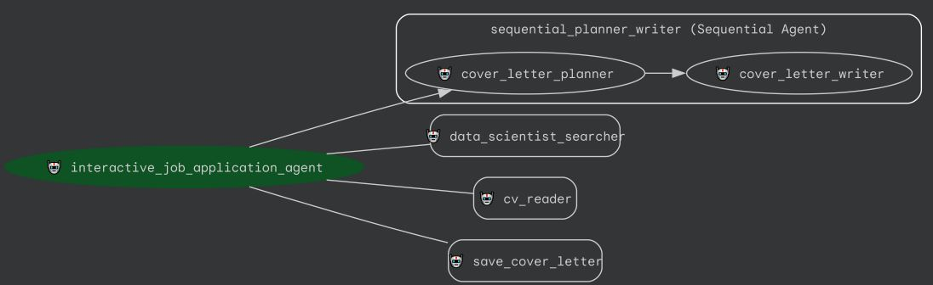

The system uses a hierarchical agent structure with specialized sub-agents:

Root Agent: `interactive_job_application_agent`
- Orchestrates the entire workflow and manages user interaction
- Presents Charlie-Dog ASCII art greeting
- Handles feedback loops for job satisfaction and cover letter revisions
- Manages the sequential flow from job search to cover letter saving

### Sub-Agents:
1. **data_scientist_searcher** (LlmAgent):
- Searches for the most recent Data Scientist job posting in Melbourne using Google Search
- Extracts comprehensive job information organized into sections: Job Overview, Key Responsibilities, Required Skills, Secondary Requirements, and Company Background

2. **cv_reader** (Agent):
- Reads `CV.pdf` using the `read_cv` tool (powered by pdfplumber)
- Transforms raw CV content into a clean, well-structured format with clear sections

3. **sequential_planner_writer** (SequentialAgent):
- Orchestrates the sequential execution of cover letter planning and writing
- Sub-agents:
- **cover_letter_planner**: Compares job requirements with CV content and creates a structured outline
- **cover_letter_writer**: Generates a professional cover letter based on the outline, following a specific template structure

4. **save_cover_letter** (Agent):
- Uses the `save_cover_letter_to_file` tool to save the cover letter as PDF
- Handles character encoding to ensure special characters are properly converted

Value Delivered (approximate)
Time Savings: 60 minutes → 5 minutes per application (12x faster)
Quality at Scale: Apply to 10 jobs in the time it took to apply to 1, maintaining professional standards
Consistent Results: Structured templates ensure every cover letter is production-ready

Technical Highlights
Framework: Google ADK with Gemini 2.5 Flash
Agent Patterns: Hierarchical delegation, sequential composition, tool specialization

This project was submitted to the Freestyle Track because the agent not only streamlines job applications for individuals but also has broader potential to accelerate hiring for highly skilled candidates. By producing personalized, vacancy-aligned cover letters that emphasize key competencies required for each role, the system helps talented job seekers reach interview stages faster, improving the efficiency of both job search and recruitment.

