Network Traffic Analysis

Assumptions
The dataset provided is assumed to represent the real-world network traffic metrics, collected for cybersecurity analysis purposes. It contains a broad variation of features and parameters commonly used in traffic classification and malicious activity identification. For this Data Analysis Documentation, the following assumptions were agreed:

- Data represents the real-world metrics; it is accurately captured from real network flow. Each feature presented in dataset preserves its original operational meaning and relation to other features as it is in real-world cases.
- Data reflects a combination of both normal traffic and malicious activity. The attacks presented in dataset are various and correlates with real-world occurrence rate.
- It is assumed that each record in provided dataset represents a separated record of network activity, that do not depend on closes allocated network activity records.
- The Relations between metrics presented in dataset mimic real cases occurrences, its naming conventions are matching actual metrics, the elaboration and research via external resources may lead to development in hypothesis and objectives testing.

Hypothesis and Objectives
The research hypothesis that this study work is aimed to elaborate can be formulated as:

There is a significant correlation between the following independent variables - duration (dur), source packets (spkts) - and the likelihood of network traffic being classified as an attack.

Data Preparation of Shared Columns: id and label
This section includes the cleaning procedures of the columns 'id' and 'label' to ensure consistency and accuracy of subsequential statistical analysis and machine learning.
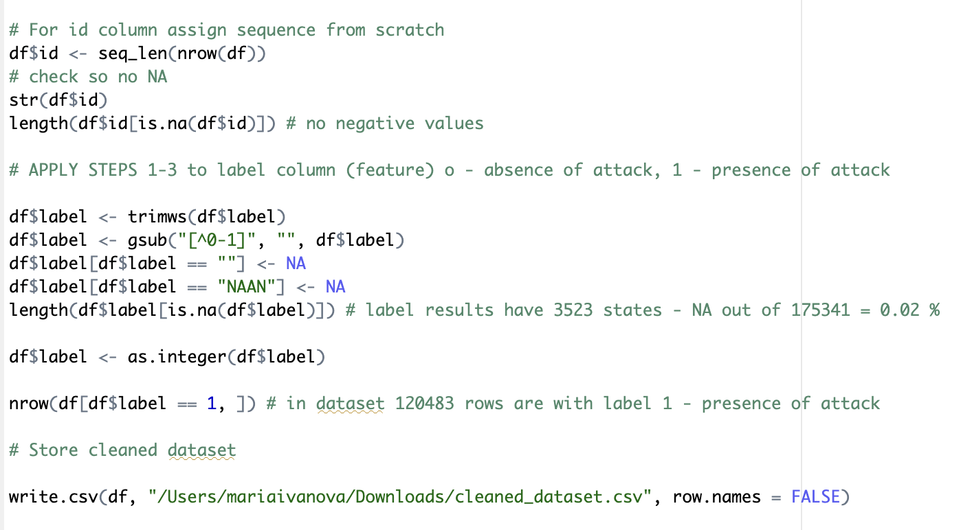
Figure 1
Cleaning of the id Column:
The main objective of this column cleaning: reassurance that the numbers are sequential and coherent.
- df$id <- seq_len(nrow(df))
This appoarch guarantees that the id column values are assigned to sequence of number from 1 to n, where n is replaces with number of rows in dataframe.
Cleaning of the label Column:
The label column represents a classification of the presence (label=”1”) or the absence (label=”0”) of an attack. Initial exploration of the dataset revealed that data presented contains mismatching value, extra characters or inconsistent formatting.
Techniques and functions used to clean data:
- trimws() – to remove whitespaces in values of the label column
- gsub() to find a specific pattern in the instances and replace it by the defined value
o [^0-1] – regex expression to find all characters except digits (0-1)
o Main purpose: exclude all characters except digits (0-1)
- as.integer() – turn all instances of the label column into integers
Observed Patterns After Cleaning
After following the cleaning procedures, an interesting pattern was identified:
- 120,483 instances labelled “1”, indicating the presence of an attack.
- 58,381 instances labelled “0”, indicating its absence.
This imbalance might have an effect on the subsequent analysis. Class imbalance introduces bias for predictive models; model weights might be disproportionately sensitive to the class with larger occurrence. Proper handling of this issue is essential to ensure fair, robust, and reliable performance in future analyses.
Cleaning of spkts and dpkts:
Two labels chosen for hypothesis exploration and required for initial cleaning procedures: spkts and dpkts. Source Packets or Sent Packets (spkts) label represents the metric used in network data analysis to represent the amount of packets sent from a source host to a destination point during packets exchange timeline. Delivered packets (dpkts) label is used to represent the number of packets receives from the source host. The difference, ratio or literally their values can significantly clarify the analysis of attack presence or absence patterns.
The following cleaning guideline was applied.
Cleaning Plan for Spkts and Dptks:
- Validation of the data type for both features
- Inspection of missing values
- Ranging and Validity check
- Visualization of outliers
- Scaling
- Final save procedure
The following paragraph contains precise explanation of techniques applied to both spkts and dpkts columns. To illustrate and describe functions utilization precisely but still succinctly, the functions describe further were applied twice: to both labels.
- Validation of the data type:
The validation of the current type of values in column was performed with str() function.
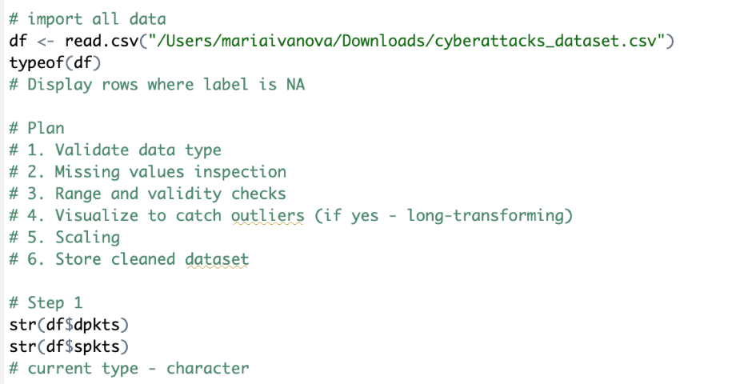
Figure 2
Results: character type. The objective is to preserve the numeric type.
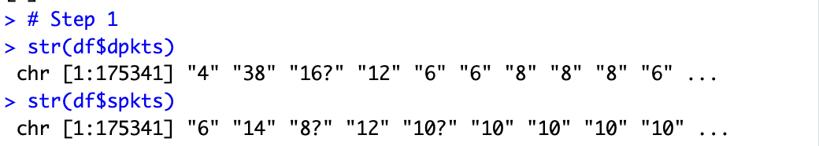
Figure 3
- Inspection of missing values:
Whitespaces and blank strings were identified in the instances variation. They can cause false prediction statements and wrongly based patterns as well as cause termination of the code execution. Trimws() function was used to replace blank strings. The subsequential step aimed to detect non-numeric values. For this purpose using grepl() function led to correct identification of malformed entries (for example, instances with punctuation characters).
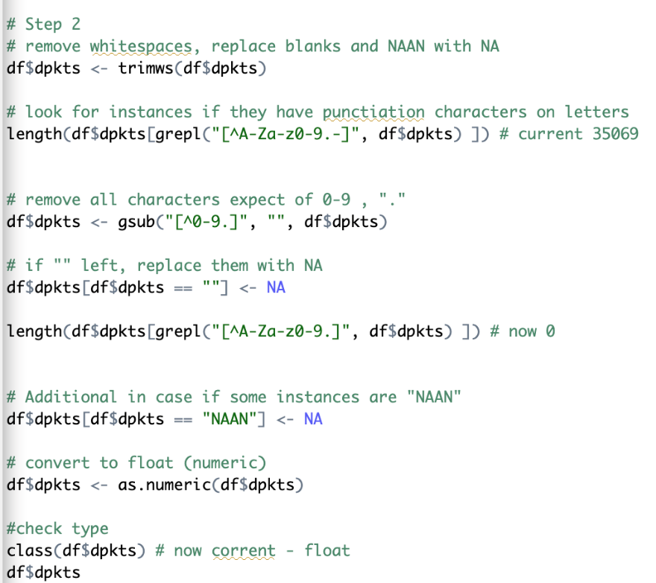
Figure 4
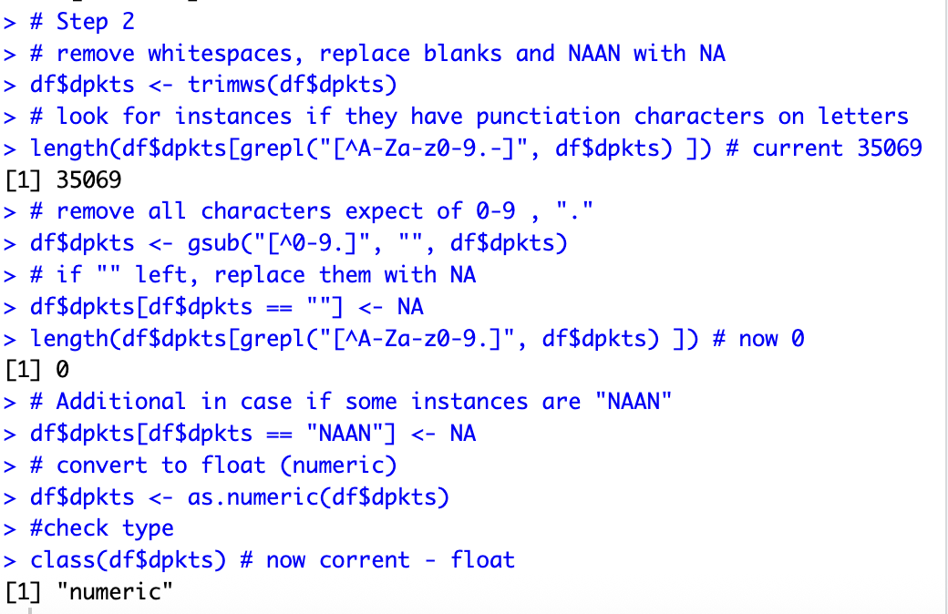
Figure 5
Sanitization of strings by excluding of all non-numeric values was performed via gsub() function. The application aimed to replace any character except digits 0-9.
df$dpkts <- gsub("[^0-9.]", "", df$dpkts)
Additionally, after automated removal of letters or any other characters except digits, some values appeared to contain no characters – “”. This might cause additional errors in statistical analysis and predictive models training. The replacement of all empty values or NAAN (non-interpretable tokens was executed by selection of the dataframe column variable with only rows matching the pattern. These values were replaced with NA.
Finally, the cleaned grammatically values were converted to numeric type via as.numeric() function.
- Ranging and Validity check
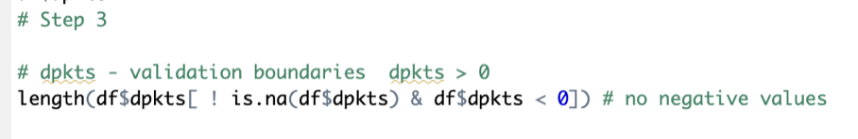
Figure 6
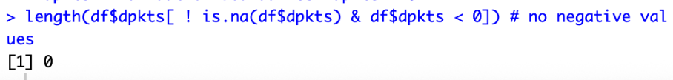
Figure 7
The performance of extra integrity check was required to detect logically impossible values, such as negative number of packets.
length(df$dpkts[ ! is.na(df$dpkts) & df$dpkts < 0])
- Visualization of outliers
The primary cleaning procedure contained brief visualization of instances distribution for logical summarization of possible outliers' pattern. The histogram representation– hist(), was used to understand skewness and outliers.
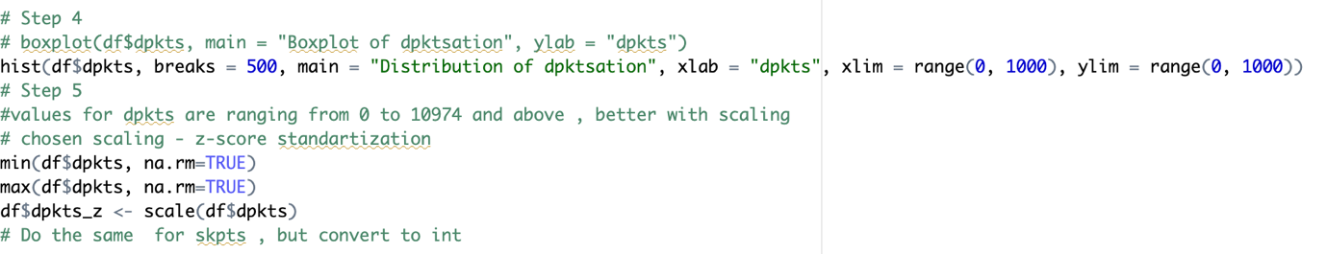
Figure 8
The received observation can be concluded as: the majority of instances for both spkts and dpkts instances belongs within the range of 0 to 200 value. The majority of outliers are exceeding the value of 1000 for both labels.
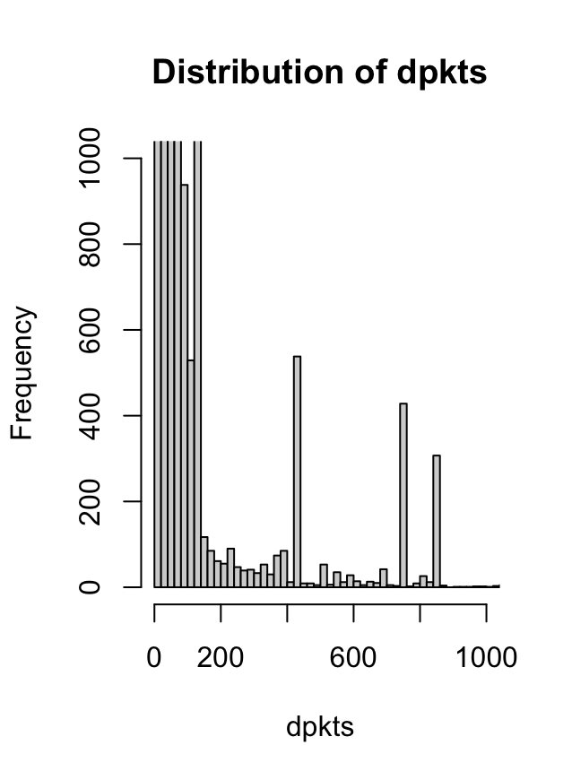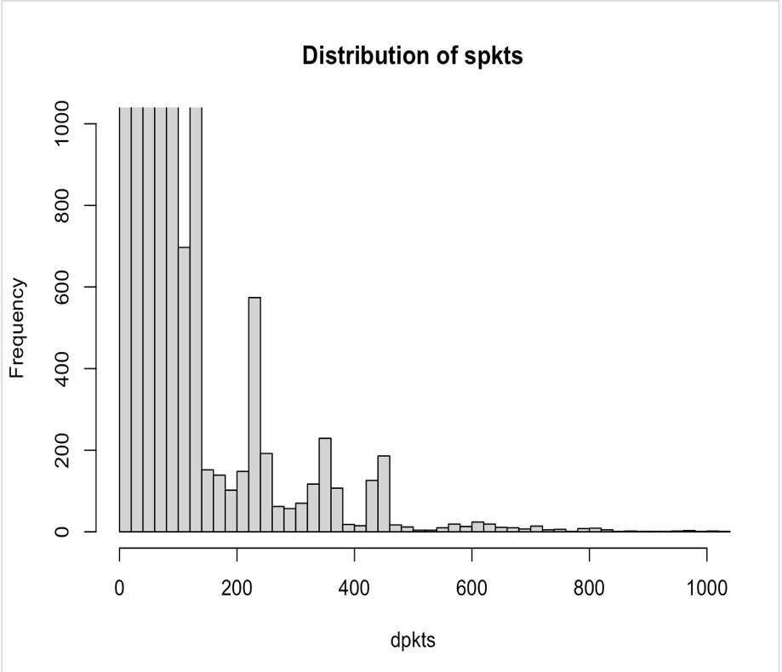
Figure 9,10
- Scaling (z-score normalization)
Creating of standardized versions for both labels can be used in future predictive analysis and model training, while keeping the distribution accurate. New columns were created: dpkts_z and spkts_z. This step contained calculation of the maximum and minimum values to correctly identify the boundaries for normalization.
Figure 11
- Final save procedure.
The final save procedure was performed via write.csv() function. The reasons for this activity can be explained with the necessity for backup file in case of the modification of current of further analysis files. Additionally, logical conclusion of data cleaning stage was sentenced by this function.
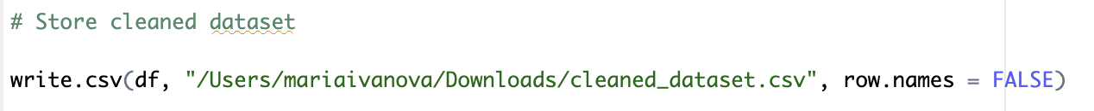
Figure 12
Data Analysis
Objective: To investigate the impact of dur and spkts towards presence of attack.
This section provides elaboration of hypothesis via objective that can be formulated as “To investigate the impact of dpkts and spkts on the presence of attack.” In the context of a real-world network environment, the parameters spkts (source packets) and dpkts (destination packets) can serve as indicators that, based on their values, can showcase the presence of malicious activity.
For the selected parameters, the following workflow was confirmed and executed.
# Data Import and Data Type Validation
1. Statistics Data Collection
2. Visualisation of outliers and distribution of values
3. Visualisation of normal distribution (manual function)
4. Visualisation of line pattern on the scatter plot
5. Correlation via attack category
6. If a pattern is identified, training models (supervised learning)
Data Import and Data Type Validation
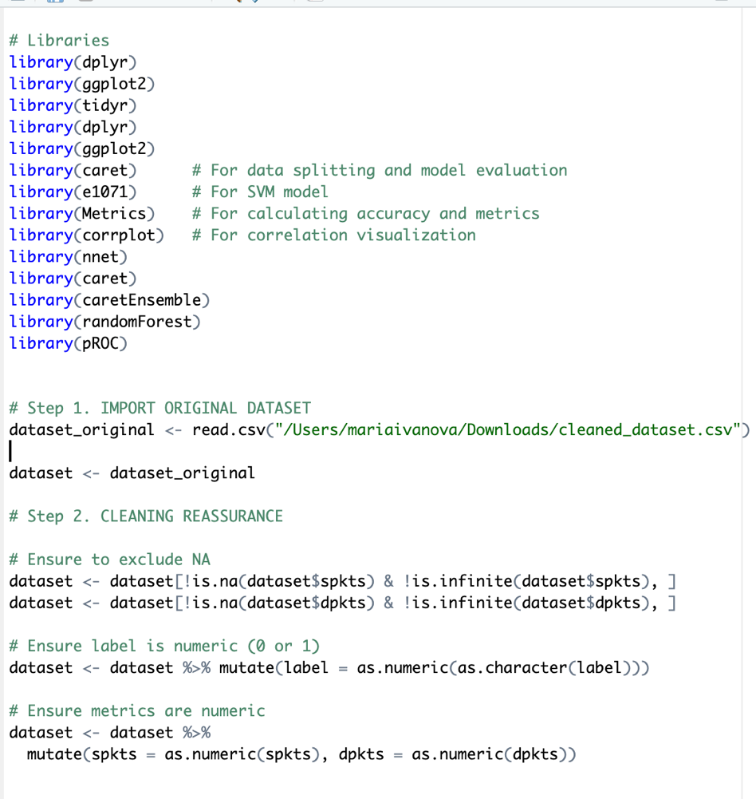
Figure 13
Statistics Data Collection
The content of objective statement can be classified as focused and considerably narrowed, as long as both parameters directly represent traffic packets exchange count and mostly signal the attack via an imbalanced relation to each other or via values themselves. The metrics collected during the Statistics Data step were mean and median for both parameters, differentiated by attack category.
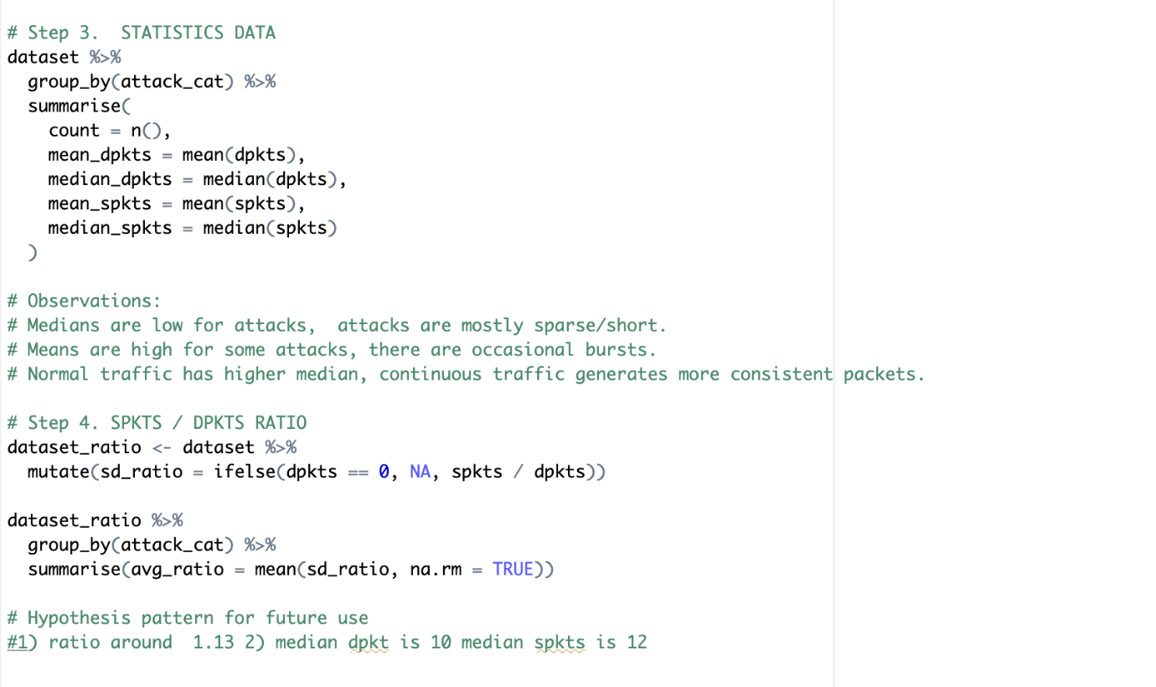
Figure 14
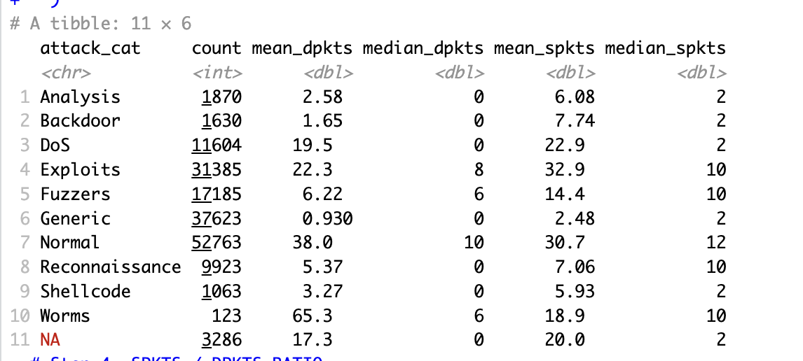
Figure 15
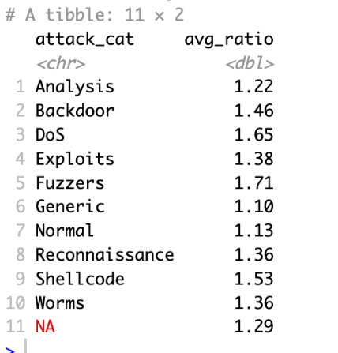
Figure 16
Interpretation and Observation:
The median for both dpkts and spkts for the normal category (absence of attack) shows the values of 10 and 12, respectively. That is generally higher for the median values across other categories of attack. The mean illustrates an approximately similar ratio; however, its value is considerably higher than for other attack categories, except for worms.
Additionally, for exclusion of calculation errors, the spkts / dpkts ratio was calculated. The results indicate a ratio of 1.13 (almost symmetrical) that is consistent with the pattern noticed. (Although, it is important to highlight that the ratio of Analysis type of attack is the closest to the value of “Normal” – 1.22.
The succinct conclusion for statistics data collection can be formulated as:
- Medians are statistically low for presented attacks; the Normal category has the highest values across all medians.
- Means are high for some attacks; there are occasional bursts.
- The ratio of SPKTS and DPKTS values is around 1.13, while the median DPKTS = 10, for SPKTS = 12.
Visualisation of outliers and distribution of values
The histogram plot was chosen for visualisation of the distribution of values and its occurrence rate. Originally, the histograms were configured to display all values for both dpkts and sptks. The issue appears with huge values of outliers (4000 and above) that cause the histogram to be uninformative. For the visualisation purposes, the histogram was zoomed to a 300 value limit to catch distribution within a dedicated range (for both spkts and dptks).
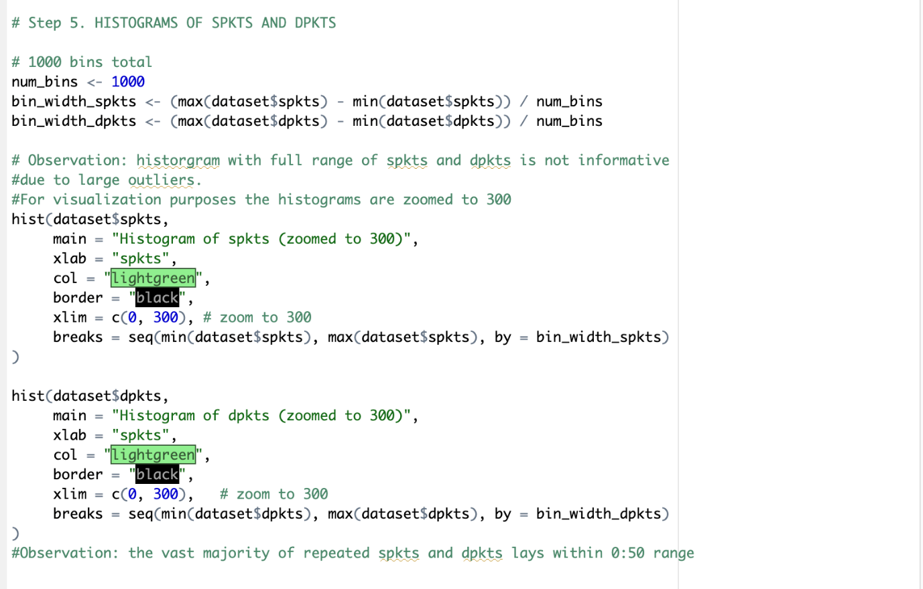
Figure 17
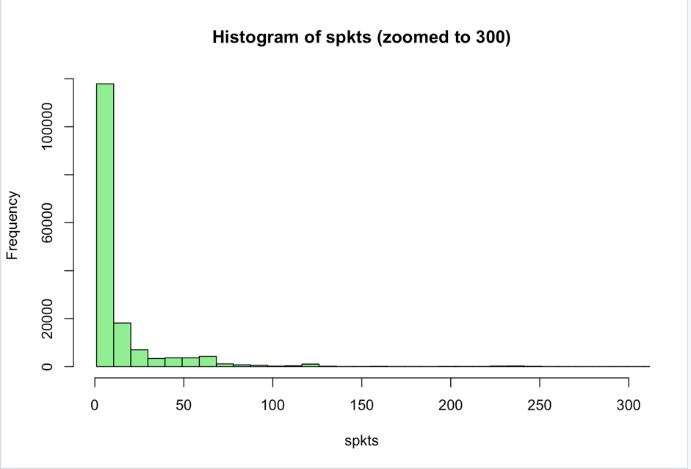
Figure 18
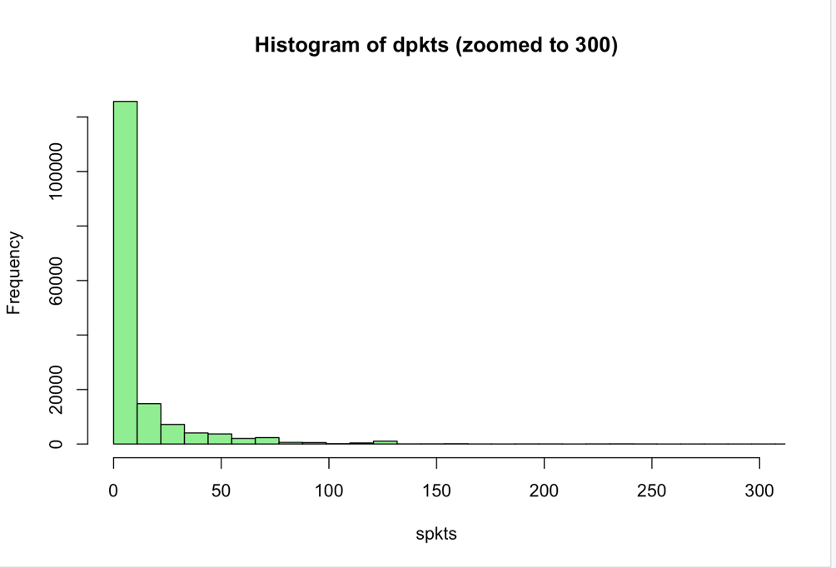
Figure 19
The Interpretation and Observation:
The distribution of both spkts and dpkts represented on the plot illustrated that the vast majority of values fall within a range of 0 to 50. With the upper boundary of approximately 300. It is necessary to state at the current stage that while some values exceed this boundary, their occurrence does not directly correspond to the presence of an attack.
Visualisation of normal distribution
This validation is required for determination of the next path and range of tests and visualisation that can be executed on the data without being violated. For correct and humanly understandable perception of the data distribution, the manual function was constructed. This code aimed to visualise normal distribution by a) sorting all values b) Each value is assigned a score between 0 and 1 that shows its location in the overall distribution. c) This data is visualised by axis, where x is the data “location” (quantile) and the y-axis represents the value of this data entry.
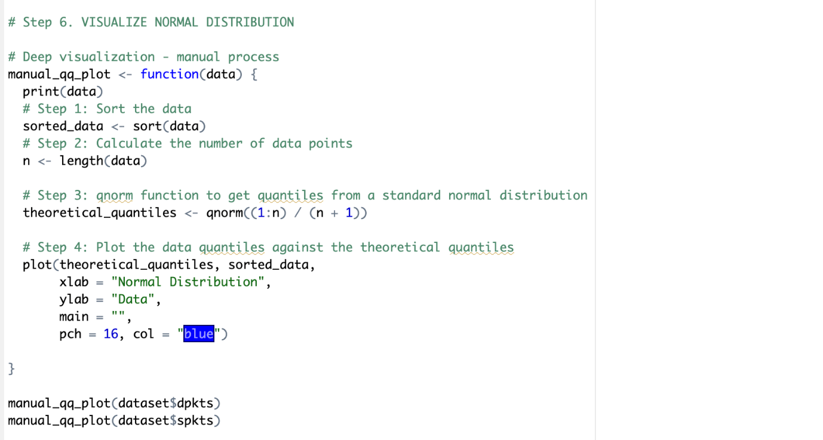
Figure 20
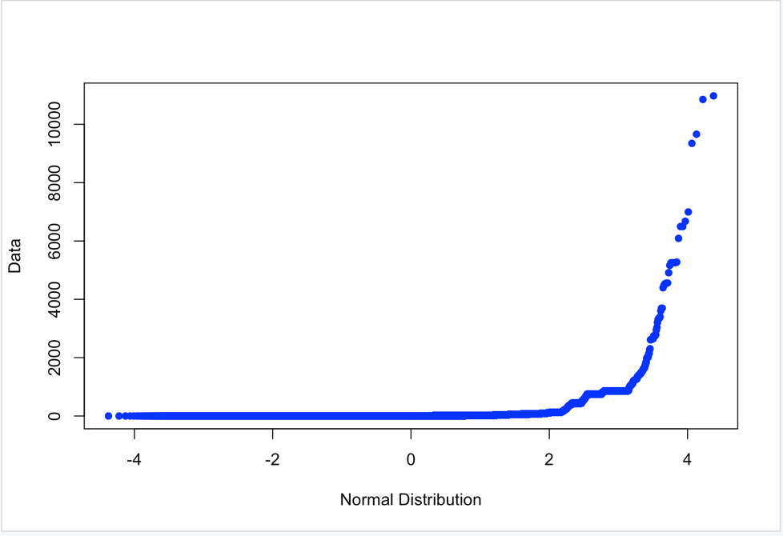
Figure 21
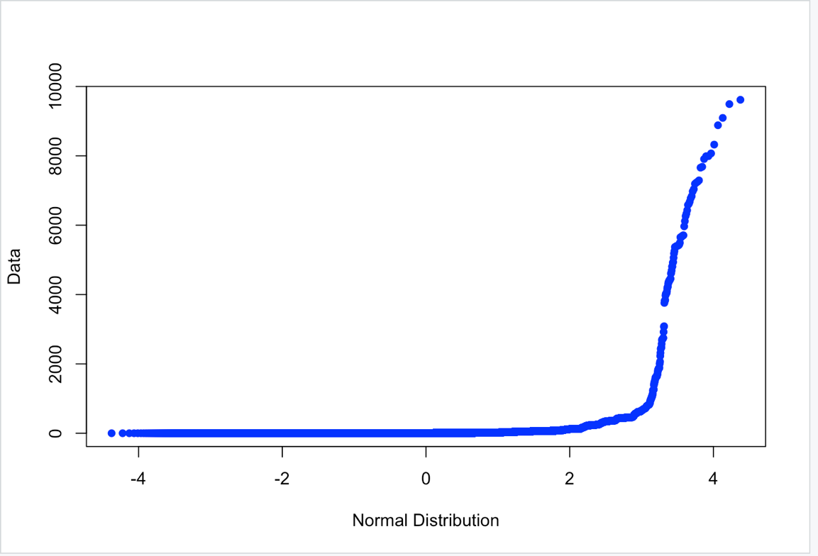
Figure 22
Interpretation and Observation.
The characteristics of a normally distributed data would be the diagonal line from the bottom left to top right corners; however, for both spkts and dpkts, this line happens to be curved to the bottom due to its extreme growth at the right end of the line. The interpretation of this data can be formulated that although a lot of data belongs to approximately the same y range (the values of 0:50 or 0:300 for the outliers section), some data presented belongs to higher values that cause data to be imbalanced in the aspect of distribution. This leads to a key pivot in the analysis path that shows that some tests that require data normality cannot be applied to sptks and dpkts, such as the t-test, ANOVA, Pearson correlation, etc.
Visualisation of line pattern on the scatter plot
Although in the previous step the conclusion states that the data imbalance condition limits some test implementation, the visualisation of data entries in a scatter plot might lead to the identification of some other patterns and justification of the pattern collection during the statistical data stage.
The following scatter plot was performed originally for the label parameter (presence or absence of attack) to specifically separate the normal state of traffic from the malicious operations.
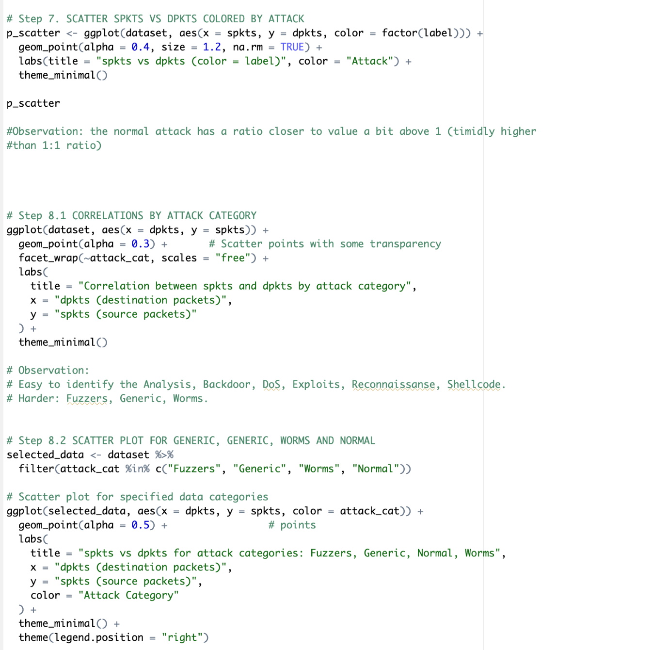
Figure 23
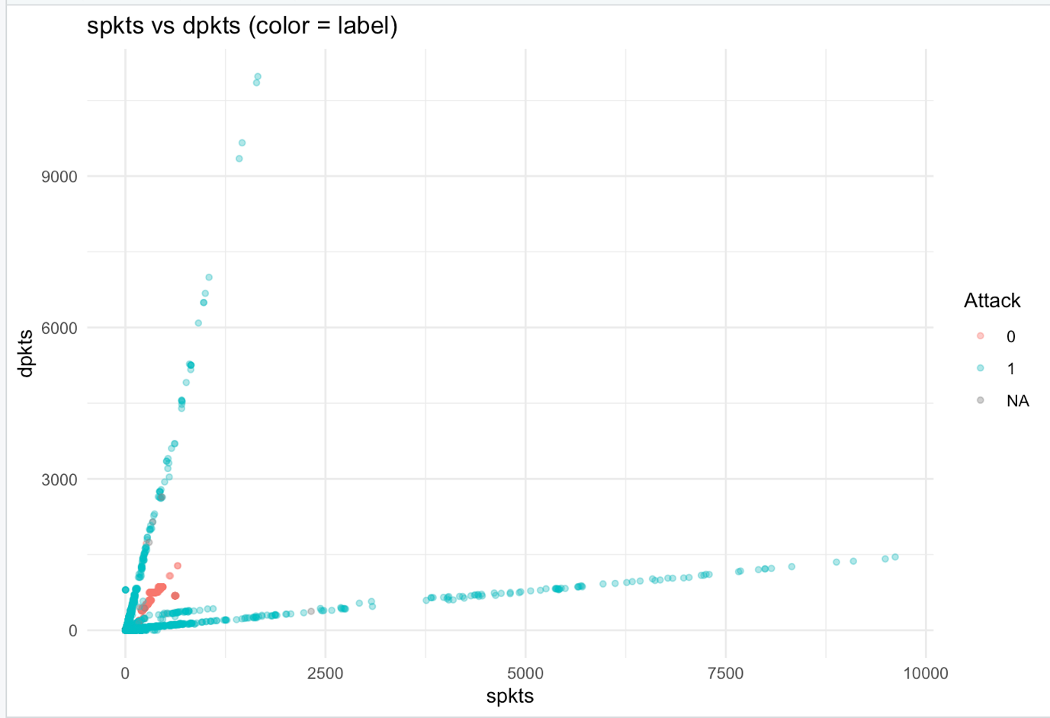
Figure 24
Interpretation and Observation:
The results on the scatter plot directly correlated with previous observations of a slightly larger ratio of spkts to spkts than 1 (1.13) for absence of attack. Additionally, the graph illustrates that all outliers belong to the category of attack (all outliers illustrate the presence of attack).
Correlation via attack category
To further investigate the possible patterns and clear all possible mismatches in identified patterns, the scatter plots were constructed for each of the attack categories, including the “Normal” category.
Figure 25
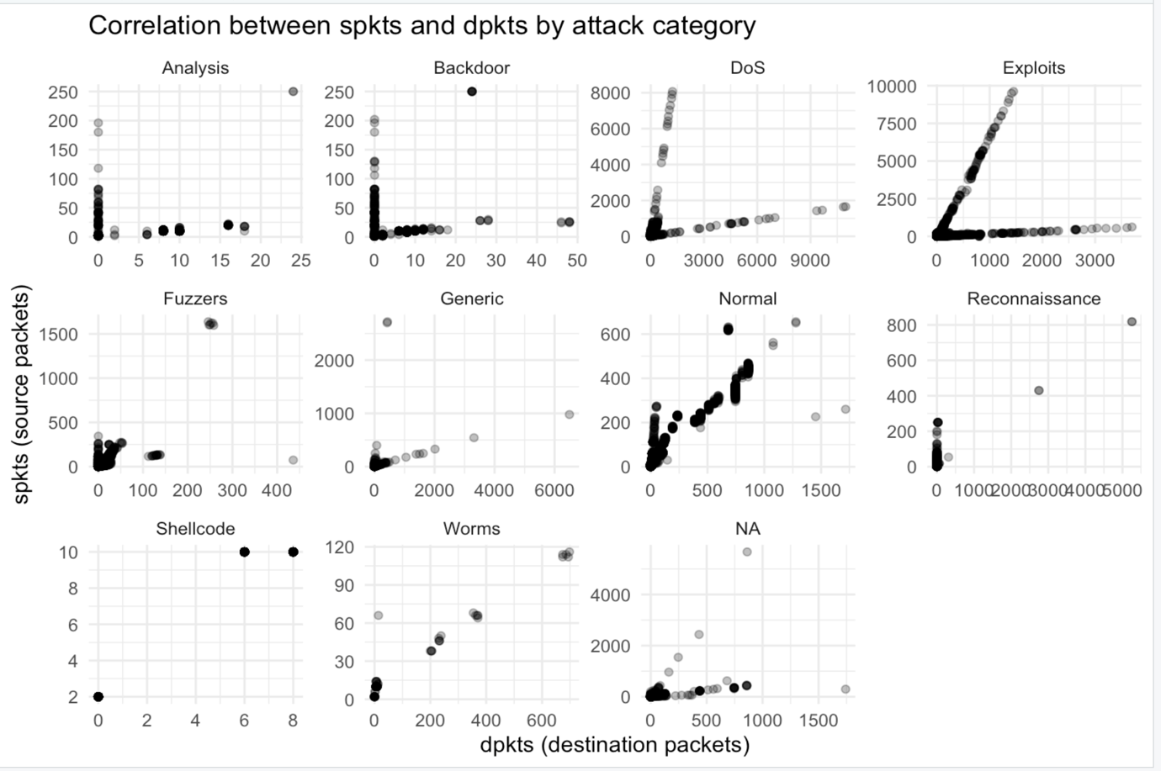
Figure 26
Interpretation and Observation:
Various attack categories have formed different patterns. The Analysis and Backdoor categories illustrate the state of extreme ratio of spkts to dpkts, meaning that with one of the parameters staying low, another one stays extremely higher, from 100% to 1000%. The DoS and Exploits categories form approximately identical patterns with slightly less extreme imbalance; visually it can be noticed by lines that lay closer to the diagonal line.
There are some attack categories that do not fall into any visually specific pattern, such as Fuzzers, Generic, Reconnaissance, Shellcode and Worms (However, Worms type forms a relatively visually straight line. It is important to state that although this line seems to match the diagonal line, the values of the x and y-axes are disproportional; that can validate that this line does not belong to the ratio 1:1 or even closely. Other researchers have similarly noted that: several intrusion categories fail to form distinct geometric or distributional patterns when visualised using packet-based features, especially in flow-based datasets (Moustafa & Slay, 2016).
The biggest confusion for accurate attack presence identification may appear within the range of 0:50 or 300. An additional scatter plot was constructed specifically for attack categories that don’t form a visual pattern and contain data instances in a specified range: Fuzzers, Generic, and Worms (Normal is also included).
Figure 27
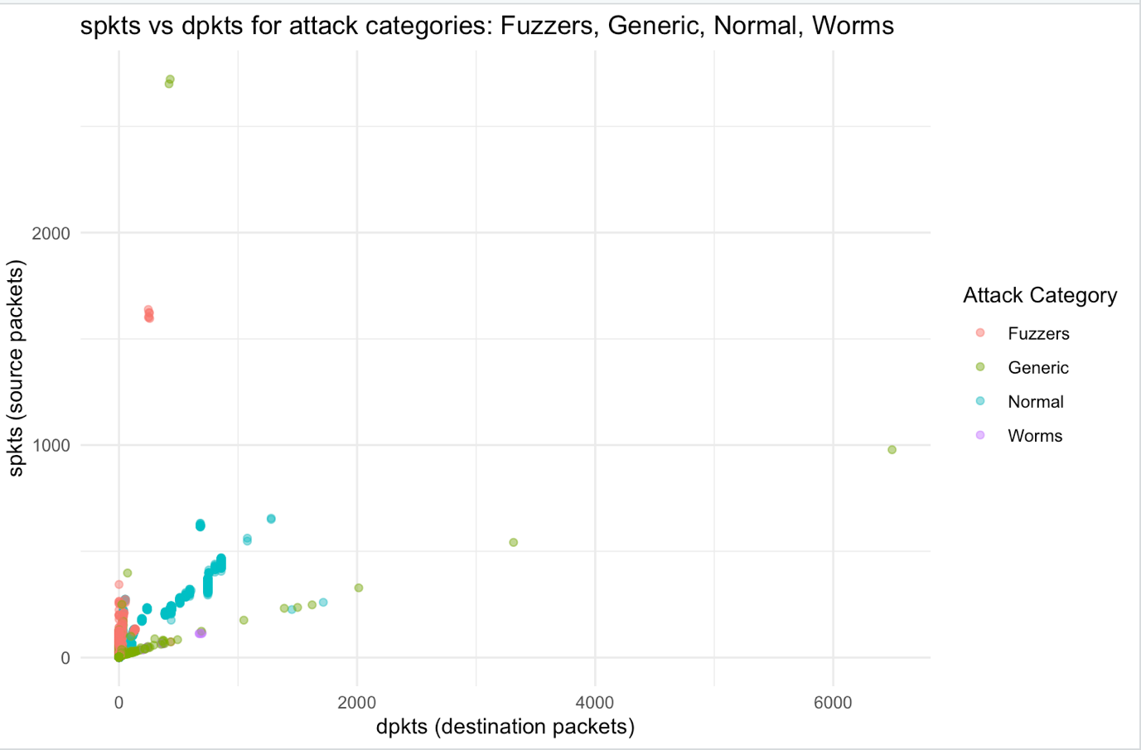
Figure 29
Fuzzer type instances visually tend to have a high ratio of spkts to dpkts (the dpkts value does not exceed 100 value points, while spkts belongs to the form 0 to 1700); the generic category forms a line pattern ,that is lower than a 1:1 ratio; however, it still preserves outliers that don’t follow this pattern.
The training of predictive models can directly illustrate the clarity and accuracy of defined pattern statements. The chosen predictive models are: Logistic Regression and Random Forest. This choice is justified by both spkts and dpkts features to be imbalanced in terms of distribution normality.
# Additional Feature 1 – Supervised Learning (Logistic Regression)
The training of the logistic regression model starts with the creation of two additional features – log_spkts and log_dpkts. These values are added to the existing dataset and afterwards used in both training procedures for reassuring that models are much more robust to large values of outliers.
There is a necessity to introduce another feature – a flag that mimics the values of the label column of the dataset; however, its value is a type of factor (categorical value). This step is essential for training a classification model, because a numeric value of 0 or 1 will be considered by the model as a continuous value.
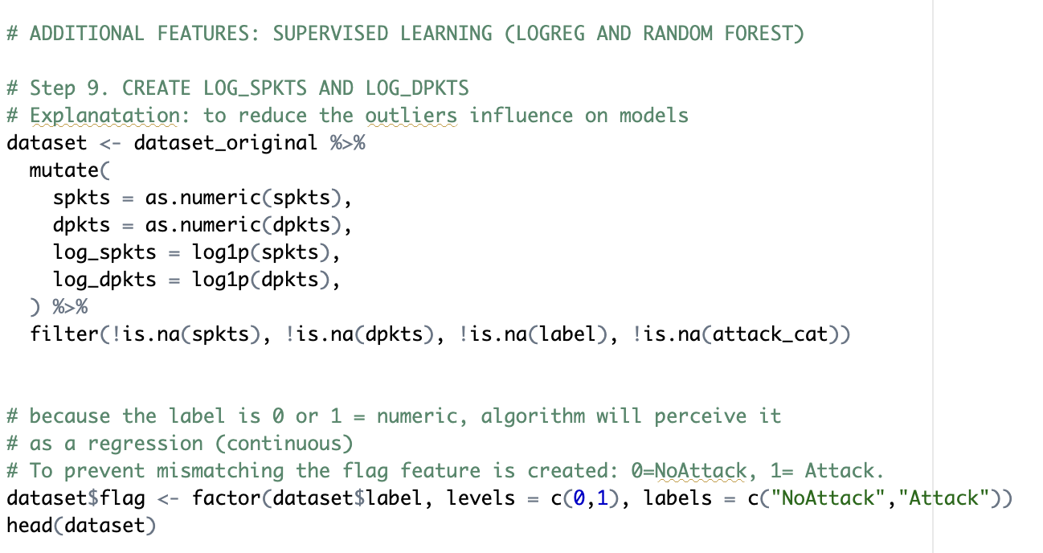
Figure 30
Train/test Split
For these models the split chosen was 80% for training and 20% for testing purposes. Additionally, to escape bias, originally mentioned in the cleaning stage, for the identification of an attack rather than its absence, the stratified split was implemented via the createDataPartition() function.
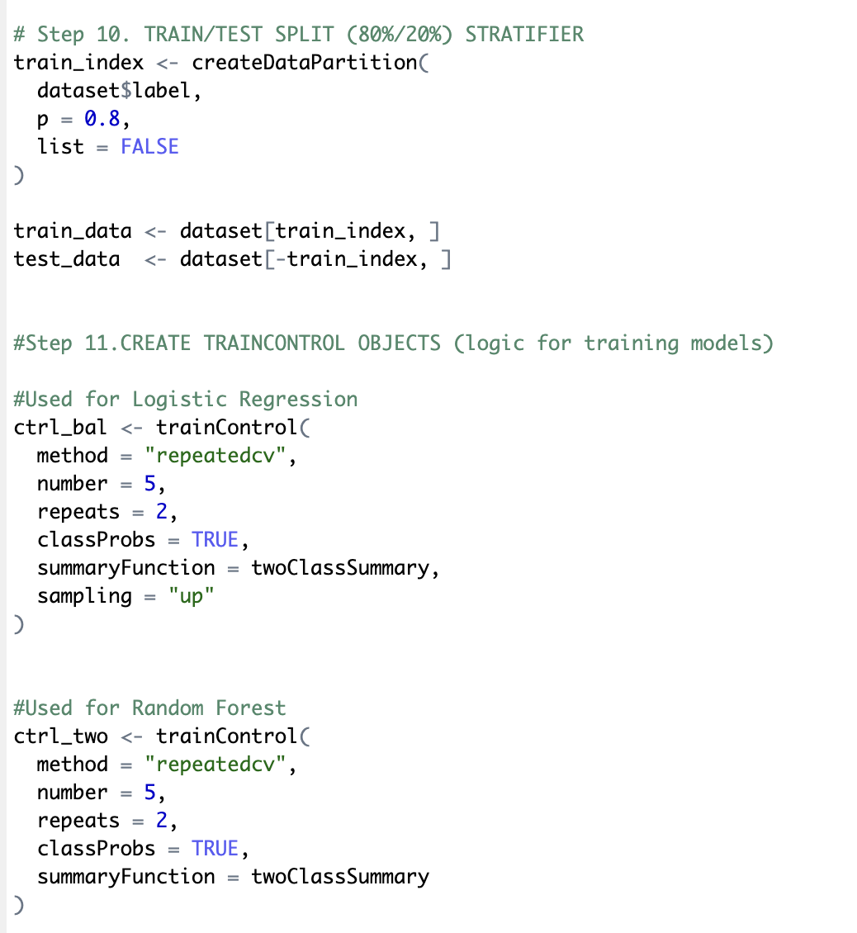
Figure 31
The rules and settings for the model were defined in a trainControl object to reassure that the configuration of the model matches the purposes of classification. Specifically for the Logistic Regression model up-sampling was used to address the class imbalance.
Training Results
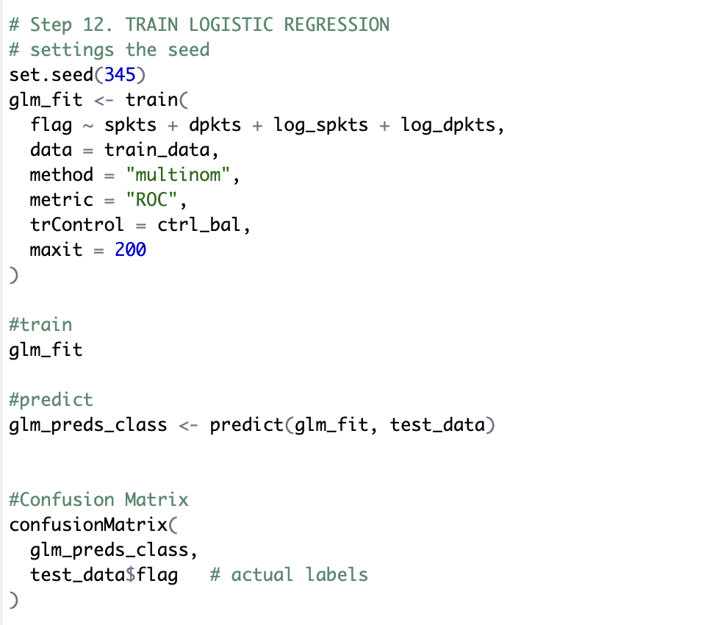
Figure 32
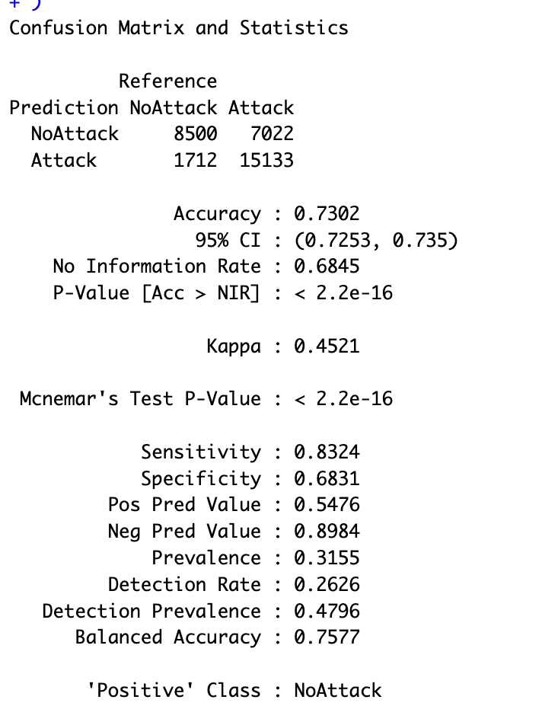
Figure 33
The model trained showed the results of 0.73 accuracy (73%). Examination of the confusion matrix reveals that almost 50% of NoAttack instances were incorrectly classified as Attack. The decision threshold seems to be set too conservatively for the NoAttack type. The results are meaningful for illustration of the pattern identified; however, this achieved metric is not sufficient for accurate attack presence prediction.
# Additional Feature 2 – Supervised Learning (Random Forest)
As it was mentioned, the achieved accuracy of LogReg showed that the results are validated by the pattern identified, and these results can be improved. The second model – Random Forest – was chosen for its automated ability (due to its structure and logic rules) to capture complex non-linear relationships. Its majority voting principle additionally may improve accuracy by elimination of all noisy data and outliers.
For training of the Random Forest Model, the same collection of the features was used: spkts, dpkts, log_spkts, and log_dpkts. Through iterative training, the best parameters identified were:
- Number of trees: 1000
- Metric: “ROC” – uses Area under the Curve (AUC) to differentiate how accurately the model identifies Attack and NoAttack
- Method: ranger – this implementation method optimises the model for memory efficiency.
Training Results
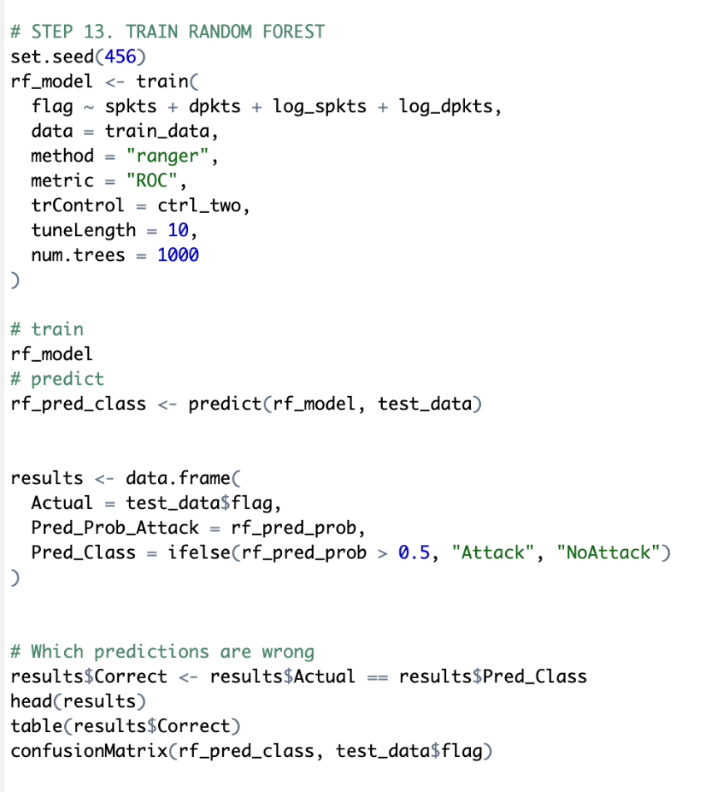
Figure 34
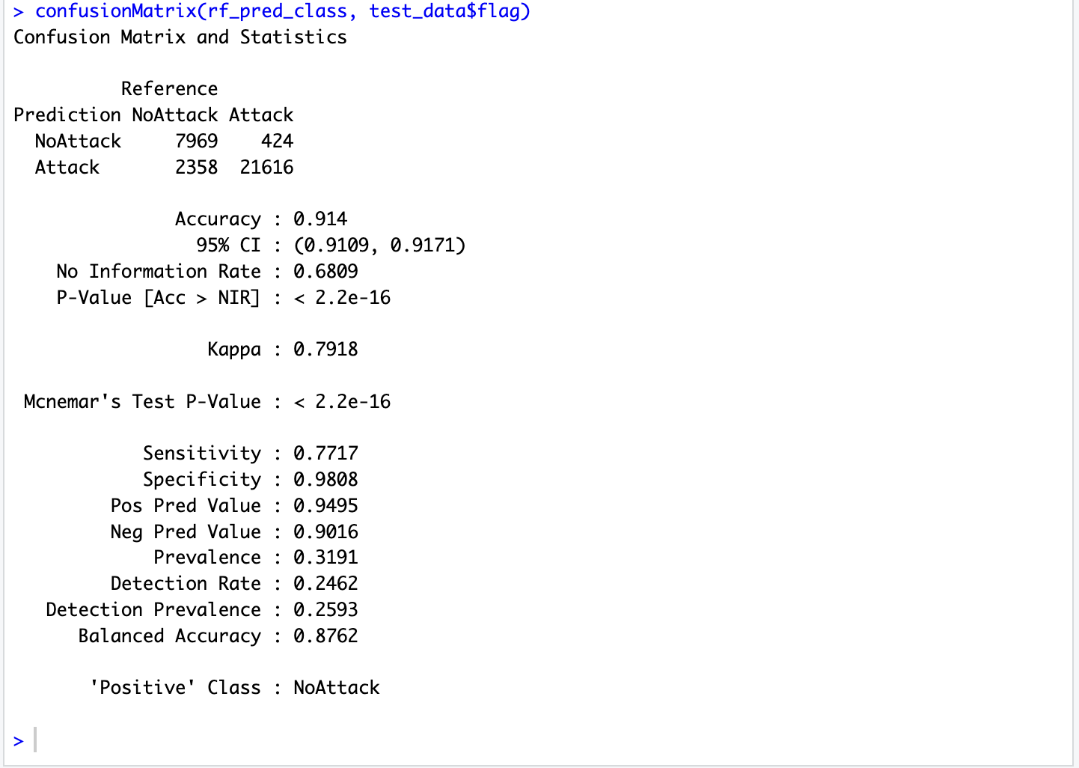
Figure 35
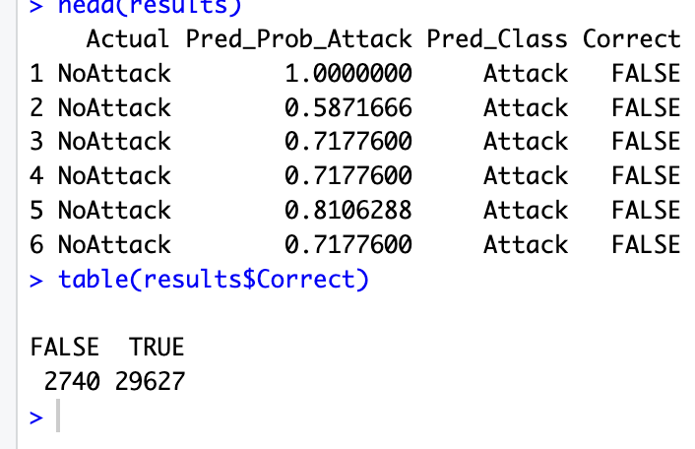
Figure 36
The Random Forest model accuracy received is 0.91 (91%), which indicates strong predictive performance. The model succeeded to correct identifying NoAttack instances with an incredibly small misclassification rate (0.05). It is important to state that utilisation of log_spkts and log_dpkts considerably influences the model’s generalisation abilities. ”Logarithmic transformation can mitigate skewness and stabilize variance in highly skewed features, thereby improving a model’s generalization performance” (Leydesdorff & Bensman, 2009). As a conclusion, these results justify the appropriateness of the Random Forest model for the identification of the network attack patterns and the absence of malicious activity as well.
Data Analysis Conclusion
The conducted exploratory analysis focused on the hypothesis objective: to investigate the influence of spkts and dpkts on the presence of attack. The investigation included descriptive statistics, distribution visualisation and analysis, scatter plot construction and identification of parameter correlations. The details of the identified are as follows: the features are right-skewed, the majority of instances fall in the range 0 to 50, with the vast majority belonging to the slice below 300 value, although some extreme outliers were identified and further proved to belong to the attack presence type. Normal traffic shows higher medians across all data and an approximately symmetric ratio of packet exchange. The visualisation revealed attack categories that are complicated to identify, such as Fuzzers, Generic, and Reconnaissance, which tend to be more heterogeneous.
The analysis performed validates that spkts and dpkts are sufficient for determination of attack presence. This statement was supported by conducted model training of Logistic Regression (0.78) and Random Forest (0.91) models.
The future direction of pattern recognition and model training may contain the application of non-parametric statistical tests and combinations with additional features. “Non-parametric methods such as the Mann–Whitney U test and the Kruskal–Wallis test are particularly well suited for analyzing data that deviate from normality and contain outliers, as they make no assumption about the underlying distribution”. (Vickers, 2005)

References

Moustafa, N., & Slay, J. (2016). The evaluation of network anomaly detection systems: Statistical analysis of the UNSW-NB15 data set and the comparison with the KDD99 data set. Information Security Journal: A Global Perspective, 25(1–3), 18–31.
Leydesdorff, L., & Bensman, S. (2009). Classification and Power-laws: The Logarithmic Transformation. arXiv. https://arxiv.org/abs/0911.3416
Vickers, A. J. (2005). Parametric versus non-parametric statistics in the analysis of randomized trials with non-normally distributed data. BMC Medical Research Methodology, 5, Article 35. https://doi.org/10.1186/1471-2288-5-35

Author: Ivanova Mariia

