ASMI MEMBER & SECTOR RESEARCH
Association of Singapore Marine & Offshore Energy Industries (ASMI)

Scope
- ASMI overview and member-business profile
- Communication structure
- Top 100 active members
- ASMI × WSG 2026 presentation pain points
- Compliance and reporting applicability
- Software landscape, problem frequency, and digital presence
1. What is ASMI?
Official website: https://asmi.com/
The Association of Singapore Marine and Offshore Energy Industries (ASMI) is a non-profit trade association based in Singapore. It was formed in 1968 to represent and advance Singapore's marine industry and today represents companies across the marine and offshore energy sector.
Item | Description
Full name | Association of Singapore Marine and Offshore Energy Industries (ASMI)
Type | Non-profit trade association
Established | 1968; the organisation began as the Singapore Association of Shipbuilders and Repairers (SASAR).
Country of operation | Singapore, with member-facing and international industry activities.
Core functions | Represent member interests; foster cooperation among members; support productivity, technology and skills upgrading; raise safety, health and environmental standards; liaise with regulatory bodies; and support international collaboration and industry development.
Nature of members' businesses | Large and small shipyards; local and foreign manufacturers and suppliers of marine equipment and components; marine engineering and consultancy companies; MRO and service providers; technology firms; and other businesses directly related to the marine and offshore energy industry.
Official ASMI sources
- About ASMI / mission & objectives
- Our history

2. ASMI Communication Schema
The communication structure below preserves the relationships shown in the source document, reformatted as a clean organisational flow.
ASMI MEMBERS
↓
Large companies | SMEs | Technology firms
Seatrium | Mencast etc. | Rolls-Royce etc.
↓
ASMI communication
↓
Council | Committees | Direct channels | News Section
senior executives  from members | member reps by topic  Dialogues · Lunches · AGM · Events | WhatsApp (for confirmed members)  Learning Circles | Members News/Offers publications in ASMI website
↓
ASMI Secretariat
↓
Government agencies | Training partners | Programmes / initiatives

3. Top 100 Active Members
The table below retains all columns from the source dataset, including activity indicators and each company’s brief business description / nature of activity.
rank | company_name | member_type (ASMI's own business_nature field) | active_within_  6mo | content_recency_  tier | activity_tier | brief_description
1 | Seatrium Limited | Shipyard | Y | Active (<=6mo) | Very High | Seatrium Limited provides innovative engineering solutions to the global offshore, marine and energy industries.
2 | Marco Polo Marine Limited | Shipyard | N | Active (<=6mo) | Very High | SGX-listed Singapore shipyard and offshore support vessel owner/operator, with a Batam shipyard and a growing offshore-wind CSOV/CTV fleet alongside its legacy oil & gas OSV business.
3 | PaxOcean Singapore Pte Ltd | Shipyard | Y | Active (<=6mo) | Very High | First established in 2007 as part of the Kuok Maritime Group, PaxOcean Singapore Pte Ltd has evolved into a global powerhouse for marine and offshore engineering.
4 | Aesen Pte. Ltd. | Traders Or Integrators | Y | Active (<=6mo) | Very High | With a presence across Asia Pacific, the Middle East, and Africa, Aesen is a leading provider of integrated marine, crew mobility, and offshore support solutions for the oil & gas, renewables, and marine civil construction sectors.
5 | Cyan Renewables Pte Ltd | M R O | N | Somewhat active (6-18mo) | Very High | Founded in 2022 and headquartered in Republic Plaza, Singapore, Cyan Renewables Pte Ltd has scaled rapidly to become the largest dedicated offshore wind services platform in the Asia-Pacific region, with an active corporate and operational presence...
6 | Strategic Marine (S) Pte Ltd | M R O | Y | Active (<=6mo) | Very High | Originating from roots established in Western Australia in 1984 and expanding its global headquarters to Singapore in 1998, Strategic Marine (S) Pte Ltd has spent decades growing into an undisputed international benchmark for high-velocity aluminum hull...
7 | Kim Heng Marine & Oilfield Pte Ltd | Shipyard | Y | Active (<=6mo) | Very High | Operating as a primary engine of the publicly listed SGX powerhouse Kim Heng Limited, Kim Heng Marine & Oilfield Pte Ltd translates more than half a century of deep-sea engineering legacy into total maritime infrastructure reliability.
8 | DESMI Singapore Pte Ltd | Equipment Seller | Y | Active (<=6mo) | Very High | Established in 2011 and operating from our centralized regional sales and technical hub at Bukit Batok Connection, DESMI Singapore Pte Ltd functions as the direct Southeast Asian gateway for the global DESMI Group.
9 | Bureau Veritas Marine (Singapore) Pte Ltd | Classification Societies (Primary - SSIC 71200 / 82999) and Technical Testing and Analysis Services | Y | Active (<=6mo) | Very High | Operating as an essential regional technical nexus for the global Bureau Veritas Group (established in 1828), Bureau Veritas Marine (Singapore) Pte Ltd represents the absolute peak of regulatory trust and technical conformity assessment.
10 | Jurong Port Pte Ltd | Shipyard | N | Somewhat active (6-18mo) | Very High | Jurong Port Pte. Ltd. is a leading, international multi-purpose port operator headquartered in Singapore.
11 | Pinnacle Marine (Singpore) Pte Ltd | Shipyard | Y | Active (<=6mo) | Very High | Established as a highly responsive engineering partner, Pinnacle Marine (Singapore) Pte Ltd has built a strong reputation as a reliable specialist contractor serving major shipyards, commercial vessel fleets, and offshore energy operators.
12 | Institute of Technical Education (ITE) | Others | Y | Active (<=6mo) | Very High | The Institute of Technical Education (ITE) is a principal post-secondary institution and statutory board operating under the purview of Singapore's Ministry of Education (MOE).
13 | Carizon Pte Ltd | Other Holding Companies (Investment & Asset Management) and Marine & Offshore Energy Consultancy and Project Management | Y | Active (<=6mo) | Very High | Headquartered at Boat Quay in Singapore with a dynamic international footprint spanning Japan and Mexico, Carizon Pte Ltd operates as a high-value integrated energy service provider and family office platform.
14 | Tru-Marine Pte Ltd | M R O | Y | Active (<=6mo) | Very High | Tru-Marine Pte Ltd is a premier, home-grown global maritime engineering firm specializing in the Maintenance, Repair, and Overhaul (MRO) of critical vessel propulsion and engine components.
15 | Korindo Energy (Singapore) Pte Ltd | Equipment Seller | Y | Active (<=6mo) | Very High | Korindo Energy (Singapore) Pte Ltd is an established, specialized energy solutions provider and heavy mechanical systems integrator catering to the marine propulsion, offshore power, and clean energy sectors.
16 | Synergy Marine Pte Ltd | Support Activities for Water Transportation (Primary - SSIC 52226) and Deep Sea Freight Transportation (Secondary - SSIC 50021) | Y | Active (<=6mo) | Very High | Founded in 2006 and headquartered in Singapore, Synergy Marine Pte Ltd has spent two decades completely redefining the standards of global third-party ship management.
17 | Beng Kuang Marine Limited | M R O | Y | Active (<=6mo) | Very High | Established in the 1990s and listed on the Mainboard of the Singapore Exchange (SGX) since 2004, Beng Kuang Marine Limited has evolved from a foundational shipyard sub-contractor into a globally trusted, service-centric offshore engineering platform.
18 | Everllence Singapore Pte. Ltd. | M R O | Y | Active (<=6mo) | Very High | Everllence Singapore Pte. Ltd., with its rich marine engineering legacy comprised of B&W, Mirrlees Blackstone, Paxman, Pielstick, Ruston, and more brands, is proud of its contribution to the world’s marine history and long presence in Singapore.
19 | Seagull Pte Ltd | M R O | Y | Active (<=6mo) | Very High | Established in Singapore in 2003, Seagull Pte Ltd has spent more than two decades scaling into a dominant, internationally trusted one-stop solution provider for the global marine and offshore industries.
20 | Seatrium (SG) Pte Ltd | Shipyard | Y | Active (<=6mo) | Very High | Born from the historic integration of Keppel O&M and Sembcorp Marine, Seatrium (SG) Pte Ltd brings over 60 years of foundational maritime heritage into a unified, world-class engineering powerhouse.
21 | Junma Services Pte Ltd | M R O | Y | Active (<=6mo) | Very High | Founded in 2005, Junma Services Pte Ltd has built a powerhouse reputation over two decades as a "one-stop" independent partner for complex marine diesel engine systems and maritime decarbonization.
22 | Goltens Singapore Pte Ltd | M R O | Y | Active (<=6mo) | Very High | Incorporated in 1974 and strategically operating from an advanced, heavy-capacity industrial facility at Benoi Road in Jurong, Goltens Singapore Pte Ltd serves as the absolute regional spearhead for the internationally renowned Goltens Group.
23 | OCEANIS ROBOTICS PTE. LTD. | M R O | Y | Active (<=6mo) | Very High | Oceanis Robotics is a company specialized in underwater Remotely Operated Vehicle (ROV) leasing and its related services.
24 | Toll Offshore Petroleum Services Pte Ltd | Port Operator | Y | Active (<=6mo) | Very High | Toll Offshore Petroleum Services (TOPS) owns and operates Asia's premier supply base in Singapore.
25 | Kongsberg Maritime Pte Ltd | M R O | Y | Active (<=6mo) | Very High | Established in Singapore in 1987 and operating as the premier, cross-functional Asia-Pacific headquarters of the legendary Norwegian technology group Kongsberg Gruppen ASA, Kongsberg Maritime Pte Ltd represents the absolute peak of maritime digitalization...
26 | Schottel Far East (Pte) Ltd | Equipment Seller | Y | Active (<=6mo) | Very High | Operating from its fully equipped, high-capacity technical facility at Tech Park Crescent in Tuas, Schottel Far East (Pte) Ltd functions as the direct regional subsidiary of the global SCHOTTEL Group (headquartered in Spay, Germany).
27 | Wartsila Singapore Pte Ltd | M R O | Y | Active (<=6mo) | Very High | Wartsila Singapore Pte Ltd operates as the critical regional hub and flagship Southeast Asian subsidiary of Wärtsilä Corporation, a Finnish global leader in innovative technologies and complete lifecycle solutions for the marine and energy markets.
28 | ASL Shipyard Pte Ltd | Shipyard | Y | Active (<=6mo) | Very High | ASL Shipyard Pte. Ltd. is a prominent, vertically-integrated marine services company and the flagship operating subsidiary of the SGX-listed ASL Marine Holdings Ltd. Headquartered at Pandan Road in Singapore with operations dating back to 1974, the company...
29 | Beng Hui Marine Electrical Pte Ltd | Traders Or Integrators | Y | Active (<=6mo) | Very High | No description available in source data (member type: Traders Or Integrators).
30 | Chugoku Marine Paints (S) Pte Ltd | Others | Y | Active (<=6mo) | Very High | Chugoku Marine Paints (Singapore) Pte. Ltd. is a prominent regional subsidiary of Chugoku Marine Paints, Ltd. (CMP), a Tokyo-listed Japanese global leader with over a century of history in specialized coating technology.
31 | SOPEX INNOVATIONS | Equipment Seller | Y | Active (<=6mo) | Very High | No description available in source data (member type: Equipment Seller).
32 | Mencast Holdings Ltd | M R O | N | Has news section, no dates visible | High | Mencast Holdings Ltd. is a Singapore-based, SGX-listed engineering and MRO group specializing in the offshore, marine, and oil and gas industries.
33 | ST Engineering Marine Ltd | M R O | N | Has news section, no dates visible | High | ST Engineering Marine Ltd (formerly known as ST Marine) is a premier global naval defense and commercial shipyard operator, serving as the flagship maritime division of Singapore Technologies Engineering Ltd (ST Engineering).
34 | Technology Centre for Offshore and Marine | Others | N | Has news section, no dates visible | High | AME International Pte Ltd is a premier global provider of advanced manufacturing and precision engineering solutions.
35 | Vinssen International Pte Ltd | Equipment Seller | N | Has news section, no dates visible | High | Vinssen International Pte Ltd is an established green maritime technology company and clean energy systems integrator specializing in zero-emission propulsion.
36 | Divetech Offshore Pte Ltd | Established provider of commercial diving and underwater marine engineering services | N | Has news section, no dates visible | High | Established as a highly responsive marine contractor, Divetech Offshore Pte Ltd specializes in providing comprehensive commercial diving and underwater engineering services to the global maritime and offshore sectors.
37 | Seatech Solutions International (S) Pte Ltd | Resident Contractor To Shipyard | N | Has news section, no dates visible | High | Founded in 2000 and headquartered at Boon Lay Way, Singapore, Seatech Solutions International (S) Pte Ltd has spent over a quarter-century cementing its reputation as a premier global beacon for independent ship design and maritime digitalization.
38 | Mencast Marine Pte Ltd | M R O | N | No news/press section found | High | Operating as a cornerstone subsidiary of the SGX-listed Mencast Holdings Ltd, Mencast Marine Pte Ltd is a recognized market leader in stern-gear equipment manufacturing and comprehensive ship repair solutions for the global maritime, offshore energy, and...
39 | Singatac Engineering Pte Ltd | Fabricators Or Installation | N | Has news section, no dates visible | High | Established in Singapore in 1997, Singatac Engineering Pte Ltd has spent nearly three decades evolving from a specialized ship-repair sub-contractor into a dominant, internationally trusted engineering and fabrication powerhouse.
40 | Vallianz Shipbuilding & Engineering Pte Ltd | M R O | N | Has news section, no dates visible | High | Vallianz Shipbuilding & Engineering Pte Ltd is an established shipyard operator and engineering powerhouse providing comprehensive, turnkey solutions to the global marine and energy industries.
41 | Mooreast Asia Pte Ltd | Equipment Seller | N | No news/press section found | High | Founded as a core operational cornerstone of the SGX-listed Mooreast Holdings Ltd, Mooreast Asia Pte Ltd has spent more than three decades scaling into a global authority in total mooring, heavy lifting, and rigging engineering.
42 | Unidive Subsea Pte Ltd | Resident Contractor To Shipyard | N | Has news section, no dates visible | High | No canonical description on file (member type: Resident Contractor To Shipyard). From research evidence: Singapore diving contractor Unidive Subsea signed a lease agreement with HullWiper to bring HullWiper's ROV hull cleaning system into its own service operations in Singapore, launching January...
43 | Lita Ocean Pte Ltd | Shipyard | N | Stale (>18mo, dated content exists) | High | Lita Ocean was established in the 1970s and has since become one of the leading shipping companies in Singapore providing a diverse range of marine and shipyard services.
44 | MTQ Engineering Pte Ltd | M R O | N | Has news section, no dates visible | High | MTQ Corporation Limited (“MTQ”) is a premier engineering solutions provider specializing in the oil and gas sector.
45 | Siemen Pte Ltd | Shipyard | N | Has news section, no dates visible | High | Siemens Pte. Ltd. is the Singapore-based regional subsidiary of Siemens AG, the German multinational technology giant and Europe's largest engineering conglomerate.
46 | Invertek Drives Far East Pte Ltd | Equipment Seller | N | Has news section, no dates visible | High | Invertek Drives Far East Pte Ltd, is dedicated to continuous exploration and development of decarbonization solutions, toward achieving greener and sustainable living environment.
47 | Ventionex International Pte Ltd | Equipment Seller | N | Has news section, no dates visible | High | Established in 2009, Ventionex International Pte Ltd is a highly specialized engineering and technology firm dedicated to securing critical infrastructure across the global energy, marine, oil and gas, and petrochemical sectors.
48 | Centurion Corporation Limited | Global investment, development, and specialized asset management of institutional-grade Purpose-Built Worker (PBWA) and Student (PBSA) accommodations. | N | Has news section, no dates visible | High | Centurion Corporation Limited is a leading global owner, developer, and manager of specialized living sector real estate.
49 | Jason Electronics Pte Ltd | Resident Contractor To Shipyard | N | Has news section, no dates visible | High | Jason Electronics Pte. Ltd. is a leading Singapore-based provider of marine electronics, satellite connectivity, and integrated digital solutions, serving as the flagship subsidiary of the SGX-listed Jason Marine Group.
50 | RINA Hong Kong Ltd. Singapore Branch | Provision of international ship classification, statutory maritime certification, offshore energy engineering verification, and green shipping technical advisory services. | Y | Active (<=6mo) | High | RINA Hong Kong Limited (Singapore Branch) operates as the regional Southeast Asian hub for RINA S.p.A., one of the world's oldest and most prestigious international Ship Classification Societies and third-party engineering certification bodies (originally...
51 | CESCO Environmental Technologies Pte Ltd | M R O | Y | Active (<=6mo) | High | Cesco Environmental Technologies Pte Ltd is a premier, integrated industrial service provider and an established leader in mechanical completion, pre-commissioning, and specialized environmental engineering.
52 | ESAB Asia Pacific Pte Ltd | Traders Or Integrators | Y | Active (<=6mo) | High | ESAB Asia Pacific Pte Ltd serves as the regional headquarters for the ESAB Corporation, a world-renowned leader in welding and cutting technology.
53 | Hempel (Singapore) Pte Ltd | Traders Or Integrators | Y | Active (<=6mo) | High | Hempel (Singapore) Pte Ltd serves as the vital Southeast Asian regional headquarters for the Hempel Group, a world-leading global coatings manufacturer founded in Denmark in 1915.
54 | Aflex Ships Equipment Pte Ltd | Supply, assembly, and technical testing of high-performance marine pumps and engine room fluid handling systems. | Y | Active (<=6mo) | High | Aflex Ships Equipment Pte. Ltd. is a specialized Singapore-based marine engineering supplier and equipment solution provider incorporated in April 2003.
55 | Institute of High Performance Computing, A*STAR Research Entities | Research and Development | Y | Active (<=6mo) | High | The Agency for Science, Technology and Research (A*STAR) is Singapore's lead public sector R&D agency.
56 | Seatrium Repairs & Upgrades Pte Ltd | Shipyard | Y | Active (<=6mo) | High | Seatrium Repairs & Upgrades Pte. Ltd. is a key, specialized operating subsidiary of Seatrium Limited, the global engineering heavyweight formed by the landmark 2023 merger of Keppel Offshore & Marine and Sembcorp Marine.
57 | PACC Offshore Services Holdings Ltd | Resident Contractor To Shipyard | N | Somewhat active (6-18mo) | High | With a legendary operating heritage dating back more than 60 years and structured as a premier maritime division of Kuok Singapore Limited (KSL), PACC Offshore Services Holdings Ltd (POSH) represents the pinnacle of specialized ocean-going asset management.
58 | Caterpillar Marine Asia Pacific Pte Ltd | Traders Or Integrators | Y | Active (<=6mo) | High | Caterpillar Marine Asia Pacific Pte. Ltd. is a wholly owned subsidiary of Caterpillar Inc., incorporated in Singapore in December 1999.
59 | Cyclect Electrical Engineering Pte Ltd | Traders Or Integrators | Y | Active (<=6mo) | High | Cyclect Engineering Pte Ltd is an award-winning, multi-disciplinary engineering, construction, and technical solutions provider headquartered in Singapore.
60 | Tractors Singapore Ltd | Equipment Seller | Y | Active (<=6mo) | High | Established in Singapore in 1966 and operating as a wholly owned, heavy-performing subsidiary of the multinational conglomerate Sime Darby Berhad, Tractors Singapore Limited (TSL) represents the pinnacle of industrial equipment distribution and machinery...
61 | Huisman Singapore Pte Ltd | M R O | Y | Active (<=6mo) | High | Established in 2008 and operating out of a specialized technical facility at Tuas View Place, Huisman Singapore Pte Ltd serves as the strategic Southeast Asian service, assembly, and training hub for the global Huisman organization.
62 | Tuff Offshore Engineering Services Pte Ltd | EPCIC | Y | Active (<=6mo) | High | Since our inception from a modest office in Singapore, TUFF has grown to become a leading global Engineering, Procurement, and Construction (EPC) and Operations & Maintenance (O&M) contractor.
63 | Corvus Energy Singapore Pte Ltd | Traders Or Integrators | Y | Active (<=6mo) | High | No description available in source data (member type: Traders Or Integrators).
64 | Daikin MR Engineering CO., LTD Singapore Branch | Equipment Seller | Y | Active (<=6mo) | High | Established locally in 2018 at International Plaza, Anson Road, Daikin MR Engineering Co., Ltd. Singapore Branch operates as a direct foreign branch of Japan’s premier marine climate control innovator, Daikin MR Engineering Co., Ltd. (headquartered in Osaka).
65 | Codar (Pte) Ltd | Equipment Seller | Y | Active (<=6mo) | High | Incorporated in 1968, Codar (Pte) Ltd has established a multi-decade legacy as a cornerstone pioneer in the Southeast Asian marine electronics sector.
66 | Seagull Frontier Pte Ltd | M R O | Y | Active (<=6mo) | High | No description available in source data (member type: M R O).
67 | Omega 365 Singapore Pte Ltd | Fabricators Or Installation | Y | Active (<=6mo) | High | Established in 1994 and headquartered at Bukit Batok Crescent, Singapore, Marc-Plan Pte Ltd has spent more than three decades cementing its reputation as a dominant, household force in the Southeast Asian marine outfitting industry.
68 | Matcor Technology & Services Pte Ltd | Equipment Seller | Y | Active (<=6mo) | High | Incorporated in 1992, Matcor Technology & Services Pte Ltd has built a decades-long reputation as the preferred forensic engineering partner for high-stakes industrial, legal, and insurance sectors.
69 | Smart Ship Hub (SSH) Digital Pte Ltd | Resident Contractor To Shipyard | Y | Active (<=6mo) | High | Founded in 2019 and headquartered in Singapore's tech hub at Vision Exchange, Smart Ship Hub (SSH) Digital Pte Ltd has emerged as a global frontrunner redefining the future of connected shipping.
70 | Teho International Inc Ltd | Equipment Seller | N | Stale (>18mo, dated content exists) | High | Established in 1986 and listed on the Singapore Exchange (SGX-ST) in 2009, Teho International Inc Ltd has evolved from a specialized regional supplier into a multi-faceted international enterprise.
71 | Zicom Pte Ltd | Equipment Seller | N | Somewhat active (6-18mo) | High | Founded in 1978 and operating out of a massive 30,000-square-meter manufacturing and testing footprint at Tuas Avenue 9, Singapore, Zicom Pte Ltd has established a nearly 50-year legacy as a cornerstone pioneer in the marine and offshore engineering sectors.
72 | Yanmar Asia (S) Corporation Pte Ltd | Traders Or Integrators | Y | Active (<=6mo) | High | Incorporated in 1989, Yanmar Asia (S) Corporation Pte Ltd serves as the crucial regional headquarters for the global Yanmar Group.
73 | LFA Global Pte Ltd | Equipment Seller | Y | Active (<=6mo) | High | Founded in 1986, LFA Global Pte Ltd has evolved over four decades from a boutique Singapore supplier into an international maritime force.
74 | ZF Asia Pacific Pte Ltd | Equipment Seller | Y | Active (<=6mo) | High | Operating as a critical regional center for the global ZF Group, ZF Asia Pacific Pte Ltd is an industry benchmark in engineering, supplying, and servicing the world’s most advanced mobility solutions.
75 | FLS (Singapore) Pte Ltd | M R O | N | Somewhat active (6-18mo) | High | Incorporated in 2014, FLS (Singapore) Pte Ltd operates as a premier strategic node within the global FLS Group network.
76 | A-STAR Testing & Inspection Pte Ltd | Wholesale of Industrial Machinery, Fluid Components, and Equipment and Environmental and Mechanical Engineering Design and Consultancy Services | Y | Active (<=6mo) | High | Incorporated in 2024 and operating out of its specialized industrial logistics centers at Toh Guan Road East and TradeHub 21 in Jurong East, SG Fluid Technologies Pte Ltd has quickly scaled to become a key infrastructure supplier to the regional processing...
77 | Ascenz Marorka Pte Ltd | M R O | N | Somewhat active (6-18mo) | High | Operating from its strategic Asia-Pacific regional hub at Mapletree Business City in Singapore, Ascenz Marorka Pte Ltd serves as the specialized Smart Shipping arm of the publicly listed French engineering powerhouse GTT Group.
78 | Scania Engineering Pte Ltd | Others | Y | Active (<=6mo) | High | Founded in 2006, Scania Engineering Pte Ltd has spent two decades establishing itself as a highly reliable and technically precise mechanical engineering partner within Singapore's maritime sector.
79 | IO3 PTE. LTD. | Maritime digital Solution | Y | Active (<=6mo) | High | iO3 Pte Ltd is a Singapore-based maritime technology company delivering digital, connectivity, and cybersecurity solutions for vessel operators.
80 | Roxtec Singapore Pte Ltd | M R O | Y | Active (<=6mo) | High | Roxtec Singapore Pte Ltd operates as the critical Southeast Asian regional headquarters for the Swedish multinational Roxtec International AB, the undisputed global leader in modular-based cable and pipe transits.
81 | Megawatts Engineering Services Pte Ltd | M R O | Y | Active (<=6mo) | High | Megawatts Engineering Services Pte Ltd is a multi-disciplinary electrical and mechanical engineering contractor and green energy solutions provider based in Singapore.
82 | Crestsa Marine & Offshore Pte Ltd | Shipyard | Y | Active (<=6mo) | High | Cresta Marine & Offshore Pte. Ltd. is a Singapore-based maritime service provider and port facility operator.
83 | Valves & Piping Asia Pte Ltd | Traders Or Integrators | Y | Active (<=6mo) | High | Valves & Piping Asia Pte Ltd (VPA) is an established distributor and stockist specializing in high-performance flow control and piping products for large-scale energy infrastructure.
84 | Delton Marine Pte Ltd | Equipment Seller | N | Somewhat active (6-18mo) | High | Delton Marine Pte Ltd is a specialized fluid engineering and technical supply company serving the regional maritime and offshore energy sectors.
85 | Heinen & Hopman Engineering Singapore Pte Ltd | Equipment Seller | Y | Active (<=6mo) | High | Heinen & Hopman Engineering Singapore Pte Ltd is the largest and most prominent Heating, Ventilation, Air Conditioning, and Refrigeration (HVAC&R) engineering specialist operating in the Singapore marine and offshore markets.
86 | Furuno Singapore Pte Ltd | Equipment Seller | Y | Active (<=6mo) | High | Furuno Singapore Pte Ltd operates as a critical regional subsidiary and major global hub for Furuno Electric Co., Ltd., a pioneering Japanese multinational renowned for inventing the world’s first practical fish finder in 1948.
87 | Modern Automation & Engineering Pte Ltd | Equipment Seller | Y | Active (<=6mo) | High | Modern Automation & Engineering Pte Ltd is an established engineering contractor and specialized systems manufacturer focusing on marine and offshore automation and instrumentation.
88 | Seatrium Fixed Platforms Pte Ltd | Shipyard | Y | Active (<=6mo) | High | Seatrium Energy (Fixed Platforms) Pte. Ltd. (formerly known as Sembcorp Marine Offshore Platforms) is a key Singapore-based specialized operating subsidiary of Seatrium Limited, the massive engineering global conglomerate formed by the landmark 2023 merger...
89 | Aquametro Oil & Marine (S.E.A) Pte Ltd | Equipment Seller | Y | Active (<=6mo) | High | Since 1928, Aquametro Oil & Marine has been among the leading manufacturers and suppliers of measurement, optimization and monitoring solutions for all kinds of fluids on ships, vehicles and industrial applications.
90 | Global Offshore & Marine Pte Ltd | Shipyard | N | Somewhat active (6-18mo) | High | Global Offshore & Marine Pte Ltd (GOM) is a specialized boutique shipyard and turnkey project contractor based in Singapore.
91 | Fire Fighting Systems (Far East) Pte Ltd | Equipment Seller | Y | Active (<=6mo) | High | Fire Fighting Systems (Far East) Pte. Ltd. is a Singapore-based engineering company incorporated in 2006 that operates as a wholly-owned subsidiary of Fire Fighting Systems (FFS), a Norwegian global leader in large-flow firefighting technology.
92 | Ngee Ann Polytechnic | Higher education and training | Y | Active (<=6mo) | High | Ngee Ann Polytechnic (NP) is a premier public post-secondary institution and statutory board operating under Singapore’s Ministry of Education (MOE).
93 | VC POWER PTE. LTD. | Fabricators Or Installation | Y | Active (<=6mo) | High | VC Power aims to provide a holistic solution addressing EV vessels, high-end battery performance systems, reliable charging infrastructure which is supported by digital solution of battery health and battery charging infrastructure.
94 | American Bureau of Shipping | Setting & Enforcing Standards, Independent Surveys, Government Authorization, Technical Advisory | N | Has news section, no dates visible | Medium | American Bureau of Shipping (ABS) is a premier global maritime classification society established in 1862 and headquartered in Spring, Texas.
95 | Penguin International Ltd | Shipyard | N | No news/press section found | Medium | Penguin International Limited is a Singaporean homegrown, publicly listed designer, builder, owner and operator of aluminium high-speed craft.
96 | Nordic Flow Control Pte Ltd | Equipment Seller | N | No news/press section found | Medium | Nordic Flow Control Pte Ltd is an established automation systems integrator, flow control specialist, and marine services provider based in Singapore.
97 | Marinteknik Shipbuilders (S) Pte Ltd | M R O | N | Has news section, no dates visible | Medium | No canonical description on file (member type: M R O). From research evidence: Signed a Letter of Intent with SeaTech Solutions, UMOE Advanced Composites and other partners to develop a hydrogen-fuelled harbour craft, contributing ship design and construction, and entering...
98 | Rolls-Royce Solutions Asia Pte. Ltd | Equipment Seller | N | No news/press section found | Medium | Rolls-Royce Solutions Asia Pte Ltd is the regional hub for Rolls-Royce Power Systems, delivering cutting-edge drive, propulsion, and distributed energy solutions under the elite mtu brand.
99 | Stewart Engineering Works (S) Pte Ltd | M R O | N | No news/press section found | Medium | Stewart Engineering Works (S) Pte Ltd has been serving customers in the marine, oil and gas, construction, mining, building and various industries for more than 40 years.
100 | HIRO Engineering Pte Ltd | M R O | N | No news/press section found | Medium | HIRO Engineering Pte Ltd is a specialized maritime services and offshore maintenance provider based in Singapore.

4. ASMI × WSG Seminar 2026 — Main Pain Points
Source presentation: https://asmi-production.sgp1.cdn.digitaloceanspaces.com/9907f6dc-476b-44e6-b55a-36791ccacc48-pre-agm-slides-2026_combined.pdf
Date: 28 May 2026
Title: “AI in Action: Workforce Transformation in Marine & Offshore”
The seminar was organised by the Association of Singapore Marine and Offshore Energy Industries (ASMI) and supported by Workforce Singapore (WSG).
The event focused on how marine and offshore companies can use AI not only as a standalone technology, but as part of wider workforce, job, process, and operational transformation. The material combines government/workforce support programmes, sector-level AI use cases, and company case studies showing how AI is already being applied to engineering, safety, knowledge management, training, administration, and manufacturing.

Main organisations and presenters represented
- ASMI — event organiser and marine/offshore industry association.
- Workforce Singapore (WSG) — workforce transformation, job redesign, reskilling, AI-readiness, and support programmes for the Marine & Offshore Energy sector.
- NTUC’s Employment and Employability Institute (e2i) — represented by Cryan Ong, Manager (Manufacturing), Industry Partnership Group; covered recruitment, onboarding, Career Conversion Programme (CCP), training, grants, and job/workforce redesign.
- PwC Singapore — represented by Tommy Tan, Digital Solutions; covered AI types, sector use cases, AI transformation roadmaps, implementation requirements, and funding opportunities.
- ICF International Pte Ltd — represented by Dr. Annie Chua, Group CEO, and Richard Ho, Digitalization & Sustainability Manager; presented an operational safety and multilingual AI case study.
- Mencast Marine — represented by Dr Chia Boon Tat, CTO, and Lee Hwee Teng, Manager; presented Mencast’s internal AI transformation, engineering knowledge digitisation, AI-assisted design, workflow automation, and manufacturing transformation.

The intended audience was primarily ASMI member companies and other organisations in Singapore’s marine and offshore energy sector, particularly leaders responsible for operations, engineering, workforce development, digitalisation, and AI adoption.

Main Pain Points Identified in the Presentation
Pain point | What the presentation is really saying | Evidence strength
1. Expensive and slow onboarding / training | Companies spend significant employee time teaching new hires, reskilling people, and repeatedly delivering product/customer training. They want to reduce trainer dependency and make learning reusable and self-paced. | Strong
2. Difficulty accessing skilled technical talent | Marine companies need people with data, digital, and AI-related capabilities, but existing teams often lack those skills. They therefore need either retraining or access to people switching from other careers. | Strong
3. Knowledge is trapped inside documents and experienced employees | Engineering knowledge sits in PDFs, manuals, trial logs, defect reports, service bulletins, historical files, and employees’ heads. Finding the correct answer requires people who know where to look and what previous projects did. | Very strong
4. Too much repetitive manual engineering/admin work | Report creation, data extraction, inspection, document validation, reconciliation, scheduling, and training consume skilled employees' time. | Very strong
5. Companies don't know how to measure whether AI is actually valuable | Many companies measure the number of AI tools or pilots instead of operational outcomes. They need ways to measure downtime reduction, accuracy, throughput, worker capability, time savings, and ROI. | Strong sector-level pain
6. AI is being added on top of old workflows rather than redesigning work | Buying Copilot, ChatGPT, or another AI tool is insufficient. Existing processes, responsibilities, and job roles are still designed for the pre-AI organisation. Companies need to redesign end-to-end workflows and clearly define what humans and AI should each do. | Very strong sector-level pain
7. Data is fragmented and difficult to use | Information is distributed across PDFs, paper records, legacy systems, spreadsheets, and different operational systems. This makes analytics, automation, and AI deployment difficult. | Very strong, including direct Mencast evidence
8. Tender / contract analysis is labour-intensive | Employees have to manually read long tenders and contracts, understand scope, compare requirements against company capabilities, assess resource availability, review pricing, identify clauses, and reconcile contract variations. | Identified use case rather than fully proven complaint
9. Engineering problem-solving depends too much on individual experience | Engineers repeatedly rely on senior employees or reconstruct knowledge from previous projects instead of being able to query accumulated organisational knowledge directly. | Strong inference + direct Mencast support
10. Manual planning and workforce scheduling | Planning is often siloed, scheduling is manual, and scenario analysis is limited. Companies must manually match projects with qualified employees, licences, certifications, availability, and resources. | Strong sector-level pain

Summary — 6 Big Family Problems

1. Workforce and Knowledge Transfer
Expensive onboarding, repetitive manual training, shortages of skilled workers, difficulty reskilling employees, and dependency on experienced staff for knowledge transfer.

2. Enterprise Knowledge Fragmentation
Valuable knowledge is distributed across PDFs, manuals, spreadsheets, historical projects, technical reports, paper archives, and employees’ heads, making it difficult to search, connect, and reuse.

3. Manual Technical and Administrative Work
Skilled employees spend too much time extracting information, comparing documents, preparing reports, validating data, reconciling records, scheduling work, and performing other repetitive tasks instead of higher-value technical or commercial work.

4. Experience Dependency
Critical engineering and operational knowledge depends too heavily on particular experienced employees, creating key-person risk and forcing teams to repeatedly reconstruct solutions that may already exist somewhere in the organisation.

5. Disconnected Workflows and Systems
Legacy systems, spreadsheets, documents, departmental software, and manual processes are poorly connected. Information and decisions do not flow smoothly across the organisation, limiting the value of automation and AI.

6. AI Transformation Uncertainty
Companies are interested in AI but often do not know which processes to automate first, how to redesign roles and workflows, how to integrate AI into existing systems, how to measure ROI, or how to scale successful pilots.

Source: ASMI × WSG Seminar, AI in Action: Workforce Transformation in Marine & Offshore, 28 May 2026.

5. Compliance & Reporting — Applicability Across the Top 100
This section maps recurring compliance and reporting regimes against the Top 100 companies. The applicability chart is an indicative screening rather than a legal determination: the SGX/ISSB category was verified against listed status, while most other regimes were inferred from company business type. The table then explains each regime in plain language and describes how the required data is commonly gathered today.
Which government/regulatory "papers" the 100 most active companies are plausibly required to fill, and in plain language: what each one actually is, and how a company would gather the data to fill it today.
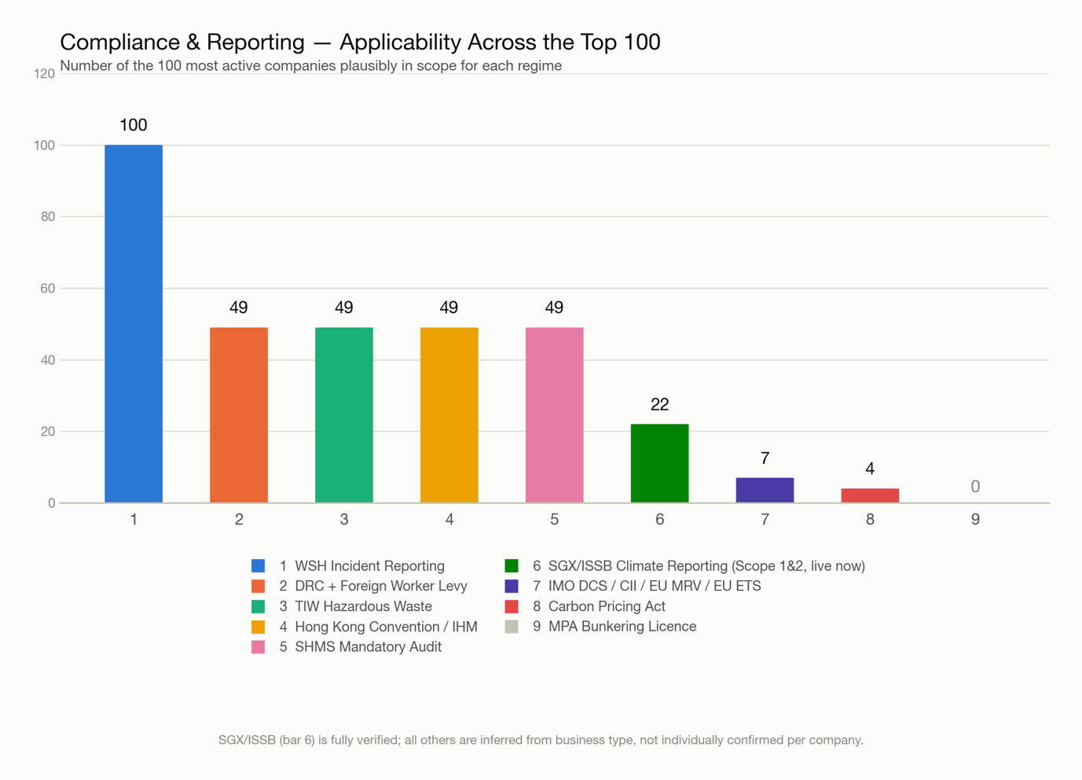
Compliance & Reporting — Applicability Across the Top 100
# | Paper | What it actually is (plain language) | How the data gets collected today
1 | WSH Incident Reporting | If someone gets badly hurt (or worse) at work, or something dangerous almost happens, the company must tell Singapore's Ministry of Manpower within a set number of days. | A supervisor writes up what happened, takes photos, and collects witness statements; someone then decides if it's serious enough to report to MOM. Today this is mostly paper and email, retyped into MOM's online form.
2 | DRC + Foreign Worker Levy | Singapore limits how many foreign (migrant) workers a company can hire relative to its local staff, and charges a monthly fee ("levy") for every foreign worker. | HR needs a live count of local vs. foreign staff, each worker's skill grade, and their safety-certificate expiry dates — usually tracked in a spreadsheet and checked by hand before every new hire.
3 | TIW Hazardous Waste | Chemical, oily, or otherwise hazardous waste from repair work (used solvents, paint sludge, contaminated oil) must go to a licensed collector, with proof of where it ended up. | Someone logs what waste was produced, how much, when it was picked up, and by which licensed company — usually on paper waste dockets that get filed away rather than tracked digitally.
4 | Hong Kong Convention / IHM | Every ship carries an official list ("inventory") of the hazardous materials on board, and any repair work that adds or removes something on that list must update that record. | The repair yard has to note what material it touched, get the supplier's paperwork proving it's compliant, and pass that back to update the ship's file — today this mostly lives in supplier PDFs and job cards, not a shared system.
5 | SHMS Mandatory Audit | Bigger companies (200+ employees) must prove, once a year, via an independent auditor, that they have a real system for preventing accidents — not just reporting them after the fact. | The company gathers everything — risk assessments, training records, inspection reports, past incidents, corrective actions — and shows the auditor it's all current and connected. Today it's usually scattered across folders and spreadsheets.
6 | SGX/ISSB Climate Reporting | Companies listed on the Singapore stock exchange must publish how much carbon they emit and how climate change affects their business, following an international disclosure standard. | Someone adds up fuel and electricity use across every site, converts it into carbon emissions using official formulas, and writes it up — today pieced together from utility bills and fuel logs, usually with no dedicated system.
7 | IMO DCS / CII / EU MRV / EU ETS | Four linked rules for ships: how much fuel it burned, how carbon-efficient it was, and — for European voyages — how much the company must pay for its emissions. | Data comes from daily "noon reports" each ship sends in, fuel-delivery receipts, and voyage/port records — today typically collected by emailing spreadsheets back and forth between the ship and head office.
8 | Carbon Pricing Act | Singapore's carbon tax on large industrial facilities that emit a lot of greenhouse gas — it only applies to genuinely big emitters, like a very large fabrication yard. | The facility meters its fuel use, calculates emissions using approved formulas, and gets an independent party to verify the numbers before submitting the report and paying the tax.
9 | MPA Bunkering Licence | A special licence needed to supply fuel ("bunkers") to ships in the Port of Singapore, with strict rules on how the fuel quantity is measured and documented. | Every fuel delivery needs a signed delivery note, meter readings, and quality-test paperwork, all reconciled before being reported to the port authority. Not relevant to this membership — no company in the Top 100 was found doing this.

Bar 6 (SGX/ISSB) is fully verified against each company's actual listed status. All other bars are inferred from business type (shipyard / MRO / equipment seller / etc.), not individually confirmed per company — see `outputs/asmi_compliance_reporting_research.md` §5 for what a verification pass would need to check.

6. ASMI Members — Software Landscape, Problem Frequency & Digital Presence Gap
Prepared 17 September 2026, for slide/presentation use. Sources: `software_research.md` and `evidence_base.md` (a 29-company deep-dive research pass, separate from the 300-company pain/investment pipeline) and `asmi_member_activity_full.csv` / `asmi_top100_most_active_companies.csv` (the 300-company website/activity check).

1. Software & Tools Landscape — what's actually in use
Headline finding: across all 29 companies researched in depth, no named commercial ERP was verifiable for any member's marine entity (no confirmed SAP, Oracle, Dynamics, IFS, Infor or NetSuite deployment). What is documented clusters into a small number of repeating tool categories — each company has its own product, not a shared one.
Tool category | Companies using it | # cos
Condition monitoring / predictive maintenance | Seatrium, ST Engineering Marine, DESMI, Tru-Marine, Everllence, Junma | 6
Digital twins | Seatrium, ST Engineering Marine, Jurong Port, PaxOcean, TCOMS | 5
In-house / proprietary platforms (built, not bought) | Synergy (ShipPalm, OceanEye, Ahoy app), ST Engineering (AGIL Vision), Beng Hui (WMS + eStore), Junma | 4
Simulation & alt-fuel crew training tech | Wärtsilä, TCOMS, Synergy (Seably), Schottel | 4
5G connectivity | Seatrium, ST Engineering Marine | 2
AR (augmented reality) remote inspection/service | Seatrium, Schottel | 2
GIS-based operations platform | Jurong Port (Esri) | 1
ERP (discussed as a need; never confirmed as deployed) | Seatrium, ST Engineering, DESMI, Synergy, Goltens | 0 confirmed / 5 aspirational

Do any two companies share the same tool?
Most probably yes, but no public evidence. Zero named commercial software product is shared by name across two or more companies — every company that has condition-monitoring or a digital twin built or bought its own. The two genuine points of overlap are not tools at all:
- A*STAR (Singapore's national research agency) is the enabling R&D partner behind three unrelated companies' AI projects — Seatrium's LLM/design work, Mencast's AI-assisted propeller design, and Tru-Marine's TruCare predictive-maintenance product. A shared institution, not a shared platform.
- EnterpriseSG / EDB grant funding recurs as the funding mechanism behind Seatrium's digitalisation programme and PaxOcean's R&D centre.
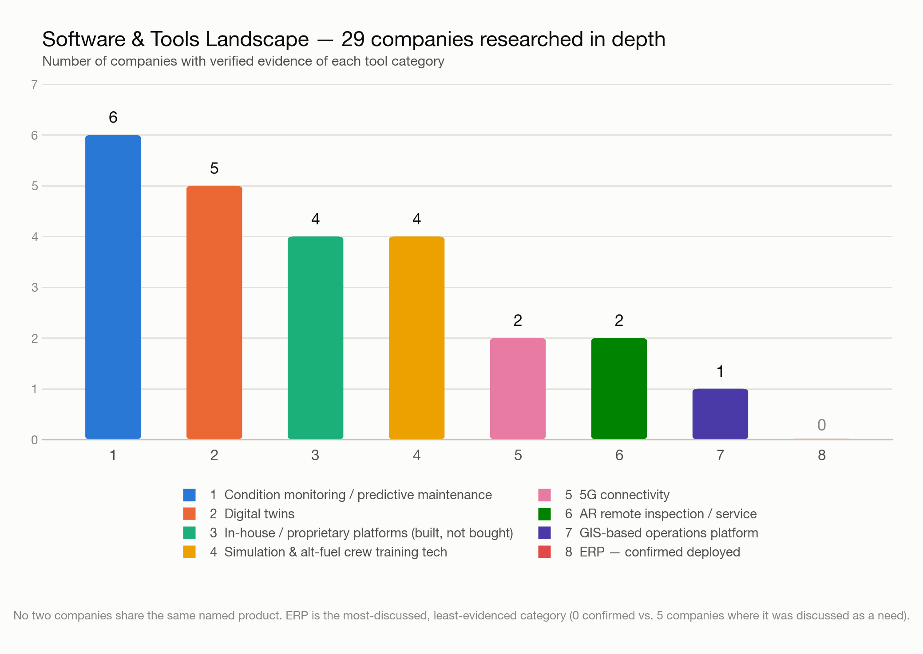

2. Most Frequent Problems — across the 29 researched companies. Evidence the company publishes itself
Companies with more than one stated problem are counted in every category they touch, so the column does not sum to 29.
# | Problem category | # companies | What this problem actually means
1 | No public evidence found | 12 | Not a "problem" — a research-coverage gap. These companies (mostly private SMEs) simply publish nothing about their finances or operational difficulties, so nothing could be verified either way.
2 | Margin pressure / cost base | 7 | Profitability is shrinking — falling gross margins, rising costs, or outright losses — usually from a mix of softer customer demand, higher labour/material costs, and legacy low-margin contracts. Companies respond with cost-cutting, divestment of weak business lines, or restructuring.
3 | Digitalisation / fragmented systems | 6 | The company's internal systems are disconnected, manual, or duplicated across sites/entities (e.g. three separate ERPs after a merger, or phone calls between yards instead of shared data). This shows up as a stated need to digitise or unify systems, not as complaints about a specific tool.
4 | Decarbonisation / regulatory burden | 6 | Customers and regulators (e.g. MPA's 2030 zero-emission harbour-craft mandate) are forcing investment in alternative fuels, electrification, or emissions reporting, before the economics or technology are fully proven — a compliance-driven cost, not a self-identified complaint.
5 | Manpower shortage / productivity / labour cost | 5 | Not enough skilled workers are available, or the workforce that exists is spending time on slow, manual tasks (e.g. 12-hour manual cargo unloading, or phoning between yards to coordinate work) that could be automated.
6 | Workforce training / knowledge | 5 | Existing staff lack the skills the business now needs — most often for new fuel types, new equipment, or new digital tools — requiring dedicated training centres, simulators, or partnerships with training institutes.
7 | Project delays / execution risk | 4 | Projects or shipments run later than planned — due to supply-chain logistics, subcontractor coordination, weather, or capacity constraints — leading to penalty payments, lost revenue, or damaged customer relationships.
8 | Other (cyclical/diversification pressure) | 1 | The company's core business is tied to a boom-bust cycle (here, oil & gas), so it is diversifying into adjacent markets to reduce that dependency — an inferred pressure, not a stated complaint.

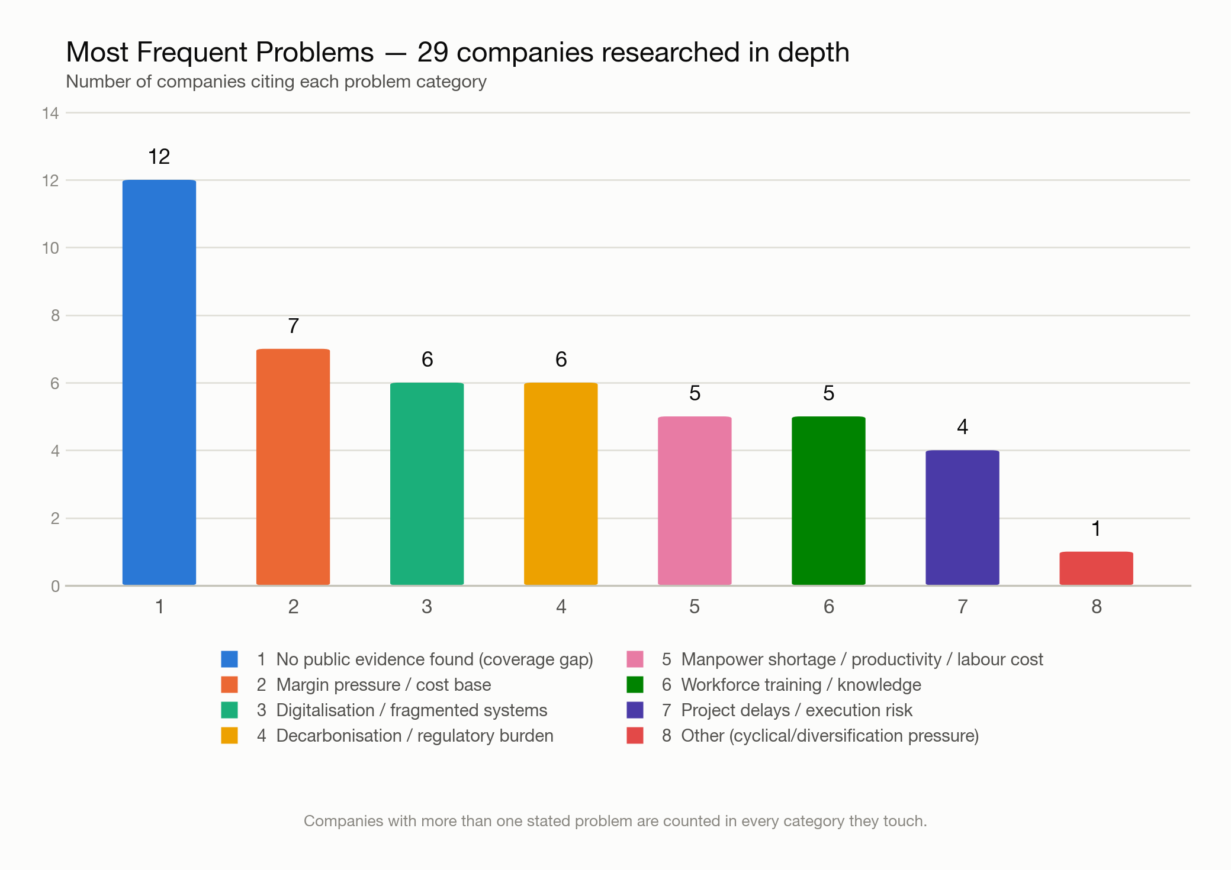

3. Digital Presence Gap — website & customer-interaction check (all 300 members)
This section is from the separate, full-population (300-company) website/activity check — a different and larger sample than the 29-company deep dive above.
Metric | Count | % of 300
No website at all, or only a third-party directory listing | 15 | 5.0%
Has a website, but confirmed static-only (no news, blog, or interactive/customer-facing section) | 96 | 32%
Total: no website or static-only ("no customer interaction") | 110 | 36.7%
Website exists but was unreachable/blocked when checked (broken cert, DNS failure, timeout — static-or-not unknown) | 31 | 10.7%
Combined: no website, static-only, or unreachable | 143 | 47.7%

Overlap with the Top 100 Most Active Companies
Despite having no website or only a static one, a small number of these companies still rank in the top 100 most active companies overall — because the activity score also weighs ASMI news-feed presence, LinkedIn presence, SGX-listed status, and research-evidence richness, not the website alone.
Overlap | Count | % of that group (110 / 33) | % of the Top 100 active list
No-website-or-static companies (110) that are still in the Top 100 | 7 | 6.4% | 7.0%
Unreachable-website companies (33) that are still in the Top 100 | 0 | 0.0% | 0.0%
Combined (143) that are still in the Top 100 | 8 | 5.6% | 8.0%

The 7 static/no-website companies that made the Top 100 anyway: Penguin International Ltd, Mooreast Asia Pte Ltd, Nordic Flow Control Pte Ltd, Mencast Marine Pte Ltd, Rolls-Royce Solutions Asia Pte. Ltd, Stewart Engineering Works (S) Pte Ltd, HIRO Engineering Pte Ltd — all SGX-listed (or SGX-listed-parent) companies or companies with rich research evidence, whose own website is static or absent.
.Reading this for a slide: roughly 1 in 3 ASMI members (37%) have no meaningful digital storefront at all — no live news, no customer-facing interaction, sometimes no website whatsoever — and this is true even for a handful of companies that are otherwise demonstrably active in the industry (SGX filings, press coverage, ASMI's own news feed). The digital-presence gap is not just a "small/inactive company" phenomenon.
