PandaBear Final Architecture Blueprints
Zero Data Leakage Organizational Memory
1. The Core Value Proposition
"We separate intelligence from trust."
Enterprise Al is currently broken: to get smart answers, companies must send their most sensitive data to external LLMs. Our architecture flips this. We provide a Sovereign Local Execution Layer. The remote LLM
provides high-level reasoning and planning, but all credentials, raw data, permissions, and execution stay strictly inside the customer's environment. The external model receives only sanitized intents and minimal result codes.

Twelve-Slide Presentation Content
Visual style guide
Minimalist black-and-white foundation. Use high contrast, clean enterprise typography, and subtle line-art panda illustrations such as a panda holding a glowing node or guarding a vault. The style should soften the technical architecture without losing seriousness.

Slide 1: Cover
Visual | Minimalist black-and-white line drawing of a panda face with eyes as glowing neural nodes.
Headline | PandaBear
Subtitle / Text | Solving Knowledge Evaporation with Zero-Leak Organizational Memory.
Speaker notes | Welcome. Today we are solving the biggest paradox in enterprise AI: how do we give employees the AI they demand, without giving away the company's most sensitive data?

Slide 2: The Problem - Knowledge Evaporation
Visual | Fading, ghost-like footprint walking away from a server rack.
Headline | Knowledge Evaporation Destroys Competitive Advantage.
Bullet points | • Employees build effective, context-heavy AI workflows daily.  • When they leave, that institutional reasoning walks out the door.  • Prompts disappear, decisions are forgotten, and solved problems are re-solved.
Speaker notes | Your company's most valuable asset is not just its data; it is the reasoning applied to that data. Right now, that reasoning evaporates every time an employee logs off or quits.

Slide 3: The Enterprise Contradiction
Visual | Split screen: employee with a rocket (AI) vs. IT/Legal with a heavy shield (Security).
Headline | The Enterprise Contradiction.
Bullet points | • Employees demand AI productivity to save time and focus on deep work.  • IT & Legal block it due to data leakage, Shadow AI, and audit risks.  • Result: 75% of workers use AI, but 90% of enterprise pilots fail to show P&L impact because they are blocked or siloed.  - Another Problem is the Fragmented Knowledge. The Organizations are living in the ecosystem of the static and monolithic tools, ERM, CRM, systems that require custom management to get the overall picture
Speaker notes | Employees are using Shadow AI because it is useful. IT is blocking it because it is leaky. The enterprise is paralyzed. Company cannot send its data to remote models = Violation of Governance.

Slide 4: The Solution - Zero-Leak Architecture
Visual | Sovereign Patch visual: local fortress sending a tiny sealed envelope to server machine.
Headline | PandaBear’s Zero-Leak Sovereign Architecture.
Bullet points | • The Sovereign Patch deploys entirely inside the customer infrastructure.  • Sensitive data, credentials, and policies never leave the building.  • Only generic, reference-based intents are sent to remote models.  - All calculations and data management happens with the machine and data never reaches the internet  - The only communication is possible via security level that can produce just general queries and predefined status options
Speaker notes | PandaBear flips the model. We do not send your data to the AI. We bring the AI to your data. The remote model only sees sanitized references and status codes.

Slide 5: Absolute Ownership
Visual | Panda sitting protectively over a digital glowing ledger.
Headline | Absolute Ownership of Data and Insights.
Bullet points | • The enterprise retains 100% ownership of proprietary data.  • AI-derived insights and organizational memory belong to the company.  • Ironclad guarantee: nothing trains external models. Ever.
Speaker notes | With PandaBear, you are not just renting AI. You are building a proprietary asset. Your data, workflows, and AI insights remain entirely yours.

Slide 6: Governed Organizational Memory
Visual | Scattered puzzle pieces being assembled into a structured brain/tree.
Headline | From Isolated Prompts to Governed Memory.
Bullet points | • Local Model Captures how work actually gets done: decisions, approvals, and mistakes.  • Local Model Transforms fragmented chats into shareable, permission-aware Knowledge Objects.  • Survives employee turnover; the company gets smarter every day.
Speaker notes | We do not just answer questions. We capture the reasoning and turn isolated prompts into governed memory that survives turnover and compounds in value.

Slide 7: Justifying Enterprise Premiums
Visual | Minimalist scale: Commodity AI Access vs. Ironclad Compliance & ROI.
Headline | Selling Governance, Not Just Compute.
Bullet points | • We do not compete on commodity model access.  • Premium justified by SOC2, GDPR, HIPAA-ready audit trails.  • Usage insights show measurable ROI and time saved.  • Shadow AI elimination brings rogue workflows under control.
Speaker notes | We are not selling API wrappers. We are selling risk mitigation, compliance, and measurable operational ROI.

Slide 8: Go-To-Market Strategy
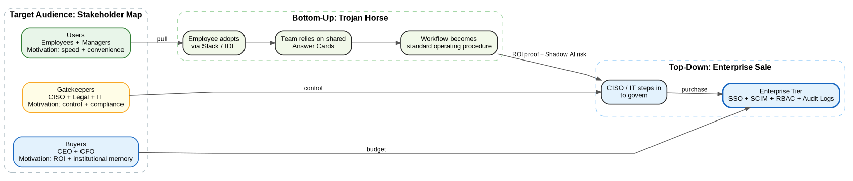
Visual | Castle Strategy diagram from section 2.
Headline | The Trojan Horse: Bottom-Up Adoption, Top-Down Scale.
Bullet points | • Bottom-up: employees adopt instantly via Slack/IDE.  • Top-down: usage produces evidence for SSO, SCIM, RBAC, and audit controls.  • Result: inside pressure from employees, outside pressure from executives.
Speaker notes | Employees adopt it because it makes their day easier. Once teams rely on it, IT and Legal buy the Enterprise tier to govern it and capture ROI.

Slide 9: The Finance Workflow Case
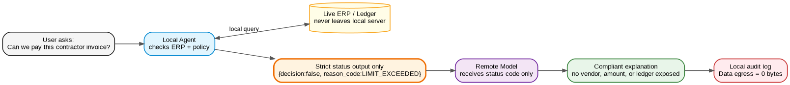
Visual | Raw invoice -> Local Agent -> status code -> Remote Model -> compliant insight.
Headline | Case Study: The Secure Finance Workflow.
Bullet points | • User asks: “Can we pay this contractor invoice?”  • Local Agent checks ERP, evaluates policy, and returns only {decision:false, reason_code:LIMIT_EXCEEDED}.  • Remote Model receives the status code and generates compliant reasoning.  • Result: zero ledger data exposed.
Speaker notes | The remote model never sees the vendor, amount, or ledger. It receives a status code and still provides compliant decision support.

Slide 10: The 4-Month Roadmap
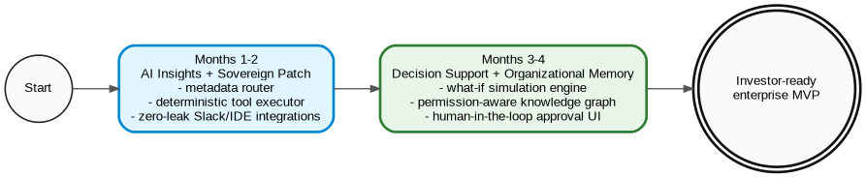
Visual | Clean horizontal timeline with two major milestones.
Headline | Grounded Execution: 4-Month Roadmap.
Bullet points | • Months 1-2: AI Insights & Sovereign Patch.  • Deliver local metadata router, deterministic tool executor, and zero-leak Slack/IDE integrations.  • Months 3-4: Decision Support & Organizational Memory.  • Unlock what-if simulation engine, permission-aware knowledge graph, and human-in-the-loop approval UI.
Speaker notes | Months 1 and 2 deliver the secure zero-leak insights engine. Months 3 and 4 unlock decision support and compounding organizational memory.

Slide 11: Capital Allocation
Visual | Minimalist block diagram showing Engineering vs. GTM.
Headline | Capital Allocation: Schema, Observability, and Scale.
Bullet points | • Core Engineering (50%): metadata schema, deterministic sandbox, local routing optimization.  • Observability & Compliance (20%): immutable audit logging, telemetry, governance dashboards.  • Go-To-Market (30%): bottom-up acquisition, enterprise sales, customer success.
Speaker notes | Our allocation reflects the thesis: invest in schema and observability for ironclad compliance while funding bottom-up GTM.

Slide 12: The Ask
Visual | PandaBear logo, clean, bold, centered, black and white.
Headline | Build the Trusted Institutional Memory Layer.
Subtitle / Text | Invest in PandaBear to make enterprise AI scalable, secure, and profitable.
Speaker notes | The enterprise does not need another chatbot. They need a trusted institutional memory layer that makes AI scalable, secure, and profitable. Join us in building PandaBear.

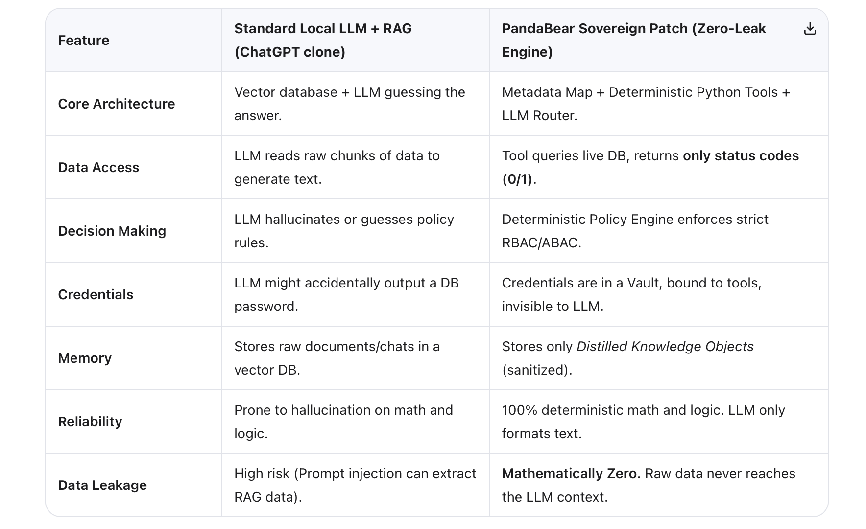

Architecture 1: Bootstrapping & Setup Pipeline (Step 1)
Goal: The company data is redistributed, the future system should be capable of querying it. The goal is to prepare the tools and metadata the local model will use for the AI insights.
┌─────────────────────────────────────────────────────────────────────────┐
│ PHASE 1: THE EPHEMERAL COMPILER (Runs in PandaBear's Secure Cloud) │
├─────────────────────────────────────────────────────────────────────────┤
│ 1. Admin connects generic schemas (e.g., "Standard Postgres ERP"). │
│ 2. LOCAL MODEL . It writes generic Python │
│ blueprints for deterministic tools (e.g., check_stock.py). │
│ 3. LOCAL the initial Capability Map (metadata). │
│ 4. ZERO company data is sent. Only abstract schema structures are used. │
└─────────────────────────────────────────────────────────────────────────┘
↓ (Secure Transfer of Blueprints)
┌─────────────────────────────────────────────────────────────────────────┐
│ PHASE 2: THE LOCAL SANDBOX & NEGOTIATION (Runs on Customer Server) │
├─────────────────────────────────────────────────────────────────────────┤
│ 1. Docker Patch spins up. Admin accesses Local UI. │
│ 2. Local Small Model initiates chat: "What are your goals?" │
│ - Admin: "Monitor inventory costs, automate reorders under $500." │
│ - Admin: "Alert the branch manager if milk is low." │
│ 3. Local Model maps goals to the generic blueprints. │
│ 4. ENTER THE SANDBOX VOLUME: │
│ - Blueprints are compiled into executable Python tools. │
│ - Tools are tested against MOCK data to ensure they don't crash. │
│ - Tools are validated to ensure they ONLY output status codes (0/1). │
└─────────────────────────────────────────────────────────────────────────┘
↓
┌─────────────────────────────────────────────────────────────────────────┐
│ PHASE 3: CREDENTIAL BINDING & THE "0/1 RULE" ENFORCEMENT │
├─────────────────────────────────────────────────────────────────────────┤
│ 1. Admin inputs live credentials (DB passwords, API keys) via UI. │
│ 2. Credentials are encrypted and stored in the Local Vault. │
│ 3. Credentials are BOUND to specific tools (e.g., erp.inventory.read). │
│ 4. THE 0/1 RULE IS ENFORCED: The tool layer is hardcoded to NEVER │
│ return raw payloads. It only returns: │
│ { "status": "STOCK_LOW", "action_required": "DRAFT_REORDER" } │
└─────────────────────────────────────────────────────────────────────────┘
↓
┌─────────────────────────────────────────────────────────────────────────┐
│ PHASE 4: THE CONTEXT WIPE (The Security Guarantee) │
├─────────────────────────────────────────────────────────────────────────┤
│ 1. Admin confirms roles, policies, and alert thresholds via UI. │
│ 2. The system compiles the final Metadata Registry (SQLite/JSON). │
│ 3. 🔥 DESTROY EPHEMERAL CONTEXT: │
│ - The conversational setup chat is permanently deleted. │
│ - The raw schema dumps are deleted. │
│ - The Ephemeral Compiler server is destroyed. │
│ 4. WHAT REMAINS: Only the Metadata-over-Metadata (Capability Map), │
│ the Tool Registry, the Policy Registry, and the Encrypted Vault. │
└─────────────────────────────────────────────────────────────────────────┘
↓
(( SYSTEM READY FOR RUNTIME ))

Customer Setup Flow (from Customer Perspective)
FROM THE TECHNICAL SIDE

Figure 1. Bootstrapping flow from ephemeral compiler to local sandbox, credential binding, and final context wipe.

Key Technical Details of the Setup Flow
1. The Sandbox Volume: all code generation happens in an isolated, ephemeral Docker volume. The local model writes Python scripts, tests them against mock data to ensure they accurately extract flexible columns rather than hardcoded ones, and validates that they do not leak data.
2. The 0/1 Credential Rule: the layer that touches the Vault and the live database is strictly constrained. It processes raw data internally but only returns a boolean, enum, or status code, such as {"decision": false, "reason_code": "LIMIT_EXCEEDED"}. It never shares credentials how to connect, it can only configure connect for the tools
3. Context Wipe: once tools, capabilities, and policies are compiled into the metadata registry, the conversational context, raw schema dumps, and setup prompts are permanently deleted. Only the Metadata-over-Metadata navigation map remains.
TOOL CREATION
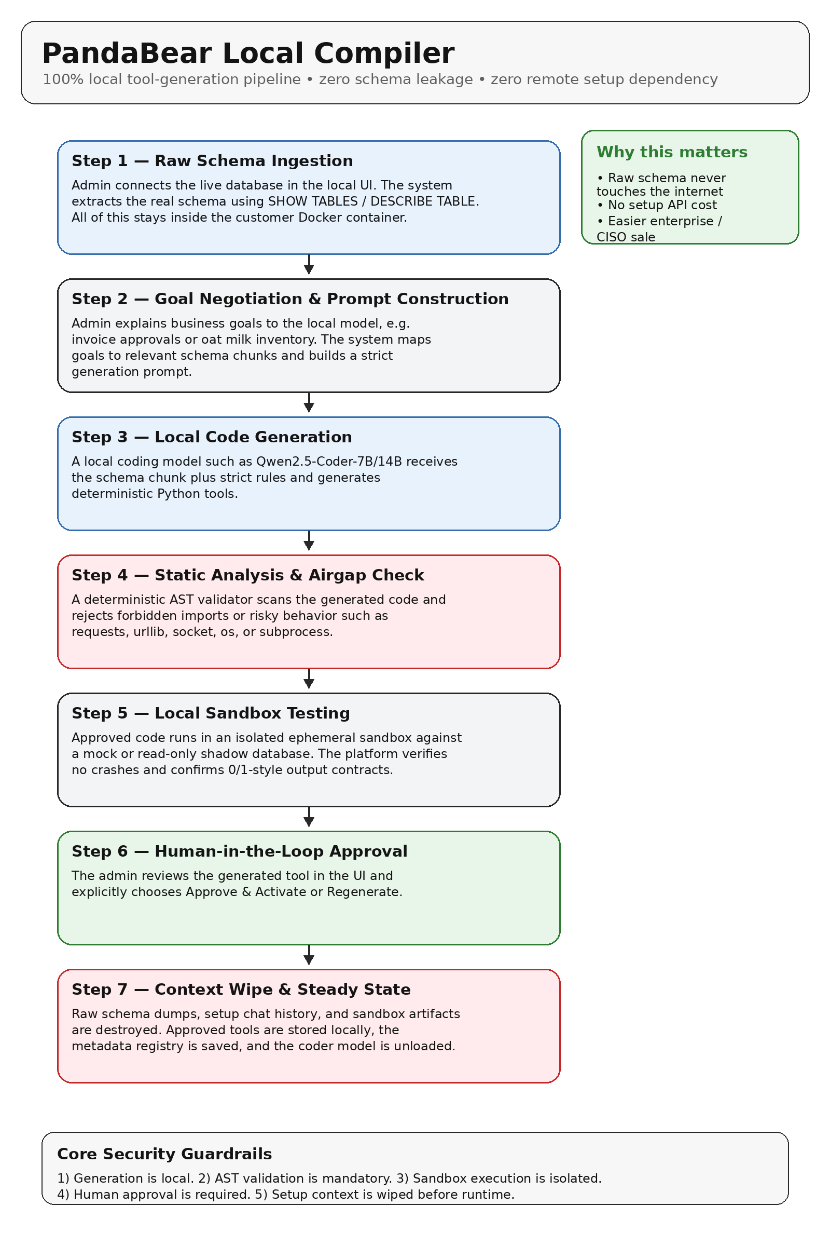

Why this tools GENERATION?

Local Code Generation
A coding-optimized local model such as Qwen2.5-Coder-7B or 14B receives the schema chunk plus strict generation rules and outputs a deterministic Python tool.

Static Analysis & the “Airgap” Code Check
Before any generated code is allowed to run, a deterministic validator scans the abstract syntax tree (AST) to detect forbidden imports or risky patterns. If it finds anything such as requests, urllib, socket, os, or subprocess, the tool is rejected and regenerated.

Local Sandbox Testing
Approved code is executed in an isolated, ephemeral sub-container against a mock database or read-only shadow database. PandaBear verifies that the tool runs successfully and returns only the allowed contract output.

Human-in-the-Loop Approval
The admin reviews the generated tool inside the UI and explicitly chooses Approve & Activate or Regenerate.
NO need to duplicate DATA!!!! , the actual data of the company is never embedded or transformed to something else/ THE tools that are created duruign archtiecutre 1, will enable local model in all next lifecycle to retrieve data. THE LOCAL MODEL DOES NOT HAVE ACCESS TO THE CREDENTIALS. It will be stored under another layer

Architecture 2: Server Runtime Engine (Steady State)
Goal: Run live monitoring, Q&A, alerts, and policy enforcement as a deterministic metadata-driven operating system. The local small model routes and formats; it does not become a general chatbot.
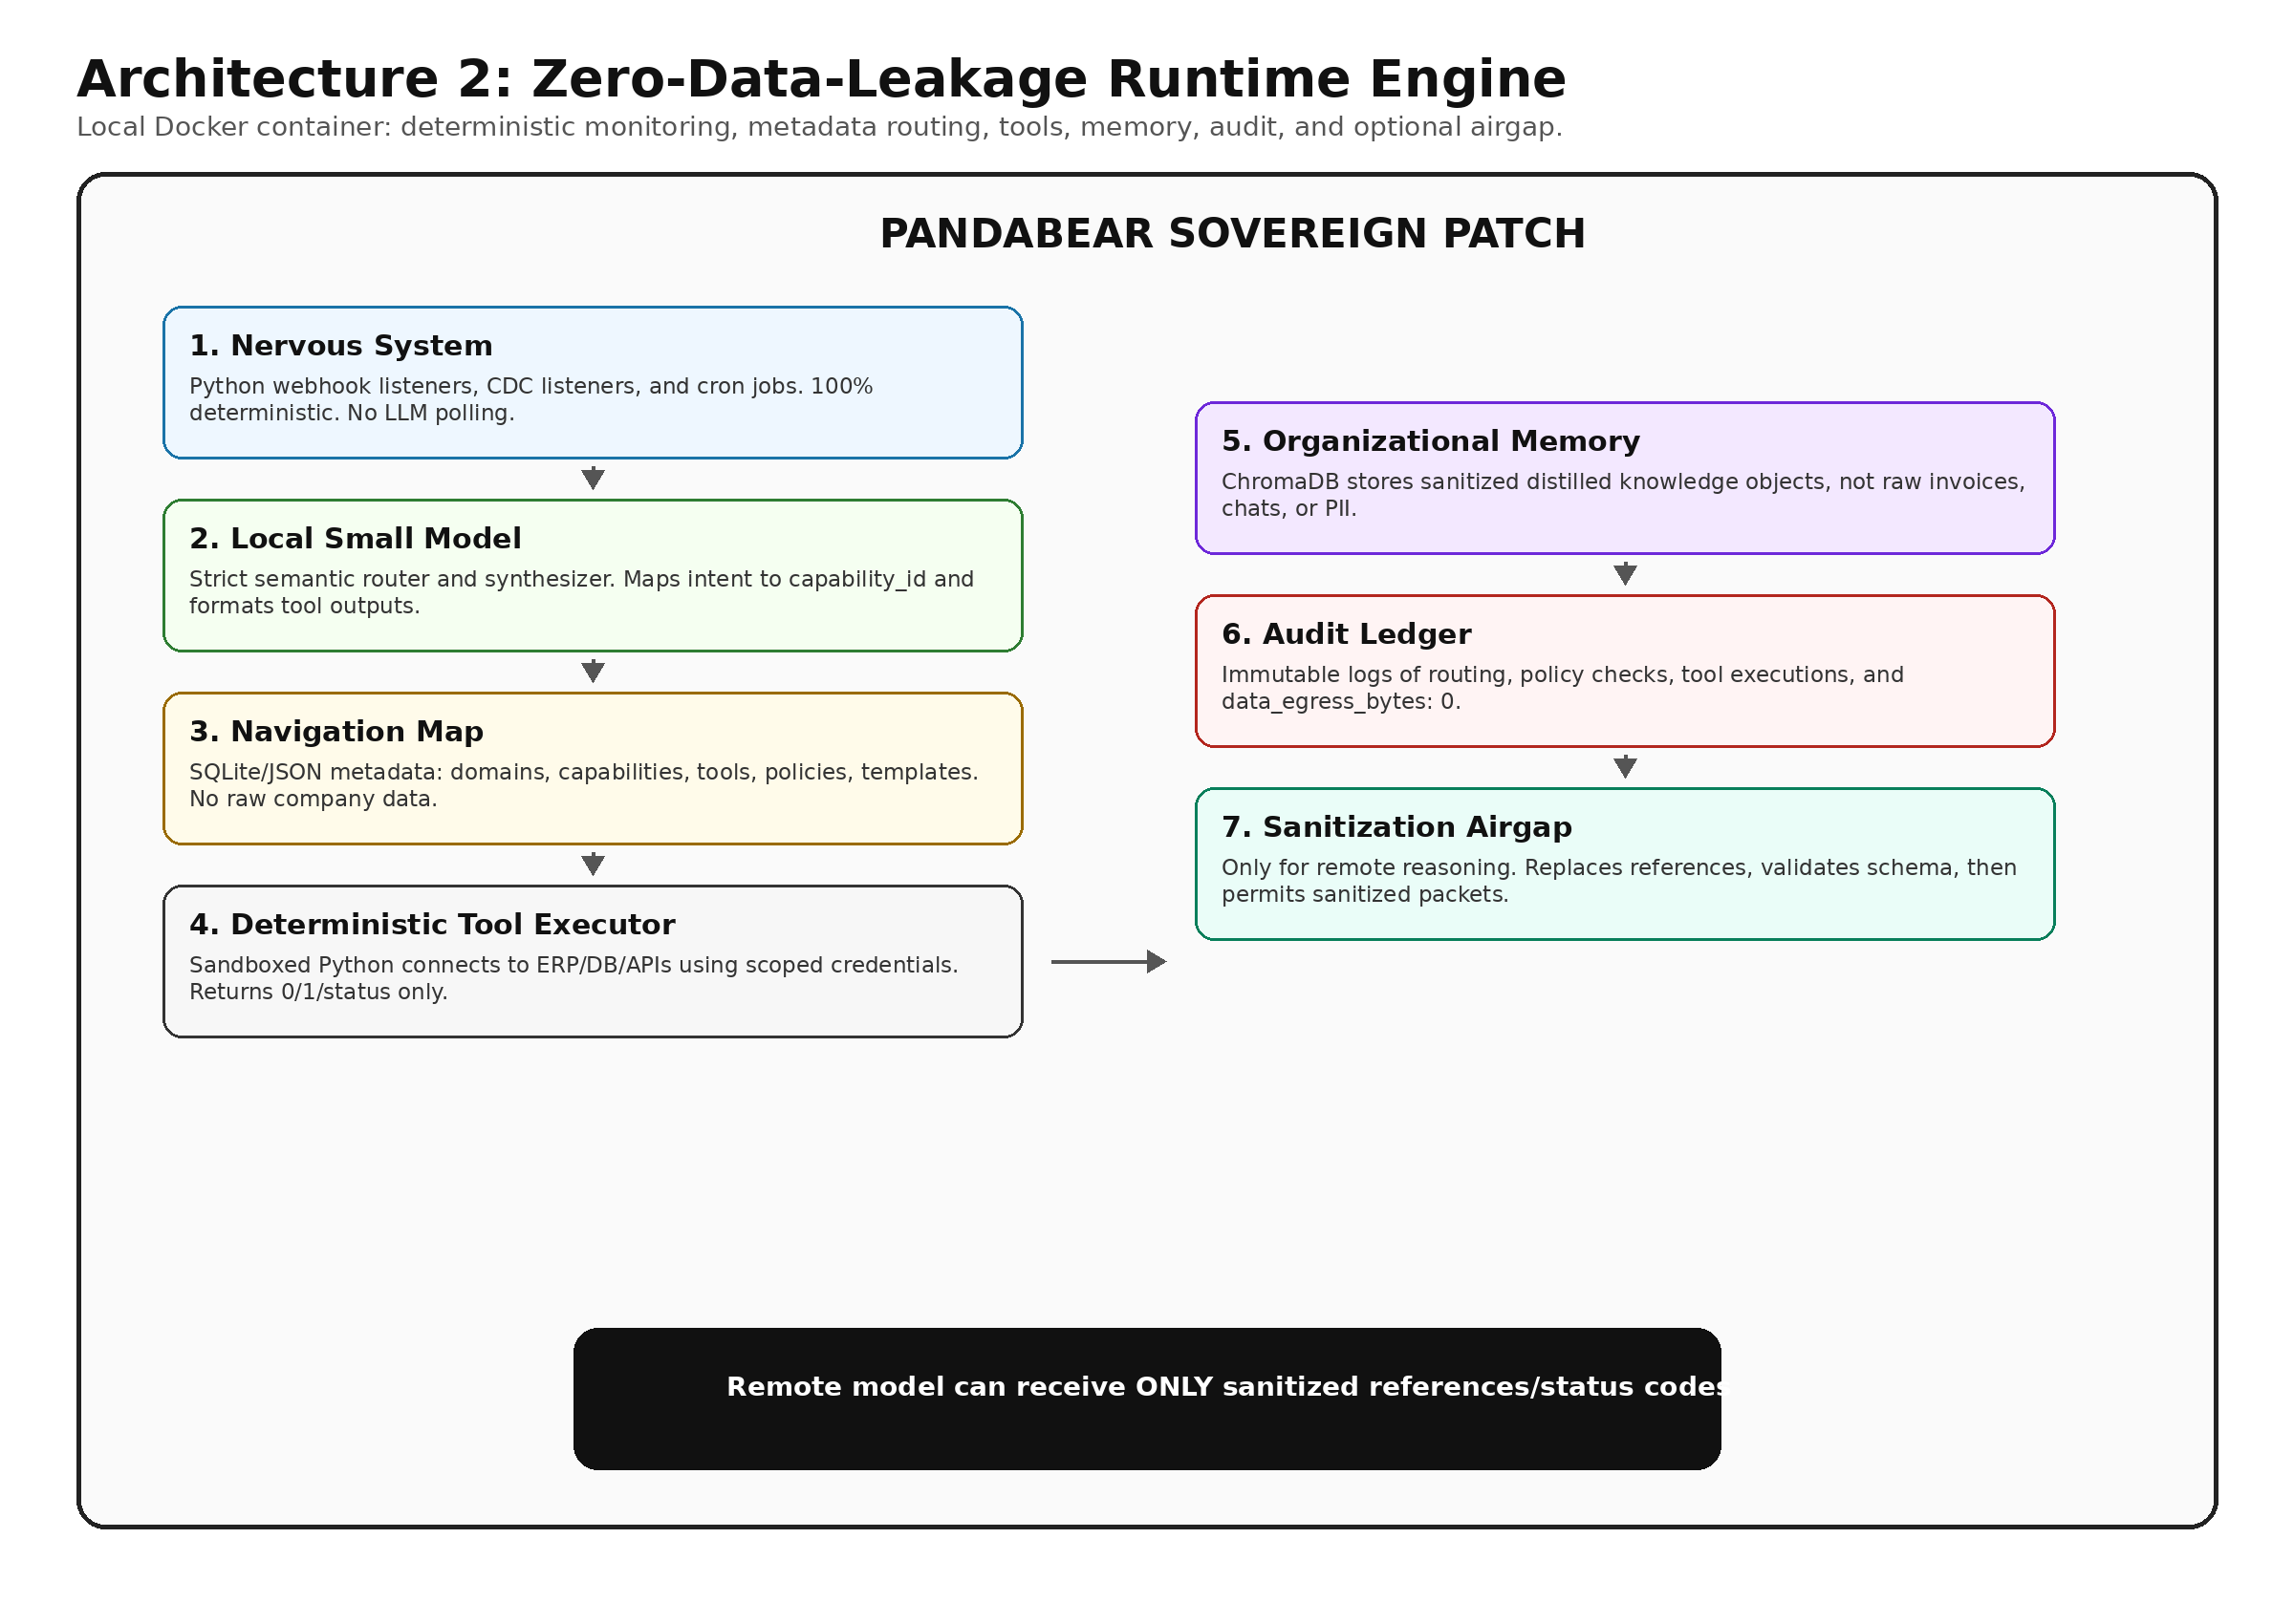

Runtime Components
Component | Function and Security Rule
1. The Nervous System - Monitoring & Alerts | Python webhook listeners, CDC listeners, and cron jobs detect events. This layer is 100% deterministic and never uses an LLM for polling.
2. The Brain - Local Small Model | A Llama/Qwen-class local model acts as semantic router and insight synthesizer. It reads metadata, maps intent, extracts entity mentions, and formats status outputs.
3. The Navigation Map - Metadata-over-Metadata | SQLite/JSON stores domain catalog, capability catalog, tool registry, policy registry, credential scopes, and response templates. It contains no raw company data.
4. The Muscle - Deterministic Tool Executor | Sandboxed Python executes pre-approved tools, connects to live infrastructure with scoped credentials, performs calculations locally, and returns only status codes/enums/booleans.
5. The Memory - Organizational Memory | ChromaDB stores distilled knowledge objects: sanitized summaries of decisions, workflow patterns, and policy exceptions. It never stores raw invoices, chat logs, or PII.
6. The Ledger - Audit Logger & Telemetry | Every routing decision, policy check, and tool execution is logged. Audit events include data_egress_bytes: 0.
7. The Airgap - Sanitization Gateway | Only used when remote reasoning is needed. It replaces references with synthetic placeholders, validates schemas, and blocks unsafe payloads.

Part 1 — Monitoring & Alerts Layer: The Nervous System

The customer question
What checks messengers, databases, and ERP/CRM/ARM systems for alert triggers: Python tools or the LLM?

The answer
The monitoring layer is 100% deterministic Python tools and event queues. The LLM — local or remote — should never continuously poll databases or read Slack channels. Continuous polling by an LLM would waste compute, increase cost, and create unnecessary security risk. Monitoring must be deterministic, event-driven, and local.
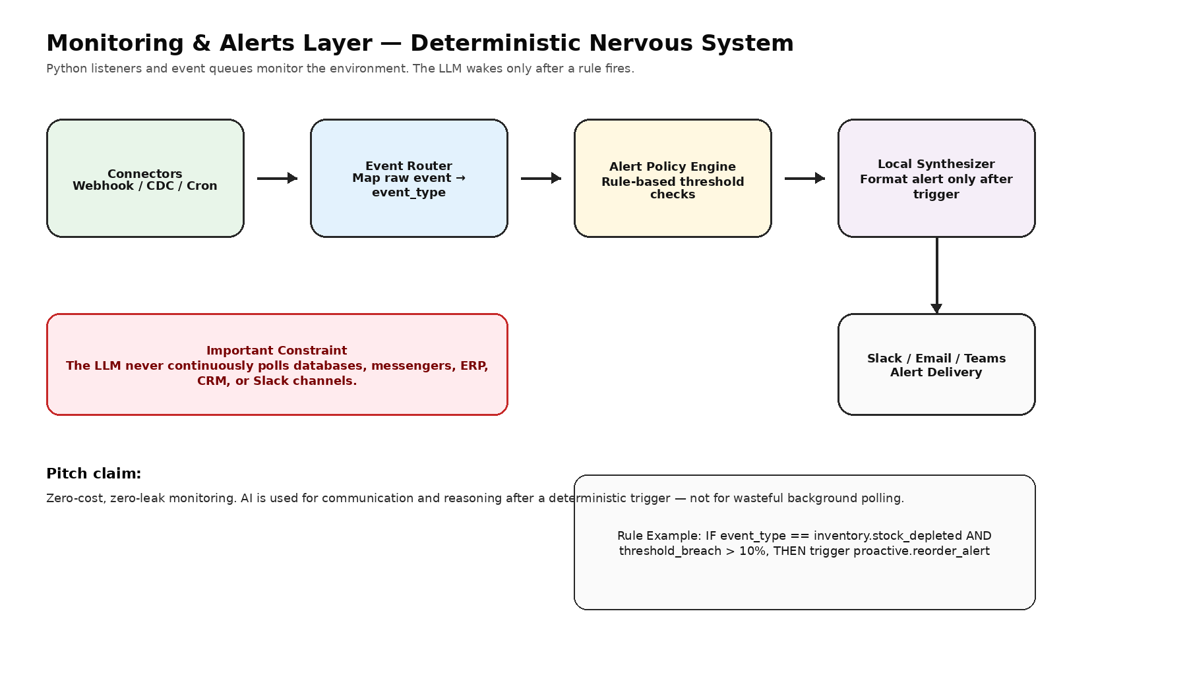
Figure 2. Monitoring is event-driven and deterministic; the local model wakes only after a policy rule triggers.

Architecture of the Monitoring Layer
Layer | Responsibility | Examples / Contract
Connectors: Python Listeners | Receive events from internal and external systems without involving the LLM. | FastAPI webhooks for Slack/GitHub/Jira; CDC listeners via Debezium or DB polling; cron jobs for scheduled checks.
Event Router: Deterministic | Normalize incoming events into internal event types. | Maps raw input to event_type such as inventory.stock_depleted or finance.invoice_overdue.
Alert Policy Engine: Rule-Based | Evaluate events against the Alert Registry and decide whether a capability should be triggered. | IF event_type == inventory.stock_depleted AND threshold_breach > 10%, THEN trigger proactive.reorder_alert.
Local Synthesizer: Small LLM | Wake only after a deterministic trigger and format the alert for the right user/channel. | Receives sanitized structured event data and outputs a concise Slack/Email/Teams message.
Investor-ready line
Our monitoring layer does not burn API tokens reading your database. It uses deterministic, zero-cost Python listeners. AI wakes only when an alert needs to be formatted and delivered.

Core Differentiator: Why This Is Not ChatGPT
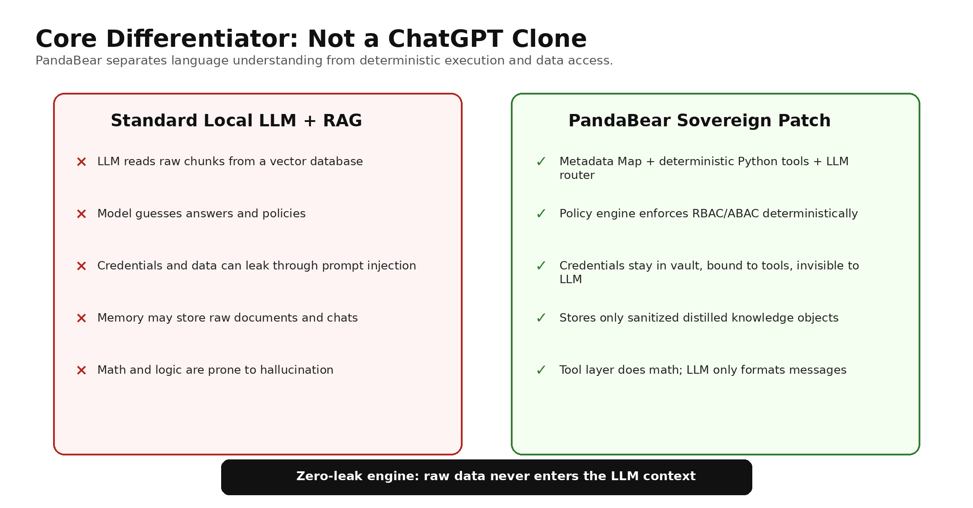
Figure 3. PandaBear replaces raw-data RAG with metadata routing and deterministic execution.

Diagram 2: Use Cases
What this covers: how communication happens during daily operations, what happens inside the system, and the exact list of entities the local model routes and matches against.
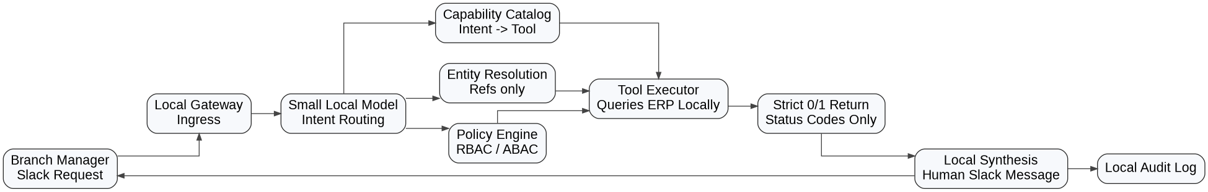
Figure 2. Runtime request flow from Slack to local tools and back to the user.

Runtime Use Case Flow
Scenario: A Branch Manager asks in Slack: “Can we reorder oat milk for branch 2?”
1. Ingress: Slack webhook hits the Local Gateway.
2. Local Routing: the small model reads the Capability Catalog metadata. It matches the intent to inventory.reorder.check and extracts entities: product = oat milk, location = branch 2.
3. Entity Resolution: the system maps “oat milk” to a local reference ref:prod_992 and “branch 2” to ref:br_02.
4. Policy Check: the Policy Engine checks the Policy Registry. The Branch Manager is allowed to check, but creating a draft requires status: APPROVED.
5. Tool Execution: the Tool Executor runs check_reorder_eligibility.py, queries the live ERP, and calculates the math locally.
6. The 0/1 Return: the tool returns strictly to the local model: {"status": "STOCK_LOW", "action_required": "DRAFT_REORDER", "approval_needed": false}. Zero raw data is returned.
7. Local Synthesis: the local small model formats the status code into a human-readable Slack message: “Branch 2 oat milk is low. I have drafted a reorder for you. [Approve] [Dismiss].”
8. Audit: the event is logged locally.

Diagram 3: The Zero-Data-Leakage & Sanitization Protocol
What this shows: the justification of zero data leakage, including how communication to the external LLM happens, how the strict “Declare, Don’t Guess” criteria are enforced, and how references or predefined statuses are used instead of raw data.
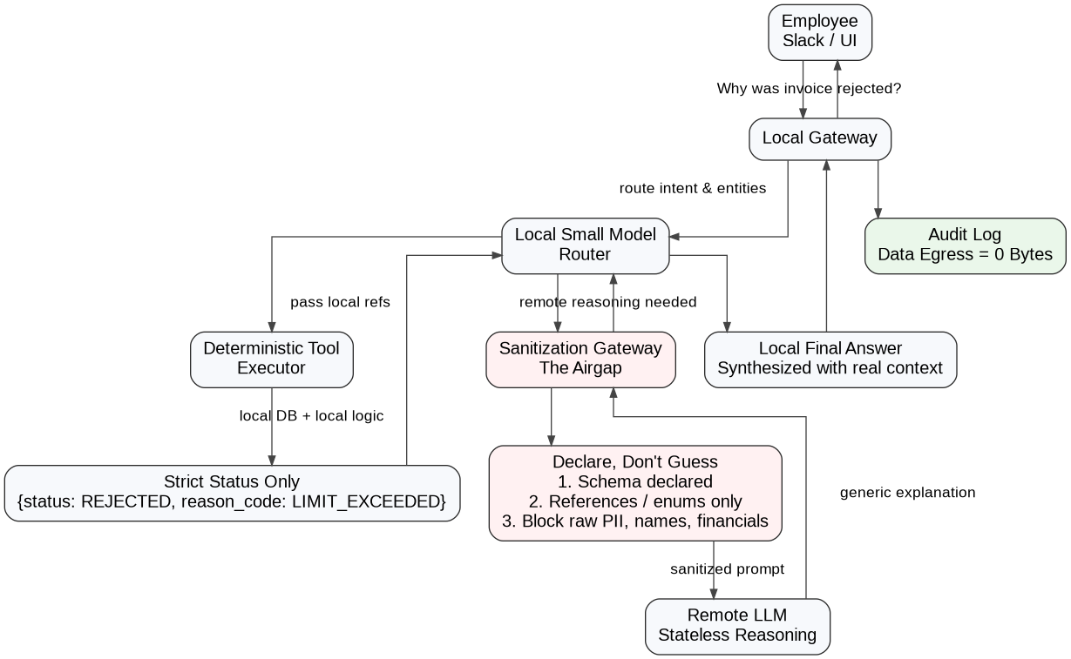
Figure 3. Sanitization airgap between local execution and remote reasoning

Part 2 — Prompt Engineering for the Local Model: The Strict Router
The local small model must not behave like a general chatbot. It must behave like a strict, stateless API gateway. Its job is to route, extract, synthesize, and draft structured insights under narrow contracts. This prevents hallucination from becoming system behavior.
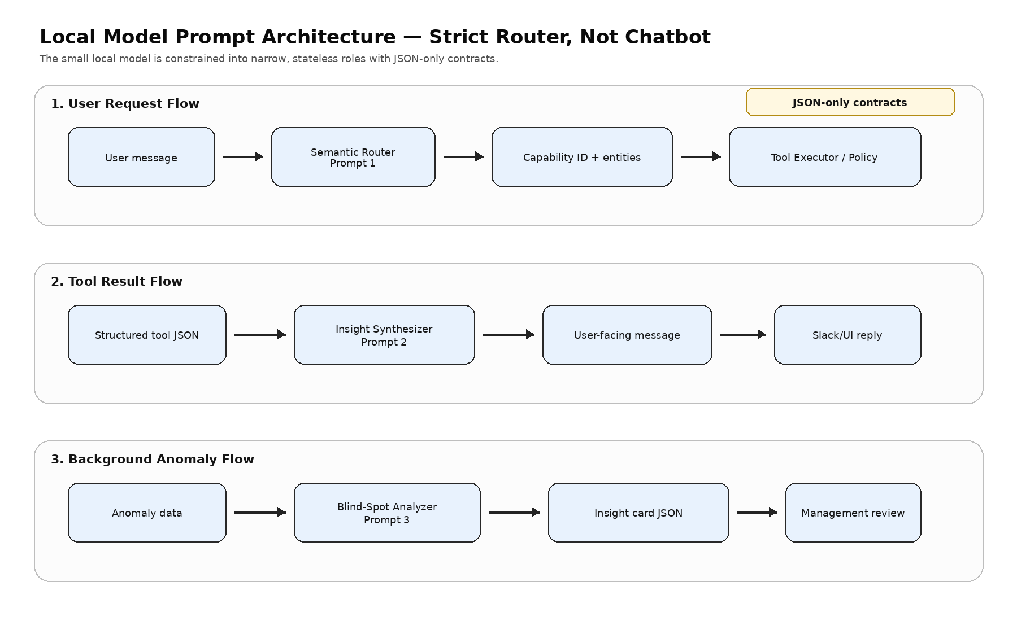
Figure 3. The local model is constrained into three narrow roles with JSON-only or template-controlled outputs.

Prompt 1 — Semantic Router & Entity Extractor
Used when a user sends a message. The goal is to map intent to the Metadata Capability Catalog and extract required entity mentions.
SYSTEM:
You are the Semantic Router for PandaBear, a secure enterprise AI agent.
Your ONLY job is to map the user's request to a specific capability_id from the provided Capability Catalog and extract required entity mentions.

STRICT RULES:
1. DO NOT answer the user's question.
2. DO NOT guess or hallucinate capabilities. If it doesn't match the catalog, return "UNKNOWN".
3. DO NOT attempt to access databases or execute tools yourself.
4. Extract entity mentions exactly as they appear in the text.
5. Output ONLY valid JSON. No markdown, no explanations.

CAPABILITY CATALOG:
{capabilities_json}

USER INPUT: "{user_message}"
ACTOR ROLE: "{user_role}"

OUTPUT JSON SCHEMA:
{
"capability_id": "string or UNKNOWN",
"confidence_score": 0.0 to 1.0,
"extracted_entities": {"entity_type": "mention"},
"requires_clarification": boolean,
"clarification_reason": "string or null"
}

Prompt 2 — Local Insight Synthesizer
Used after a deterministic tool executes and returns structured JSON. The goal is to transform dry tool output into a concise, human-readable insight.
SYSTEM:
You are the Insight Synthesizer for PandaBear. You will receive the structured output from a local deterministic tool.
Your job is to translate this technical output into a concise, professional, and actionable message for the user.

STRICT RULES:
1. Use ONLY the data provided in the Tool Output JSON. Do not invent facts, numbers, or names.
2. If the tool output indicates an error or denial, explain the policy reason neutrally.
3. Keep the tone professional, objective, and helpful.
4. Do not expose internal tool IDs, database names, or raw JSON in your final response.

TOOL OUTPUT:
{tool_output_json}

RESPONSE TEMPLATE GUIDELINES:
{template_guidelines}

Generate the final user-facing message:

Prompt 3 — Proactive Blind-Spot Analyzer
Used by the background monitoring layer after anomaly detection. The goal is to draft a management insight card while avoiding raw PII and specific sensitive values.
SYSTEM:
You are the Strategic Analyst for PandaBear. You are analyzing a localized operational anomaly detected by our monitoring system.
Your job is to draft a "Blind Spot Insight" card for the management team.

STRICT RULES:
1. Identify the core operational friction or risk based on the anomaly data.
2. Suggest a high-level, generic mitigation strategy.
3. Do not use raw PII or specific financial amounts; use the provided reference tags.
4. Output ONLY valid JSON.

ANOMALY DATA:
{anomaly_json}

OUTPUT JSON SCHEMA:
{
"insight_title": "string",
"risk_level": "low | medium | high",
"operational_blind_spot": "string",
"recommended_policy_adjustment": "string",
"requires_human_review": true
}

Part 1: Evolution Diagram - Current vs. Future Architecture
This diagram shows how PandaBear scales from a secure, read-only insight engine into an autonomous, decision-making operating system.
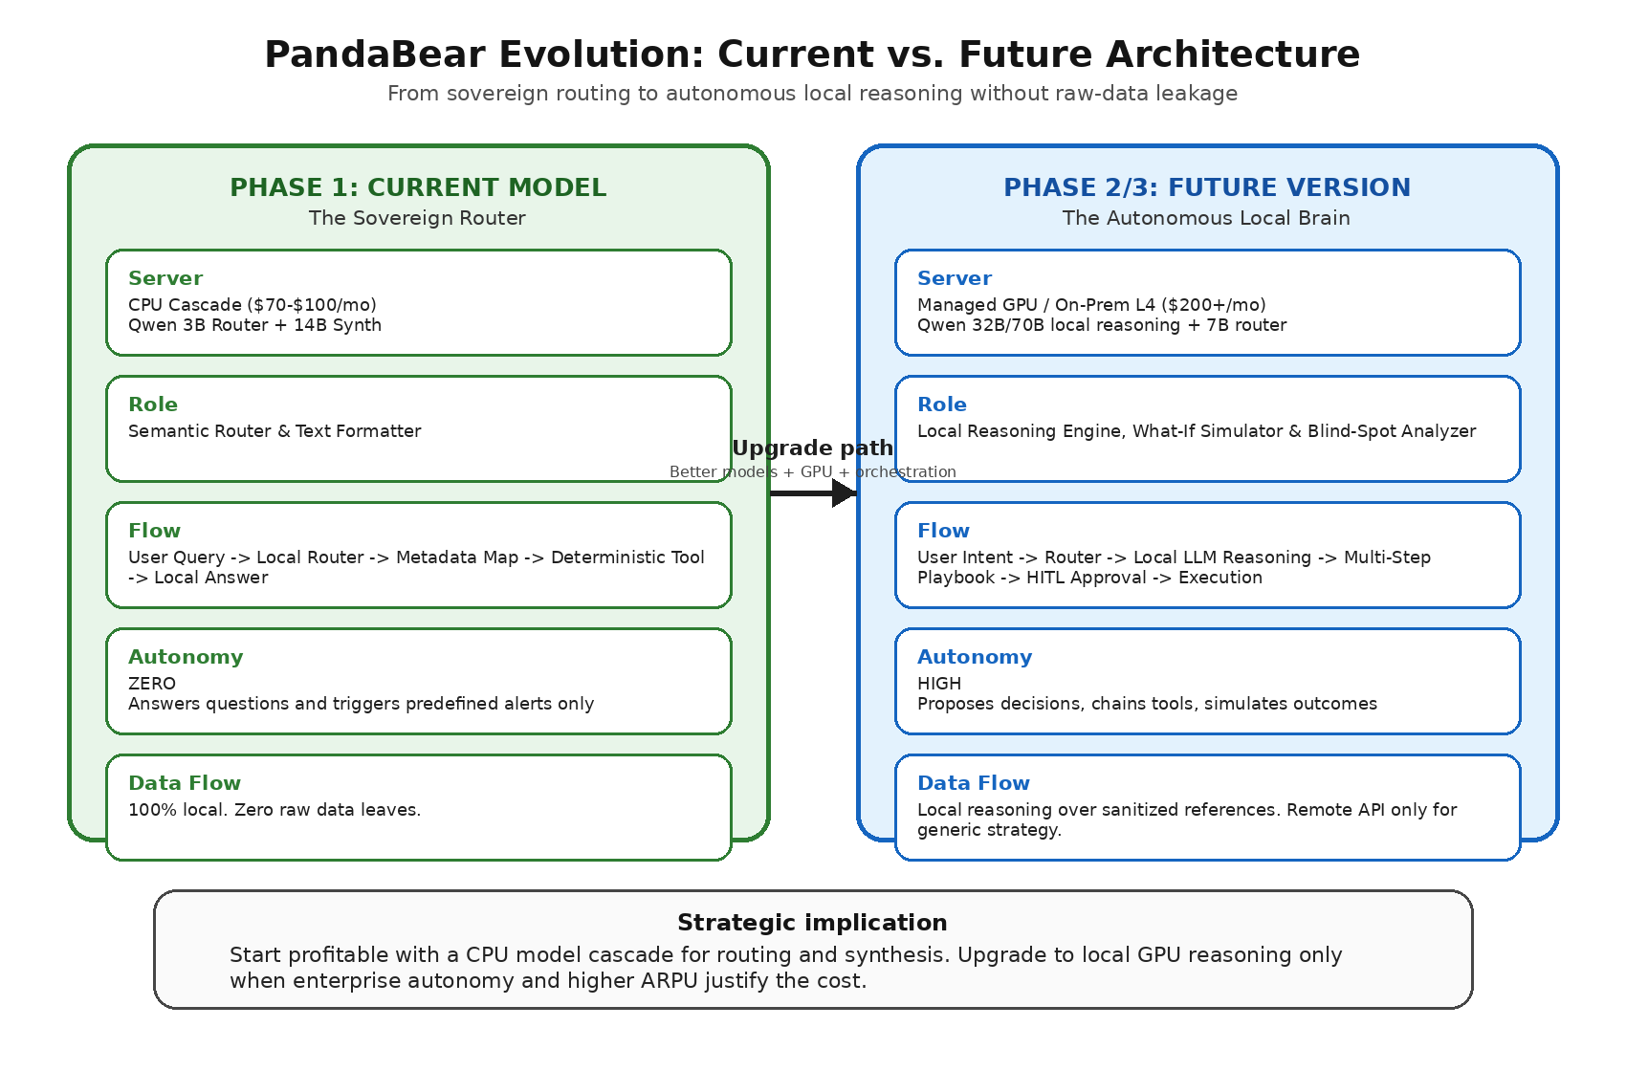
Figure 1. PandaBear evolution path from Sovereign Router to Autonomous Local Brain.

Part 2: Infrastructure & Model Matrix - Finding the Sweet Spot
The goal is to protect the $399/month SMB price point and maintain 75%+ gross margins. The matrix below ruthlessly eliminates options that break the budget or the service experience.
Option | Monthly Cost | PandaBear Verdict | Why
1. CPU-only budget | $40-$70 | Reject | 5-20s latency is too slow for a real-time Slack/Teams assistant. Users will abandon it.
2. Best CPU-only | $70-$100 | Conditional | Useful for background batch processing and alerts, but 10-60s latency hurts interactive chat UX.
3. CPU + model cascade | $70-$100 | Winner - Phase 1 | The sweet spot. 3B handles routing in under 2s; 14B handles complex synthesis in under 15s. Keeps COGS under $100.
4. Cheap GPU marketplace | $95-$150 | Reject | Great latency, but enterprise buyers will not accept availability variance in an SLA.
5. Managed GPU cloud | $190-$330+ | Reject for Phase 1 | Destroys margins. At $300/mo COGS, a $399/mo product yields only about 25% margin. Save for Enterprise Phase 2.
6. Remote LLM API hybrid | $20-$100+ | Winner - Setup | Crucial for the compiler phase. Used only during ephemeral setup to generate deterministic tools; strictly gated at runtime.

Test 1: Routing Latency & Accuracy Test (3B Model)
- Goal: prove the small model can act as a fast semantic router.
- Feed 100 diverse, messy user queries such as “Can we reorder milk?”, “Did we pay the weird vendor?”, and “Check branch 2 stock”.
- Success: >95% correct capability_id mapping, correct entity extraction, under 2.5 seconds on target CPU hardware, and UNKNOWN instead of hallucinated tools when uncertain.

Test 2: Sanitization Stress Test (Airgap)
- Goal: prove the deterministic scrubber catches 100% of raw data before any remote API call.
- Intentionally feed prompts containing raw PII, financial amounts, and database passwords.
- Success: the scrubber intercepts the payload, replaces raw values with references/enums, and the remote API receives zero raw strings.

Test 3: Synthesis Quality Test (14B Model)
- Goal: prove the larger local model can turn deterministic JSON into a human-readable Slack message without hallucinating.
- Feed 50 different JSON outputs from deterministic tools, such as {status: OVER_LIMIT, reason_code: POLICY_4B}.
- Success: professional, empathetic, accurate responses; zero invented numbers, names, or reasons; under 15 seconds.

Step 7: Context Wipe & Steady State
Raw schema dumps, setup chat history, and temporary sandbox artifacts are permanently destroyed. The final metadata registry is saved, the approved tool is placed into the local tools directory, and the coder model is unloaded to free runtime resources.

8. MONETIZATION & SCALABILITY

. Pricing Tiers
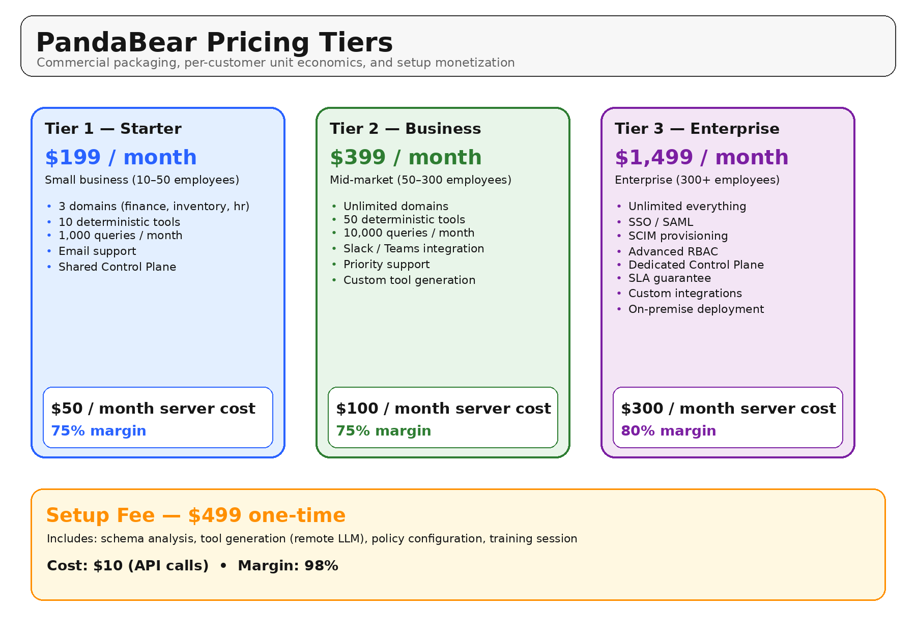
Figure 1. Pricing tiers and setup fee overview.
• Tier 1 — Starter: $199/month • Small business (10–50 employees) • 3 domains • 10 deterministic tools • 1,000 queries/month • Email support • Shared Control Plane • Server cost $50/month • Margin 75%
• Tier 2 — Business: $399/month • Mid-market (50–300 employees) • Unlimited domains • 50 deterministic tools • 10,000 queries/month • Slack/Teams integration • Priority support • Custom tool generation • Server cost $100/month • Margin 75%
• Tier 3 — Enterprise: $1,499/month • Enterprise (300+ employees) • Unlimited everything • SSO/SAML • SCIM provisioning • Advanced RBAC • Dedicated Control Plane • SLA guarantee • Custom integrations • On-premise deployment • Server cost $300/month • Margin 80%
• Setup Fee: $499 one-time • Includes schema analysis, tool generation (remote LLM), policy configuration, and training session • Cost $10 • Margin 98%

2. Unit Economics
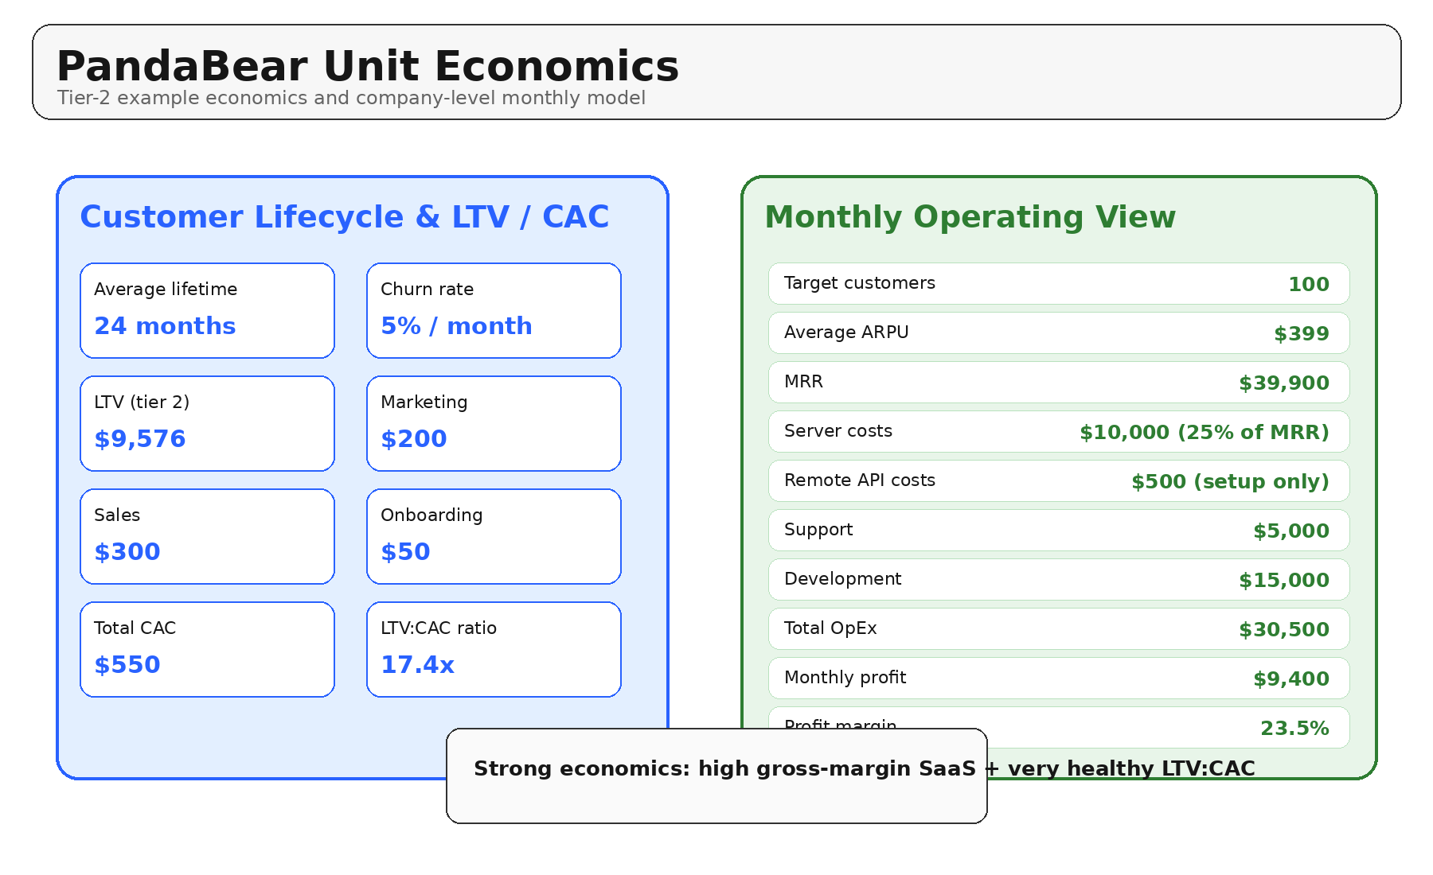
Figure 2. Customer lifecycle economics and monthly operating view.
• Customer lifecycle: average lifetime 24 months, churn rate 5%/month, LTV $9,576 (tier 2).
• Acquisition cost: marketing $200, sales $300, onboarding $50, total CAC $550.
• LTV:CAC ratio: 17.4x.
• Monthly recurring revenue model: 100 target customers, average ARPU $399, MRR $39,900.
• Operating costs: server costs $10,000, remote API costs $500 (setup only), support $5,000, development $15,000, total OpEx $30,500.
• Monthly profit: $9,400 • Profit margin: 23.5%.

