Addition of Transient Kinetics Capabilities to an Infrared Reflection Absorption Spectroscopy System through Synchronized Gas Pulsing and Data Acquisition

Zubin Darbari,†,‡ Marija Iloska§, Monica Bugallo,§ and J. Anibal Boscoboinik*,†

† Center for Functional Nanomaterials, Brookhaven National Laboratory, Upton, New York 11973, United States of America

‡ Department of Materials Science and Chemical Engineering, Stony Brook University, Stony Brook, New York 11794, United States of America

§ Department of Electrical and Computer Engineering, Stony Brook University, Stony Brook, New York 11794, United States of America

* Corresponding author

Email: [jboscoboinik@bnl.gov](mailto:jboscoboinik@bnl.gov)

**Abstract**

Surface science methodologies for understanding thermodynamic aspects of surface processes are at an advanced level. However, instrumentation and approaches for extracting kinetic parameters from elementary steps are far less accessible. In this work, we present an approach combining the use of a fast gas pulsing valve synchronized with data acquisition to enable surface transient kinetics studies using infrared reflection absorption spectroscopy. This methodology applies to the study of reversible processes and borrows concepts and ideas from molecular beam spectroscopy and temporal analysis of products. A temporal resolution of ~60 milliseconds is achieved, and this is illustrated through the study of CO adsorption and desorption on a Pd(111) crystal in the presence and absence of background O2. The same approach can be extended to other surface spectroscopies, such as X-ray photoelectron spectroscopy, to obtain spectra with high temporal resolution and signal-to-noise ratio and enable future multimodal surface transient kinetic studies aiming at elucidating reaction mechanisms.

**Introduction**Surface science analytical methods using flat, usually single crystal, model systems have aided in the understanding of a multitude of chemical and physical processes on surfaces of materials, especially in the area of heterogeneous catalysis [1-6]. However, for some of the most used spectroscopies, such as X-ray photoelectron spectroscopy (XPS) and infrared reflection absorption spectroscopy (IRRAS), it takes in the order of seconds or minutes to acquire a single spectrum with a reasonable signal-to-noise ratio[6]. This limits our ability to carry out reliable surface kinetics studies, required for a thorough understanding of reaction mechanisms. A lot of progress was made in the past to address this, using molecular beams, but these instruments are complicated, limited to ultra-high vacuum (UHV) conditions, and inaccessible to most researchers in the field.[7, 8] [<https://doi.org/10.1016/j.surfrep.2005.03.002>, <https://doi.org/10.1063/1.5093487> ] In addition to the complicated nature of typical molecular beam scattering (MBS) instruments, the UHV nature of the technique results in limitations when trying to address cases in which the behavior might change at higher pressure, the well-known concept of “pressure-gap” [3, 4, 9]. The approach we propose here borrows concepts of molecular beam techniques, and in some way, it can be considered a simplified version of such complex instruments. MBS systems typically operate in UHV and consist of one or more beams (effusive or supersonic) of gases coinciding on a sample surface [<https://doi.org/10.1063/1.1318919>].[10] Spectroscopy measurements can be carried out on such surfaces in the presence of these beams, while mass spectrometry can be used to detect the molecules scattered or evolving from the surface. [7][<https://doi.org/10.1016/j.surfrep.2005.03.002>] Building on the developments in MBS for flat surfaces, a related technique, known as temporal analysis of products (TAP) [11][https://doi.org/10.1080/01614948808078616 ] was developed for powder catalysts to explore reactions mechanisms on material configurations that are closer to technical catalysts. In this instrument, a fast valve delivers the gas or gas mixture through a reactor that contains a thin slice of packed powder catalyst. The gas is then exhausted to a mass spectrometer in close proximity. TAP machines and the methods needed for the analysis and interpretation of the data that comes out of them are complex and have evolved significantly in the last few decades.[12][ [**https://doi.org/10.1039/C7CY00678K**](https://doi.org/10.1039/C7CY00678K)] Both MBS and TAP have in common the need for fast valves or gas choppers to achieve the time resolution needed for transient kinetics studies, and a few different designs have been proposed and built in the past.[13-16][Zubin add references on the valve designs that you found]

In this work, we describe a home-built instrument with fast gas pulsing capabilities using a typical IRRAS configuration, with a UHV chamber positioned between the IR light source and the detector, and an evacuated beam path. Synchronizing the actuation of the valve with the data acquisition allows for high temporal resolution as it will be shown below for CO pulsing on Pd(111) as the case study to illustrate the instrument capabilities.

**Implementation of Transient Kinetics Capabilities**

The IRRAS system modified in this work uses a Vertex 80v Fourier transform infrared spectrometer (Bruker Optics, Ettlingen, Germany) with polarization modulation capabilities and has been described previously[17], with a liquid-nitrogen-cooled MCT detector. The IR chamber was designed to work in a pressure range between 5 x 10-9 mbar and 100 mbar, and a sample temperature range between 120 K and 800 K. The whole path of the IR light is evacuated. The original system was designed in collaboration with SPECS GmbH and Bruker, and it is part of a larger instrument that also has a sample preparation chamber and an ambient pressure XPS chamber (Figure 1, left). The IRRAS chamber was modified to introduce the capability of pulsing a gas at close proximity to the sample surface, and rapid scanning capabilities were added to the spectrometer in order to achieve ~ 67 ms per spectrum.

The pulsing of gas is performed using a commercial pulsing valve (Parker, model 009-1670-900) with a 0.1 mm orifice and a response time better than 2 ms. A custom-made amplifier is required to drive the pulsing valve, which includes a capacitor bank to prevent sudden current drop when operating the pulsing valve at high speed. The pulsing valve coupled with a rigid metal capillary is directed towards the sample surface at an approximate distance of 1 cm. This is shown at the right of Figure 1, where the capillary tube is seen pointing toward the sample location (shaded blue).

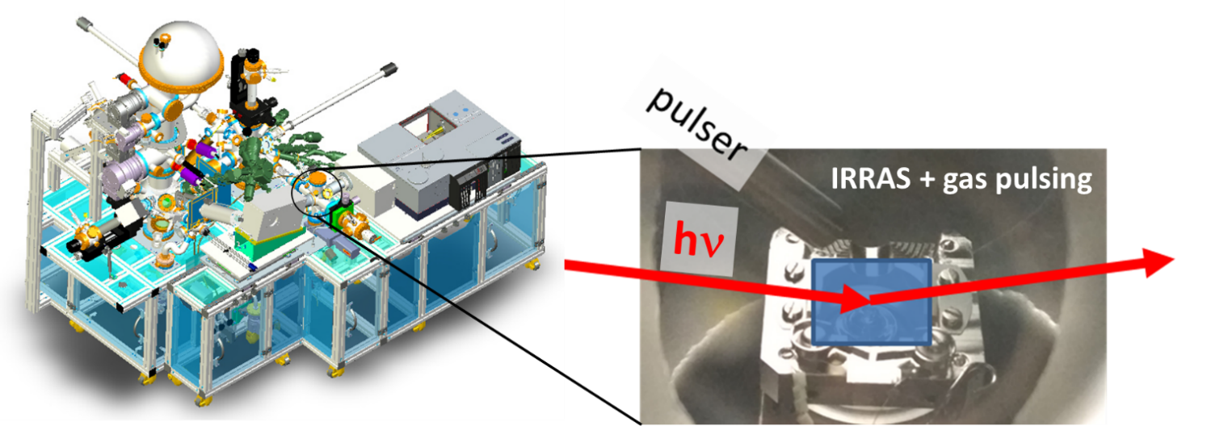

Figure 1. Left, Instrument modified to enable fast IRRAS data acquisitions for transient kinetics measurements. While the instrument has three chambers, for XPS, IRRAS, and sample preparation, only the IRRAS section was modified in the current work. Right, photograph showing the sample stage, IR beam path, and gas pulsing capillary in the IRRAS chamber.

The instrument has additional leak valves that allow having a background pressure of additional gases during the pulsing experiment.

Along with pulsing capability, a quadrupole mass spectrometer (Prisma Plus QMG 220, Pfeiffer vacuum) was installed facing the sample surface to collect molecules scattered from the surface. The mass spectrometer can operate at high speed (2ms dwell time) and can monitor multiple gases simultaneously.

The pulsing valve and spectra acquisition are synchronized using a triggering box (E525/Z) controlled through a macro executed in the Bruker OPUS software. User input includes the pulsing duration (valve opening time), spectra acquisition and length of a cycle and total cycles to be performed. However, the voltage and power generated by the trigger box was not enough to drive the pulsing valve. To increase the voltage and supply additional power, a custom-made fast switching amplifier along with a DC power supply (Sorensen XG 100-8.5) will provide appropriate voltage and sufficient power to drive the valve. The valve is connected to a gas manifold, which controls the gas mixture and pressure behind the valve and is dependent on user input. A schematic of the system is shown in figure 2.

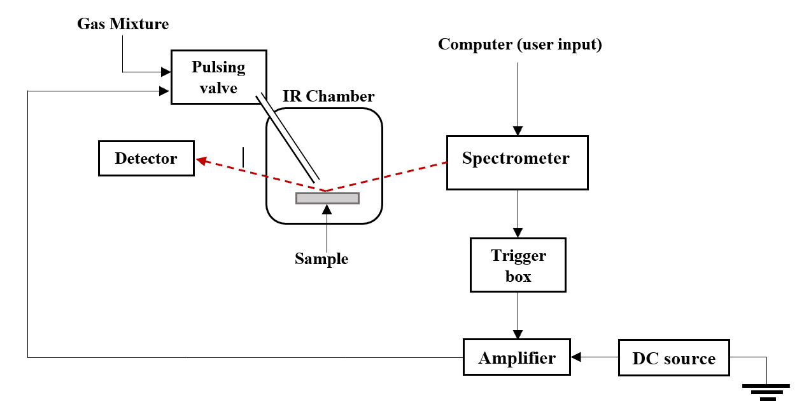

Figure 2. Diagram of the system. A gas pulsing valve is connected to a cappillary tube ponting toward the sample in the IRRAS chamber. The valve opening and closing is programmed by the user in a synchronized manner with the data acquisition. In the current version, this is done through the Bruker OPUS software, which controls both the data acquisition and a triger box connected to the amplifier that powers the solenoid vavle.

Experiments can be programmed in a variety of ways, with various combinations of valve opening times, gas pressure, cycle duration, spectra acquisition duration, mixtures of gases, etc. In the following section, we describe a very simple experiment to illustrate the performance of the system, by exposing a clean Pd(111) crystal to square waves of CO (~10-5 mbar), in which the surface is under pressure for 2 seconds, followed by 6 seconds in ultra-high vacuum (UHV) at three different temperatures, acquiring spectra every 200 ms, and repeating this for 400 cycles.

**Case Study: CO square waves on Pd(111)**

One of the issues with many surface spectroscopies is that, even if the instrument can be set up for faster data acquisition, the signal-to-noise ratio is too low to obtain reliable spectra. For example, Figure 3 shows in black (square symbols) a 200 ms spectrum after an exposure of a Pd(111) surface to 1.8*10-5 mbar CO for 1.8 s at 500 K, where the peak corresponding to the CO stretching vibration can be barely distinguished from the background noise. However, if the experiment is carried out in a cycle manner (CO valve open for 2 s and closed for 6 s in each cycle), such that all cycles are equivalent, when 400 equivalent spectra are averaged, a clear peak emerges at 1850 cm-1 in the spectrum in orange (x symbols). Note that this approach of averaging equivalent spectra through subsequent cycles is only valid for reversible processes, such as in the case here for CO adsorption/desorption at 500 K.

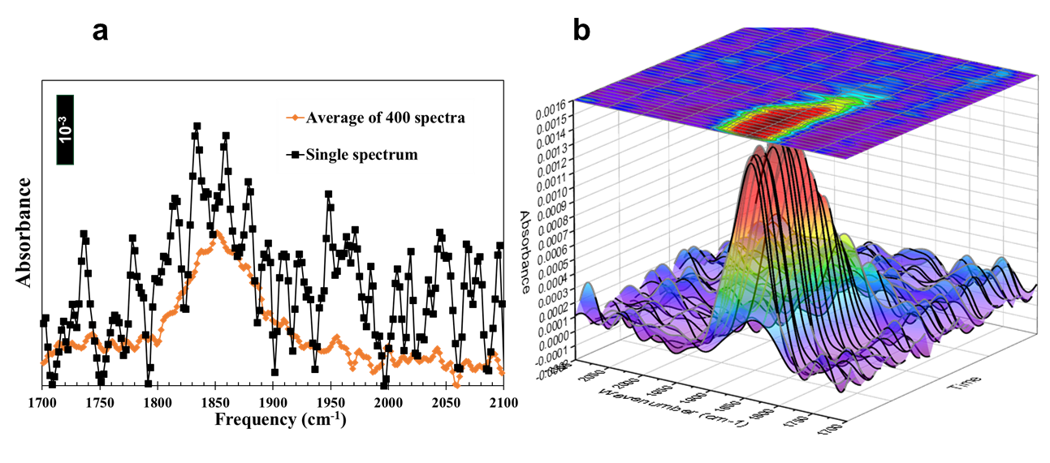

Figure 3. a. comparison between a single spectrum taken over 200 ms and the average of equivalent spectra through 400 cycles allowing a 200 ms time resolution with a significantly enhanced signal-to-noise ratio. The spectra were taken at 500 K, 1.8 s after exposure to 1.8 × 10-8 mbar CO. b. Three-dimensional plot of IRRAS spectra vs time corresponding to the same experiment. During each of the 400 cycles the valve is open for 2 seconds and closed for 6 seconds, while the data is acquired with a 200 ms time resolution.

As described above, we now have a method for obtaining spectra with high time resolution. Figure 3a, corresponded to the point in time 1.8 s after valve opening. Figure 3b is a three-dimensional representation of the same experiment where the absorbance vs frequency is shown as a function of time. A color-coded representation of the absorbance intensity is shown on top, and this is the format that will be used in the subsequent figures.

There is extensive literature for CO adsorption studies on multiple transition metals, e.g.: Pd(100)[18], Rh(111)[19], Cu(100)[20], Ru(0001)[21], Ni(100)[20], Pt(111)[22], and Pd(111) [18]. The case on Pd(111), which we use in the current work, has been studied using various methods ranging from temperature programmed desorption[23, 24], adsorption microcalorimetry[24], adsorption isotherms[18], modulated beam[25, 26], scanning tunnelling microscopy (STM)[27], low energy electron diffraction (LEED)[28], infrared adsorption spectroscopy (IR)[28], density functional theory (DFT)[29] and sum frequency generation (SFG)[30].  
Given that our experiments require a reversible process, we have chosen to work in the temperature range between 450 K and 500 K, in which only three-fold hollow sites or bridge sites on the surface can be occupied. CO does not adsorb on a-top sites in this temperature range at the pressures we will use.[28] Prior work by Bradshaw and Hoffman[28] showed that on the Pd(111) surface the CO stretch frequency is found at 1823 cm−1 at very low coverages, rising to 1936 cm−1 at θ = 0.5. That work provides a correlation between coverage and vibrational frequency, which will allow us to obtain coverage values from our data (from the vibrational frequency) to use in the analysis of the transient kinetics data. For θ < 1/3, CO adsorbs on three-fold hollow sites and the vibrational frequency remains below 1840 cm-1, with the area of the IR band being proportional to the CO coverage. For θ > 1/3, a more compressed CO structure is formed for which the vibrational frequency changes with coverage. There is debate in the literature about the nature of this structure, but at a coverage of 0.5, CO has been experimentally shown to form a c(4x2) structure using STM[27]. However it has not been settled whether this is at bridge site or hollow site[31]. For this coverage range (0.5 > θ > 1/3), we draw a correlation from the work by Bradshaw and Hoffmann in order to estimate the coverage. Figure 4 shows plots for CO adsorption (0 to 2 s) and desorption (2 to 8 s) at 450 K, 475 K, and 500 K. The coverage vs frequency plots adapted from ref [28] are included for reference below. This allow inferring the equilibrium coverage reached at each temperature.

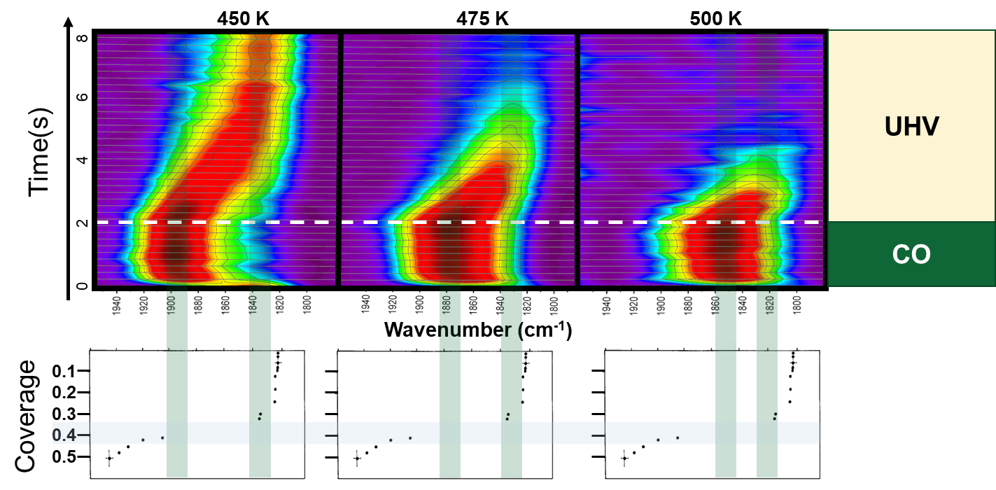

Figure 4. IRRAS spectra as a function of time at 450 K, 475 K, and 500 K. The sample is exposed to CO during the first 2 seconds (adsorption step) and in UHV during the following 6 seconds (desorption step). Coverage vs frequency plots reproduced from ref [28] are included below for reference.

One of the first observations is that in all cases a steady state coverage is reached within at most 0.4 s of the valve opening, for all temperatures, while the desorption phase takes considerably longer. Capturing this behaviour would be impossible without the approach used here, given that spectra with reasonable signal-to-noise ratios for this system take in the order or tens of seconds to minutes. Plots of coverage (as determined indirectly from frequency and area) vs time are shown in Figure S1. As expected, the equilibrium coverage decreases with increasing temperature, as evident by the decreasing CO vibrational frequency reached at equilibrium.

Full desorption occurs within 3 s of closing the valve at 500 K, and within 5 s at 475 K. However, full desorption is not achieved at 450 K within the duration of the cycle used in this series of experiments. Nevertheless, the starting coverage of each subsequent cycle, even if not zero, should be identical except for the first cycle, which contribution is negligible when averaging out 400 cycles as it was the case here. To capture complete desorption, and to illustrate more complex sequences that can be programmed in this setup, a macro was written such that the spectra acquisition time was faster during the adsorption time (with a time resolution of ~60 ms) but slower during the desorption (1.65 s) with a total cycle duration of ~ 32 seconds, allowing ~30 seconds for desorption. The result of this experiment at 450 K is shown in Figure 5.

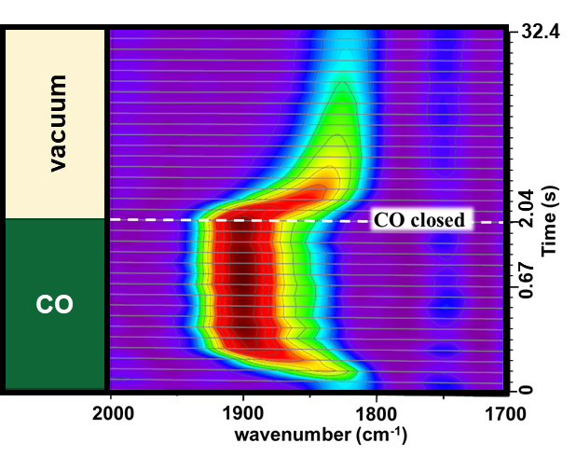

Figure 5. IRRA spectra vs time at 450 K for an experiment in which the data acquisition followed a more complex sequence of time intervals. During the adsorption step, 10 spectra were taken at time intervals of 67 ms to capture the fast adsorption, followed by steps of 202 ms during equilibrium. Time intervals of 1686 ms were used during the much slower desorption phase.

While this system is very simple and it has been very widely studied, there is significant complexity when considering each detailed elementary step of the process, since for coverages higher than 1/3 there is also a transition to a more compressed phase. Considering this, there are, in the simplest possible case, two different surface structures that CO can adsorb onto or desorb from a Pd(111) crystal, which can also interconvert. A detailed analysis complemented by modelling and theory will be the subject of a subsequent paper. To put these experiments in the context of prior literature where desorption activation energies are reported, we focused our attention next on the desorption region for coverages below 1/3, where a simple first order desorption from a single CO adsorbed phase can be assumed. Then, the rate of desorption can be described with a linear differential equation

*Eq. 1*

where *k* is the desorption rate constant, and *t* is time. This can be analytically solved by simple separation of variables, and yields the following equation:

*Eq. 2*

where is the initial coverage. By taking the natural log on each side, we can rearrange the equation to fit a simple linear regression model [32]

*Eq. 3*

given the set of points , with being the time at which the final data point was collected. Fitting this regression line amounts to applying ordinary least squares [33] to get the best fit line. In mathematical terms, we write that as

Eq. 4

Solving this optimization task in Eq.1 gives us the solution for :

Eq. 5

The desorption rate constant *k* was estimated as described above for three different datasets pertaining to temperatures of The data was fitted using the estimated parameter k into equation 3, assuming we have the starting data point .To obtain suitable datasets for this fitting, the experiments were repeated using longer cycles for the desorption step.

The fittings for each dataset are shown in Figure 6a. The scattered plots represent the experimental data, while the line plots represent the fittings. For a better visual assessment, we have included the linear fits (and the corresponding curved fits) separately for each temperature in the SI.

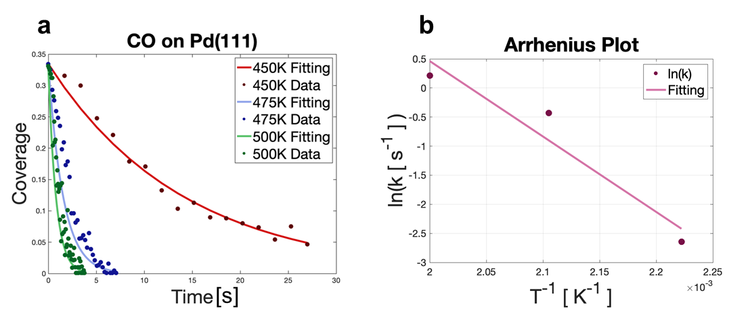

Figure 6. a. Coverage fitting for temperatures at T ∈ {450 K,475 K,500 K}. b. Arrhenius plot based on rate constants obtained from figure 6a.

The estimated desorption constants *k* for the temperatures were respectively. Using these estimates, an Arrhenius plot [34](see Figure 6b) was used to obtain the activation energy of desorption Ea, as well as the pre-exponential factor A. We would like to acknowledge that using three points is, of course, too little to report confident results, however, the purpose of this section is only to demonstrate the usage of our method, and a series of experiments with a more thorough analysis are to follow in a future effort.

The activation energy obtained is Ea = 24.04 kcal, and the pre-exponential factor A = 6.45 x 1010. The value is in agreement with previously reported data Ea = 23-34 kcal and A ~ 1014, calculated using multiple methods[26, 35, 36].

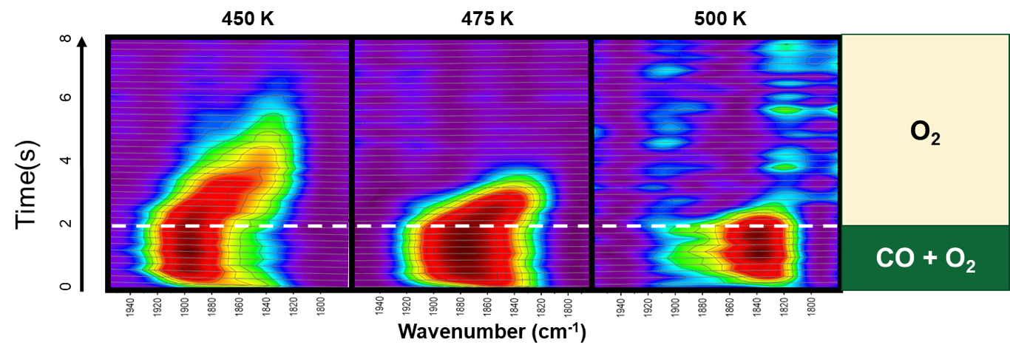

Figure 7. IRRA spectra as a function of time at 450 K, 475 K, and 500 K in the presence of background O2 (10-5 mbar), with CO exposure (1.8 × 10-5 mbar) during the first 2 s, and in the absence of CO in the following 6 s.

The same experiment presented in Figure 4 was repeated by now in the presence of a background pressure of O2 (10-5 mbar), condition at which CO oxidation can occur in addition to the adsorption/desorption and surface compression processes described above. This is a widely studied reaction, and has shown very rich behaviour, including the formation of complex spatio-temporal patterns, as highlighted in Ertl’s Noble prize lecture [37][https://doi.org/10.1002/anie.200800480].

While the general trends as a function of temperature as similar to the case in UHV, under these conditions, the CO adsorption step is slower and the desorption/removal steps is faster. This is expected, as it is not only adsorption and desorption that is taking place, but also reaction between CO and surface oxygen. Additionally, CO and O compete for the available surface sites. Exploring the various elementary steps taking place in parallel requires additional modelling, which beyond the scope of the current work. Nevertheless, this data illustrates the potential of the experimental setup described here to capture these complex phenomena, which can be followed within the time scales accessible in this system, to provide mechanistic insights in complex surface reactions.

**Conclusions and Outlook**

In this work we describe the modification of an infrared reflection absorption spectroscopy (IRRAS) system to enable transient kinetics measurements by adding a fast gas pulsing valve and synchronizing it with a fast data acquisition system. This allows obtaining IRRAS spectra with a time resolution down to ~ 60 ms with a signal-to-noise ratio that would normally require orders of magnitude longer acquisition times. The new system is able to achieve this by programming repeated cycles that are equivalent to each other and can be averaged. The main limitation of this approach is that is valid for processes that are reversible within the time span of the experiment. The use of this instrument is illustrated by following the kinetics of adsorption and desorption of CO from a clean Pd(111) crystal at elevated temperatures (at which the process is reversible), both in ultra-high vacuum and in the presence of background O2 in the system. This shows how kinetics of fast processes can be captured with this approach, which can in turn provide insights into the elementary steps of reaction mechanisms when coupled with the development of modelling methodologies. Additionally, the approach used here can be easily extended to other surface science spectroscopies, such as X-ray photoelectron spectroscopy.

**Acknowledgments**

Evgeniy+Funding

**References**

1. Ertl, G. and H.-J. Freund, *Catalysis and Surface Science.* Physics Today, 1999. **52**(1): p. 32-38.

2. Freund, H.J., *Model studies in heterogeneous catalysis.* Chemistry–A European Journal, 2010. **16**(31): p. 9384-9397.

3. Prieto, G. and F. Schüth, *Bridging the gap between insightful simplicity and successful complexity: From fundamental studies on model systems to technical catalysts.* Journal of Catalysis, 2015. **328**: p. 59-71.

4. Somorjai, G.A., *Catalysis and surface science.* Surface Science, 1979. **89**(1-3): p. 496-524.

5. Bent, B.E., *Mimicking aspects of heterogeneous catalysis: generating, isolating, and reacting proposed surface intermediates on single crystals in vacuum.* Chemical reviews, 1996. **96**(4): p. 1361-1390.

6. Goodman, D., *Model catalysts: from extended single crystals to supported particles.* Surface Review and Letters, 1995. **2**(01): p. 9-24.

7. Libuda, J. and H.-J. Freund, *Molecular beam experiments on model catalysts.* Surface Science Reports, 2005. **57**(7-8): p. 157-298.

8. Attia, S., et al., *Molecular beam/infrared reflection-absorption spectroscopy apparatus for probing heterogeneously catalyzed reactions on functionalized and nanostructured model surfaces.* Review of Scientific Instruments, 2019. **90**(5): p. 053903.

9. Park, J.Y., *Current trends of surface science and catalysis*. 2014: Springer.

10. Libuda, J., et al., *A molecular beam/surface spectroscopy apparatus for the study of reactions on complex model catalysts.* Review of Scientific Instruments, 2000. **71**(12): p. 4395-4408.

11. Gleaves, J.T., J. Ebner, and T. Kuechler, *Temporal analysis of products (TAP)—a unique catalyst evaluation system with submillisecond time resolution.* Catalysis Reviews Science and Engineering, 1988. **30**(1): p. 49-116.

12. Morgan, K., et al., *Forty years of temporal analysis of products.* Catalysis Science & Technology, 2017. **7**(12): p. 2416-2439.

13. Inoue, N. and T. Uchida, *New Type of High Speed Valve.* Review of Scientific Instruments, 1968. **39**(10): p. 1461-1464.

14. Kuswa, G., C. Stallings, and A. Stamm, *Improved fast opening gas puff valve.* Review of Scientific Instruments, 1970. **41**(9): p. 1362-1363.

15. Henins, I. and J. Marshall, *A pulsed gas valve for fast timeable high pressure operation.* Review of Scientific Instruments, 1969. **40**(7): p. 875-878.

16. Gentry, W.R. and C.F. Giese, *Ten‐microsecond pulsed molecular beam source and a fast ionization detector.* Review of Scientific instruments, 1978. **49**(5): p. 595-600.

17. Eads, C.N., et al., *Multi-modal surface analysis of porous films under operando conditions.* AIP Advances, 2020. **10**(8): p. 085109.

18. Conrad, H., et al., *Adsorption of CO on Pd single crystal surfaces.* Surface Science, 1974. **43**(2): p. 462-480.

19. Van Hove, M., et al., *The structure of Rh (111)(2× 2)-3CO from LEED intensities: Simultaneous bridge and near-top adsorption in a distorted compact hexagonal CO overlayer.* Surface Science, 1983. **129**(2-3): p. 482-506.

20. Andersson, S. and J. Pendry, *Structure of CO adsorbed on Cu (100) and Ni (100).* Physical Review Letters, 1979. **43**(5): p. 363.

21. Michalk, G., et al., *A LEED determination of the structures of Ru (001) and of CORu (001)−√ 3×√ 3 R30°.* Surface Science, 1983. **129**(1): p. 92-106.

22. Ogletree, D., M. Van Hove, and G. Somorjai, *LEED intensity analysis of the structures of clean Pt (111) and of CO adsorbed on Pt (111) in the c (4× 2) arrangement.* Surface science, 1986. **173**(2-3): p. 351-365.

23. Guo, X. and J.T. Yates Jr, *Dependence of effective desorption kinetic parameters on surface coverage and adsorption temperature: CO on Pd (111).* The Journal of Chemical Physics, 1989. **90**(11): p. 6761-6766.

24. Dropsch, H. and M. Baerns, *CO adsorption on supported Pd catalysts studied by adsorption microcalorimetry and temperature programmed desorption.* Applied Catalysis A: General, 1997. **158**(1-2): p. 163-183.

25. Engel, T., *A molecular beam investigation of He, CO, and O2 scattering from Pd (111).* The Journal of Chemical Physics, 1978. **69**(1): p. 373-385.

26. Engel, T. and G. Ertl, *Surface residence times and reaction mechanism in the catalytic oxidation of CO on Pd (111).* Chemical Physics Letters, 1978. **54**(1): p. 95-98.

27. Rose, M., et al., *Ordered structures of CO on Pd (1 1 1) studied by STM.* Surface science, 2002. **512**(1-2): p. 48-60.

28. Bradshaw, A. and F. Hoffmann, *The chemisorption of carbon monoxide on palladium single crystal surfaces: IR spectroscopic evidence for localised site adsorption.* Surface Science, 1978. **72**(3): p. 513-535.

29. Loffreda, D., D. Simon, and P. Sautet, *Dependence of stretching frequency on surface coverage and adsorbate–adsorbate interactions: a density-functional theory approach of CO on Pd (111).* Surface science, 1999. **425**(1): p. 68-80.

30. Morkel, M., et al., *SFG spectroscopy from 10− 8 to 1000 mbar: less-ordered CO structures and coadsorption on Pd (111).* Surface science, 2003. **532**: p. 103-107.

31. Hooshmand, Z., D. Le, and T.S. Rahman, *CO adsorption on Pd (111) at 0.5 ML: A first principles study.* Surface Science, 2017. **655**: p. 7-11.

32. Zou, K.H., K. Tuncali, and S.G. Silverman, *Correlation and simple linear regression.* Radiology, 2003. **227**(3): p. 617-628.

33. Hutcheson, G.D., *Ordinary least-squares regression.* L. Moutinho and GD Hutcheson, The SAGE dictionary of quantitative management research, 2011: p. 224-228.

34. Zhdanov, V.P., *Arrhenius parameters for rate processes on solid surfaces.* Surface Science Reports, 1991. **12**(5): p. 185-242.

35. Matsushima, T. and H. Asada, *Kinetic studies on the CO oxidation on Pd (111) with low energy electron diffraction (LEED) and angle‐resolved thermal desorption.* The Journal of chemical physics, 1986. **85**(3): p. 1658-1668.

36. Seebauer, E.G., A. Kong, and L. Schmidt, *The coverage dependence of the pre-exponential factor for desorption.* Surface science, 1988. **193**(3): p. 417-436.

37. Ertl, G., *Reactions at surfaces: From atoms to complexity (Nobel lecture).* Angewandte Chemie International Edition, 2008. **47**(19): p. 3524-3535.