**Project : Pizza Sales Analysis**

**Table of Contents:**

* [Problem Statement](https://github.com/yogeshkasar778/Sales_insights_of_data_analysis-AtliQ_Hardware/edit/main/README.md#problem-statement-)

* [Data Analysis using MySQL](https://github.com/yogeshkasar778/Sales_insights_of_data_analysis-AtliQ_Hardware/edit/main/README.md" \l "data-analysis-using-mysql-)
* Data Cleaning
* [Build Dashboard Or a Report](https://github.com/yogeshkasar778/Sales_insights_of_data_analysis-AtliQ_Hardware/edit/main/README.md#build-dashboard-or-a-report) using Power BI
* [Data Analysis and visualization using Jupyter](https://github.com/yogeshkasar778/Sales_insights_of_data_analysis-AtliQ_Hardware/edit/main/README.md#data-analysis-using-mysql-) Notebook, Python libraries such as pandas, matplotlib, seaborn, and plotly
* [Tools, Software and Libraries](https://github.com/yogeshkasar778/Sales_insights_of_data_analysis-AtliQ_Hardware/edit/main/README.md#tools-software-and-libraries-)
* [References](https://github.com/yogeshkasar778/Sales_insights_of_data_analysis-AtliQ_Hardware/edit/main/README.md#references-)

**Problem Statement**

**KPI’s REQUIREMENT**

We need to analyze key indicators for our pizza sales data to gain insights into our business performance. Specifically, we want to calculate the following metrics:

1. Total Revenue: The sum of the total price of all pizza orders.
2. Average Order Value: The average amount spent per order, calculated by dividing the total revenue by the total number of orders.
3. Total Pizzas Sold: The sum of the quantities of all pizzas sold.
4. Total Orders: The total number of orders placed.
5. Average Pizzas Per Order: The average number of pizzas sold per order, calculated by dividing the total number of pizzas sold by the total number of orders.

**CHARTS REQUIREMENT**

We would like to visualize various aspects of our pizza sales data to gain insights and understand key trends. We have identified the following requirements for creating charts:

**1. Daily Trend for Total Orders:** Create a bar chart that displays the daily trend of total orders over a specific time period. This chart will help us identify any patterns or fluctuations in order volumes on a daily basis.

**2. Montly Trend for Total Orders:** Create a line chart that illustrates the hourly trend of total orders throughout the day. This chart will allow us to identify peak hours or periods of high order activity.

**3. Percentage of Sales by Pizza Category:** Create a pie chart that shows the distribution of sales across different pizza categories. This chart will provide insights into the popularity of various pizza categories and their contribution to overall sales.

**4. Percentage of Sales by Pizza Size:** Generate a pie chart that represents the percentage of sales attributed to different pizza sizes. This chart will help us understand customer preferences for pizza sizes and their impact on sales.

**5. Total Pizzas Sold by Pizza Category:** Create a funnel chart that presents the total number of pizzas sold for each pizza category. This chart will allow us to compare the sales performance of different pizza categories.

**6.** **Top 5 Best Sellers by Revenue, Total Quantity and Total Orders:** Create a bar chart highlighting the top 5 best-selling pizzas based on the Revenue, Total Quantity, Total Orders. This chart will help us identify the most popular pizza options.

**7. Bottom 5 Best Sellers by Revenue, Total Quantity and Total Orders:** Create a bar chart showcasing the bottom 5 worst-selling pizzas based on the Revenue, Total Quantity, Total Orders. This chart will enable us to identify underperforming or less popular pizza options.

**Data Analysis using MySQL**

Utilized MySQL for data extraction and calculation of key metrics such as Total Revenue, Average Order Value, Total Pizzas Sold, Total Orders, and Average Pizzas Per Order.

**DATA IMPORT**

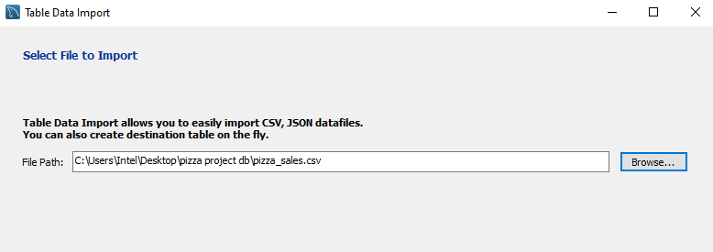

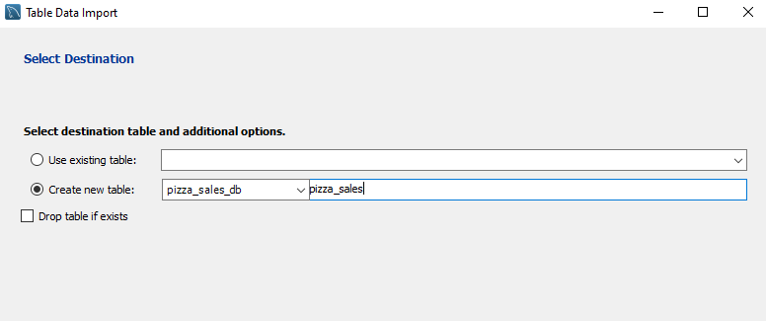

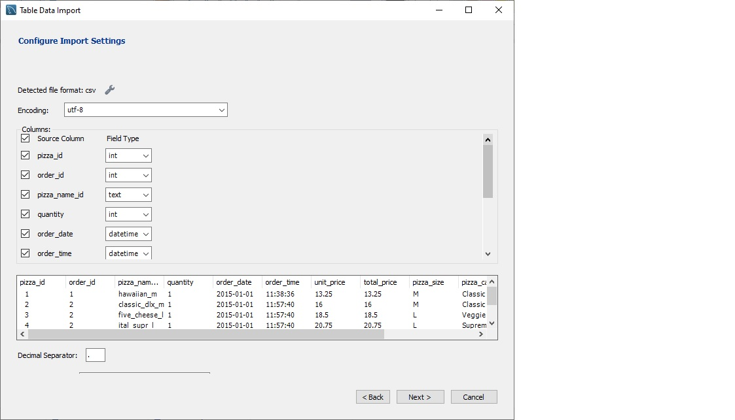

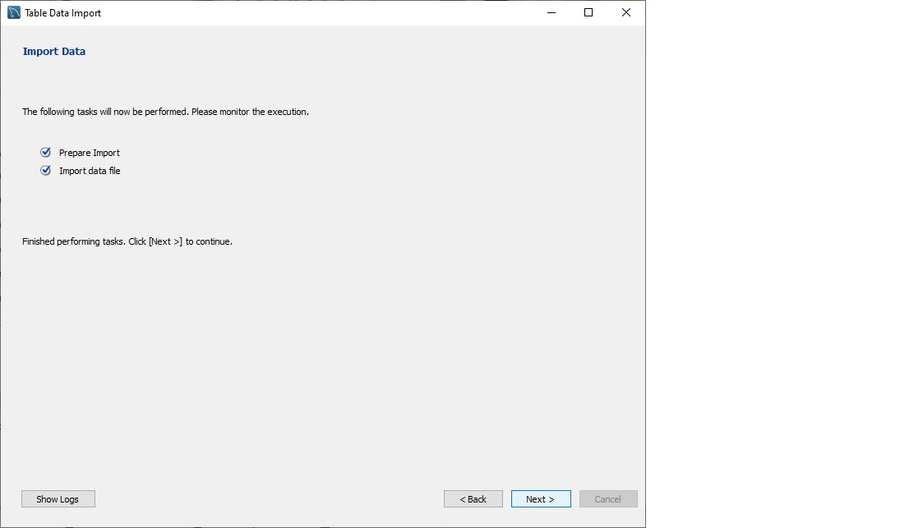

ANALYSIS OF DIFFERENT SQL STATEMENT ON DATA BASE

1. **KPI’s**

**CONVERT DATE (order_date) COLUMN TO PROPER DATE FORMAT**

UPDATE pizza_sales

SET order_date = STR_TO_DATE(order_date, '%d-%m-%Y');

**ALTER DATE (order_date) COLUMN TO DATE DATA TYPE**

ALTER TABLE pizza_sales

MODIFY COLUMN order_date DATE;

**CONVERT TIME (order_time) COLUMN TO PROPER DATE FORMAT**

UPDATE pizza_sales

SET order_time = STR_TO_DATE(order_time, '%H:%i:%s');

**ALTER TIME (order_time) COLUMN TO DATE DATA TYPE**

ALTER TABLE pizza_sales

MODIFY COLUMN order_time TIME;

1. **Total Revenue:**

SELECT SUM(total_price) AS total_revenue FROM pizza_sales;

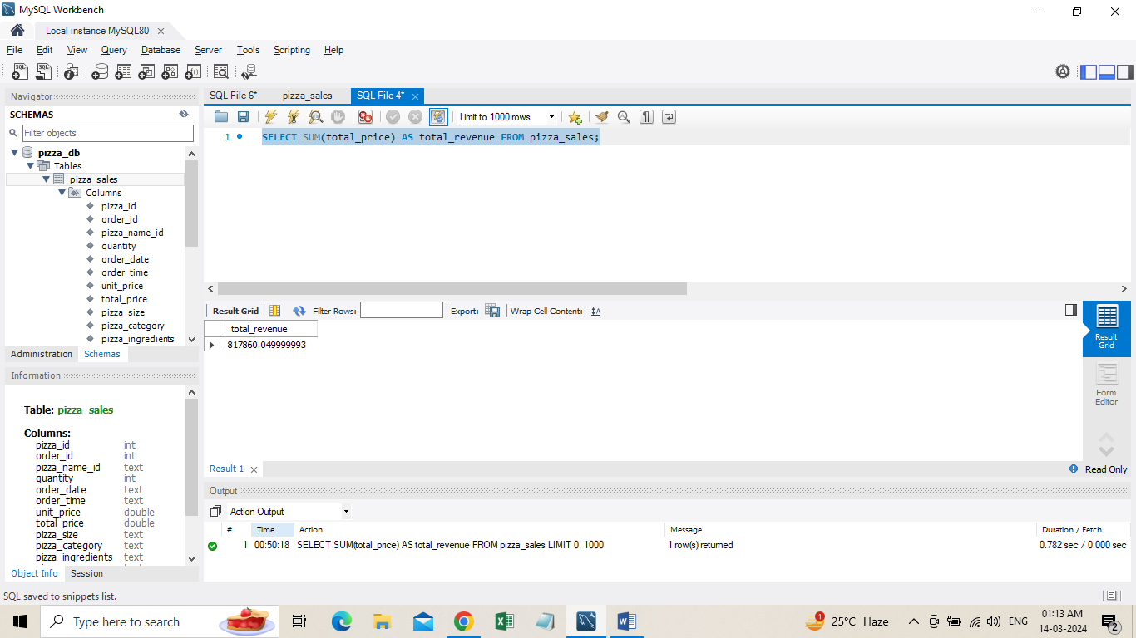

**2**. **Average Order Value:**

SELECT SUM(total_price) / COUNT(DISTINCT order_id) AS avg_order_value FROM pizza_sales;

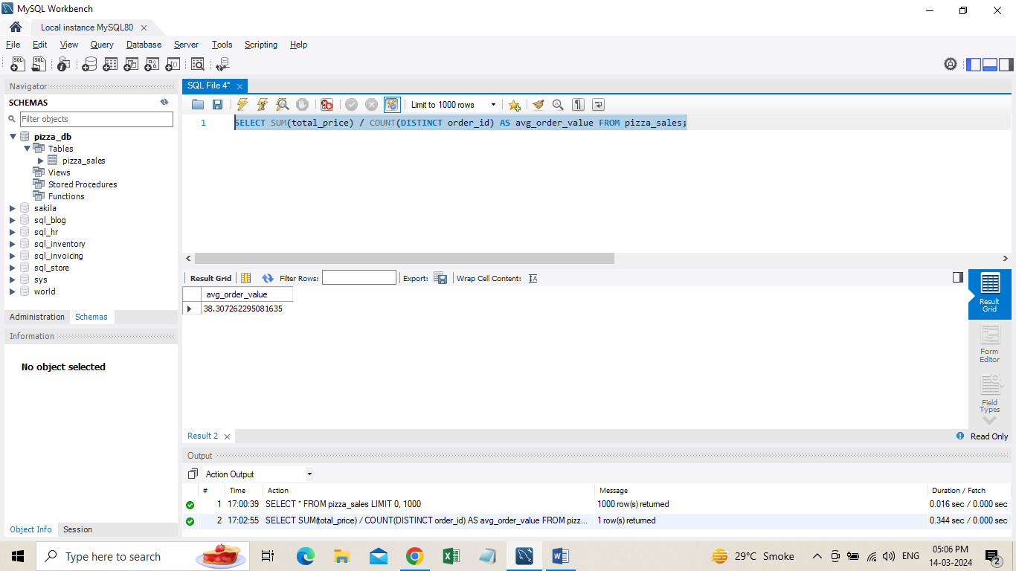

1. **Total Pizza Sold**

SELECT SUM(quantity) AS total_pizza_sold FROM pizza_sales;

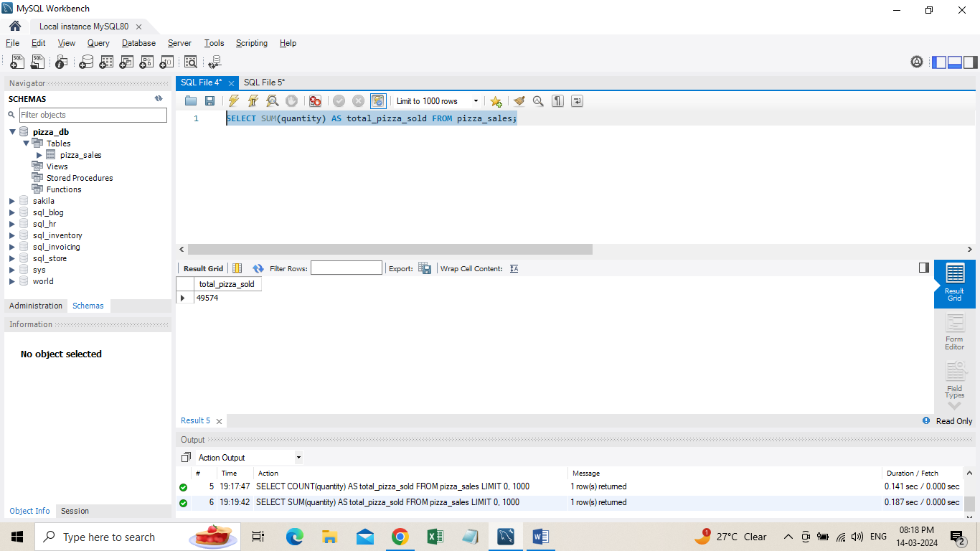

1. **Total Orders**

SELECT COUNT(DISTINCT order_id) AS total_order FROM pizza_sales;

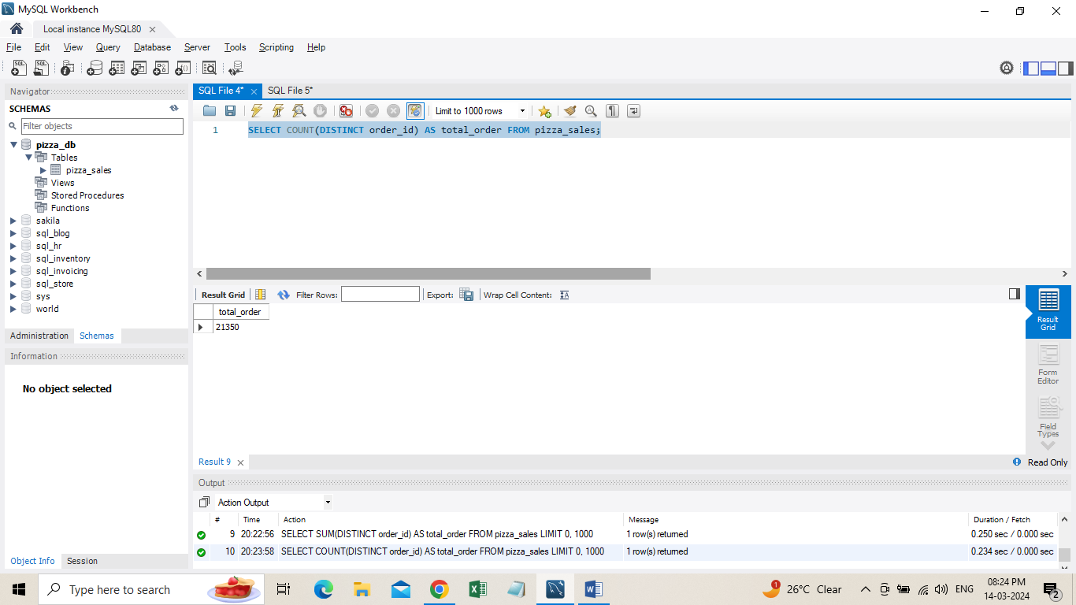

1. **Average Pizzas Per Order**

SELECT ROUND(SUM(quantity) / COUNT(DISTINCT order_id), 2) AS avg_pizza_per_order FROM pizza_sales;

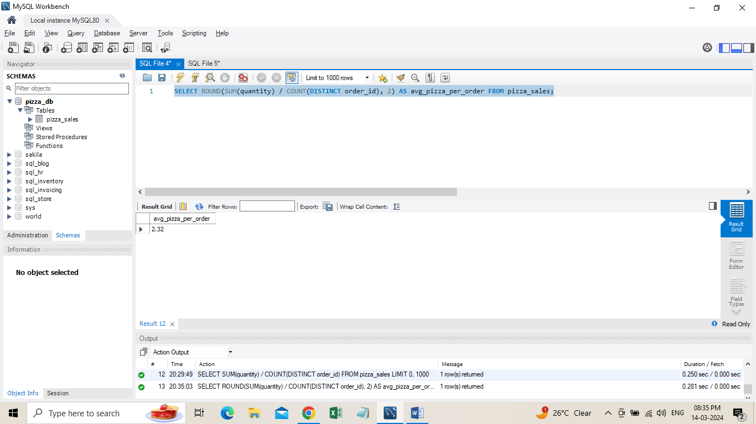

**B. Daily Trend for Total Orders**

SELECT DAYNAME(order_date) AS order_day, COUNT(DISTINCT order_id) AS total_orders

FROM pizza_sales

GROUP BY DAYNAME(order_date);

***Output:***

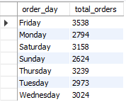

**C. Monthly Trend for Orders**

SELECT DATE_FORMAT(order_date, '%M') AS Month_Name, COUNT(DISTINCT order_id) AS Total_Orders

FROM pizza_sales

GROUP BY DATE_FORMAT(order_date, '%M');

***Output:***

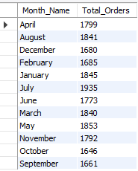

**D. % of Sales by Pizza Category**

SELECT pizza_category,

ROUND(SUM(total_price), 2) AS total_revenue,

ROUND(SUM(total_price) * 100 / (SELECT SUM(total_price) FROM pizza_sales), 2) AS PCT

FROM pizza_sales

GROUP BY pizza_category;

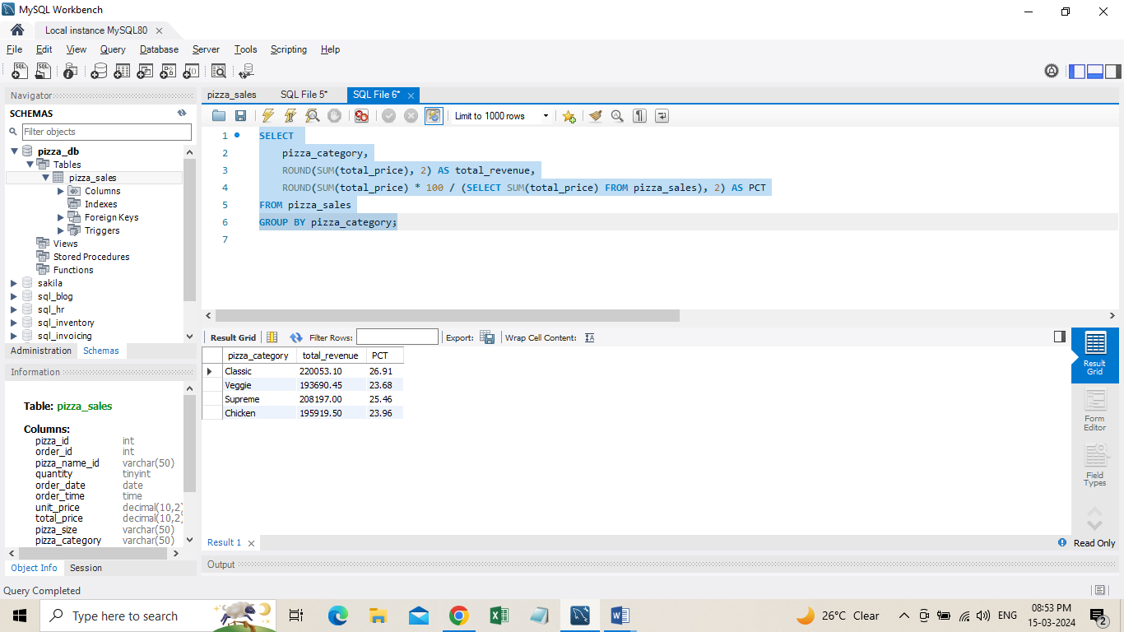

**E. % of Sales by Pizza Size**

SELECT pizza_size,

ROUND(SUM(total_price), 2) AS total_revenue,

ROUND(SUM(total_price) * 100 / (SELECT SUM(total_price) FROM pizza_sales), 2) AS PCT

FROM pizza_sales

GROUP BY pizza_size

ORDER BY pizza_size;

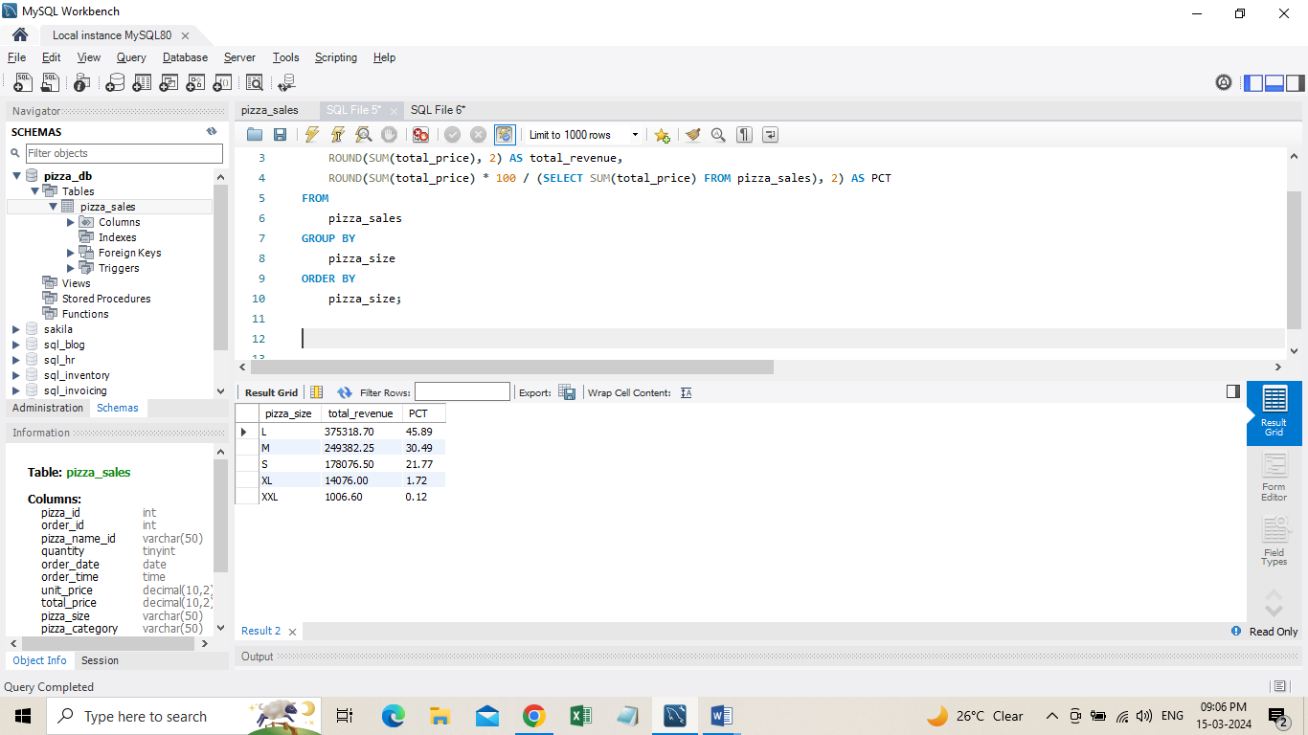

**F. Total Pizzas Sold by Pizza Category**

SELECT pizza_category, SUM(quantity) AS Total_Quantity_Sold

FROM pizza_sales

-- WHERE MONTH(order_date) = 2

GROUP BY pizza_category

ORDER BY Total_Quantity_Sold DESC;

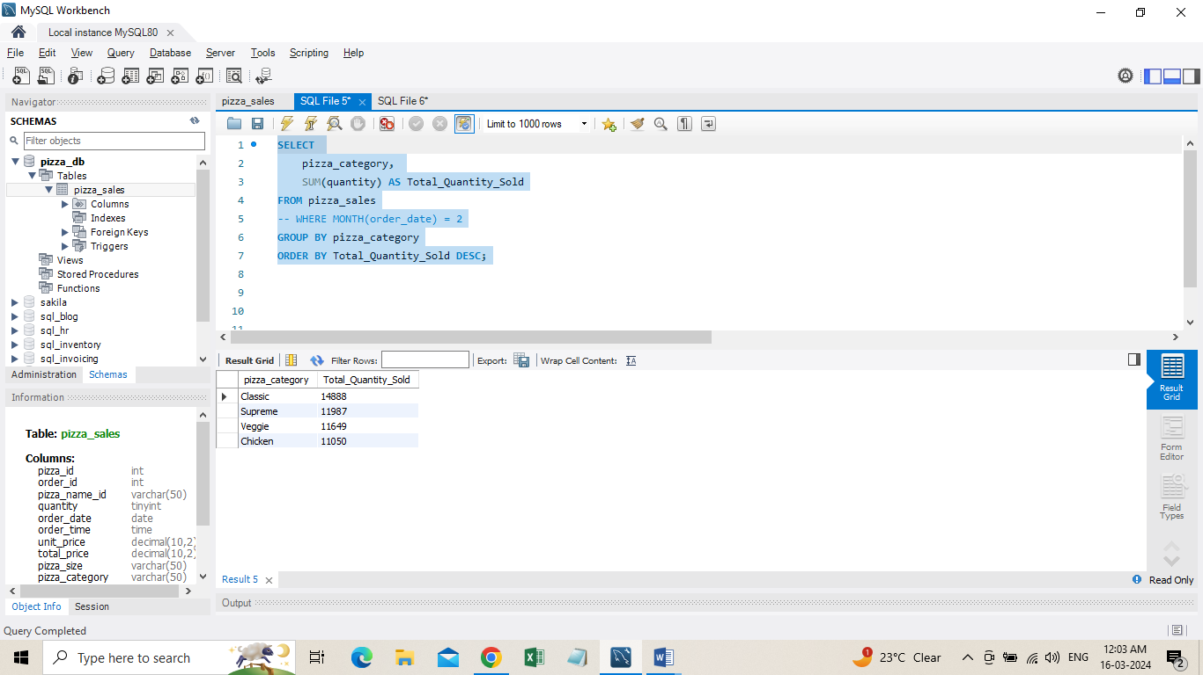

**G. Top 5 Pizzas by Revenue**

SELECT pizza_name, SUM(total_price) AS Total_Revenue

FROM pizza_sales

GROUP BY pizza_name

ORDER BY Total_Revenue DESC LIMIT 5;

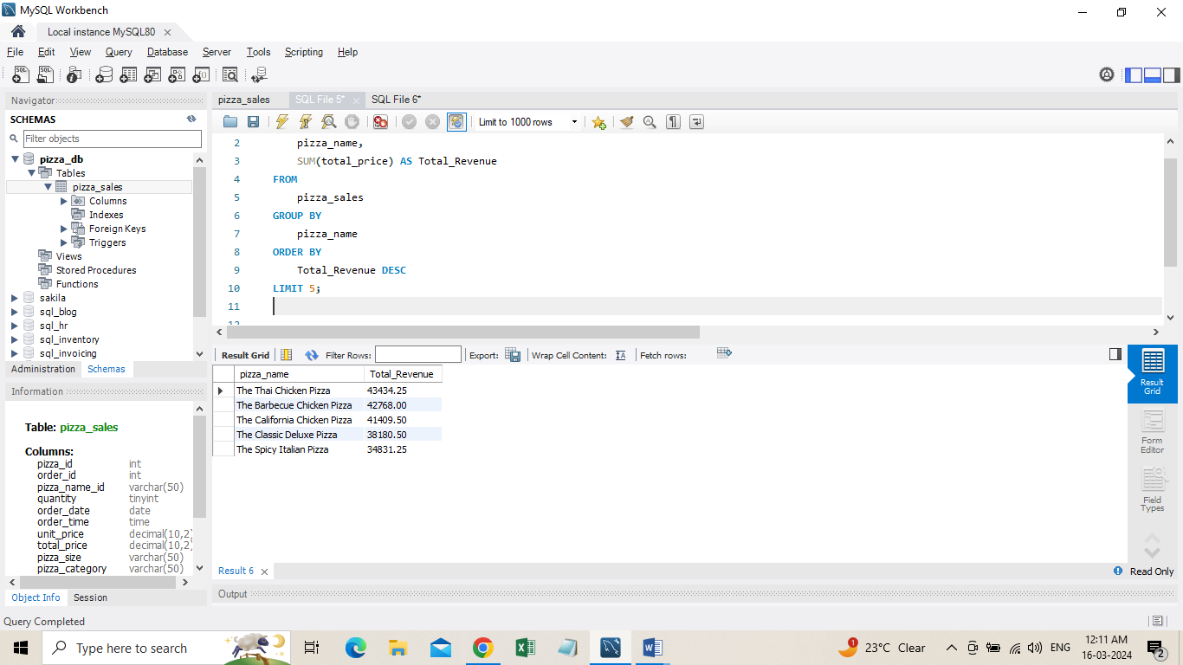

**H. Bottom 5 Pizzas by Revenue**

SELECT pizza_name, SUM(total_price) AS Total_Revenue

FROM pizza_sales

GROUP BY pizza_name

ORDER BY Total_Revenue ASC LIMIT 5;

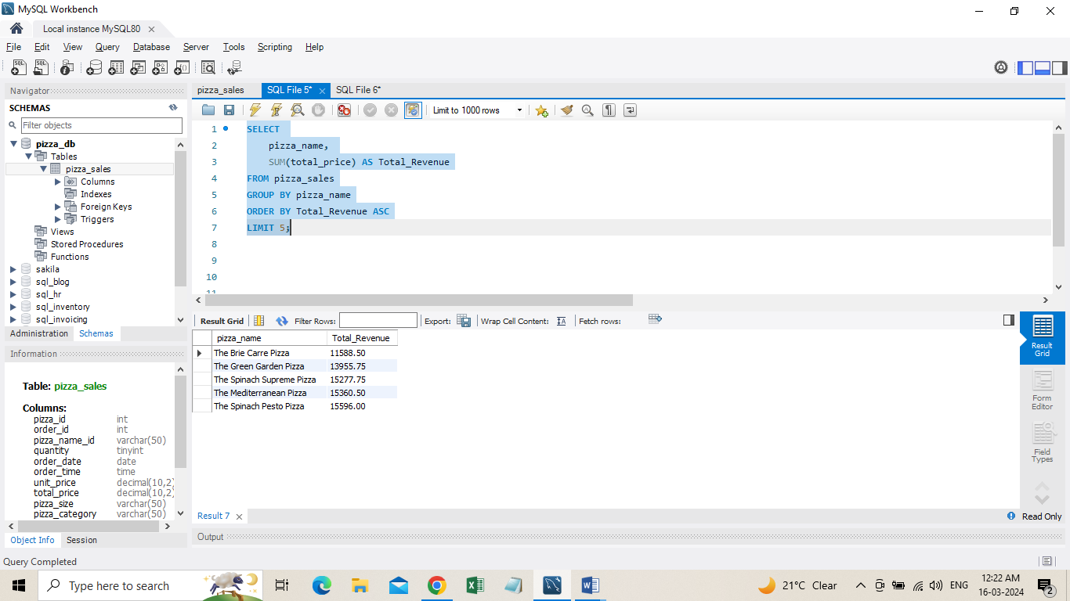

**K. Top 5 Pizzas by Quantity**

SELECT pizza_name, SUM(quantity) AS Total_Pizza_Sold

FROM pizza_sales

GROUP BY pizza_name

ORDER BY Total_Pizza_Sold ASC

LIMIT 5;

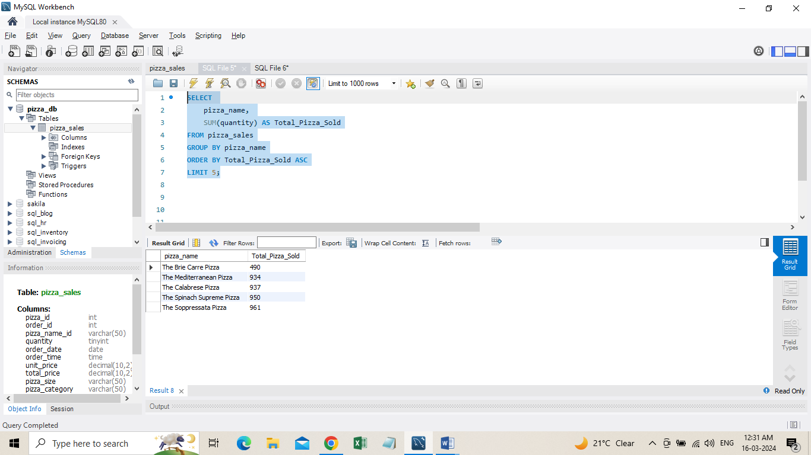

**L. Top 5 Pizzas by Total Orders**

SELECT pizza_name, COUNT(DISTINCT order_id) AS Total_Orders

FROM pizza_sales

GROUP BY pizza_name

ORDER BY Total_Orders DESC

LIMIT 5;

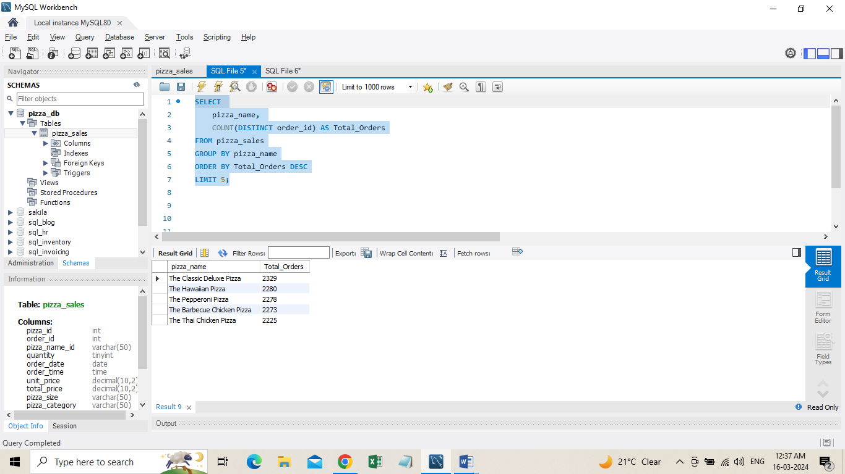

**M. Borrom 5 Pizzas by Total Orders**

SELECT

pizza_name,

COUNT(DISTINCT order_id) AS Total_Orders

FROM pizza_sales

GROUP BY pizza_name

ORDER BY Total_Orders ASC

LIMIT 5;

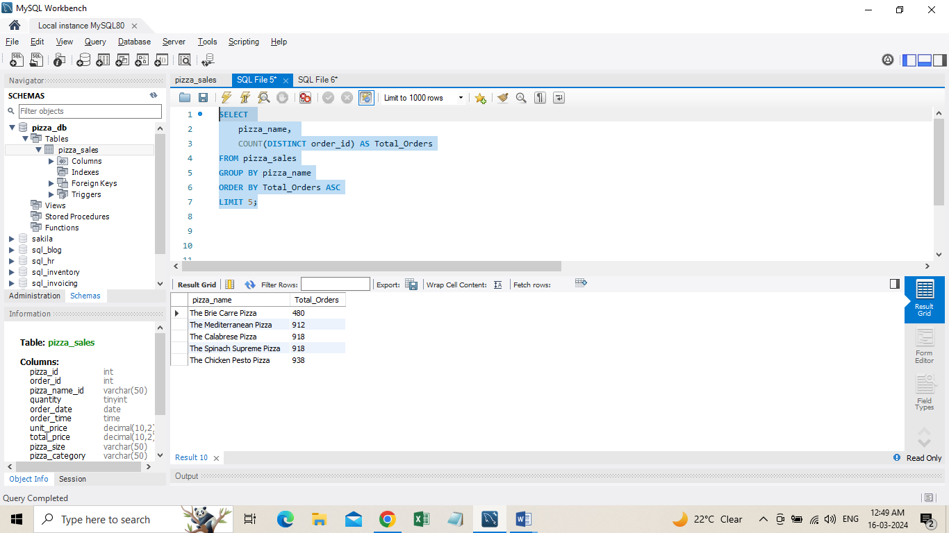

**Data Cleaning**

Pizza size category we have in our database is abbreviated and for dashboard we need it in full expanded form. For eg. L= large, M= medium etc, so we will create an alias to temporary change its name in required format.

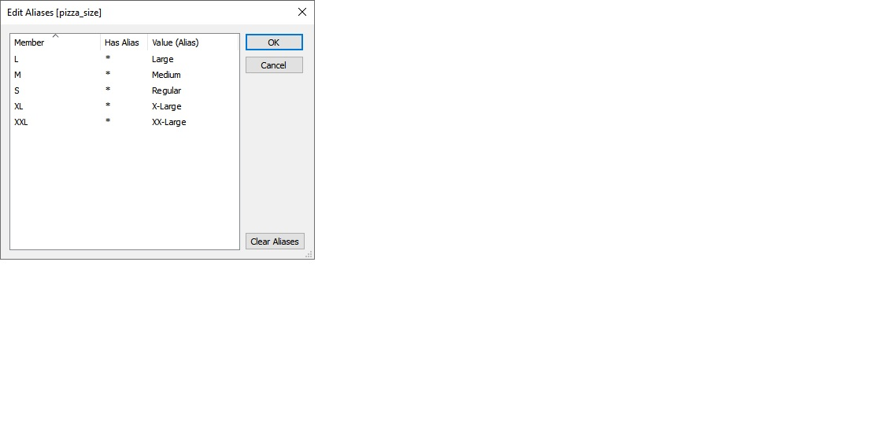

**Build Dashboard or a Report using Power BI**

Created a comprehensive dashboard in Power BI featuring key metrics and charts, including Hourly Trend, Weekly Trend, Sales by Category, Sales by Size, Total Pizzas Sold by Category, Top 5 Best Sellers, and Bottom 5 Worst Sellers.

KPI’S

* **Total Revenue** SUM([total prices])
* **Total Orders** COUNTD([order id])
* **Average Order Value** [total revenue] / [total orders]
* **Total Pizzas Sold** SUM([quantity])
* **Average Pizzas Per Order** [total pizzas sold] / [total orders]

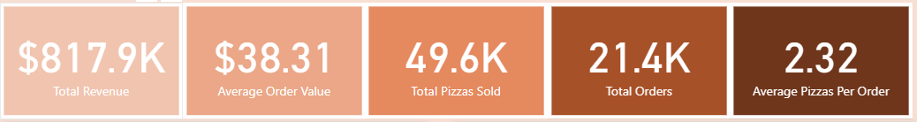

KEY INSIGHTS

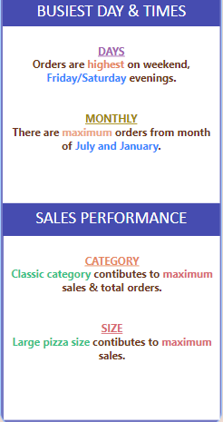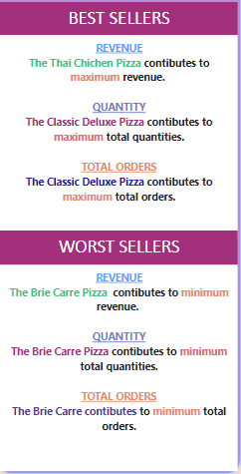

DASHBOARD

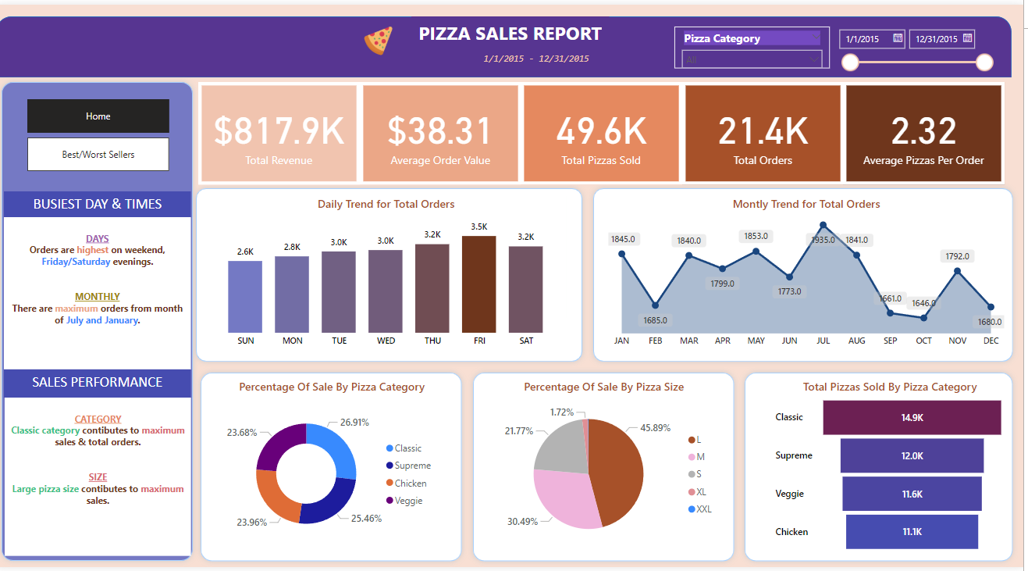

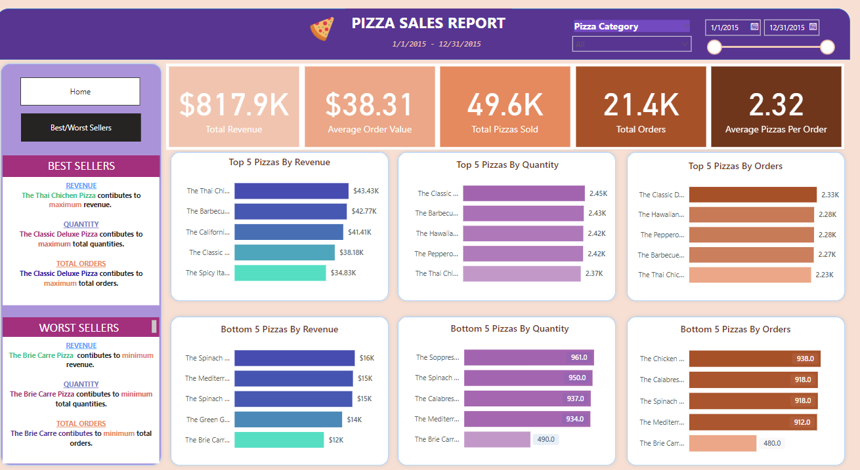

[**Data Analysis and visualization Jupyter Notebook, Python**](https://github.com/yogeshkasar778/Sales_insights_of_data_analysis-AtliQ_Hardware/edit/main/README.md#data-analysis-using-mysql-) **libraries such as pandas, matplotlib, seaborn, and plotly**

KPI’S

* Total Revenue
* Total Orders
* Average Order Value
* Total Pizzas Sold
* Average Pizzas Per Order









CHARTS

* Monthly Trend for Total Orders (Line Chart)
* Percentage of Sales by Pizza Category (Funnel Chart)
* Percentage of Sales by Pizza Size (Funnel Chart)
* Top 5 Best Sellers by Revenue, Total Quantity and Total Orders (Bar Chart)
* Bottom 5 Best Sellers by Revenue, Total Quantity and Total Orders (Bar Chart)

Tota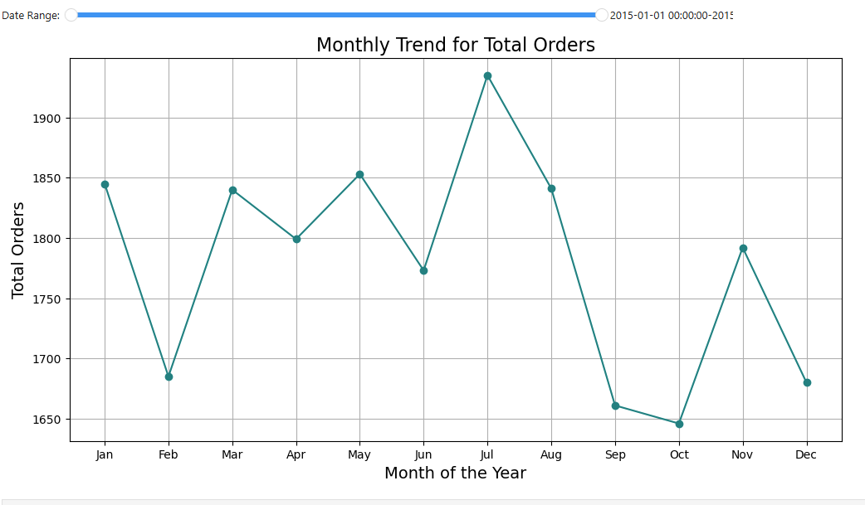l Pizzas Sold by Pizza Category (Funnel Chart)

**Tools, Software, and Libraries**

* **MySQL Workbench** **8.0 CE**

for data analysis and storage

* **Power BI Desktop**

for dashboard creation and visualization

* **Jupyter Notebook 7.2.2**

for data analysis and visualization

* **Excel version 2021**  
  for initial data exploration and manipulation

**References**

* <https://www.youtube.com/@datatutorials1>