CS 5011 Practical 1 Report
Student ID: 120010815

Wumpus: Report

Literature Review:
"Two years ago I happened by People's Computer Company (PCC) and saw some of their computer games such as Hurkle, Snark, and Mugwump. My reaction was: 'EECH!!' Each of these games was based on a 10 x 10 grid in Cartesian co-ordinates and three of them was too much for me. I started to think along the lines of: 'There has to be a hide and seek computer game without that (expletive deleted) grid!!'” This is how Wumpus has been born, in the words of its creator, Gregory Yob. It might be hard to believe but Wumpus has been around for more than 40 years. The deadly heavy monster with the sucker feet immediately became popular among those who had access to a computer. It is definitely not the first computer game, and it was, in fact, an experiment, built on top of the existing games.
In 1976, the creator of the game wrote: “I have reports of Wumpus written in RPG, a listing of one in FORTRAN, a rumor of a system command of ‘to Wumpus on a large corporation’s R&D computer system and have even seen an illustrated version for the Hazeltine CRT terminal!!” The game became so popular that in 177 Gregory Yob publicised another article, describing Wumpus 2 and Wumpus 3.
My personal favourite part of the history of “Hunt the Wumpus” is that it inspired a huge part of computer users of that time for different reasons. It was written in BASIC, a language I learnt when I was a child, and from my own experience I know that it is a perfect language for learning how to program for children. In addition, a lot of programmers designed their own versions of “Hunt the Wumpus” based on the existing one, which created a sort of a special community among the computer users.

Design:

Game
The game is designed in an intuitive way. There is a Game class, responsible for all the game controls. A game is responsible for two game boards – one is a full board, the other one is a board's representation for the player; as well as all of the moving objects of the game. For the simplicity purposes, instead of putting a moving object on the board, the moving objects are associated with a location, which allows easy lookup of the cell (i.e. room) on the board. The game also has a game dictionary, which is a set of commands that can possibly be given to the game. This allows game control to be simpler because this way the game does not have to check that a step being made has a length of on and one only.
Game is also responsible for checking the state of the game and detecting when the player wins or loses the game.
The main game loop looks as follows:
- Print the board in its current state
- Accept a move
- Process the move
- Check the new state of the game

Board
The board has all of the properties of the cave in the game and has a form of the 2D array of Cells, where the behaviour of the Torus shaped cave is specified in the getNorth/South/East/West methods.
The board initialises itself by creating an array of empty cells and then replacing some of them with special cells – exit, treasure and pit.
Additionally, the board is guaranteed to be connected since once the pits are placed, the board is checked so that no cell was surrounded by four pits. However, a cell can be surrounded by three pits and a Wumpus, but that it not as deadly as it can seem since the chance that the player will stay alive is more than zero.

Moving objects: Adventurer, Wumpus, SuperBat
Moving object is an abstract object that has a location which can be changed.
SuperBat moves the Adventurer on a random position on the board; Wumpus moves on a random adjacent cell when disturbed and the Adventurer moves on a specified adjacent cell.

Cells: Empty cells, Exit cell, Treasure Cell, Pit cell, Unknown cell
A cell is represented by its location on the board and what perceptions it has. The perceptions, however, are not stored in the object but checked every time it is requested because they would not be correct if, for example, Wumpus moved.
The rest of the cells are subclasses of the abstract Cell. They have the different behaviour specific to each of them.
Dangerous Cell and Unknown Cell are used by the AI to mark when the cell might be dangerous or when there is nothing known about the cell.

AI player
This attempt of the AI player is not perfect and does not win in most of the cases, however, testing has shown that the AI loses in cases when there is not enough information provided, so the decision made was random and, thus, the AI was simply unlucky.
The AI starts with initializing its own board. Every time it has to make a step, the whole board gets analysed in order to open cells that can be deducted easily. For example, if there are three of the same perceptions around a square and no such perceptions around then we can easily deduce the location of the pit/Wumpus/gold.
After the board has been analysed the AI returns to the current position of the player. It keeps track of the path made by the AI and records the location of the exit cell, if it accidentally steps on it on its way to gold. The AI can also have strategies which are stored in plan – a list of Locations in sequence. If there is such a strategy, then the AI simply follows it, but that means that the AI has to ensure that the path added to the plan is completely safe so that it did not accidentally step into a pit.
If there is no plan then the AI starts looking around and recording which of the adjacent cells are known or unknown. After this it tries to deduct as much information as possible. It can find gold once it is on a glittering Cell, it can find Wumpus once it finds itself on a smelly space. Locating pits is much more difficult, so a lot of the times it makes a guess, although it can recognise several situations and act upon them. For example, it recognizes the situation when three perceptions are around a cell or when 2 of them are around a cell and are diagonal to each other. It tries to deduct information from those rules, but often it is not enough, so sometimes the AI marks both of the possible pits as Dangerous cells and avoid going there.
Generally, nothing can be deduced, it will go to a random unknown cell around. If every single cell around has been visited, it will make a completely random step.

Testing:
I tested the program by running it under different conditions and by having a lot of immediate feedback provided by the process so I could see how the AI made its decisions.

Examples:
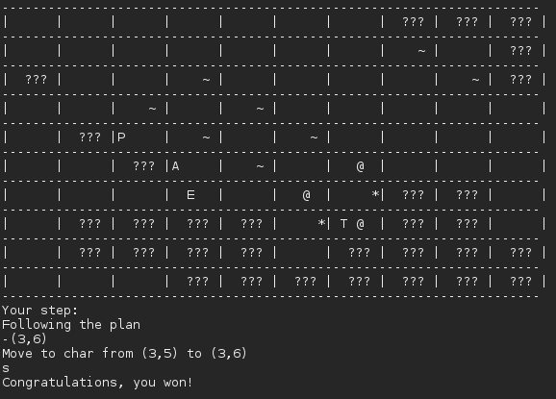
In the example above, I did not insert the whole game because it was quite long. But it can be clearly seen that the AI made a number of correct decisions in complicated situation when several pits are located near each other and share breezy cells, which is considered the biggest challenge of the game.
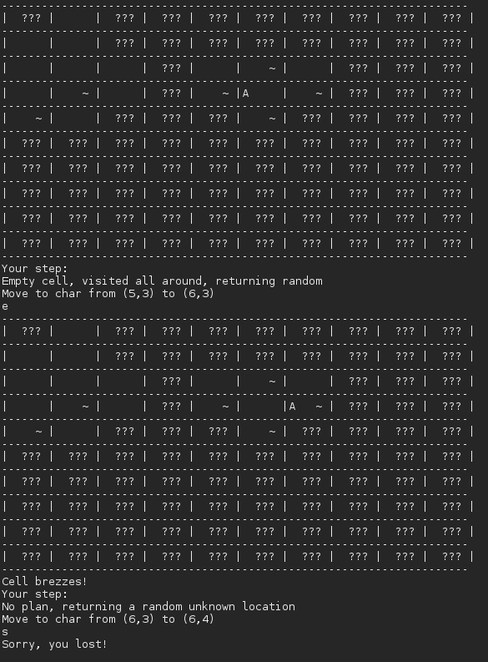
However, this situation is a perfect example of how the AI mistreats the situation and thinks that the pit is inside the “square” of breezes, whereas the pits were, in fact, around that spot.
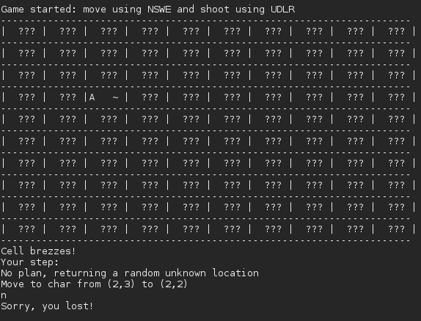
This is an example of how easily the AI can lose in case it does not start from a completely empty cell.

Evaluation:
The AI could have been much better if I had more time, however, in the situations where the AI loses, a lot of time the reason for losing is bad luck.
If I had more time, I would have implemented better ways to judge the current situation in complex situations. I also think that recursion might have been a good decision: a strategy where for a cell, each of the neighbour cells are inspected. That would take quite a lot of time ans steps, but ould probably allow for much more of the information to be revealed first and, thus, allow the AI to make better decisions.

Conclusion:
I learnt a lot while doing this practical and am glad that the AI performs quickly and makes reasonable decisions most of the time. However, I would be much happier if the percentage of winning was higher than it is right now (approximately 20%).

Bibliography:
1. Playing video games: motives, responses and consequences.
2. The Best of Creative Computing Volume 1 (1976)
3. The Best of Creative Computing Volume 2 (1977)

