Assignment:

Configure a spring boot application with multiple databases configured and with a restful web service having http verbs like post, get(by IC) and delete(by IC) to save, retrieve and delete a customer data with name, age, dob and IC(alphanumeric). IC has to be hashed before storing and matched back while retrieving  
Note: use the mysql db, and it's assumed that it covers the unit test and the services can be tested with postman collection.

Solution:

Created the “customer-service” spring boot project for the given assignment and pushed the source code into git hub. Please find the below screenshot for postman response.

Technology used:

1. Java 11
2. Spring boot 2.2.2
3. JPA
4. MySQL – Added DB script(schema.sql) to create table and pushed along with source code

Started the customer service:

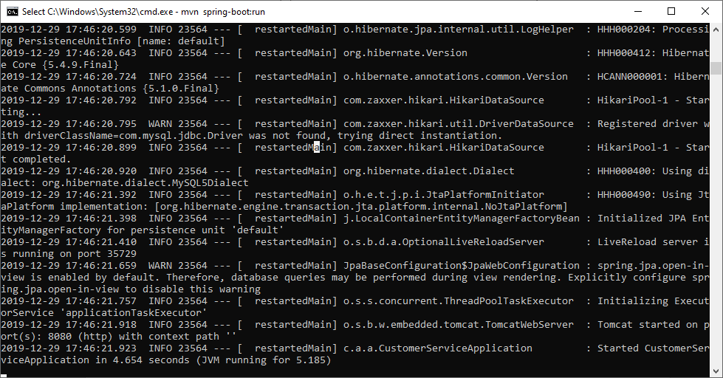

Get all customers: No customer added

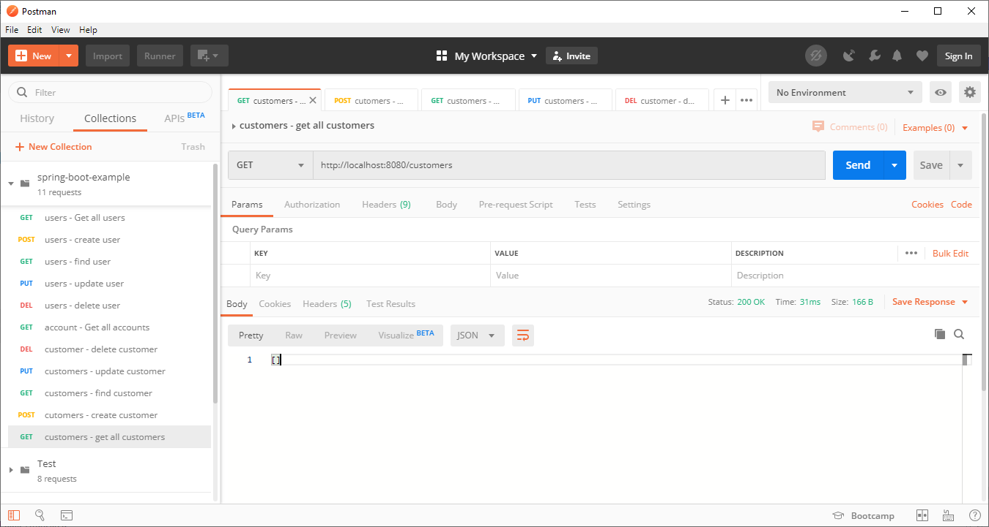

Adding customers:

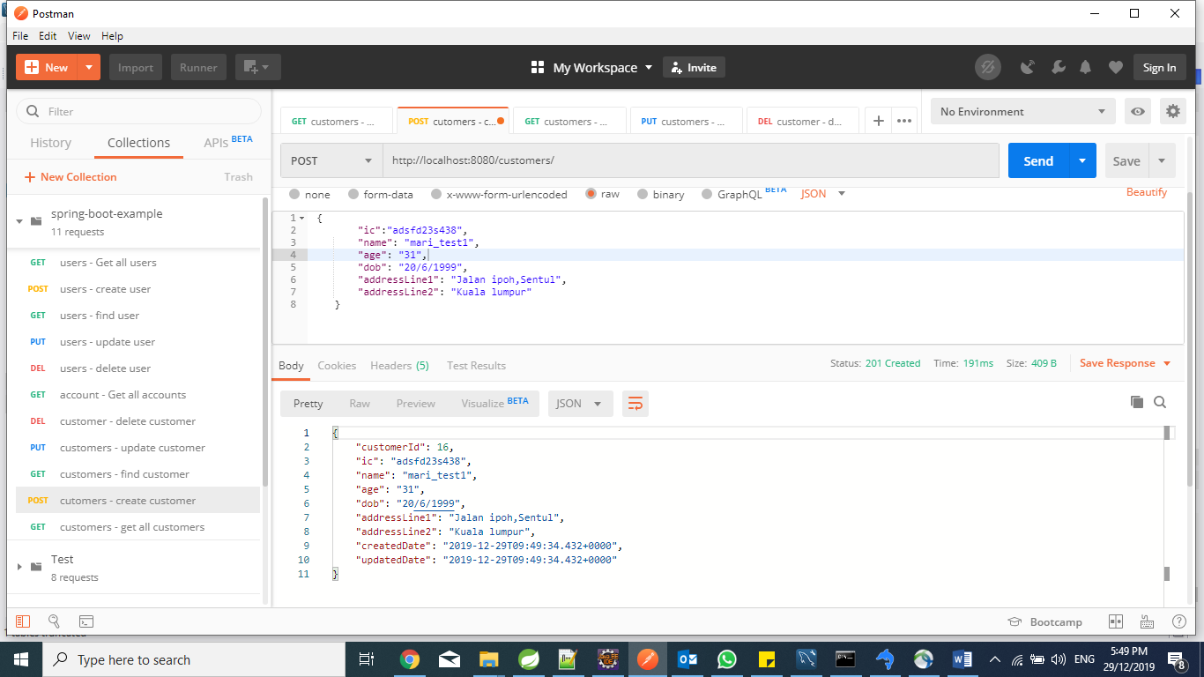

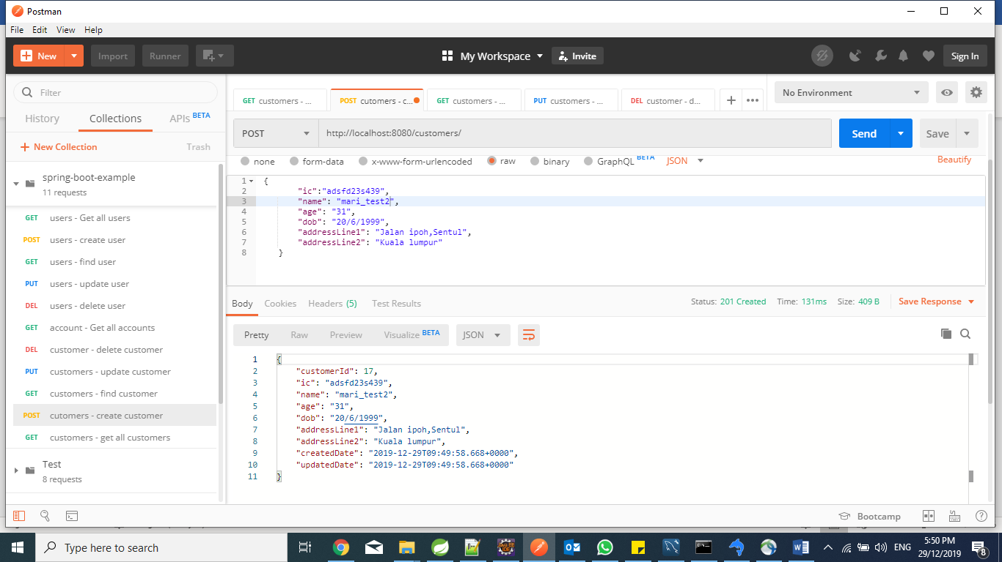

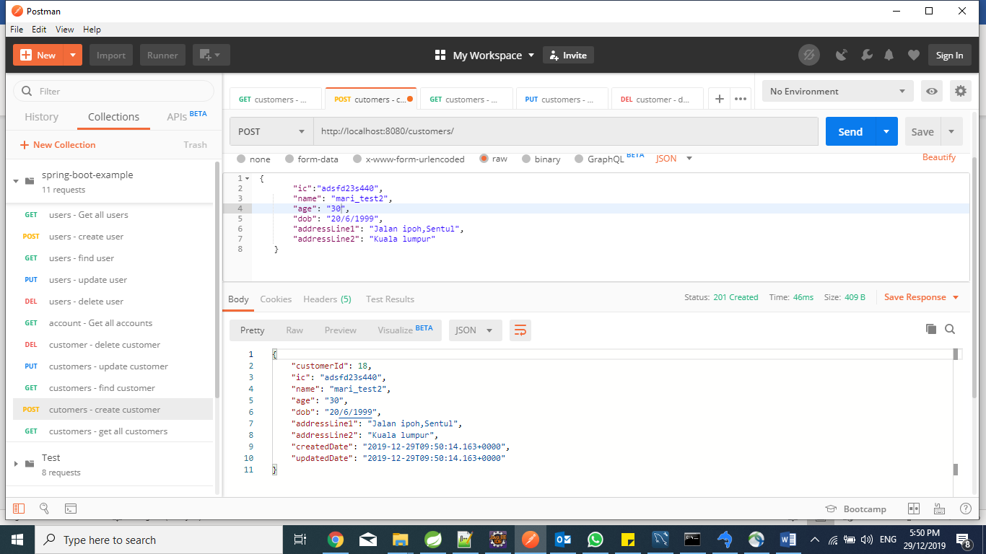

Get All customers:

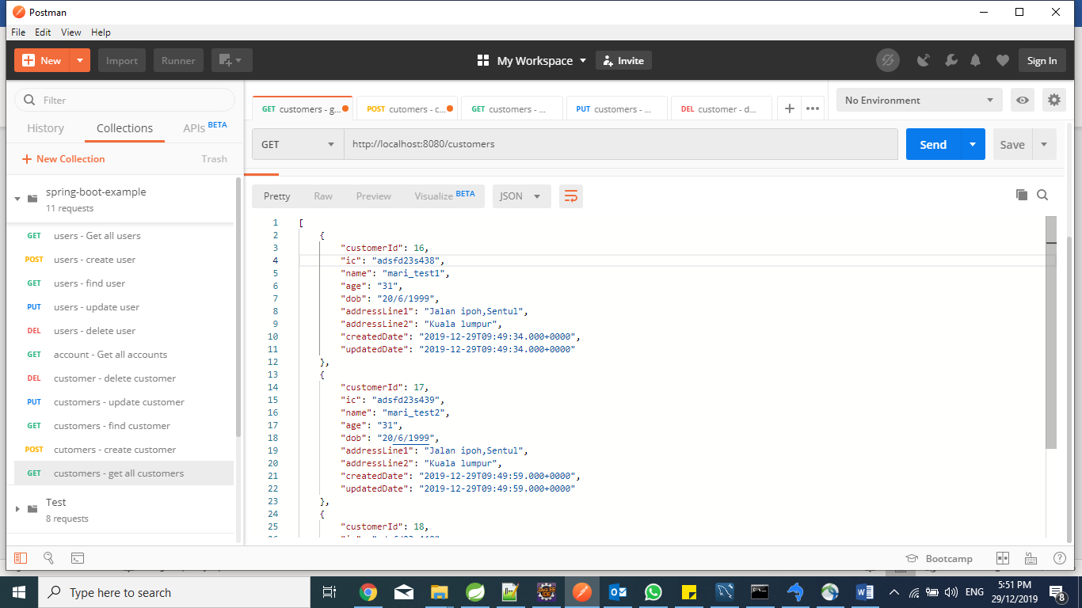

Get customer by IC:

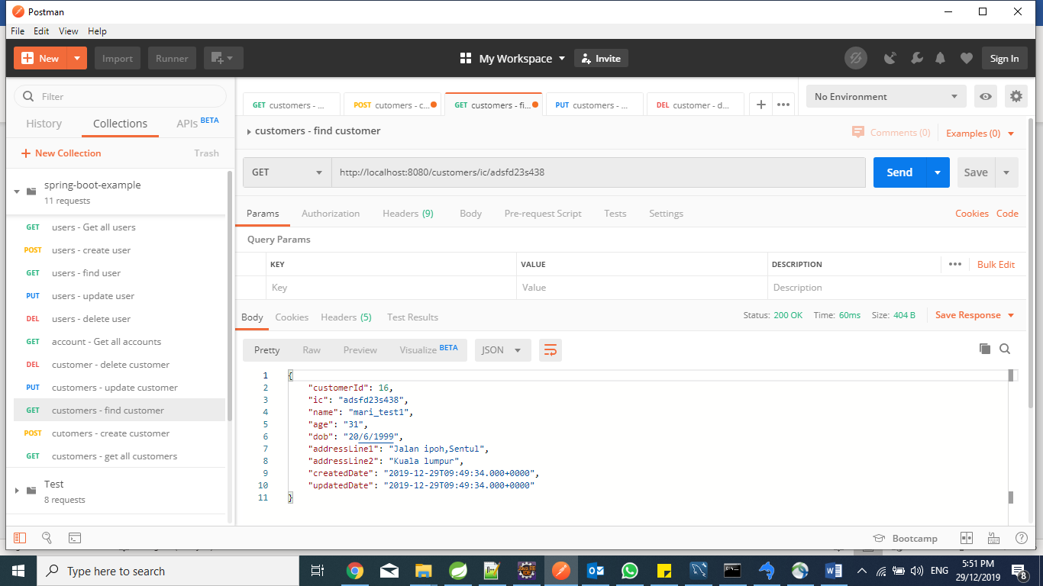

Get customer by name:

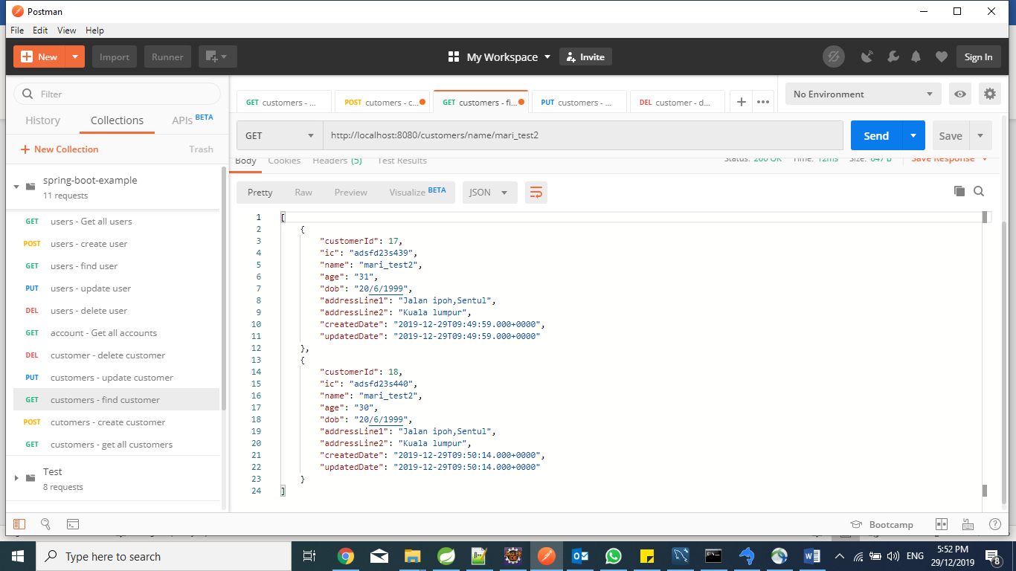

Get customer by age:

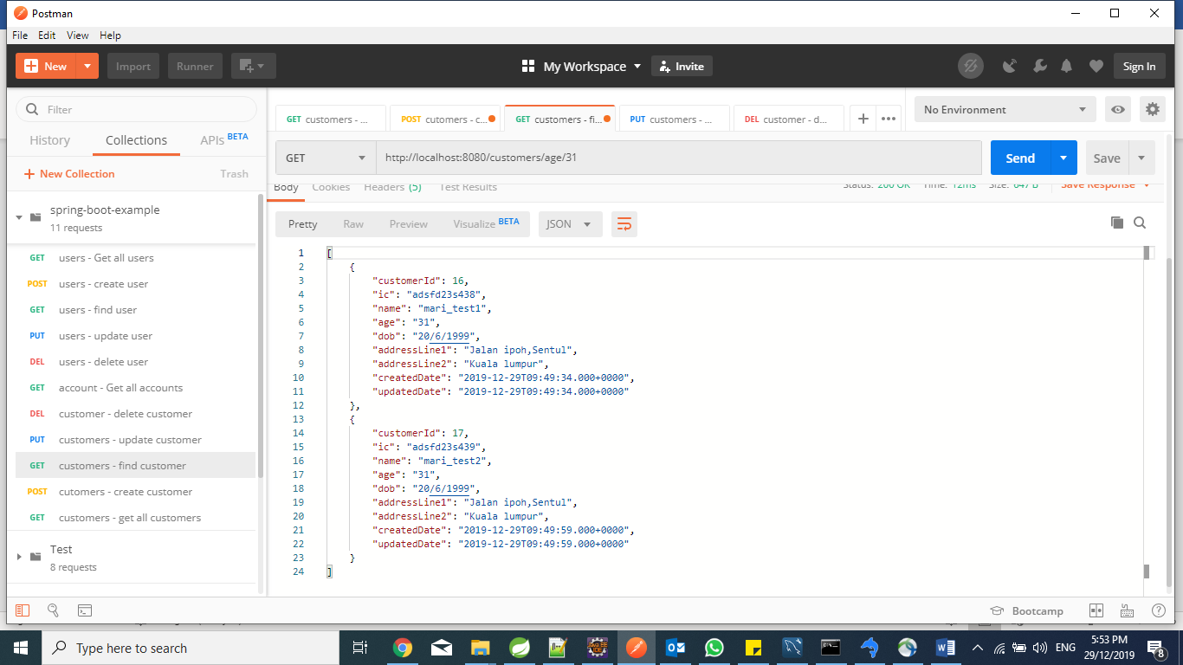

Update customer name by IC:

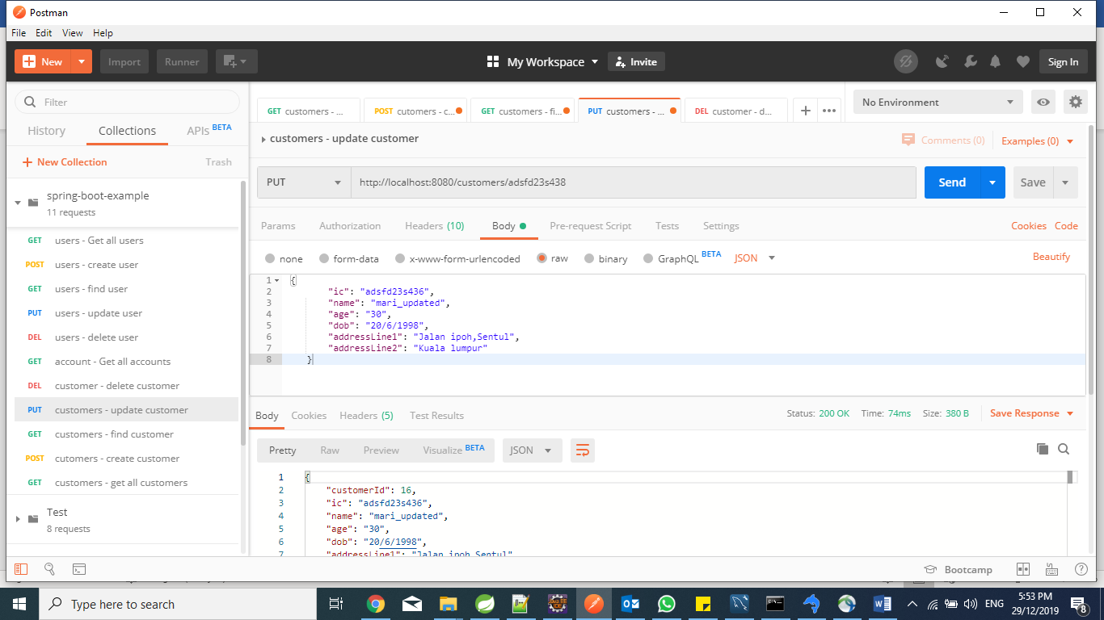

Get Updated customer by IC:

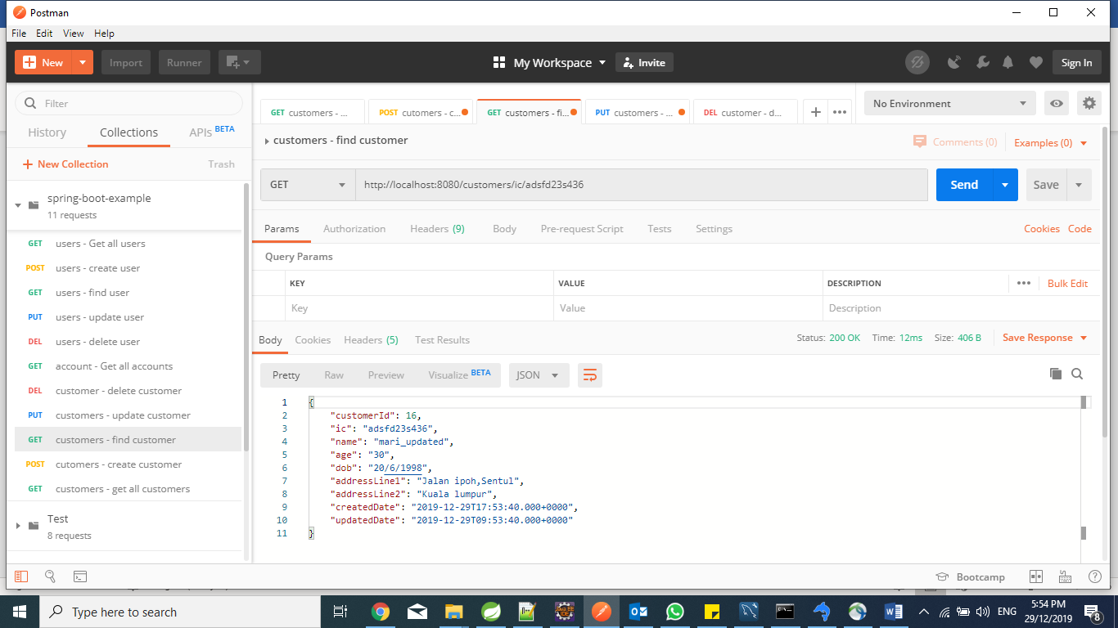

Delete customer by IC:

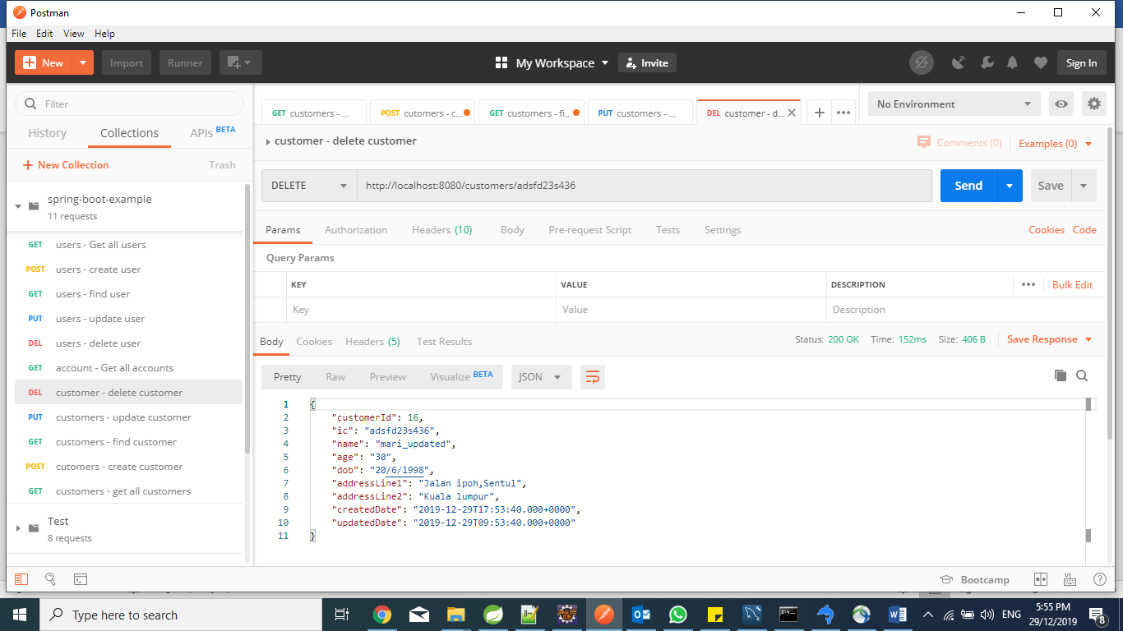

Get deleted customer by IC:

