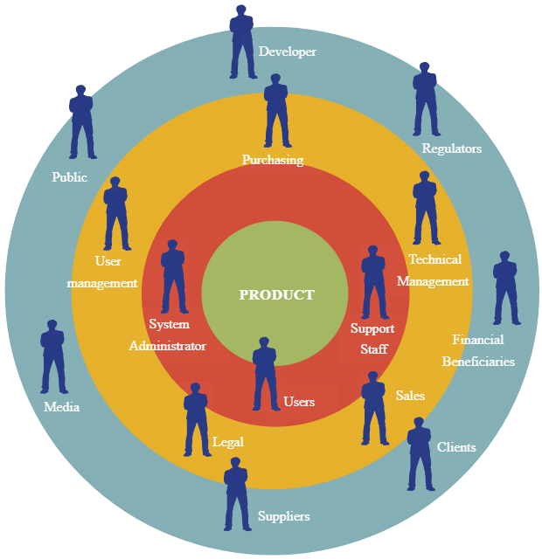

**Marildo Cani**

**Patients**

**Healthcare Policymakers /Government Officials**

**Hospital Administrators**

**Medical Researchers /Academics**

**Quality Assurance /Testers**

**Healthcare Technology Partners**

**Healthcare Providers**

**Regulatory Authorities**

**Developers**

**Support**

**Healthcare Industry Associations**

**Marketing Team**

**Insurance Providers**

**HealthMate AI**

**Individuals (Non-Patients)**

**Family Members / Caregivers**