**HealthMate AI**

*Elevating Healthcare Beyond Borders .* ***Overview***

HealthMate AI is a cutting-edge healthcare application exclusively designed for the esteemed American Hospital. It introduces a transformative approach to post-operative care and remote health management, tailored to meet the unique needs of American Hospital patients.

**A Seamless Three-Stage Experience:**

1. **Post-Operative Self-Service:**
   * Access a curated catalog of recommendations for optimal post-operative recovery.
2. **AI-Powered Guidance:**
   * Communicate directly with the application's AI, providing symptoms or images for personalized recommendations.
3. **Expert Engagement:**
   * Connect directly with hospital professionals for specialized advice, ensuring timely and informed decisions.

**Accessible Care for All:**

HealthMate AI extends its support to individuals seeking immediate health advice. By describing symptoms, users receive initial guidance, with the option for immediate consultation if needed.

**The Future of Healthcare, Today:**

HealthMate AI redefines healthcare dynamics, offering immediate accessibility and personalized recommendations. It represents a pioneering leap towards a future where patient-centered care is the cornerstone of well-being.

|  |  |  |  |  |  |  |
| --- | --- | --- | --- | --- | --- | --- |
| **Stakeholder Name** | **Role/Responsibility** | **Importance** | **Influence** | **Positive Impacts/Interests** | **Concerns** | **Communication Needs** |
| *Hospital Administrators* | Management of the Hospital | High | High | Improved patient care, efficiency, and satisfaction | Data security and privacy, system reliability | Regular updates on system performance, feedback on patient satisfaction |
| *Healthcare Providers* | Doctors, Nurses | High | High | Enhanced patient outcomes, reduced readmissions, compliance | System usability, accuracy of AI recommendations | Access to patient data, AI recommendations, channels for direct communication with patients |
| *Patients* | Individuals receiving care | High | Low/Medium | Personalized and timely healthcare support | Privacy of personal health information, system reliability | Access to AI recommendations, ability to communicate symptoms/concerns, seamless transition between stages of care |
| *IT Team* | IT Specialists, Developers | Medium | High | System functionality, security, and data privacy | Technical challenges, system scalability | Technical updates, system maintenance, feedback on user experience and system performance |
| *Sales and Marketing Team* | Sales and Marketing Professionals | Medium | Medium | User acquisition, subscription growth | User retention, market competition | User feedback, marketing strategies, feedback on subscription offerings and pricing models |
| *Customer Support* | Customer Service Representatives | Medium | Medium | Addressing user inquiries, technical support | User feedback, system downtime | User feedback, technical support, reporting system issues/bugs |
| *Individuals (Non-Patients*) | Potential Users | Low | Low | Access to fee-based service and potential future patients | Perceived value of the service, cost concerns | Marketing and promotional efforts, user feedback on service experience |
| *Regulatory Authorities* | Government Bodies, Compliance Officers | High | High | Ensuring compliance with healthcare regulations and standards | Regulatory changes, potential legal implications | Updates on compliance requirements and potential changes in regulations affecting the application |

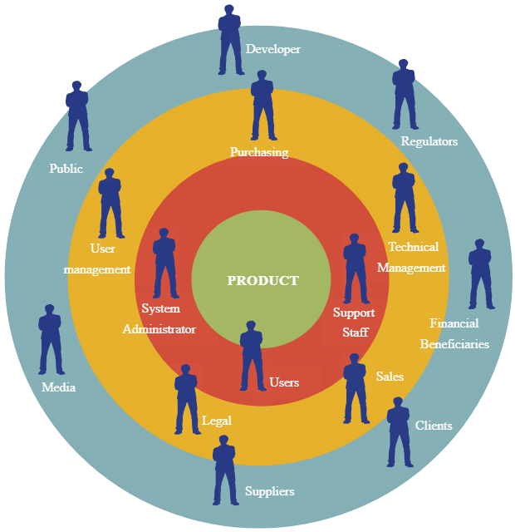

**Marildo Cani**

**Patients**

**Healthcare Policymakers /Government Officials**

**Hospital Administrators**

**Medical Researchers /Academics**

**Quality Assurance /Testers**

**Healthcare Technology Partners**

**Healthcare Providers**

**Regulatory Authorities**

**Developers**

**Support**

**Healthcare Industry Associations**

**Marketing Team**

**Insurance Providers**

**HealthMate AI**

**Individuals (Non-Patients)**

**Family Members / Caregivers**