**The Base Approach**

This work is based in an approach defined by Aleixo et al. [REF -ICEIS]. The overview of the initial definition of the approach could be seen in Figure X. The main goal of this approach is to allow the derivation of specific software development process specification according with the Eclipse Process Framework – EPF. This software development process fits the specific needs of a software development project. The approach applies the software product line concepts [REF] to software development process, reinforcing the premise that software processes are software too [REF].

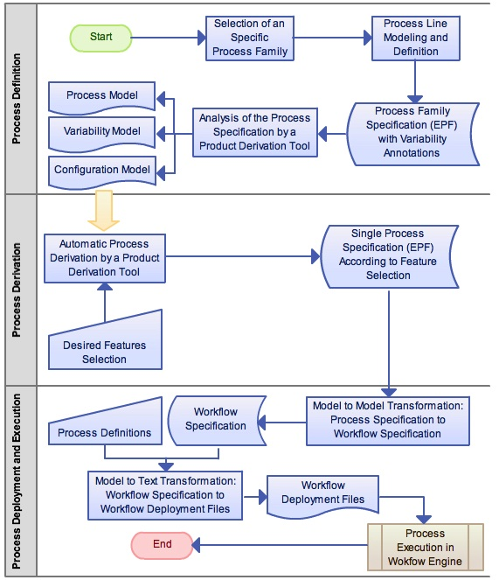

Figure 1. Initial Approach Overview

As shown in Figure X, the original approach could be defined in three stages: (i) process definition, (ii) process derivation, and (iii) process deployment and execution. In the initial stage a specific software process family is selected, as a set of software process that shares the same structure and some common process elements [REF]. After the analysis of each member of the software process family, identifying the commonalities and variabilities among the individuals, an EPF process specification is created and the variation points are annotated in the specification. These annotations could be recognized by a product derivation tool, adapted to this purpose, and interpreted to generate the models necessary to the product derivation: (i) process model, (ii) variability model, and (iii) configuration model [REF].

The second stage is intended to the software process derivation. The execution of this stage is motivated by a new software development project. After the analysis of the particularities for this new software process, a feature selection is done in an instance of the variability model. With this feature selection, a product derivation tool could be used to derivate such specific process. The result of this derivation is an EPF process specification according to the selected features.

In the third stage, the approach provides the deployment and execution of the software process specification with the support of a workflow engine. To able this intent, the process specification have to be transformed in a workflow specification. The transformation between these two models is possible with the support of model-to-model transformation language as operational QVT [REF]. To able the generation of the deployment files, beyond the workflow specification are needed some well-known information about the future execution of the software process, informations such as: (i) number of iterations in each phase (assuming that the process is based in the Unified Process – UP), (ii) people playing specific roles, (iii) milestones dates, (iv) release dates, etc. The workflow specification and the well-known execution information are used in a model to text transformation to generate the workflow deployment files. These generated files are likely to be deployed in a workflow engine.

After the deployment in the workflow engine, a new instance of this process could be started. The process execution could be monitored through the workflow engine console, which coordinates the interaction of the process stakeholders and the process instance execution. The workflow engine console indicates which the actual activity that has to be done in the process execution, and also could store some informations about the execution, such as: (i) start and end date of an activity, (ii) some related observations, (iii) produced artifacts, etc.