**System Specifications**

|  |  |
| --- | --- |
| **Project Name: Developing web application with php & mysql** | |
| **Student: marinelida oliveira** | |
| **presented to: M. Zeroug** |  |
| **Date: 4/27/2019** |  |

1. Home page

The home page allows the registered and non-registered users see all the ads of the web site, search by category and see the details.

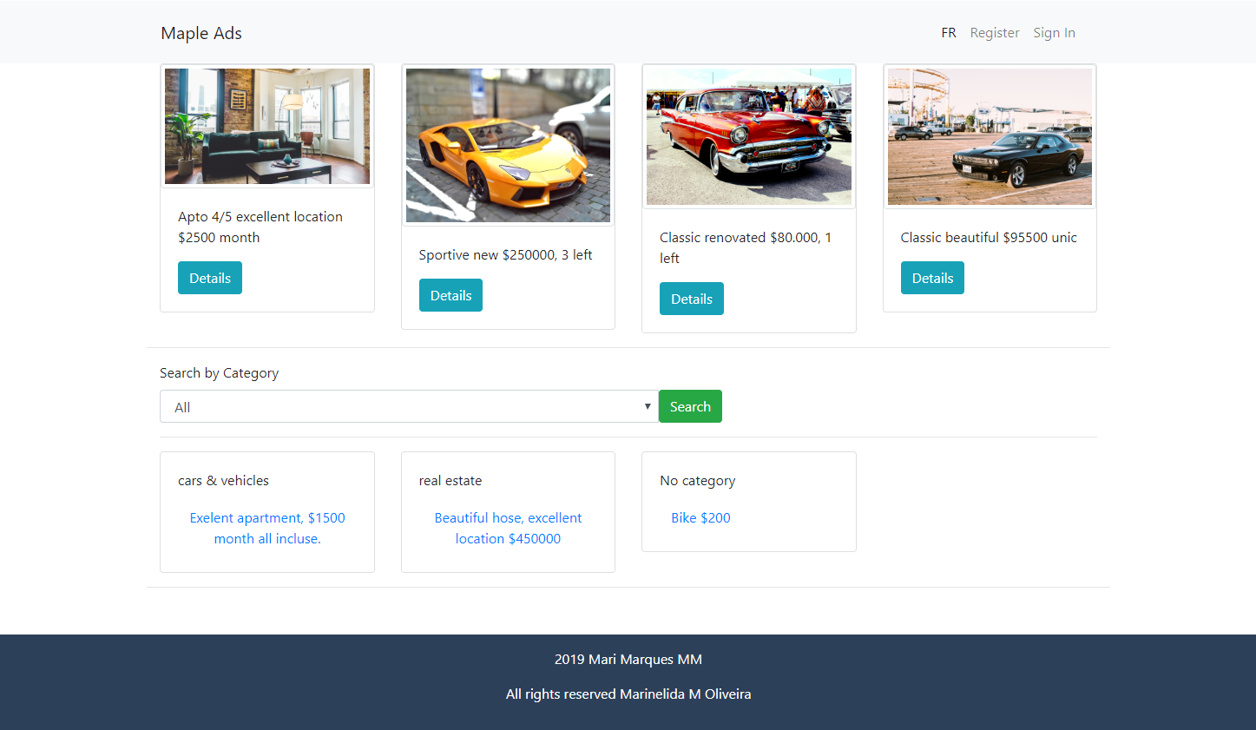

Search

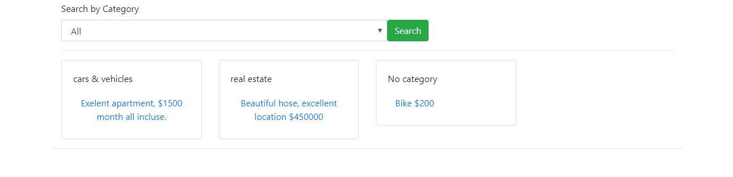

Details

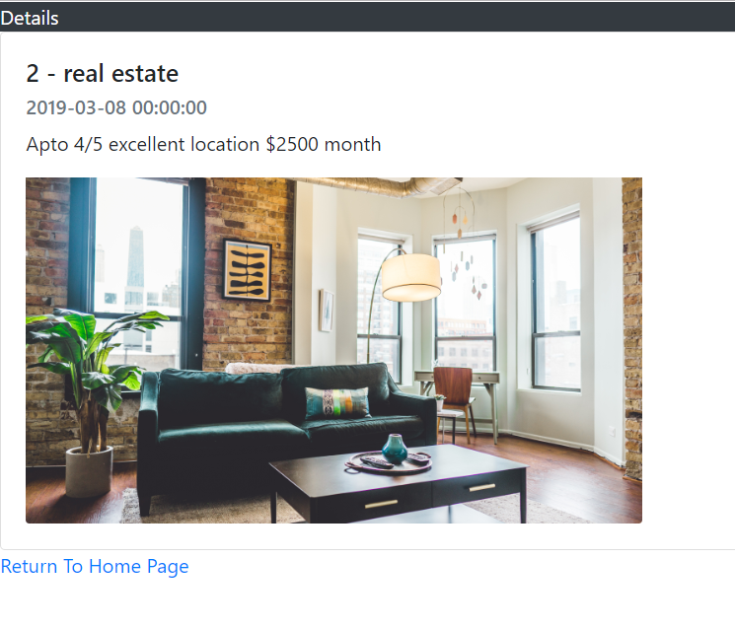

1. register page

To register the user must provide a valid email and the password must have at least 6 characters and must contain at least one uppercase and lowercase letter and one digit.

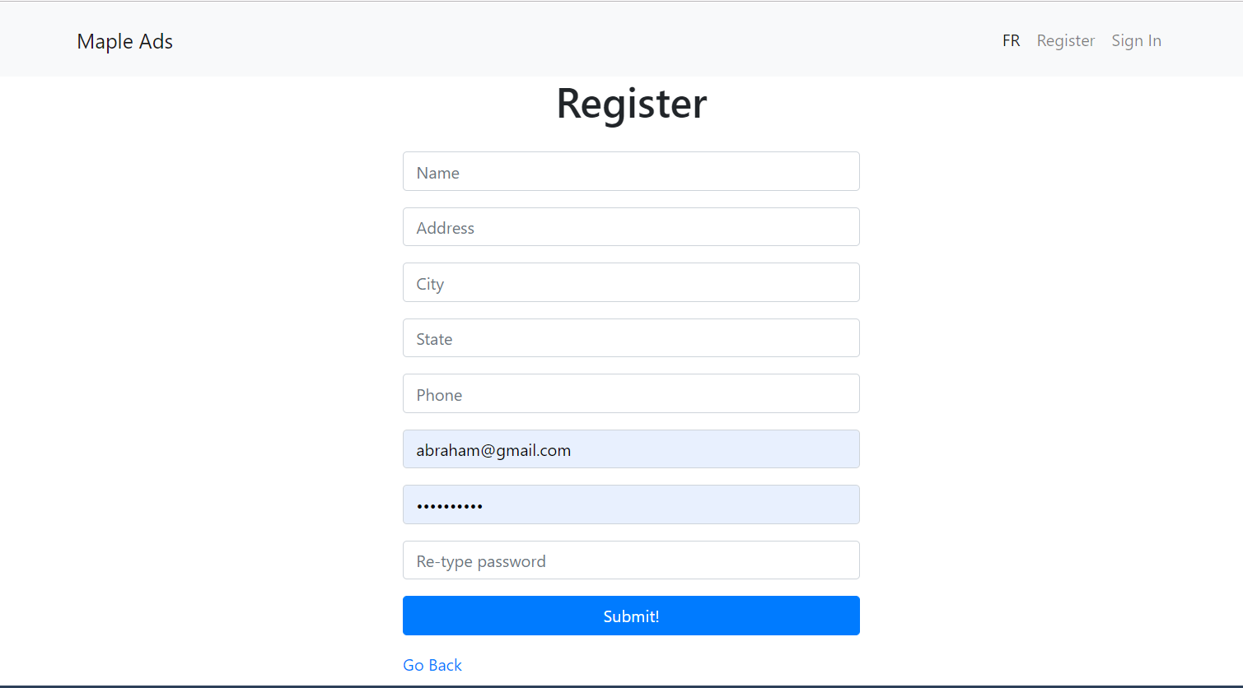

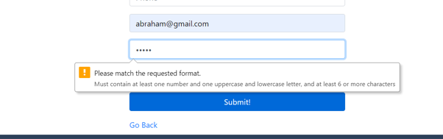

1. sign in page

Once the user sign in into the website, the system check the user permissions and redirect for the page with the correct permissions (admin or member).

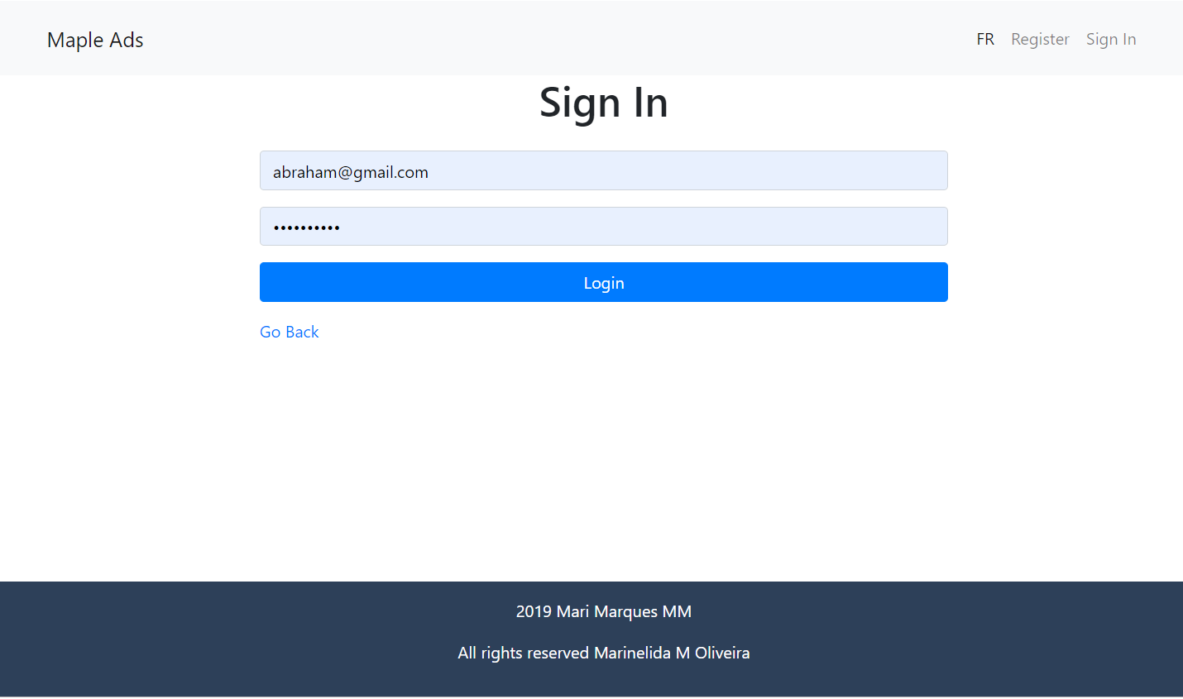

Admin Home Page

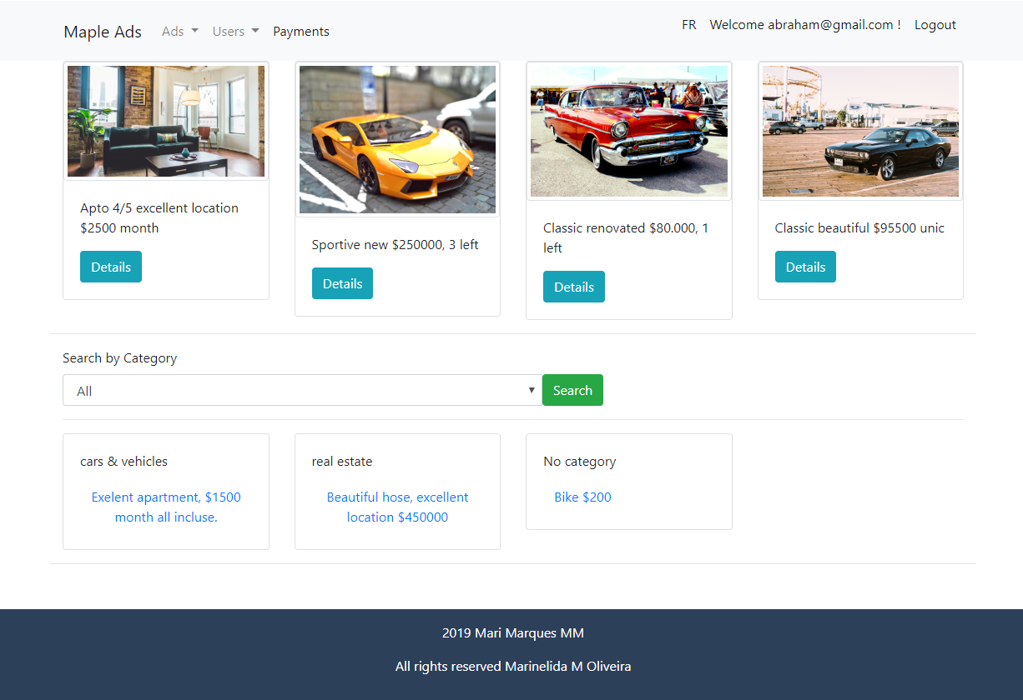

Member Home Page

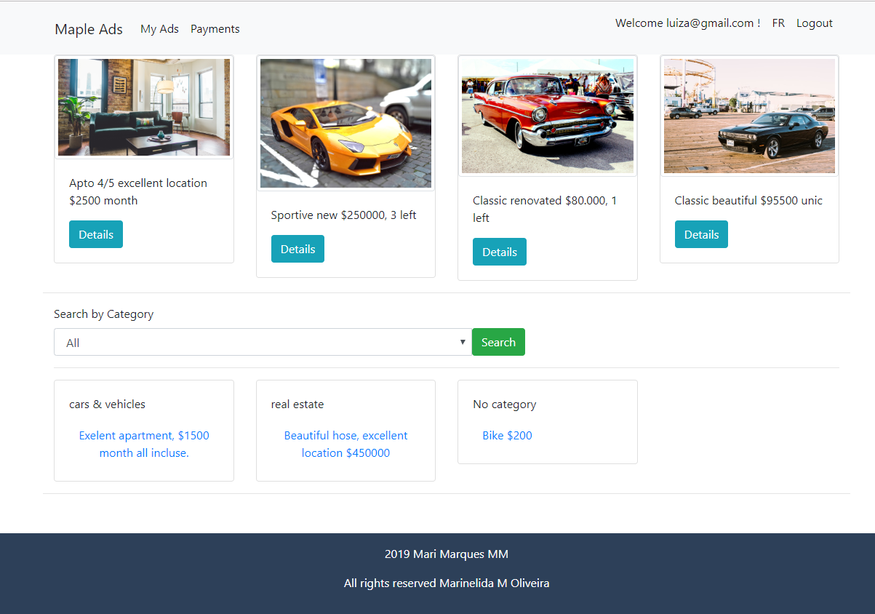

1. my ads page

The user type member can see all his ads, create new, edit or delete.

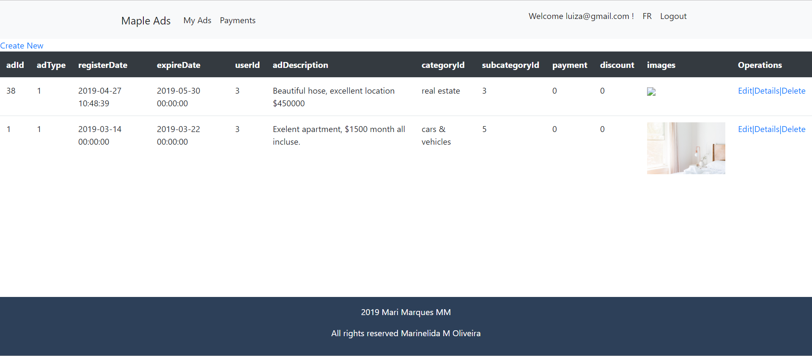

Create new Ad

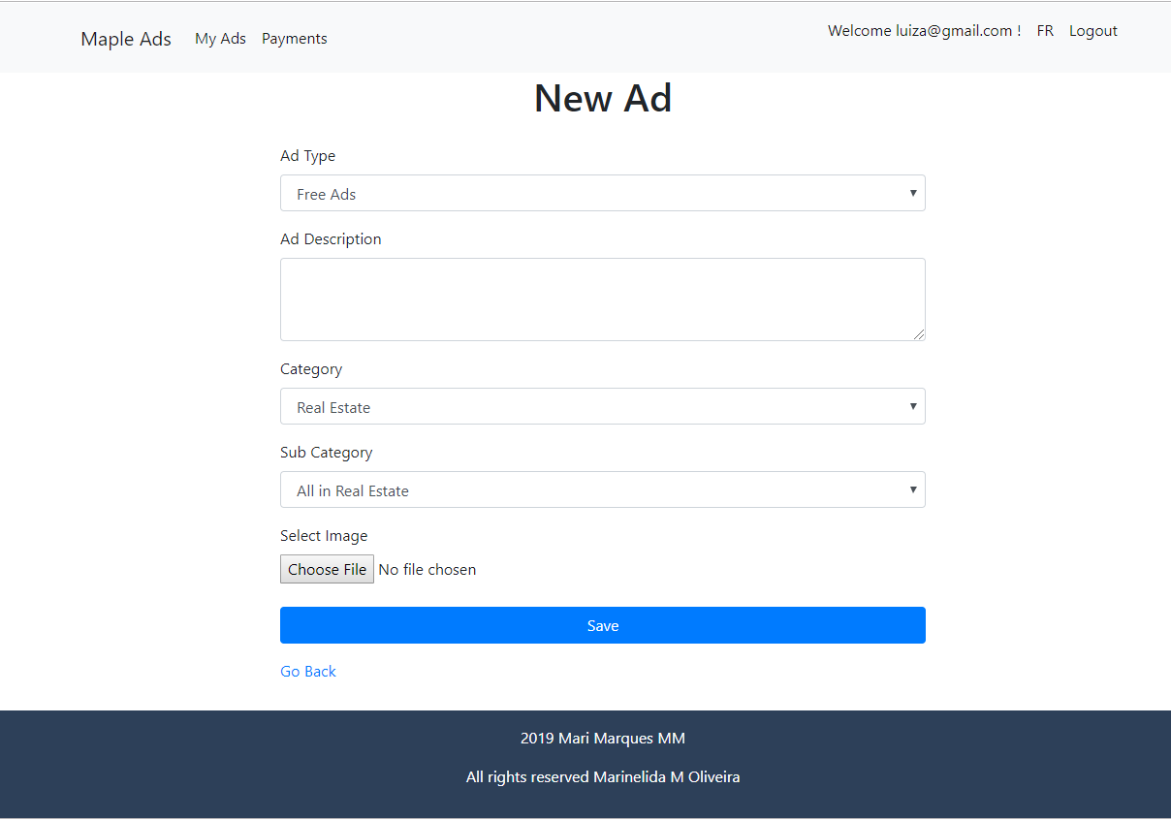

1. MENU ADS

The user type admin can view, edit and delete the ads, ads type and ads category.

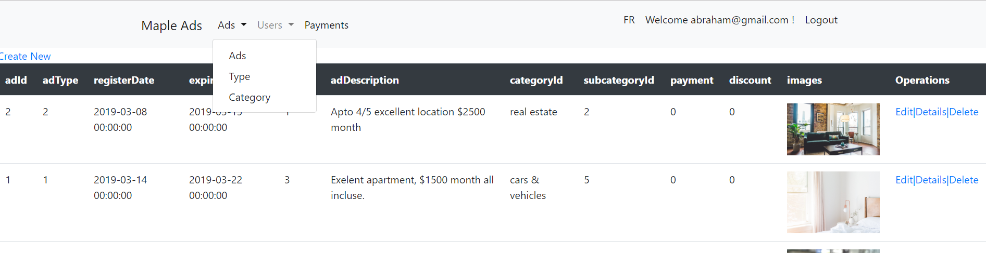

1. Menu users

The user type admin can view, edit and delete users.

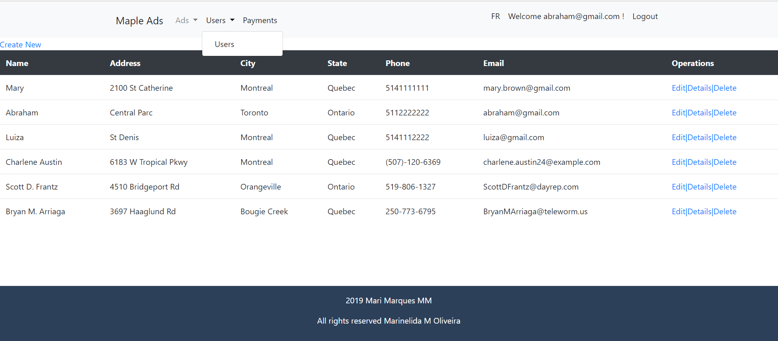

1. logout

By clicking twice on the link logout the user is redirected to the home page and the session is closed.



