Database Management System:
DBMS is a software that manages databases and allows users to access data using SQL Commands.

RDBMS – MySQL, PostgreSQL. Data Stored in tables.
DBMS – MongoDB. Data is stored in files.

Database:
A database is an organised collection of data.

SQL:
SQL – Structured Query Language
SQL is a language used to communicate with a database through a DBMS.

By using SQL commands, we can create databases and tables, insert, update, and delete data. We can also extract data from databases.

When we write SQL commands in MySQL (DBMS software) mysql server will read it, understand it and validate it and then finally execute the SQL commands we wrote.

User --> SQL --> DBMS --> Database

User uses SQL commands in MySQL to access the database.
Access in terms of creating, manipulate the data.

A schema is a logical container that groups related tables inside a database to keep data organized.
Database
├── sales (schema)
│ ├── customers (table)
│ └── orders (table)
└── hr (schema)
├── employees (table)
└── payroll (table)

Database objects are structures used to store data, improve performance, and organize a database.
Table
View
Schema
Constraint

SQL DDL and DML Commands:

Command: create database <database_name>
Will create a new database

Command: Show Databases;
Used to show databases in the DBMS.

Command: Use Database_Name;
By using that command, we can perform operations on a particular database.

Command: show tables;
Show all the tables we created in that database.

Command: desc tablename;
Used to show the structure of the table (columns) details.

Data Definition Language:
Used only at field level.

Here you can see the fields/column cust_id, cust_name, city, order_id, order_date, amount.
In this column if we want to add another column with data_type, change column name with datatype, or delete the column with datatype, change the data type alone, add primary key alone. what ever we want to do in that column/field level is by using Data Definition Language commands / statements.

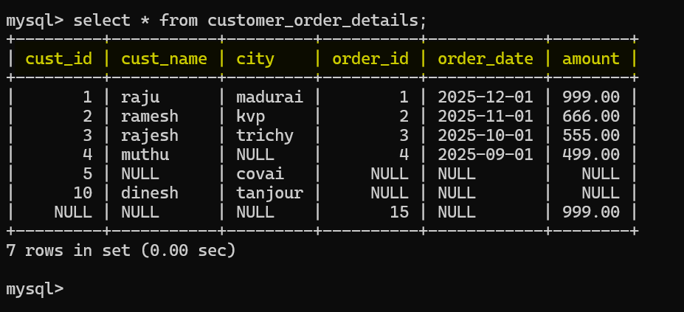

Data Manipulation Language:
Used in records level (inside the actual data).
If we want to do action in record we use the DML commands.
If we want to add one record, delete one record, or update a particular cell in a record.

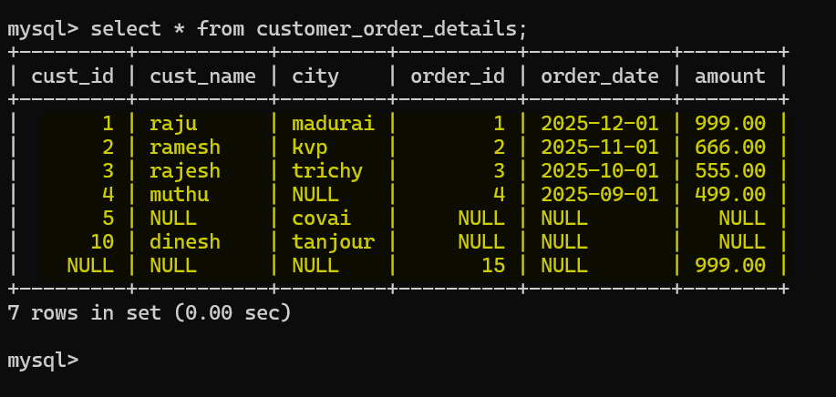

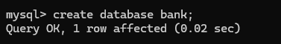

Create table syntax:
Create table <table_name> values(column_name datatype, column_name2 data type,...);

create table john_bank_account(account_id_num int primary key,transaction_number bigint, bank_balance decimal(12,2), average_processing_time float, fraud_probability float, fraud_analysis_score double, title char(4), city_code char(2), customer_name varchar(50), account_description text, transaction_done_date date, transaction_done_time time, account_created_at datetime, transaction_at timestamp, account_opened_year year,is_account_active boolean,account_type enum(‘saving’,’current’,’loan’,’dormant’),list_of_services set(‘internet_banking’,’atm’), kyc_details json);

